**Film Studies A Level- Bridging Work**

1. **Watching as many films as possible:** could there be a nicer task for your teachers to set for the summer? One of the most important things you can do in preparation for A Level Film Studies is to simply watch as many films as possible. The films we recommend starting with are the ones that you might not typically choose. If you tend to stick to Marvel movies; why not try something from the silent film era or from classic Hollywood?
2. **Going to the cinema:** It’s great that we have access to so many films from the comfort of our home but nothing quite beats the cinema. As part of the course, you’ll study the reactions of audiences and how directors intend for us to respond to certain scenes. You’ll also study the industry considering how films make profits, how decisions are made about casting and directors plus the key differences between different film industries around the world.

Come prepared to your first Film lessons with a list of your favourite films you’ve watched over the holidays. Be prepared to discuss them; a huge part of being a film student is participating in group discussion.

**Task**

As part of your NEA, you’ll be required to study a range of short films. Over the holidays, start with the ones below and make notes in relation to the questions.

**Wallace and Gromit: A Close Shave- Available for free on BBC IPlayer.**

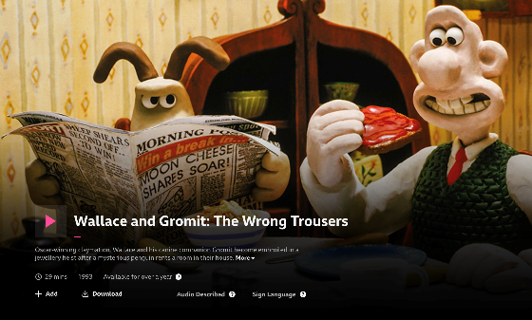

1. Do some research into Nick Park and Aardman animations. Which other films have they created?
2. The narrative of the film packs a lot into a short time. How quickly do they establish Feathers McGraw as the villain of the film? What methods do they use to make it clear that he is the antagonist to Gromit?
3. Why do you think Wallace and Gromit was such a successful film? The film won an Academy Award in 1993! What do you think the appeal would be to an international audience?

**Connect- Abrahams- available free on Youtube- search Connect short film**

[**CONNECT - BAFTA Nominated short film**](https://www.youtube.com/watch?v=SpOSIYHxAaE)

1. Why do you think the film is called Connect? How does the title link to some of the themes in the short film?
2. How do you know what is real and what is fantasy?
3. How would you describe the plot of the film? Plot the narrative sequence.



**Task**

One of the things we will be looking at a lot in film studies is mis-én-scene.

1. Define this term.

2. Why do you think consideration of mis-én-scene is important?

3. Look at the stills from award winning films below. Consider why the mis-én-scene is important in each of these images. What do you notice? What effect does this create for the audience? How does the mis-én-scene create meaning?

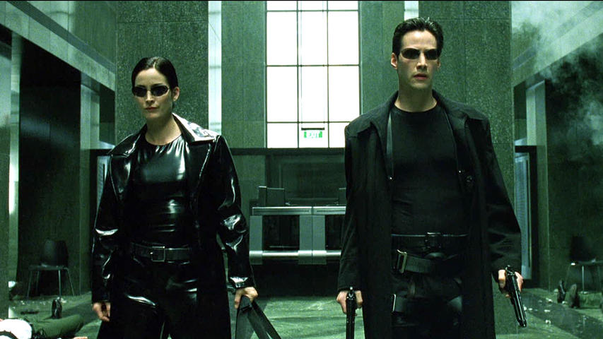

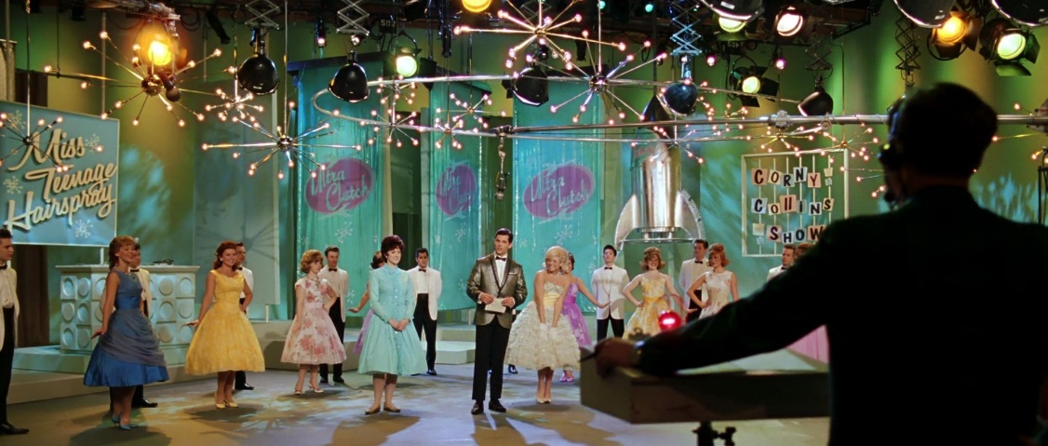

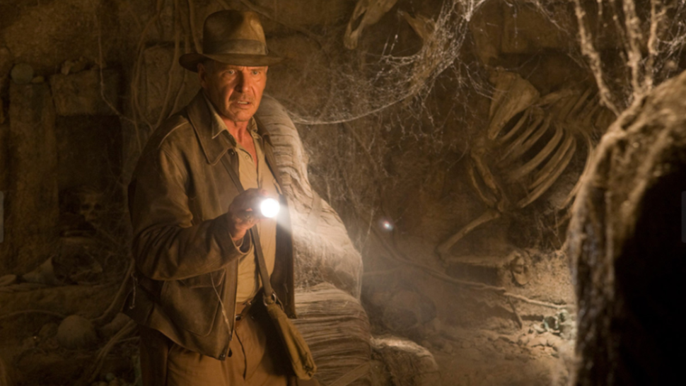

**Task**

Choose a three - five minute section of ANY film of your choice. Have a go at analysing the sequence. When you come to class in September bring your notes. Use the questions below to help.

Is there anything interesting you notice about the camera work?

How is the scene lit? do you think this adds meaning?

What sounds do you notice? Has anything been added after editing?

What effect do the costumes create?

How are men/women represented?

Are there any important links to historical context?

How does this scene develop the characters?