

Bridging task

BTEC Forensic and Criminal Investigation



In order to prepare you for a successful start to BTEC Forensic and Criminal Investigations, please complete the following tasks.

Task 1: As part of this course, you will study small parts of A-Level biology, Chemistry and Physics, so that you have a foundation of Science knowledge.

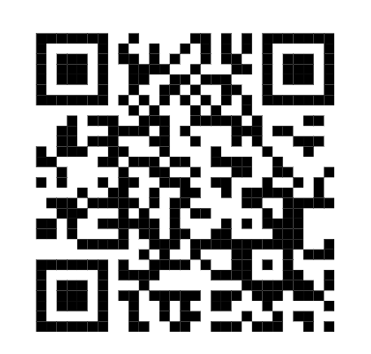

Watch this video to recap ionic, covalent and metallic bonding

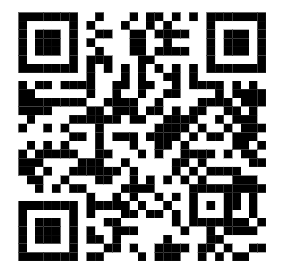

Read this information about microscopes and cells – this includes more information than what you learnt at GCSE level!

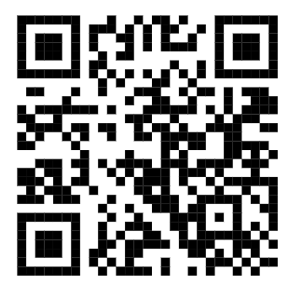

Read this article about how science links to music!

Task 2: Crime Scene!! During year 12, you will visit a crime scene simulation. Read this extract about restriction of access to a crime scene.

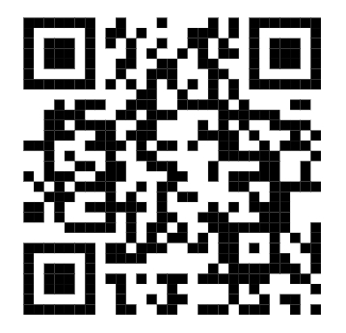

Book recommendations for the course

