**St Wilfrid’s History Y12 Bridging Unit: Russia**

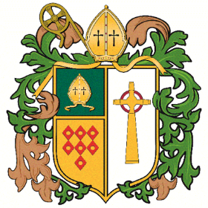

One of the papers you will complete as part of A Level History is Russia: Revolution and Dictatorship 1917-1953.

To help you gain a bit of background knowledge about Russia before 1917, complete the following activities.

Reading and annotating reading texts

* Read the text that you have been given – Corin p.2-23
* Underline the key points and annotate them with your thoughts about what this tells you about Russia
* Use the ‘Focus Route’ prompt boxes which appear in the margins of the reading to focus your note taking.
* Watch Lucy Worsley’s Empire of the Tsars: Episode 3 (on BBC iPlayer)

**Optional stretch:** Independent reading about Russia 1905-1917

* <http://spartacus-educational.com/RussiaIssues.htm>
* http://spartacus-educational.com/RussiaEvents.htm