Year 11-12 Transition Work

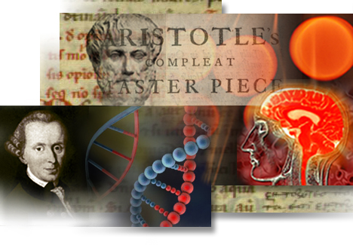

Ethics, Philosophy and DCT

Name:

**🔍 Preparing for Ethics, Philosophy & Developments in Christian Thought (DCT) in Year 12**

In Year 12, you will study a variety of units across Philosophy, Ethics, and DCT:

* **Ethics:** Learn about key ethical theories like Natural Law and Utilitarianism and apply them to topics such as sexual ethics, business ethics, and euthanasia.
* **Philosophy:** Explore the ideas of philosophers such as Plato and Aristotle, study concepts like the soul, mind and body, and examine arguments for the existence of God.
* **Developments in Christian Thought (DCT):** Study themes including human nature, knowledge of God, gender, and secularism.

**🎯 Why Complete This Preparation Work?**

Before the course begins, it’s useful to build some background knowledge on the topics and ways of thinking you’ll encounter. Philosophy, Ethics, and DCT introduce new ideas, unfamiliar vocabulary, and different approaches to big questions.

It’s completely normal if some concepts feel strange at first — we’ll explain everything in class. This preparation simply helps you feel more confident and ready to take part in discussions from day one.

**Your Task: Complete Around 3 Hours of Independent Work**

You’ll find a range of activities in this booklet to suit different interests and learning styles. Choose tasks that add up to roughly **3 hours** in total. You can mix and match from the following:

* ✍️ **Written tasks**
* 🎧 **Podcasts**
* 🎬 **Films**
* 📖 **Books or articles**

However, you choose to complete the work, make sure you **bring your notes or completed tasks with you** when you start the course.

**📝 Bringing Your Work**

Please **bring any notes, reflections, or written work with you** to your first lesson in September. You can complete tasks on paper or type them if you prefer.

|  |  |  |
| --- | --- | --- |
| A-Level topic: **An Introduction to Philosophy** | | TASK |
| **Something to read** | ‘Philosophy the basics by Nigel Warburton.  [Philosophy : The Basics (5th Edition)](https://studyhighschoolenglish.wordpress.com/wp-content/uploads/2015/11/0415693160_philosophy-the-basics.pdf) | 1. Read the **introduction** from start to finish (upto page 9) 2. Write a brief summary of what philosophy is about 3. **Extension:** Read up on Plato and Socrates, using the book. Write a list of 10 interesting things you’ve learnt about each Socrates and Plato. |
| **Something to watch** | What is Philosophy (Crash Course)  <https://www.youtube.com/watch?v=1A_CAkYt3GY>  Theory of Knowledge (Epistemology)  <https://www.youtube.com/watch?v=r_Y3utIeTPg> | 1. Watch each of the videos one at a time. We recommend watching it once fully without making notes and then a second time to be able to write things down that you found interesting. 2. Summarise the main ideas of each video in no more than 3 sentences. Make sure you include subheadings in your notes. |

|  |  |  |
| --- | --- | --- |
| A-Level topic: **An Introduction to Ethics** | | TASK |
| **Something to watch** | Moral Relativism: <https://www.youtube.com/watch?v=5RU7M6JSVtk>  Deontology: <https://www.youtube.com/watch?v=wWZi-8Wji7M>  Consequentialism: <https://www.youtube.com/watch?v=51DZteag74A>  Virtue Ethics: <https://www.youtube.com/watch?time_continue=92&v=NMblKpkKYao&feature=emb_logo> | 1. Watch each of the videos one at a time. We recommend watching it once fully without making notes and then a second time to be able to write things down that you found interesting. 2. Summarise the main ideas of each video in no more than 3 sentences. Make sure you include subheadings in your notes. |

**Extend yourself: Key scholar Research**

As you move into Year 12, you’ll be introduced to a range of key thinkers who support the arguments you’ll use in your essays. This task will help you get to know one of them in more detail.

**🎯 Your Task:** Create a **one-page leaflet or flyer** (typed or hand-written) about one of the scholars listed below. This will give you a head start in understanding the kind of thinkers we’ll be studying and how to use their ideas in your work.

**✅ What to Include (Success Criteria):**

* 📅 When did they live?
* 📚 What are their key books or writings?
* 💬 What topics or issues did they focus on?
* 🗣️ Any key quotes that stand out?
* 🤔 Do you find their ideas convincing? Why or why not?

**🧠 Scholars to Choose From:**

Pick **one** from the list:

* **Plato**
* **Aristotle**
* **St Augustine**
* **St Thomas Aquinas**
* **Richard Swinburne**
* **Mary Daly**
* **Joseph Fletcher**
* **Jeremy Bentham**

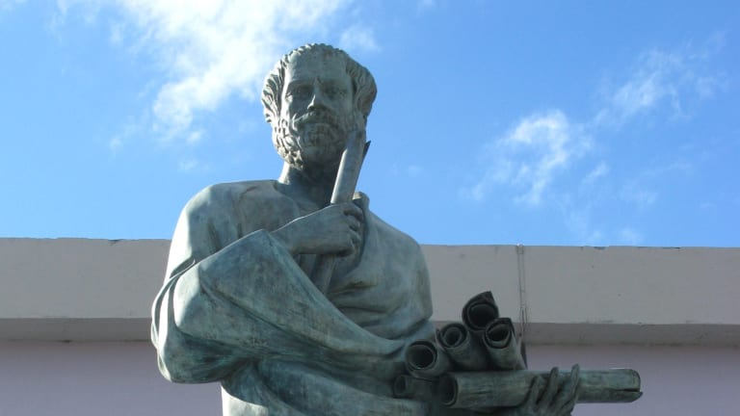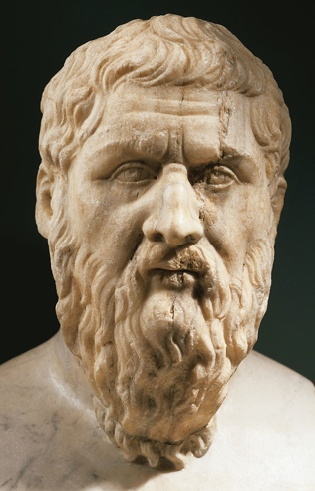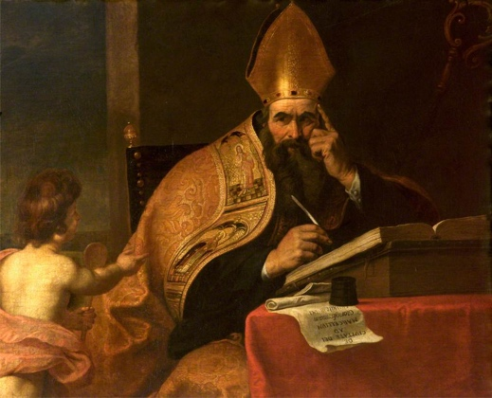

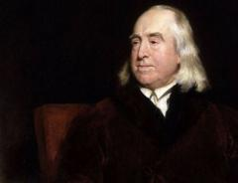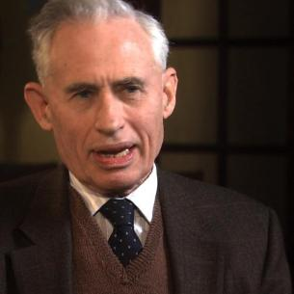

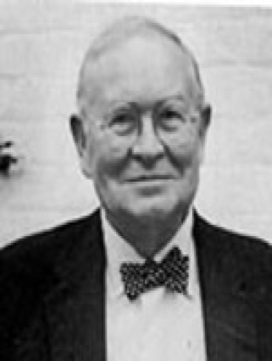

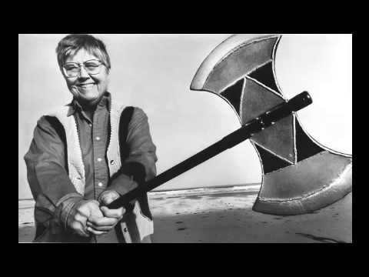

**🌟 Getting Ready to Study A Level Religious Studies- Additional Tasks**

Religious Studies at A Level is a fascinating subject that helps you become a **stronger writer, speaker, and thinker**. It encourages you to question the world around you, reflect on your own beliefs, and explore the views of others, even when they challenge your own.

**📚 Reading Activities**

Reading is one of the best ways to prepare for A Level Religious Studies. Whether it’s fiction, non-fiction, or philosophy, **good-quality reading helps improve your understanding, vocabulary, and writing**.

You don’t need to complete every book on this list — just choose **whatever interests you**. You could also dip in and out of chapters rather than reading cover to cover.

Don't worry if you don’t have access to all these resources — **reading anything thoughtful and well-written is useful**, even if it’s not on this list.

**📖 Suggested Books**

* **The Brothers Karamazov** by Fyodor Dostoevsky  
  A classic novel exploring deep questions about God, evil, loyalty, and family rivalry. It’s a challenging but rewarding read.
* **To Kill a Mockingbird** by Harper Lee  
  Another classic that explores justice, morality, and empathy — a must-read for many reasons.
* **The Puzzle of...** series by Peter Vardy  
  Non-fiction books on religion and philosophy. Very readable and accessible — you can read chapters individually without reading the whole book.
* **Candide** by Voltaire  
  A classic philosophical novel about evil and suffering. It’s a great book but can be challenging, so try it when you feel ready.
* **The Pig That Wants to Be Eaten** by Julian Baggini  
  A collection of philosophical questions and puzzles to get you thinking.
* **50 Philosophy Ideas You Must Know**  
  A clear introduction to key philosophical concepts and thinkers.
* **Think** by Simon Blackburn  
  An accessible guide to philosophy’s big questions.
* **The Blind Watchmaker** and/or **The God Delusion** by Richard Dawkins  
  Books that explore science, religion, and belief from a scientific perspective.

**Some things to watch and think about:**

All kinds of films and series have philosophical and religious ideas in them, so follow your own interests! You could try these, or choose something else, but try and use them as a stimulus for thinking and writing, rather than just sitting in front of them:

* The Two Popes – Netflix
* Conclave- Amazon Prime
* The Matrix
* Unorthodox - Netflix

**TED talks** – these are usually wonderful, with plenty to stimulate your questioning and reasoning skills.

* Elizabeth Loftus – how reliable is your memory?
* Dan Gilbert – why we make bad decisions
* Richard Dawkins – militant atheism
* Chimamanda Ngozi Adichie – We should all be feminists
* Damon Horowitz – Philosophy in prison

There are loads of talks on here, so use the search engine to find topics that interest you. Practise note-taking; write notes as you listen, just as you would if you were listening to a real-life lecture, and practise the skill of jotting down key points at speed. Ask yourself questions when you get to the end: what were the speaker’s key messages? Do you agree with the speaker? What might someone who disagreed say, and what might their reasons be?

**Podcasts**

The Panpsycast website has some great podcasts available – The one below will be a topic you will study in Philosophy on Plato’s cave.

<https://thepanpsycast.com/search?q=plato&f_collectionId=579a40262e69cf4d3e4a2297>

(They are quite long and heavyweight, don’t worry if this activity isn’t for you)

Practice your note-making skills by pausing and writing a summary of what you’ve heard so far. Think about whether you agree with what the philosopher is saying. Listen to whatever takes your interest. For RS specifically, you could concentrate on the below scholars:

* Plato and Aristotle for Philosophy
* Aquinas and Joseph Fletcher for Ethics
* Augustine for Human Nature.