**BTEC Extended Certificate in Travel and Tourism: Bridging Unit**

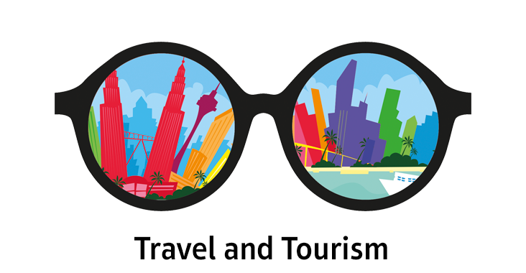

**Name:**

**Activities: Where in the UK**

**Task 1**

Add the following **capital** cities to the UK map on the next page. They must be labelled

* London
* Edinburgh
* Cardiff
* Belfast.

**Task 2**

Now add in 5 more cities. They must be labelled

**Task 3**

Answer:

Find out what is the difference between a city and a town?

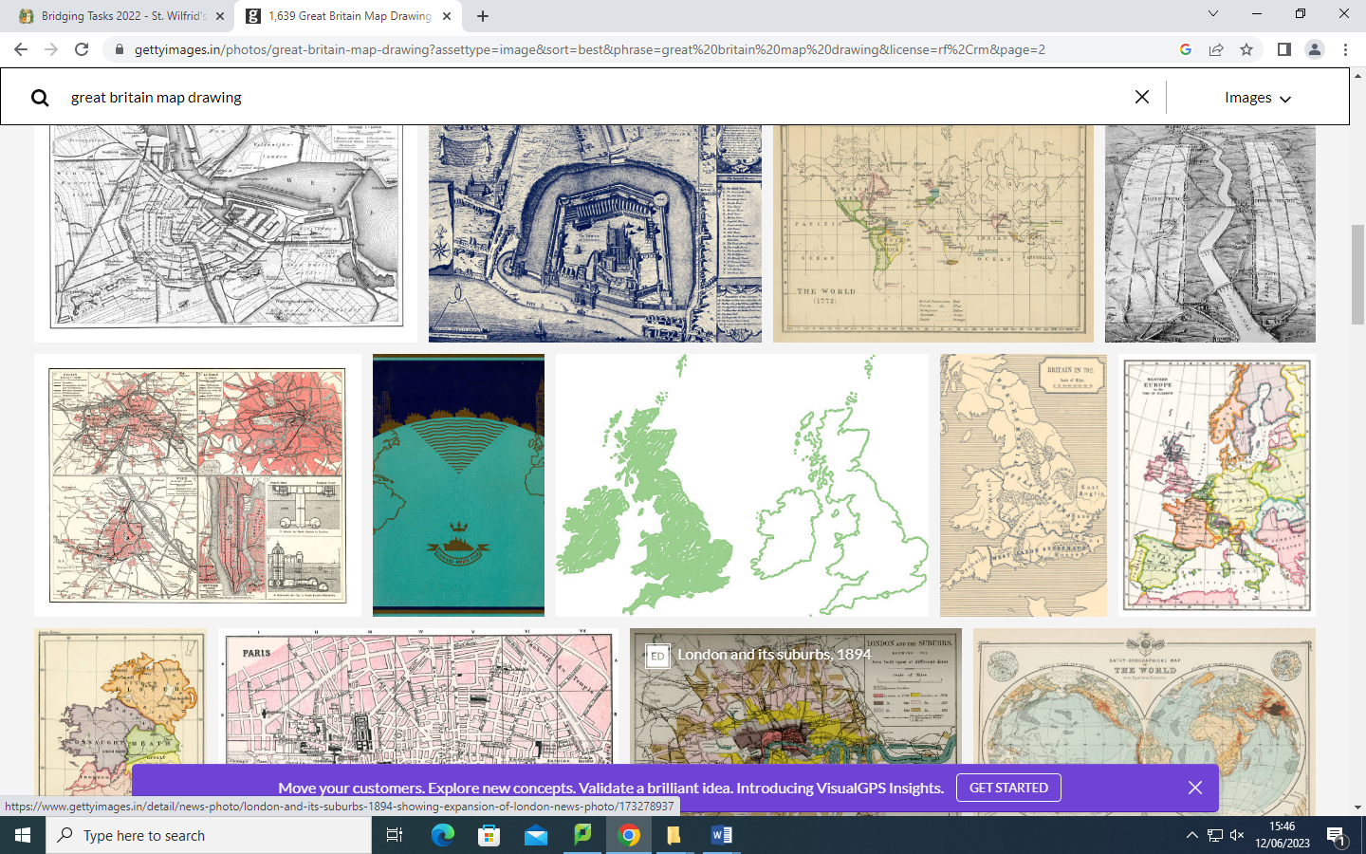

**Task 4**

Choose **two** of your cities and find 5 interesting facts about them. – Add them here

**City 1 name**:

5.

City 2 Name

**Task 5** <https://www.visitbritain.com/gb/en> This link will help

**Choose ONE of your destinations and produce a poster on this page giving information including:**

* A map showing where the destination is
* 2 Hotels with approximate cost
* 2 places to eat stating the type of restaurant and approximate cost
* 2 activities – for example- city tour or fun activity
* Information about shopping
* Are there any festivals? or events?

**Task 6 Topic: Types of visitor –**

**Task 1**

For each scenario in the grid, indicate the type of travel and the type of tourism.

|  |  |
| --- | --- |
| **Travel**   * Leisure travel * Business travel * VFR – Visiting Friends & Family * Specialist Tourism | **Tourism**   * Domestic – Staying in your home country * Outbound- Leaving your home country * Inbound – Visitors coming into your home country |

|  |  |  |
| --- | --- | --- |
| **Scenario** | **Type of travel** | **Type of tourism** |
| A young couple visiting Ibiza for a one-week all-inclusive holiday |  |  |
| A sports fan from Germany visiting Wembley to watch the European Champions League final |  |  |
| A family from Horsham, visiting Alton Towers in Staffordshire for the day |  |  |
| An elderly hospital patient travelling to New York in the USA for a medical operation |  |  |
| A Canadian couple visiting Edinburgh in the UK for a wedding |  |  |
| A businesswoman from London attending a meeting in Dubai |  |  |

**Task 7**

Now write your own scenarios and indicate the type of travel and tourism in the grid below.

|  |  |  |
| --- | --- | --- |
| **Scenario** | **Type of travel** | **Type of tourism** |
|  |  |  |
|  |  |  |
|  |  |  |
|  |  |  |