Art Department
Advanced Level Photography
Bridging Assignment
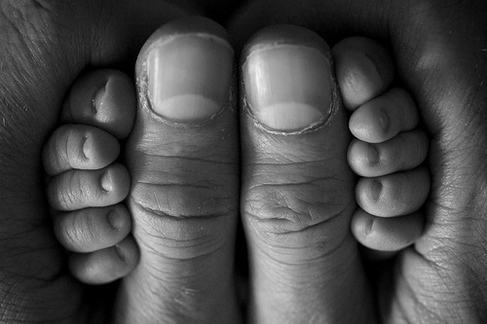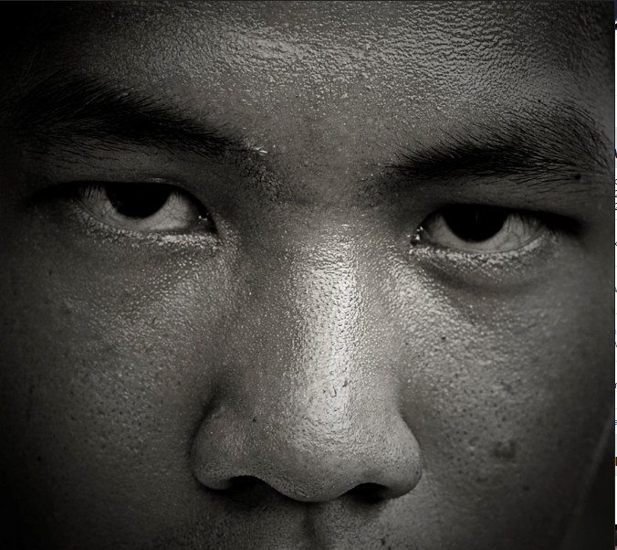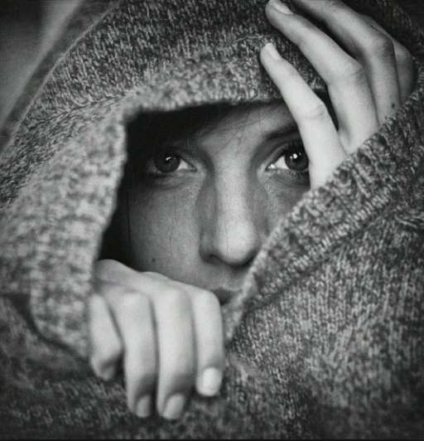
Making Pictures
An Artists Eye
Independent Task 1 “CLOSE-UP AND PERSONAL”
This is a project about photographing people and filling the frame. You are to produce 20 photographs of either yourself or someone you know, all of which must be taken from close-up.
When taking your photographs, you must comply with all of the following instructions:
- You must hold the camera yourself – all of the shots must be taken by you.
- You must not put the camera on timer and set it up at a distance that is beyond arms reach, remember to move around.
- Obviously, all of your photographs will be within arm’s length. Consider the positioning of yourself and the camera in relation to each other;
- You can be wearing what you like as this assignment is all about you! You could take your photographs at different times of the day or on different days of the week; you could be in-side or out-doors; you could change your clothes; wear different make-up; change your hair style. Remember it’s all about you!
- All the photographs do not have to be of the face. You must consider other options – hands, feet, or partial shots of the face – ears, eyes, nose, mouth, tongue, teeth, etc.
- You must consider the setting and the surroundings that you photograph in. Does this say something about you or reflect an aspect of your personality of the person you have chosen? How much background will you see – if any?
- You must consider different viewpoints, angles and compositions. Be creative with this. You are restricted anyway by the distance that you have to work in – arm’s length! Remember you can dramatically change the composition by moving the camera from horizontal to vertical format.
- Photography is all about controlling the light. You must take into consideration where the light is coming from. It could be natural light or artificial light. It could be coming from a window only, a spotlight, a table-lamp, or sunlight. The direction of the light is also a very important consideration. Front and back light will help to create strong shapes, while side light will accentuate form creating strong 3D effects;
- You must be very self-critical as you do this – question what you have done. Check out each photograph on the cameras LCD as you go. Retake photographs you are not happy with. We strongly recommend that you take many more photographs than you need so that you have plenty to select from later on.
- Don’t be afraid to try things out – not everything works all of the time – you must keep all your less successful efforts so that you can show that you know the difference between a poor image, an OK one, a good result and a great shot. You will learn how to improved and select a better result as you progress through the programme.
- You must save each photograph as a JPEG and save all your images in a file which you name – up close and personal photography-2022.
REMEMBER: Be Creative and have fun doing the task!

Helpful Links

It is also essential that you use the below links to develop your understanding of the areas of Photographic practice that you will be investigating during A Level study.
A Level Photography Project Work
Two examples of an A Grade A Level Photography Sketchbook.
https://www.youtube.com/watch?v=seKDkx_zRwk
https://www.youtube.com/watch?v=2DTALs5k-1Q

History of Photography
A fantastic resource for you to search through from one of the greatest photo journalism companies. This will help you find lots of photographers who you can use as inspiration in Y12.
https://www.magnumphotos.com/

An old but very helpful BBC documentary on the history of Photography.
https://www.youtube.com/watch?v=Olc_QLDPUeU

A BBC documentary on American documentary Photographer William Eggleston.
https://www.youtube.com/watch?v=3jZ_HkaTXh8&list=PLT6cZ7ZOJtoPwugkh8hXWQKHsTcLVRPB5&index=26

Technical and Compositional Exercises
Compositional Elements of Photography. These tips will help improve your photographs. We will look at those elements more closely in Year 12.
https://www.youtube.com/watch?v=7ZVyNjKSr0M

Exposure Triangle – This is a very helpful video that explains something which is a key feature of Photography and can be quite complicated.
https://www.youtube.com/watch?v=1E4mIlcSYLk

Long Exposure – A video looking at how to create long exposure shots.
https://www.youtube.com/watch?v=g6DIaFnnCiI

