BTEC Extended Certificate in Travel and Tourism: Bridging Unit

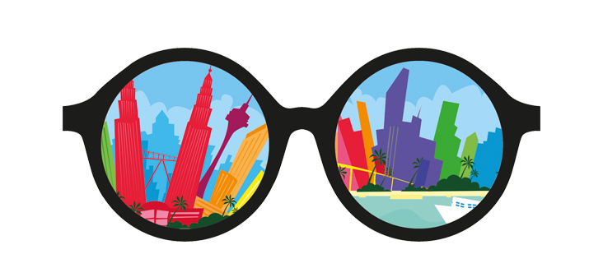

Name:

Activities: Where in the UK
Task 1
Add the following capital cities to the UK map on the next page. They must be labelled
- London
- Edinburgh
- Cardiff
- Belfast.

Task 2
Now add in 5 more cities. They must be labelled
Task 3
Answer:
Find out what is the difference between a city and a town?

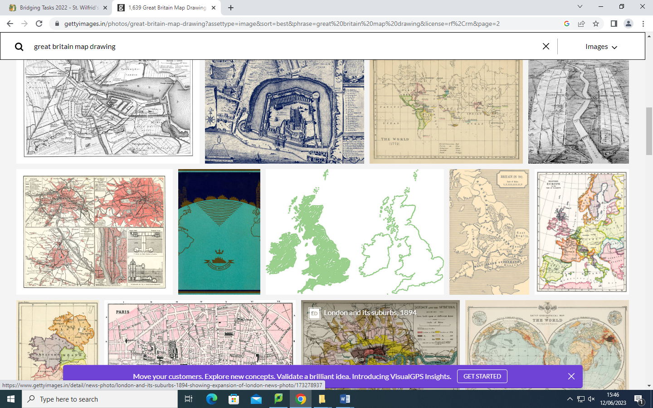

Task 4

Choose two of your cities and find 5 interesting facts about them. – Add them here
City 1 name:

5.

City 2 Name

Task 5 https://www.visitbritain.com/gb/en This link will help
Choose ONE of your destinations and produce a poster on this page giving information including:
- A map showing where the destination is
- 2 Hotels with approximate cost
- 2 places to eat stating the type of restaurant and approximate cost
- 2 activities – for example- city tour or fun activity
- Information about shopping
- Are there any festivals? or events?

Task 6 Topic: Types of visitor –
Task 1
For each scenario in the grid, indicate the type of travel and the type of tourism.
Travel  - Leisure travel  - Business travel  - VFR – Visiting Friends & Family  - Specialist Tourism | Tourism  - Domestic – Staying in your home country  - Outbound- Leaving your home country  - Inbound – Visitors coming into your home country

Scenario | Type of travel | Type of tourism
A young couple visiting Ibiza for a one-week all-inclusive holiday
A sports fan from Germany visiting Wembley to watch the European Champions League final
A family from Horsham, visiting Alton Towers in Staffordshire for the day
An elderly hospital patient travelling to New York in the USA for a medical operation
A Canadian couple visiting Edinburgh in the UK for a wedding
A businesswoman from London attending a meeting in Dubai

Task 7
Now write your own scenarios and indicate the type of travel and tourism in the grid below.
Scenario | Type of travel | Type of tourism

