12 January 2026
Dear Parent /Guardian

Year 10 Work Experience Week

Y10 work experience week will take place from Monday 6 July to Friday 10 July 2026. At St Wilfrid’s RC College we like to offer all of our students the opportunity to secure work placements that will prove beneficial to their interests and give them the experience of working for an employer. It is the responsibility of each student to find his/her own placement.

Work experience personal placement forms MUST be returned fully completed and handed into reception no later than Friday 1 April 2026. As all prospective employers must pass health and safety checks prior to pupils attending, any forms received after this date will not be processed in time therefore will not be accepted.
- Please Note: Pupils who have not organised a personal placement will be in school during work experience week participating in normal lessons.

PLEASE COMPLETE THE PARENTAL CONSENT FORM ATTACHED AND RETURN TO SCHOOL BY
FRIDAY 20 FEBRUARY 2026

It is important to remember that:

- A placement usually lasts for one week.
- No payment of wages is made by the employer.
- Pupils are responsible for their own travel arrangements.
- Pupils usually have to provide their own lunches.
- Pupils’ hours of work can be arranged with the employer between the hours of 8am - 5.30pm Monday to Friday.
- Placements depend on the goodwill of employers.
- Pupils are covered by the employer’s insurance policies.

Should you wish to discuss any of the attached information further, please do not hesitate to contact me on 0191 4569121.

Yours faithfully

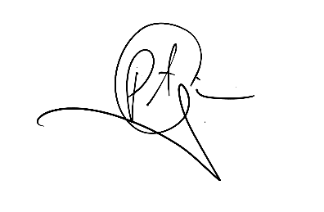

Mr P. Given
Senior Assistant Headteacher

