St William’s Catholic Academy
Foundation Subjects - Curriculum Map
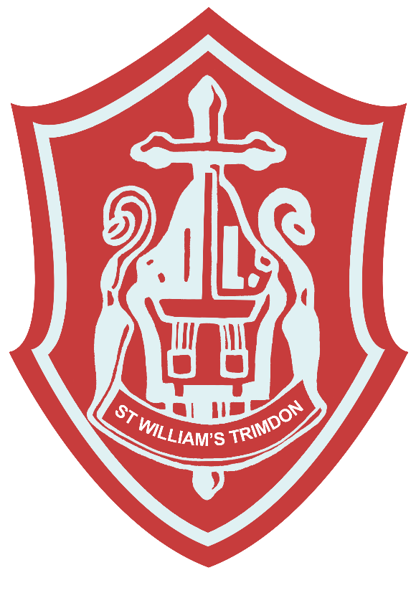
2025 – 2027

St William’s is a community where all are provided with the opportunity to achieve their full potential in a way that is rooted firmly in the values of the Gospel. We are committed to a purposeful, progressive and inclusive curriculum with Christ At The Centre, Children At The Heart. We celebrate diversity of experience, need, interest and achievement.
Our curriculum celebrates our local heritage and nurtures pupil’s understanding of the communities in which they live. It fully prepares pupils for the next steps in their learning journey and opens the doors to the wider world as life-long learners.

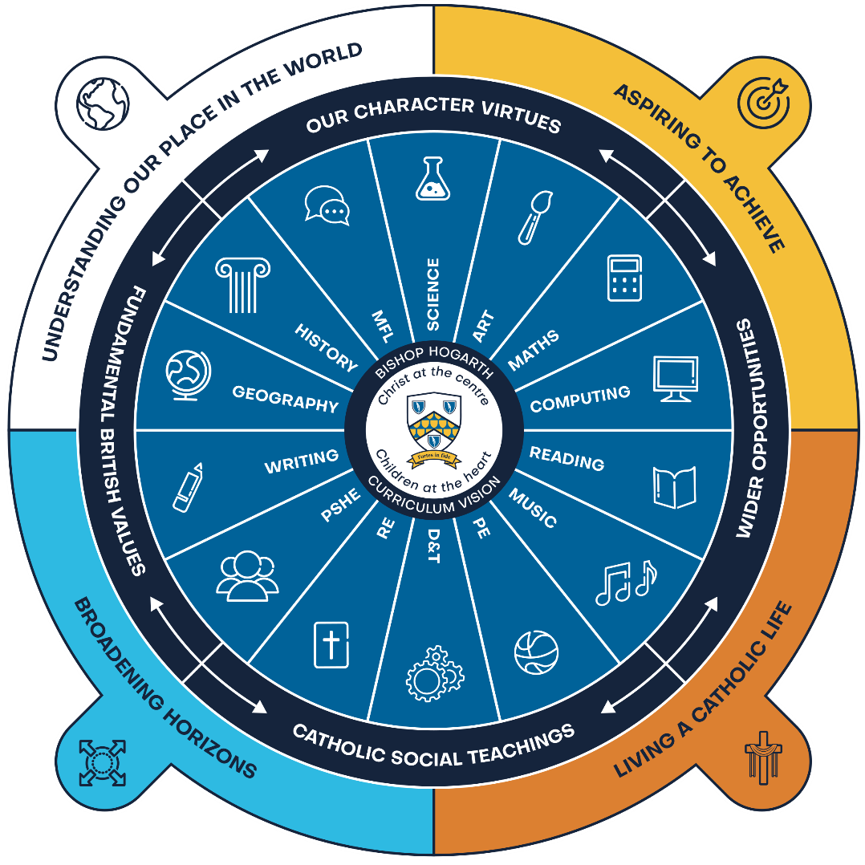

Everything begins with our curriculum drivers. They are woven through all that we do and underpin our shared belief that our role is to support children in understanding their place as a global citizen, having aspirations to achieve, broadening horizons and living the Gospel of life through Catholic Social Teaching.




UNDERSTANDING OUR PLACE IN THE WORLD
ASPIRING TO ACHIEVE
BROADENING HORIZONS
LIVING A CATHOLIC LIFE

Our curriculum is carefully planned and designed to provide academic, spiritual, social, and cultural, opportunities for all to develop their character through a focus on virtues and Catholic Social Teaching.










HUMAN DIGNITY
SOLIDARITY
SUBSIDIARITY
RIGHTS & RESPONSIBILITIES
PEACE
OPTION FOR THE POOR
COMMON GOOD
PARTICIPATION
STEWARDSHIP

The virtues of respect and responsibility, justice and compassion, confidence and resilience, honesty and self-belief, run through our curriculum and are designed to help pupils develop their sense of self and be ready to move with confidence onto their next chapter.

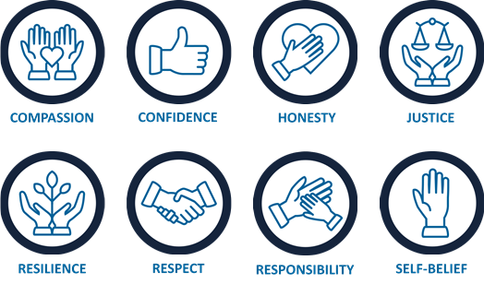

To promote fundamental British Values and Citizenship we have embedded democracy, the rule of law, individual liberty, mutual respect and tolerance of those with different faiths and beliefs within our sequences of learning.





DEMOCRACY
RULE OF LAW
INDIVIDUAL LIBERTY
MUTUAL RESPECT & TOLERANCE

Individual subject disciplines are taught explicitly with coherent links created. Our curriculum is sequenced to ensure that knowledge is cumulative.

Substantive and disciplinary knowledge is at the heart of each subject and linked areas of study are exploited to consolidate and embed learning, meaning that mental models are developed over time. We pride ourselves on evidence-informed practice and the highest quality professional development. We understand that memory lies at the heart of learning, we strategically plan opportunities for pupils to recall and remember. This allows memories to be strengthened, meaning that children can draw on previous learning with confidence enabling them to build and connect.

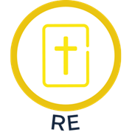
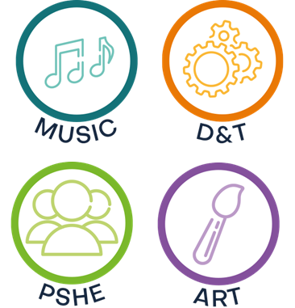
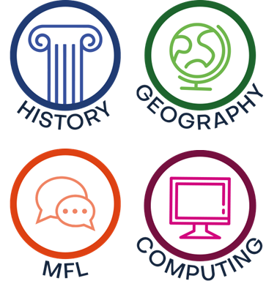
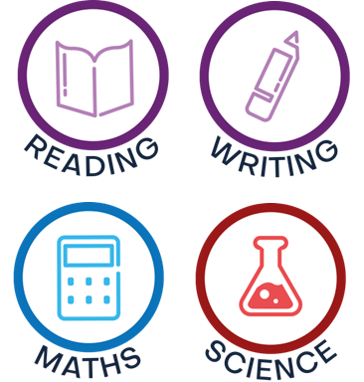



Our curriculum is purposeful and responsive - it aims to:
- Create a positive and supportive environment for all pupils without exception;
- Build an ongoing, holistic understanding of our pupils and their needs;
- Ensure all have access to high quality teaching and access all areas of the curriculum;
- Ensure that the fundamental skills of reading, writing, oracy, listening and numeracy are well established in all subjects from EYFS with academic rigour that challenges all.
- Exposure to the richness of English language so that pupils can access the pleasure of reading, the excitement of writing and to explore new learning concepts.
- Take a metacognitive approach to learning to reduce cognitive load and provide opportunities across the curriculum to engage in debate and critical thinking.

As our children are arranged into mixed aged classes we have developed, cycles of learning (rolling programmes) to ensure that pupils meet threshold concepts for their year group without repeating the same theme of learning.
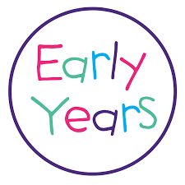
At St William’s, our Early Years provision lays the essential foundations for future learning and success. Rooted in Gospel values and our school vision — Christ At The Centre, Children At The Heart — we recognise that every child is a unique individual, created in the image of God and deserving of the highest quality education from the very beginning.
Our EYFS curriculum is broad, balanced, and designed to be purposeful and responsive. It nurtures curiosity, independence, and the joy of discovery through rich learning experiences that support the development of the whole child — academically, socially, emotionally, spiritually, and physically.
The curriculum is underpinned by the four guiding principles of the EYFS Framework:
- Every child is a unique child
- Children learn to be strong and independent through positive relationships
- Children learn and develop well in enabling environments
- Children develop and learn in different ways and at different rates
We provide a carefully structured environment in which children are encouraged to explore, take risks, and develop their resilience and self-belief. Continuous provision and high-quality adult interaction ensure that play is purposeful, and learning is embedded in meaningful contexts. Discrete teaching and guided sessions support the acquisition of early reading, writing, and mathematical skills, while opportunities to develop language and oracy are woven throughout the day.
Our curriculum is shaped by the seven areas of learning and development, with a strong emphasis on the Prime Areas — Communication and Language, Physical Development, and Personal, Social and Emotional Development — as the building blocks for future achievement across the Specific Areas of Literacy, Mathematics, Understanding the World, and Expressive Arts and Design.
We place particular importance on:
- Early language and vocabulary development to enable children to access the richness of story, discussion and learning
- Developing a strong sense of self, belonging and community
- Nurturing the values of kindness, responsibility, and compassion from the earliest age
- Supporting children to develop the characteristics of effective learning: playing and exploring, active learning, and creating and thinking critically
Through our curriculum drivers — global citizenship, aspiration, broadening horizons, and Catholic Social Teaching — children begin to understand their place in God’s world and their responsibility to care for themselves, others, and creation. The Early Years experience at St William’s ensures our youngest learners are fully prepared for the next stage of their journey, with a deep love of learning and a strong foundation in faith, values, and knowledge.

The study of history can bring pupils into a rich dialogue with the past and with the traditions of historical enquiry. Through history, pupils come to understand their place in the world, and in the long story of human development. The study of history challenges pupils to make sense of the striking similarities and vast differences in human experiences across time and place. Pupils learn how historians and others construct accounts about the past.

History

 | Year A  2025-26 |  | Year B  2026-27
Class 2 | George Stephenson | Great Fire of London | Comparing Monarchs | Toys Through Time
Class 3 | Comparing Ancient Civilizations | Life in Roman Britain | Stone Age to Iron Age | Early Islamic Civilization
Class 4 | Victorian Britain | Anglo Saxons and Vikings | Changing Power of the Monarchy | The Home Front

The Geography curriculum aims to inspire students with curiosity and fascination about the world around them. Our curriculum aims to equip students with knowledge and give them an understanding about natural and human environments, diverse places, people and resources, including the Earth’s key physical and human processes. The study of geography should give students an understanding of their place in World.

Geography

 | Year A  2025-26 |  | Year B  2026-27
Class 2 | Where I Live | Exploring the World | Beside the Seaside | Planet Earth
Class 3 | Biomes: Rainforests | Coasts | Rivers | Angry Earth
Class 4 | North America | Biomes: Deserts | Climate Change | Japanese Tsunami

Our science curriculum is designed to equip students with the knowledge and skills to explore, question, and understand the world around them—from the smallest particles to the vastness of space. Through the disciplines of biology, chemistry, and physics, students develop a deep understanding of scientific concepts, methods, and the role science plays in shaping our lives. The study of science encourages students to think critically, solve problems, and make informed decisions. It helps them understand their place in the universe and the impact they can have on the world.

Science
Physics |  |  | Chemistry |  |  |  | Biology
 | Year A  2025-26 |  |  |  | Year B  2026-27
Class 2 | Plants  Unit 1 | Earth and Space  Unit 1 |  | Animals and Humans  Unit 1 |  | Living Things  Unit 1 |  | Electricity  Unit 1 | Animals and Humans  Unit 2
Class 2 | Materials  Unit 1 |  |  | Movement, Forces and Magnets  Unit 1 |  | Materials Unit 2 |  | Electricity  Unit 1 | Plants  Unit 2
Class 3 | Plants  Unit 3 | Earth and Space  Unit 2 |  | Animals and Humans  Unit 3 |  | Living Things  Unit 2 |  | Electricity  Unit 2 | Animals and Humans Unit 4
Class 3 | Materials Unit 3 |  |  | Movement, Forces and Magnets  Unit 2 |  | Sound and Hearing  Unit 1 |  | Electricity  Unit 2 | Light and Seeing  Unit 1
Class 4 | Evolution and Inheritance  Unit 1 | Earth and Space  Unit 3 |  | Animals and Humans  Unit 5 |  | Living Things  Unit 3 |  | Electricity  Unit 3 | Animals and Humans  Unit 6
Class 4 | Materials Unit 4 |  |  | Movement, Forces and Magnets  Unit 3 |  | Sound and Hearing  Unit 2 |  | Electricity  Unit 3 | Light and Seeing  Unit 2

The Art curriculum aims to foster creativity, self-expression, and a deep appreciation for visual culture.
Our curriculum equips students with the skills and confidence to explore a wide range of materials, techniques, and ideas. Through the threshold concepts of Developing, Experimenting, Recording, and Presenting, students learn to express themselves visually, refine their ideas, and communicate meaning through their artwork. The study of art encourages students to think critically, take creative risks, and reflect on the world around them. It helps students understand their own identity and their place in a diverse and visually rich world.

Art

 | Autumn  Drawing | Spring  Sculpture | Summer  Painting
Class 2 | Observational Drawing | Paper Sculptures | Shapes
Class 3 | Use of Line | Clay Tiles and Mosaics | Portraits
Class 4 | Cubism | Human Form | Illuminated Patters

The Design and Technology curriculum aims to inspire creativity, problem-solving and practical innovation.
Our curriculum equips students with the skills and confidence to design and make purposeful, functional products for real users. Through the threshold concepts of Design, Make, Evaluate, and Technical Knowledge, students learn to generate ideas, develop prototypes, and understand the properties of materials and components. The study of design and technology encourages students to think critically and analytically, evaluating their own work and that of others. It helps students understand how design shapes the world around them and empowers them to become resourceful, enterprising individuals.

Design Technology

 | Year A  2025-26 |  |  | Year B  2026-27
 | Autumn | Spring | Autumn | Spring | Autumn | Spring
 | Mechanisms/ Mechanical Systems | Mini-Topic  (consolidation of skills) | Structures | Cooking and Nutrition | Electrical Systems | Textiles

The Music curriculum aims to foster a lifelong love of music by engaging and inspiring pupils to develop a passion for musical expression and creativity.
Rooted in the National Curriculum and supported by the Charanga scheme, our music curriculum equips students with the skills to listen to, compose, and perform music with increasing confidence and control. Through singing, playing instruments, improvising, and exploring a wide range of musical styles and traditions, pupils develop their understanding of musical elements such as pitch, rhythm, dynamics, and structure. Music lessons encourage children to express themselves, work collaboratively, and build cultural awareness. The study of music supports wellbeing, builds confidence, and helps children find their voice in a creative and joyful way.
Music
 | Year A  2025-26 |  |  | Year B  2026-27
Class | Autumn | Spring | Summer | Autumn | Spring | Summer
2 | Exploring Sounds | Recognising Different Sounds | Let’s Perform Together | Inventing a Musical Story | Learning to Listen | Our Big Concert
3 | Playing in a Band | Compose with your Friends | More Musical Styles | Musical Structures | Compose Using your Imagination | Feelings through Music
4 | Composing and Chords | Music and Technology | Creative Composition | Enjoying Musical Styles | Musical Styles Connect Us | Farewell Tour

Our Computing curriculum builds essential skills through four key strands: Programming, Data & Information, Creating Media, and Computing Systems & Networks. Students learn to write and debug code, manage and interpret data, create digital content, and understand how computers and networks work. This approach develops computational thinking, creativity, and problem-solving abilities. By exploring these areas, students become confident users and creators of technology, ready to navigate and contribute to a digital world.
Computing
Programming |  |  | Data and Information |  | Creating Media |  |  | Computing Systems and Networks
 | Year A 2025 -26 |  |  |  |  | Year B 2026 -27
 | Autumn | Spring |  | Summer |  | Autumn | Spring |  | Summer
Class 2 | Moving a robot | Digital Writing |  | Animations |  | IT Around Us | Grouping Data |  | Technology Around Us
Class 3 | Repetition in Shapes | Desktop Publishing |  | Events and Actions in Programmes |  | Branching Databases | The Internet |  | Data Logging
Class 4 | Variables in Games | Video Production |  | Sensing Movement |  | Spreadsheets | Systems and Searching |  | Presenting Data

Our PE curriculum is designed to foster physical literacy, teamwork, and a lifelong love for movement. Through engaging lessons, we ensure pupils develop fundamental skills across a range of activities, from team sports to individual challenges. By using [PE planning website name], our planning aligns with national standards, offering structured progression and diverse opportunities for pupils of all abilities. Lessons are thoughtfully sequenced, ensuring skill development, confidence-building, and enjoyment remain at the core. With a focus on inclusivity and active participation, our approach supports well-rounded physical education, promoting fitness, resilience, and positive attitudes toward health and well-being.

PE
 | Autumn 1 | Autumn 2 | Spring 1 | Spring 2 | Summer 1 | Summer 2
Class 2 | Fundamentals & Locomotion | Gymnastics | Dance | Ball Skills | Striking and Fielding | Athletics
Class 3 | Invasion Games  Football and netball | Gymnastics | Dance | Striking and Fielding  Cricket and Rounders | Net and Wall Games | Athletics
Class 4 | Invasion Games  Tag Rugby & Basketball | Gymnastics | Dance | Net and Wall Games  Tennis / Badminton | OAA Activities | Athletics

Our MFL (French) curriculum aims to develop confident communication skills, cultural understanding, and enthusiasm for language learning. Pupils engage in interactive lessons covering key vocabulary, phonics, sentence structures, and conversational fluency. Through songs, stories, and role-play, they build listening, speaking, reading, and writing skills. Lessons are designed to be accessible and enjoyable, ensuring progression from basic greetings to more complex structures. Cultural insights into French traditions, festivals, and daily life enrich learning, fostering a global mindset. By the end of the curriculum, pupils develop linguistic confidence and an appreciation for languages, preparing them for future study and real-world application.

Modern Foreign Languages (French)

 | Cycle A |  |  | Cycle B
Class | Autumn | Spring | Summer | Autumn | Spring | Summer
3 | Basics | Family | Descriptions | Where I live | Cultural
4 | Basics | Family | Descriptions | Where I live | Cultural

