SEND Information Report
Approved on:
July 2023
Next review:
June-July 2024
St William’s Catholic Academy

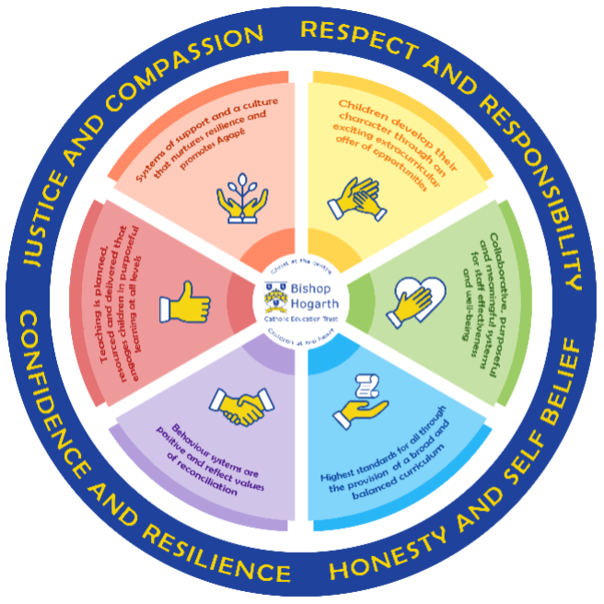

As part of the family of Bishop Hogarth Catholic Education Trust, our school has at its core, the virtues, and values of:
Respect for others and themselves, recognising that we are all created in the image of God and therefore must be compassionate towards others, especially the vulnerable. ​
Confidence in their own abilities, knowing that their talents are gifts from God and resilience to persevere when things become difficult. ​
Honesty in regard to the world around them and themselves and the ability to take responsibility for the times we may fall short of the mark. ​
Gratitude for all the amazing gifts from God and willingness to share their gifts both personal and material. ​

As an inclusive school, all teachers are teachers of pupils with Special Educational Needs & Disabilities. We deliver a curriculum and create an environment that meets the needs of every pupil within our school. We ensure that every pupil with Special Educational Needs and / or disabilities makes the best progress possible. We foster and promote effective working partnerships with parents / carers, pupils, and outside agencies. We consider the ‘whole’ child and strive to ensure that all our SEND pupils are prepared for adulthood.​

Our school’s approach to supporting pupils with SEND

St William’s Catholic Academy strives to be an inclusive school. Inclusion is central in the Catholic ethos and values of the school – a philosophy which covers every child’s rights and entitlements to the very best experiences education can offer. We aim to offer children an educational experience where staff will strive to identify and remove barriers to learning and create an environment in which every child is encouraged to reach their full potential and ensure ‘no child is left behind’.
Teachers are responsible for the progress of all pupils in their class. High quality teaching is personalised to meet every child's need/s. This is the first step in supporting pupils who may have a SEND (Special Educational Needs and/or Disabilities). All children are challenged to do their very best. This is enough for most pupils to make progress.

All children will be taught a broad and balanced curriculum; differentiated to the needs of each individual. Where children require extra support, specialist resources or extension materials, these will be provided wherever possible.

All children are known well by their class teacher and SENDCo, who develop strong relationships with them. Good behaviour and work is rewarded.

Your child can express their views in several ways, including via their class school council representative, through our buddy system or directly to staff, e.g. their 'safe person'.

Buddies, mentors and the student council representatives encourage all pupils to have a voice in school.

We manage medical needs by working closely with parents and healthcare professionals. We listen to and act on their advice, providing staff training when needed.

We have a range of extra-curricular activities which are open to all children, such as a Choir, Techy Tots, Active Kids, Football and Drama.

We also have a SEND governor (Mrs Cross), who has particular involvement with SEND policy and provision.

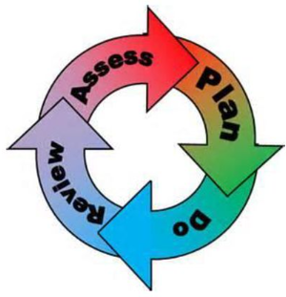
How will the school staff support my child?
The graduated response-Identifying, planning for and supporting pupils with SEND
Where a pupil is identified as having a special educational need, School will follow a graduated approach which takes the form of cycles of ‘Assess, Plan, Do, Review’. ​
• Assess a child’s special educational need. ​
• Plan the provision to meet your child’s aspirations and agreed outcomes. ​
• Do put the provision in place to meet those outcomes. ​
• Review the support and progress.

How does the school know if children need extra help and what do I do if I think my child has special educational needs?

- Assess

Identification – your child will be identified as having a SEND if they have significantly greater difficulty in learning than the majority of children of the same age or if they have a disability preventing or hindering the use of educational facilities provided for children of the same age within the Local Education Authority.
First steps – if, from our rigorous tracking and monitoring of your child's progress, it becomes apparent that he/she is not making expected progress then you will be invited to a meeting with their teacher and when appropriate, Mrs Curtis (SENDCo). Where appropriate, your child will be involved in this meeting. At the meeting, we will begin to explore the possible barriers to learning and you will be asked how we can best support your child.
Observations and assessments will then be carried out and, if required, input from specialist services may be sought with your permission.
Where appropriate, your child may be placed on our school's targeted support or SEND Support Register and a plan will be devised by the class teacher that will set achievable targets. These will be reviewed and updated at least termly.
EHCPs (Education, Health and Care Plans) will be used when a child's needs are deemed more complex and require the input from a range of outside agencies. This could be in the form of Educational Psychologists, Occupational Therapists or other professionals with an area of expertise, e.g. Autism. An EHCP helps to determine the level of educational, social and health support the child needs.

- Plan

Our procedures are in line with the SEND Code of Practice (2015): https://assets.publishing.service.gov.uk/government/uploads/system/uploads/attachment_data/file/398815/SEND_Code_of_Practice_January_2015.pdf
The first point of contact is the class teacher, who has overall responsibility for the welfare of your child. Additional provision is planned carefully and overseen by Mrs Curtis the SENDCo. It is implemented by a skilled team of teachers and supported by experienced teaching assistants.
At St William's, we have an extensive range of different SEND resources and interventions available. These are closely matched to the needs of our children and their progress is monitored by the class teacher, the SENDCo and staff with specific curriculum responsibilities, e.g. English or Maths Co-ordinator.
Where provision does not result in adequate progress, as outlined in the SEND Code of Practice, the SENDCo should be consulted for advice.

- Do

Our teachers are skilled at adapting teaching and learning to meet the diverse needs in each class. ​
Daily planning considers individual children’s needs and requirements and is annotated and adapted according to need. Explicit reference is made in the teacher’s planning to the needs of those children identified with SEND. ​
Adaptive teaching is approached in a range of ways to support access to the curriculum and ensure that all children can experience success and challenge in their learning. ​

Grouping arrangements consider the different skills and abilities of each child. This ensures that learning is maximised. ​

Additional adults support groups and individual children with the long-term goal of developing independent learning skills. The class teacher monitors this support to avoid students becoming over reliant on this. ​
We fully encourage parental support and offer opportunities for individual meetings with parents/carers to provide clarity and recommendations on how they can support their child at home.

- Review

Progress of children with a SEND will be reviewed at least termly.

If, despite all steps taken, good progress is still not being made, we will refer back to our graduated approach and increase/change support whilst continuing to monitor and review progress. It may also be necessary at this stage, to consult with the expertise and specialist services secured by school.

Consultation sessions are held in the Autumn and Spring terms where you can meet your child's teacher to discuss and look at their work in different subject areas. A further opportunity is provided in the Summer term for you to discuss your child's end of year report.

Parents that have children on the school's SEND Support Register, may also be invited to termly meetings to review their child's support plan. Your child will be involved in reviewing their targets at appropriate times throughout the term, with the class teacher or teaching assistant, and during the setting of new targets on a termly basis. If, of course, you would like to meet Mrs Curtis or your child's class teacher at any point during the term, this can be easily arranged.

How will the curriculum at our school be matched to my child’s needs?
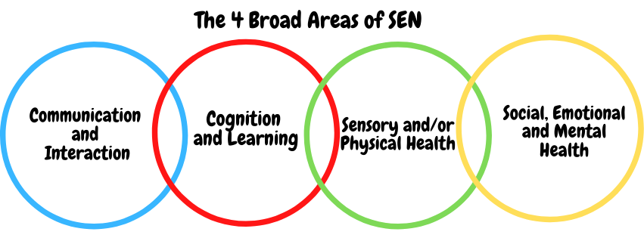SEN needs are classified under four broad areas of need. Below are the strategies, in class support and interventions that school may put in place to support your child.
Communication and Interaction
Strategies to support children with these needs include:
- Access to small group and/or individualised interventions to develop skills in communication and interaction with others, e.g. Socially Speaking, Time to Talk
- Visual timetables in every class
- Flexible approaches to timetables
- Modifications to lunch and/or break times, e.g. duties, time for children to change
- Enhanced access to additional aids/technology
- Explicit teaching of generalising skills from one context to another
- Careful planning of transitions , e.g. advanced notice, familiar resources
- Mentoring and/or buddy system
- Sensory feedback support, e.g. fidget toys, wobble cushions, feet wobble boards

Cognition and Learning
Strategies to support children with these needs include:
- Developmental support for short and long term memory through a range of specific strategies and interventions
- Resources provided by Ed Psych or other external agencies
- Regular, individually focused intervention and flexible groupings
- Increased, time-limited access to clearly focused small group support, managed by the class teacher and supported by SENDCo
- Increased access to small group support in class
- Practical aids for learning e.g. table squares, hundred squares, time/number lines, pictures, photos, accessible, age-appropriate reading material, coloured overlays or coloured tracking guides, numicon equipment
- Regular, individually focused interventions, e.g. reading, phonics, numeracy
- Increased access to ICT Programmes
- Access to technical aids, e.g. spell checker, ICT software and/or hardware
- Adaptations to assessments to enable access, e.g. readers, scribe, ICT
- Curriculum/delivery adaptations to meet the learning needs of individuals
- Frequent repetition and reinforcement

Sensory/Physical
Strategies to support children with these needs include:
- Occupational Therapy support/interventions carried out from advice provided
- Concrete apparatus available to support learning, e.g. gripped rulers, Numicon materials
- Adapted curriculum to enable full access, e.g. alternative recording devices
- Sensory resources available, e.g. wobble foot board, headphones/ear guards, wobble cushion
- Access to support for personal care, e.g. school nurse service.
- Small step re-integration of children who have undergone significant medical needs including surgery, evaluated in the light of past experience, linking closely with Paediatric Physiotherapy and Occupational Therapy staff
- Therapy programmes delivered in school, designed by NHS specialists
- Adapted curriculum to enable full access e.g. alternative recording devices, modified PE curriculum

Social, Emotional and Mental Health
Strategies to support children with these needs include:
- Access to time out/individual work area/mindfulness interventions
- Mentoring/buddy system
- Access to counselling services, e.g. CAMHS, The Road Centre, Rainbow project.
- Supported transition programme with chosen secondary school
- Opportunities to develop Social and Emotional aspects of learning through small group work
- Individualised rewards system
- Early Help Assessments, to secure multi-agency targeted support, as appropriate
- Alternative curriculum opportunities
- Additional opportunities to develop social and emotional aspects of learning
- Small group mindful meditation interventions
- TEAM Up programme was delivered for two classes which was based around improving communication skills, self-regulation and overall mental health and well-being.

What training is provided for staff supporting children with SEND?
St William's values staff training and organises courses/training programmes to ensure teachers and teaching assistants stay up to date with current research into teaching and learning.
Examples of training undertaken by staff to support of Special Educational Needs includes:
- Mental Health First Aid Training
- ADHD awareness
- Strategies for supporting children with ASC
- Anxiety training
- Supporting children with communication and language difficulties

How do we support transition in our school?

- Children with a SEND may need additional support to move into a new class, a new part of the school or a completely new school; we call these ‘Transitions.’
- We have well established arrangements for class teachers and SENDCO to meet with each other and new teachers, to share support plans and plan for smooth transitions within school.
- We work closely with all secondary schools in the area.
- The transition process will begin early, usually in year 5, for some of our more vulnerable children.
- Meetings are held for the transfer of essential information relating to a child's needs and discussions are held with class teachers, SENDCOs from our school and the secondary school.

Transition within classes/key stages: ​

- Information will be passed onto the new class teacher in advance and a transition meeting will take place with the new teacher. Individual targets/requirements for all children with a SEND will be discussed with the new teacher and agreed by Mrs Curtis.

- Children who require additional support to ensure a smooth transition to their new class, will be included in a programme supported by Mrs Curtis.

Transition to Secondary settings: ​

- If your child moves to a new school within or at the end of an academic year, Mrs Curtis will contact the school SENDCO to ensure he/she knows about any special arrangements or support that needs to be made for your child. If necessary, a meeting will be arranged with other professionals.

Where can I get further information about services for my child?

The Local Offer
Extra information for parents can be found on Durham County Council’s ‘local offer’ website.
https://www.durham.gov.uk/localoffer

What key school documents refer to support and provision for pupils with SEND?

- SEND Policy​
- Admissions Policy​
- Supporting Pupils with Medical Needs Policy​
- Accessibility Plan​

Accessibility​

With due regard to our admission policy, parental choice and accessibility of the school building, all children with special educational needs who apply will be accepted by the school.

Activities Outside of School​

St William's is an inclusive school and we will put in place appropriate support, whenever possible, to enable your child to be educated alongside their peers. This may include extra staffing and/or equipment. Staff who are arranging an offsite trip will discuss with parents and the SENDCo any requirements needed and the suitability of any trip which the school is taking part in. We will not stop your child from going on a trip due to their special educational needs and/or disability if the trip is suitable for your child and their safety and the safety of others is not compromised.

What to do if you have a complaint, a compliment, or a query.

Should you have any concerns about the support that your child is receiving, we hope that you will feel able to approach your child’s class teacher or the SENDCo to discuss this. They will be happy to meet with you and work together with you to help resolve any issues or concerns that you may have. Our SEND Governor could also be contacted. We will also always be pleased to hear from you about any aspects of our current provision that you feel are working particularly well. We will always try to arrange a meeting at the earliest possible opportunity. However, if there are still unresolved issues, you may wish to make a formal complaint according to the procedures set out in our Complaints Policy

The school details and relevant contacts
St William’s Catholic Academy, Elwick View, Trimdon Village, County Durham, TS29 6HY
01429 880348
Headteacher – Mr M Tiplady
SENDCO – Mrs H Curtis
SEND Governor – Mrs M Cross
​

