The Enquire Learning Trust

24th September 2020

Dear Parents and Carers

I trust you are all well and that your child has made a successful start to the new school year.

You will be aware that Mr Gunning has given his notice to retire from his post at Stakesby Primary Academy in December. Trustees and local Governors have engaged in a long and exhaustive recruitment process to find a successor and I am delighted to inform you that Miss Emma Robson has been appointed as Principal. I have great confidence that Miss Robson will lead the school to further success and ensure that all Stakesby serves its community well. I know you will join me in congratulating her on the appointment and wishing her every success in her new post.

Miss Robson will take up her new post from 1st January 2021.

Yours,

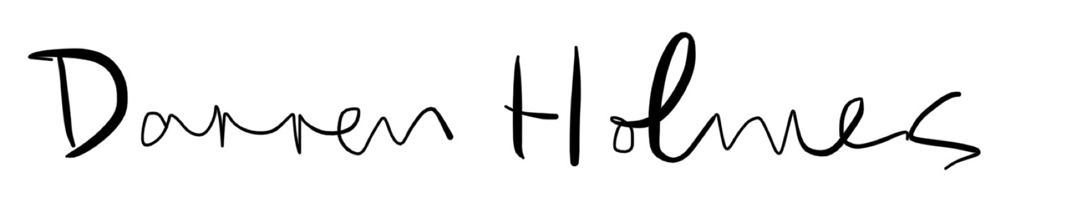

Darren Holmes
Chief Executive Officer

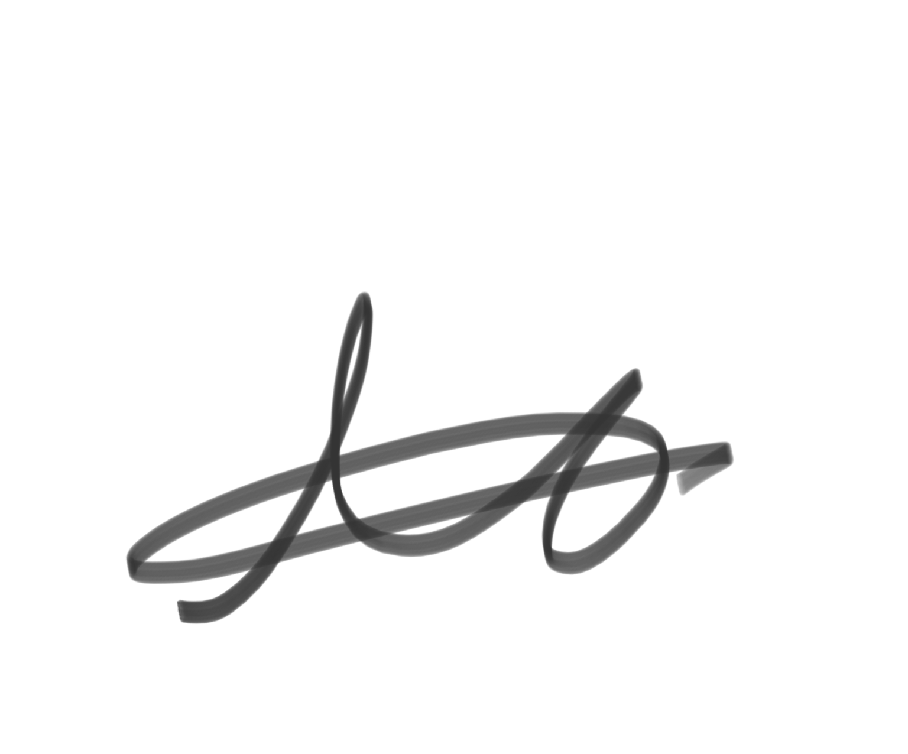
Nicky Harland
Chair of the Academy Improvement Committee

