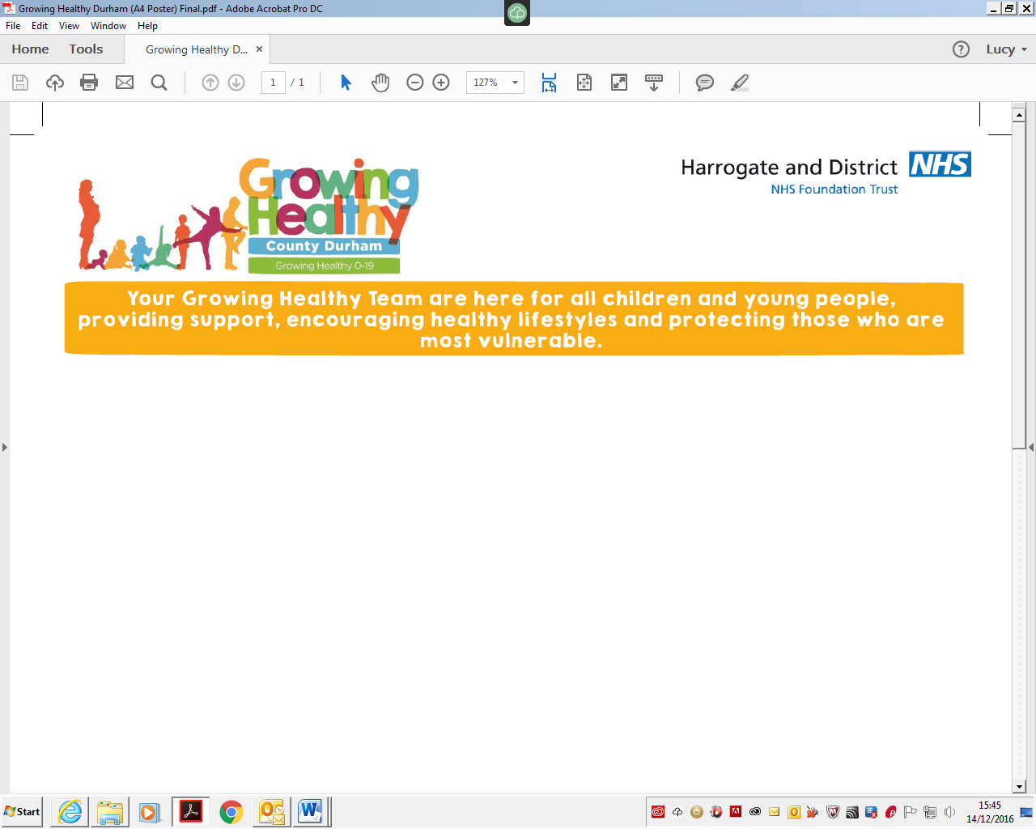



Stakesby Primary Academy
hdft.childhood.immunisations@nhs.net
01423 542360

September 2020
Dear Parent/Guardian,

Protecting Children Against Influenza (Flu) and Complications

The nasal influenza vaccination is being offered to all children in Reception-Year 7. Our team is scheduled to visit Stakesby Primary Academy this Autumn as part of this programme. If you would like your child to receive this immunisation, please ensure your consent form has been submitted no later than 18/10/2020 – if you submit your consent form after this date your child may be missed when we visit school.

Please see below for details of how to consent for your child, as well as answers to common questions about the influenza vaccination programme.

How do I give my consent?

- Go to https://www.hdft.nhs.uk/fluconsent
- Enter the School Code 146112 and click “Find School”.
- Complete the form with your child’s information and parent/guardian contact information*.
- Click the green “Submit” button.

*If you provide a valid email address you will receive an automatic email confirmation to say your form has been submitted. We will also email you to let you know that your child has been vaccinated in school. If your child has specific medical requirements one of our nurses may need to get in touch before we are due to visit school. We never pass on your contact information to third parties.

Why is the influenza vaccine being offered?

This vaccination programme is in place to help protect your child against influenza (flu) and stop the spread of the virus within schools, families and the wider community. Influenza is an unpleasant illness that can lead to school absences and sometimes causes serious complications requiring hospitalisation. Vaccinating your child doesn’t just protect them – by helping to stop the spread of influenza this winter they will also be protecting vulnerable friends and family of all ages.

How is the influenza vaccine administered?

Unlike most vaccinations, the nasal influenza vaccine is a quick and simple spray up the nose. There are a small number of children for whom the nasal vaccine is not appropriate. In these cases we offer an intramuscular injection as an alternative. Please check the link below for more information.

Does the nasal influenza vaccine contain pork gelatine?
Can my child have the injection instead?

Yes, the nasal influenza vaccine contains trace amounts of porcine gelatine. If you would like your child to receive the injectable influenza vaccine, which does not contain porcine gelatine, please do not complete the online consent form. Instead, please give us a ring on 01423 542360. You will need to bring your child to a local community clinic as we cannot give the injection in school.

Where can I find out more?

Please visit https://www.nhs.uk/conditions/vaccinations/child-flu-vaccine for more information about the childhood influenza vaccination programme.

You can contact the childhood immunisations team on hdft.childhood.immunisations@nhs.net or 01423 542360. We are a small team and we cannot always answer the phone straight away, so please leave a message if there is no one available to take your call. We endeavor to respond to all queries within one working day.

Yours sincerely,
Lois Alderson
Clinical Lead for Childhood Immunisations in North Yorkshire and City of York


A NATIONAL HEALTH SERVICE FOUNDATION TRUST Chairman – Angela Schofield Chief Executive – Steve Russell

