STAKESBY PRIMARY ACADEMY NEWSLETTER
Friday 12th June 2020

Thanks very much for all your support during these uncertain times. You have been brilliant – keeping contact with school and keeping learning going at home. We are really missing having everyone at school, so it was great to welcome back more children this week. The excited, enthusiastic and smiling faces of our youngest children have been a delight to see. Like you, we are keen to get everyone back to normal (whatever form that takes in the future) as soon as we can safely do so. We are working closely with our Trust to plan the next steps. As always, we will keep you fully informed as things develop. Stay safe and keep well.
Mr Gunning

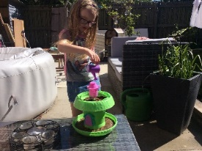
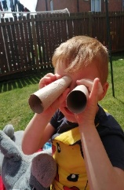
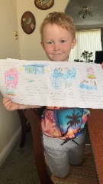
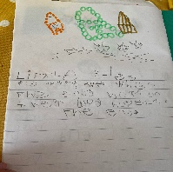
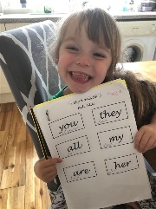

Snacks are back!
Now that bubbles are up and running successfully, we are able to reintroduce snacks at morning breaktime. You can either send a snack from home or pay via your Parent Pay account. The cost will be £1 for the week or £5 for the rest of the term. This must be received no later than 9am on Monday mornings to ensure you child gets their snack. Unfortunately if the payment is not received by then, your child be unable to have snack for that week. We will provide a shortbread biscuit which will be delivered to bubbles in time for breaktime. We are unable to be provide drinks so please could you send a water bottle from home.

Wide Owls and Super Squirrels
We normally receive free fruit and veg for our youngest children but currently, this is not being delivered. So, for now, we have opened up our snacks provision to include Early Years children.
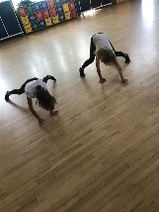
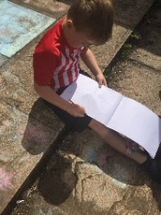
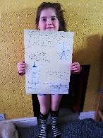
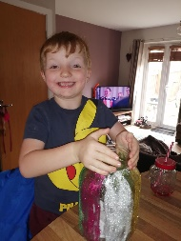
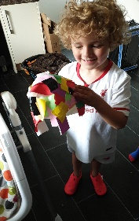

Super Squirrels and Wise Owls
We have been pleased to welcome back some children in our Super Squirrels and Wise Owl classes this week. All of the children who have returned have adjusted well to the new routines we have put in place to keep everyone safe. Staff have shared lessons on ‘washing our hands’ and ‘leaving big gaps between our friends’. The children are coping really well with our new ways of working. Thank you to parents for your support with our new drop off and pick up routines. Thank you also to parents at home who continue to complete home learning tasks. Staff will continue to use Teams and Class Dojo so please use this as a place of contact with us if your need help with anything at all.
Mrs Tacon and the Early Years Team

Holly Class
Holly Class have continued to amaze me through their hard work and positive attitude. I have been able to watch with pride as they learn at home. However, I am very much looking forward to welcoming them back to school. I am very excited to tell them, in person, how proud I am. I also think they will have grown in the last 12 weeks, so I cannot wait to see how tall they are!

I would like to show my gratitude to our parents, who have been amazing throughout this journey. The learning that has been achieved could not have been possible without their unwavering commitment and support. Thank you isn’t enough!
Miss Fenby
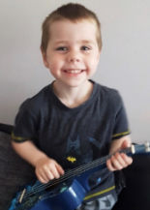
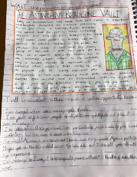
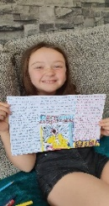
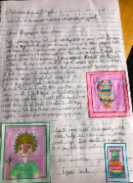
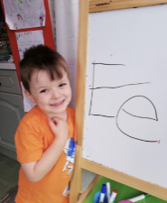
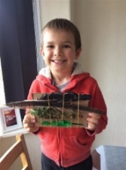

SRE - Years 5 & 6
It is usually at this time of year that we run our sex and relationship education lessons for pupils in Years 5 and 6. These lessons will go ahead as planned for the returning Year 6 pupils but will be delayed until the new academic year for our current Year 5s. As a school, we feel it is important that our pupils understand, and are prepared for, the changes that will happen to them and their peers as they reach puberty. Consent for Year 6 pupils must be given by Class Dojo; consent forms for our current Year 5 pupils will be sent out in the new academic year.
Miss Robson
Pupils returning to school
Thank you to all of the parents who have emailed and phoned to let us know your child(ren) will be returning to school. It's been lovely to talk to you and hear how excited your child(ren) have been to come back. If, in the coming weeks, you decide that you would like your child(ren) to return to Super Squirrels, Wise Owls, Holly or Oak Classes - or under Key Worker provision - please ensure you contact me on e.robson@stakesbyschool.net or via the school office on 01947 820231.
Miss Robson
Stakesby Staff – A Tribute – National Media
It really disappoints me to read in the news and on social media of our ‘lazy teachers’ who have been enjoying an ‘extended holiday’ whilst ‘parents do all their work’.

With 2 days’ notice from the Government, ALL our staff worked tirelessly to set up childcare for key workers, vulnerable children and a comprehensive home learning offer. We made a commitment to our Stakesby community that we would remain open for as many key worker and vulnerable children as possible; we are incredibly proud to have been able to off this provision and to be able to continue doing so. Apart from the recent half term, Stakesby has been open since February with staff working all day to prepare, lead and support learning at home, often-through weekends and bank holidays. When not directly working with children, there has been a significant amount of professional and curriculum-development taking place behind the scenes.

I am proud to be leading such a dedicated and committed team of people and know that they regularly go beyond their roles to ensure that Stakesby children get the best learning, environment, catering, resources and individual nurturing and support that we can offer.

I also know that you have appreciated the support that has been provided and I would like to thank the many parents and carers who have been in touch via Facebook and email to say ‘thank you’.

We appreciate that this has been a tough time for everyone, so, would ask that if you do come across negative or uninformed information nationally or locally that you please share the truth about the amazing efforts that Stakesby Primary Academy are making to keep children’s futures bright.
Roy Gunning

