|  |  |
| --- | --- |
| C:\Users\t.clayford\AppData\Local\Microsoft\Windows\INetCache\Content.MSO\B564043F.tmp | **https://lh6.googleusercontent.com/fcBn91F2DaUlbBNEiGxOzCM_LmGxzGoT61fD3zt1joWkV7rPA_6F9Pjj_r5Bj50CCrHT82j1hPST3iLzJVxlGenee3kp3obcWWDz5CwOjsqVhKpB-dhUmcQ8bcKviwM9tyiL8q-o**  **STAKESBY PRIMARY ACADEMY NEWSLETTER**  https://lh6.googleusercontent.com/fGyr7R2EJQxs90Qdw7aW2uktRFGzC2zdye_GqHg34tvYJaPOWREziYYyYirBh2eidlaovUXEGtO_--gZmxfYHYCSziFx1EhC4VwWhu5avTfoyAB2JF-tjbqEkrwf0rsMLJgivA94 **Tuesday 28th April 2020** |
| I hope that everyone had a relatively restful Easter break, given the circumstances. Welcome to our first remote summer term.  It is definitely a strange and challenging time and we have all had to adapt to new ways of living and working. I wanted to take the opportunity to say what an amazing job you are doing to support your child/ren’s wellbeing and learning during this time. We were given very little notice of the school closure so, like you, we had to put things in place very quickly. I am delighted to say that things moved across to home learning smoothly and our children have taken to remote learning enthusiastically.  Have a look at the class reports below to see how our classes are getting on.  We are here to help you every step of the way. Remember, if you have any concerns about helping your child/ren learn, or you need any other support from school, please let us know. We are using Facebook to share whole school messages. You can continue to contact the school by phone (01947 820231) or email [admin@stakesbyschool.net](mailto:admin@stakesbyschool.net).  As you are aware, our Academy has remained open for children of Key Workers and vulnerable families. We miss the children very much, but must follow the Government guidance to keep everyone in our community safe. However, just because we are not all in the same building, it does not mean that we cannot still work together.  By now, we hope that your child has accessed the Teams app and made contact with their teacher. Our staff have put together an interesting and varied set of activities for the next few weeks. Staff are available on Teams every day and have set out a structured approach to the home-schooling day for you to follow. We are also able to share the fantastic learning that is occurring at home.  If you are having any issues connecting with this, please contact us. Remember that you can also contact your child’s teacher through Class Dojos or via their email (in the format: [initial.surname@stakesbyschool.net](mailto:initial.surname@stakesbyschool.net)).  We do not know when the school will be able to reopen, but rest assured that we will continue doing our utmost to keep your child learning and our school community connected.  Thanks again for your support and keep up the good work for the summer term.    Mr Gunning  **Principal** | |

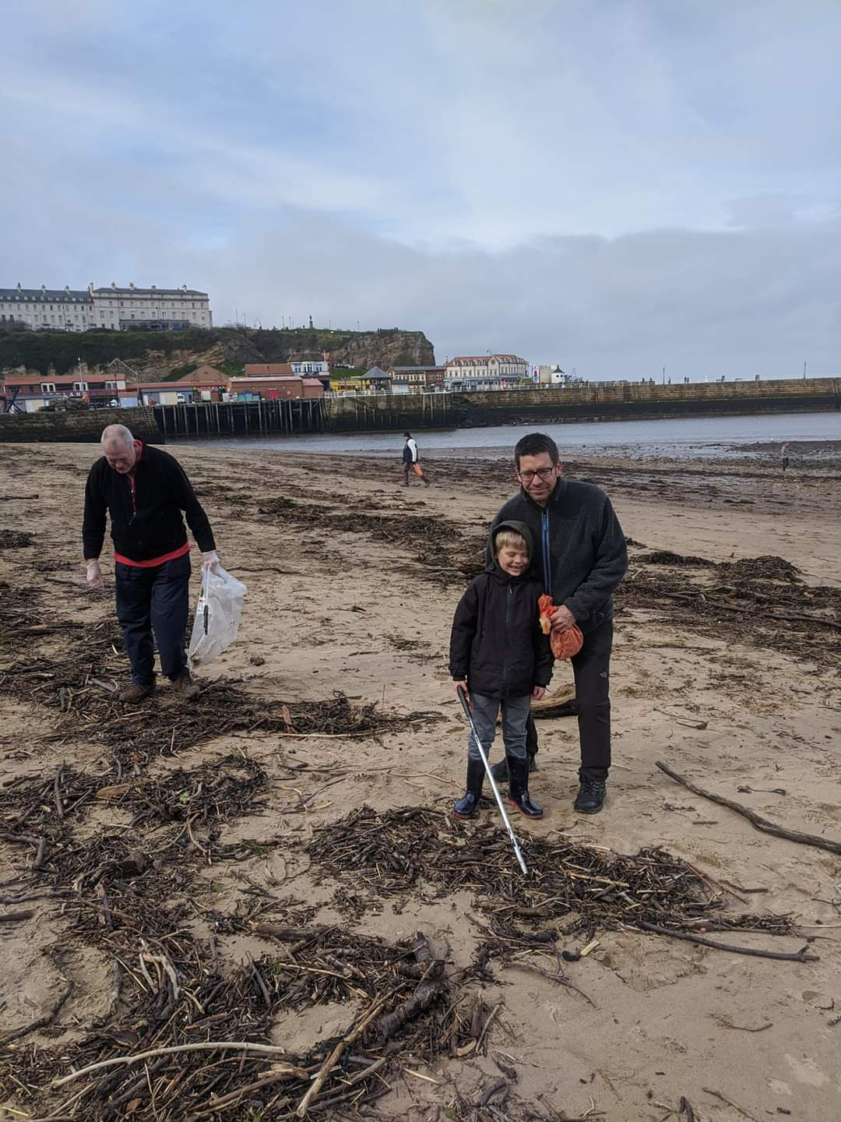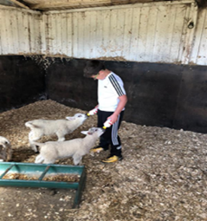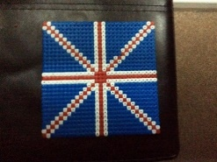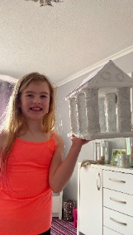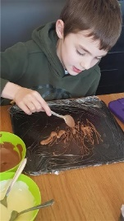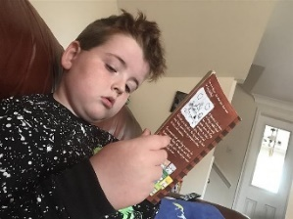

|  |
| --- |
| **Super Squirrels and Wise owls**  The Super Squirrels and Wise Owls have been starting their learning this term with the question 'What are houses like?' They have drawn pictures of their own houses using crayons, felt tip pens and chalk. They have also drawn all the people and animals that live in their house and added names to them.  To help their phonics they have looked around their homes for things that contain the sounds 'ee' and 't'. Some of the older children have then used these words to make lists and silly sentences!  To improve their number skills they have counted rooms and things in their houses like chairs and beds. The children have also counted a street of houses using ordinal numbers 1st, 2nd, 3rd and so on. Our older children have recorded some sums they worked out using objects from their houses too.  We hope the children have enjoyed our teachers’ videos to help their learning and the stories we have read to them this week. Thank you parents for posting all the videos, photos and comments showing us your children's learning.  You are helping us keep a valuable connection with our little learners until we can all be together again.  **Mrs Tacon** |
| **Holly Class**  I would like to say a HUGE thank you to the wonderful parents who have been supporting their children in completing the tasks I have set. The children in Holly Class have been the superstars I expected them to be.  It has also been wonderful to see and speak with them via the video calls. I am pleased to see they are keeping well, happy and positive. Last week, we did lots of work on Grendel the chocolate loving monster. The children decided which three things they would wish for (wishes better than Grendel’s!) and even baked some delicious chocolate truffles.  They have made me very proud.  **Miss Fenby** |
| **Beech Class**  Bonjour Beech Class,  Thank you so much for all your hard work over this first week back. You and your parents have all been incredibly patient whilst we have been sorting out some technical issues and access to work. However, it looks like it is working for all of us so that your education may continue.  The work and pictures that you have been sending us have been amazing. We cannot believe the time some of you get up. Your poor parents must be worn out!  We are also in awe of how you have seized the batten and gone out litter picking as part of your daily exercise. Who knew that some simple ‘Power of Reading’ resources could inspire you so quickly? You are truly inspirational!  Continue to learn, inspire, have fun, but most of all stay safe and well. Hopefully, it will not be long until we are all back together as one big Stakesby family. Miss you all.  **Mrs Baker and Mrs Maud** |

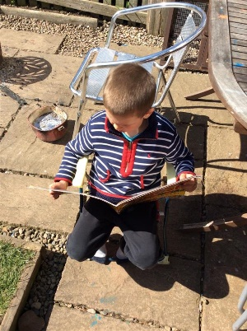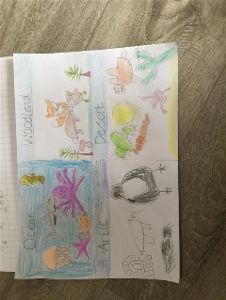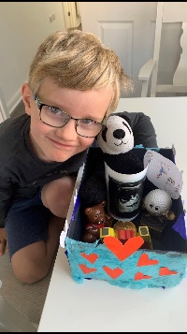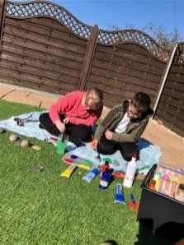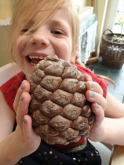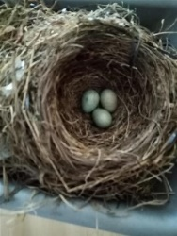

|  |
| --- |
| **Hazel Class**  Hazel class have gained Trust wide recognition for outstanding engagement with their online home learning via Teams. I have been so pleased to see all members of our class online and ready to learn, with the same enthusiasm and charisma they have in the classroom. This has meant the children have been able to produce work of outstanding quality from home, making use of video chats with staff and peer critique to improve their work with remote feedback.  The children have been making the most of the fantastic weather we have had, with lots of outdoor learning activities inspired by their experiences in forest schools. Mrs Mason has been very pleased with Hazel class’s efforts, with lots of pictures being taken - showing smiling faces and varied learning environments.  We have been exploring lots of online resources while at home. While unable to travel at this time, Hazel class have been remotely exploring our capital city (London), picking out landmarks and experiencing the other sights of the city. Mrs Gurney has set challenges for the children, which have seen an overwhelming response from the children - all very interested and excited in exploring this city.  The engagement and community spirit within our online chats has proven that all members of Hazel class are truly committed learners and kind people - upholding the values of Stakesby Academy. Even while not physically together, working remotely from home, there has been a true sense of community, togetherness and support, which has been lovely to be part of.  Keep up the fantastic work and engagement!  **Mr Nicholson** |
| **Elm Class**  I would like to say a huge 'thank you' to Elm class children and their families. We have only been back from the Easter holidays for a few days and the positive mindset and motivation for learning has been exceptional!  This week we have been busy starting work on our new ‘Power of Reading’ text - we do not know the title of the story yet as the cover is hidden but we are busy conducting research, exploring illustrations and making predictions. We have also been busy making some pop art - inspired by Andy Warhol. It has been wonderful to see how Elm class have been keeping busy at home, doing things such as baking, creating and even feeding lambs!  Fantastic work, everyone! Keep going!  **Miss Saville** |
| **Oak Class**  I am so impressed with the level of maturity and independence you have shown throughout your home learning. I look forward to our daily video calls and to seeing what emojis and gifs you put on our class chat at the start of each day. I am missing saying "good morning" to you in person but it always makes me smile when I read your daily 'good mornings' on Teams.  I have loved seeing what you have been up to during your free time, from discovering escaped sheep and painting pebbles for your neighbours to baking giant cookies and practising your cricket bowling. You make me proud to be your teacher and I can't wait to see you in person again.  **Miss Robson** |

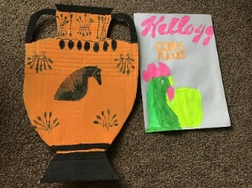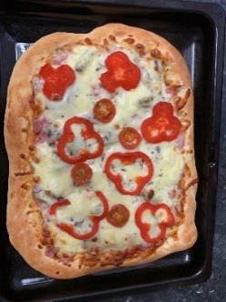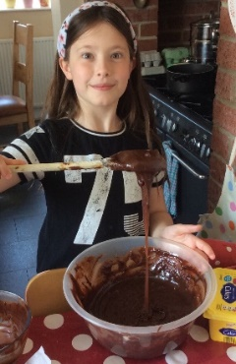

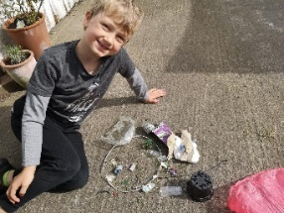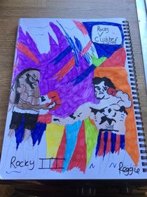

|  |
| --- |
| **Sport**  It is a rather unusual sports report this week! We have been incredibly lucky with the weather lately so hopefully you have all been able to get out and about on bike and scooter rides; enjoying walks; practising your football skills; dunking basketballs and joining in with Mr Bates' brilliant PE lesson. It is so important to stay active so it has been wonderful to see videos of the toilet roll challenge (shout out to the current leader, Connor Marsay with 13) and pictures of children riding their bikes, creating obstacle courses in their gardens and so much more. Perhaps, if this weather continues, you might be able to go swimming in your paddling pools!  **Miss Robson** |
| **FoSS**  Thank you to everyone who sent us rainbows and who entered our butterfly competition. We used a random name selector to select a winner and our winner is Pippi Upton. Well done Pippi you have won a £25 voucher to spend at the Willow Branch. We also have a quiz running on our Facebook page so why not join in?  All of our events are postponed now but as soon as we can, we will run them. FoSS are still busy thinking of ideas and we can have an event organised in no time!    We will still hold a used uniform sale as soon as we can so please keep any uniform you no longer need.  We are also collecting ‘bits and bobs’.... small toys, interesting items etc or anything small we can use that will fit in a jam jar. Please keep these and uniform until we return to school.    Watch out for another competition on our Facebook page very soon. Stay safe  **Mrs Parker and the FoSS Team** |

