Computing Curriculum 2021
Table of Contents

Curriculum Overview
Year Group Learning Overview
Assessment
Software and Apps
Year 1
Year 2
Year 3
Year 4
Year 5
Year 6
Equivalent Programs
Supplemental/After School Computer Club Lessons
Home Learning
Enquire Learning Trust - Computing Curriculum

Intent
At Enquire Learning Trust, we believe that it is vital for all our pupils to learn from and about Computing and Technology, so that they can understand the world around them. Through teaching our computing curriculum, we aim to equip our children to participate in a rapidly changing world where work and leisure activities are increasingly transformed by technology. It is our intention to enable children to find, explore, analyse, exchange and present information as well as having the skills to manipulate, develop and interpret different forms of technology in an ever-changing world.
In such a fast-moving curriculum, we are constantly looking at new ways of delivering relevant and exciting activities, while still delivering the fundamental skills needed for computing. Using technology safely and responsibly is a main priority and ensuring all pupils are able to use the internet and equipment appropriately is of paramount importance. We encourage our pupils to make links across the curriculum, the world and our local community, to reflect on their own experiences, which are designed in our curriculum, allowing horizontal and vertical links with previous year groups.
The core of computing is computer science, in which pupils are taught the principles of information and computation, how digital systems work, and how to put this knowledge to use through programming. Building on this knowledge and understanding, pupils are equipped to use information technology to create programs, systems and a range of content. Computing also ensures that pupils become digitally literate – able to use, and express themselves and develop their ideas through, information and communication technology – at a level suitable for the future workplace and as active participants in a digital world.

Implementation

The Enquire Learning Trust bespoke computing curriculum offers a cross curricular scheme of work for Key Stage 1 and Key Stage 2 presently which is congruent with the National Curriculum. The curriculum looks at the progression needed for all pupils to develop and embed skills and knowledge within the strands of: digital literacy, E-Safety, coding, computing and app specific learning. The curriculum is designed to support teaching and learning and the acquisition of subject knowledge in all areas. Children will have the opportunity to explore and respond to key issues such as digital communication, cyber-bullying, online safety, security and social media.

Impact

- Children will be confident users of technology, able to use it to accomplish a wide variety of goals, both in school and at home.
- Children will have a secure and comprehensive knowledge of the implications of technology and digital systems which is important in our ever-evolving society.
- Children will be able to apply the British Values of democracy, tolerance, mutual respect, rule of law and liberty when using digital systems.

Aims
The curriculum for computing aims to ensure that all pupils:
- can understand and apply the fundamental principles and concepts of computer science, including abstraction, logic, algorithms and data representation
- can analyse problems in computational terms, and have repeated practical experience of writing computer programs in order to solve such problems
- can evaluate and apply information technology, including new or unfamiliar technologies, analytically to solve problems
- are responsible, competent, confident and creative users of information and communication technology.

Key stage 1

Pupils should be taught to:
- understand what algorithms are; how they are implemented as programs on digital devices; and that programs execute by following precise and unambiguous instructions
- create and debug simple programs
- use logical reasoning to predict the behaviour of simple programs
- use technology purposefully to create, organise, store, manipulate and retrieve digital content
- recognise common uses of information technology beyond school
- use technology safely and respectfully, keeping personal information private; identify where to go for help and support when they have concerns about content or contact on the internet or other online technologies.

Key stage 2

Pupils should be taught to:
- design, write and debug programs that accomplish specific goals, including controlling or simulating physical systems; solve problems by decomposing them into smaller parts
- use sequence, selection, and repetition in programs, work with variables and various forms of input and output
- use logical reasoning to explain how some simple algorithms work and to detect and correct errors in algorithms and programs
- understand computer networks including the internet; how they can provide multiple services, such as the world wide web; and the opportunities they offer for communication and collaboration
- use search technologies effectively, appreciate how results are selected and ranked, and be discerning in evaluating digital content
- select, use and combine a variety of software (including internet services) on a range of digital devices to design and create a range of programs, systems and content that accomplish given goals, including collecting, analysing, evaluating and presenting data and information
- use technology safely, respectfully and responsibly; recognise acceptable/unacceptable behaviour; identify a range of ways to report concerns about content and contact.

Please use the ELT Assessment statements as guidance for progression through the curriculum

Evidence Collection for Subject Leaders
It would be good to save/screenshot evidence of some pieces of work when children are able to demonstrate independently a new skill or knowledge they have learned. This might be the end piece for their design. It is not necessary to save every piece of work but to get a sample of pupils work across the curriculum to show breadth and coverage. Evidence of progression could also be a discussion with pupils about what they have learnt within that strand and how they would use that new skill in different contexts.

Year group curriculum overview
 | Autumn 1 |  | Autumn 2 |  | Spring 1 |  | Spring 2 |  | Summer 1 |  |  | Summer 2
Year 1 | E-safety:  Using the internet safely. |  | Coding with Tynker JR | E-safety:  the internet safely | Digital Literacy & E-safety: using a computer/device. Typing training. |  | Digital Literacy: bug hunters |  | Digital Literacy: Potty painters |  |  |  | Coding: Scratch Jnr - introduction and fundamentals
Year 2 | E-safety: Staying safe on the internet – Jessie and Friends. |  | Digital Literacy & E-safety: Using search. Typing training. |  | Coding: Scratch Jnr - introduction and fundamentals | E-safety: Appropriate behaviour online. | Digital Literacy - using a computer.  What is the Internet. | Digital Literacy: Introduction to photo editing. | E-safety: Staying safe on the internet. | Digital Literacy: taking and using photos |  | Coding: Scratch Jnr - introduction and fundamentals
Topic related activities throughout the year.
Year 3 | E-safety: Google Share with care |  | Digital Literacy:  Computer Networks | Digital Literacy:  Email | E-safety: Trust | Digital Literacy: Social media and evaluating search results | Coding: Animations – Tynker or Code Spark Academy |  | Coding: Loops, debugging and events. |  |  | Coding: If statements. HTML App Coding
Topic related activities throughout the year.
Year 4 | E-safety: Google Don’t fall for fake |  | Digital Literacy: Research and develop a topic |  | Word processing  PowerPoint | Photo Editing -  Editing functions | Coding: Algorithms -Tynker |  | Digital Literacy: Stop motion animation |  |  | Coding: Conditions, Functions and App design
Topic related activities throughout the year.
Year 5 | E-safety: Google Secure your secrets | Digital Literacy: Plan an event using shared documents | Digital Literacy: Spreadsheets |  | E-safety: Cyberbullying | Coding: Swift Playgrounds – Commands, Debugging | Coding: Conditional Code, While loops and Logic. |  | Digital Literacy: Animation through varied apps and websites |  | Digital Literacy: Website creation. SharePoint | Coding: Algorithms. Game creation
Topic related activities throughout the year.
Year 6 | E-safety: Google It’s cool to be kind  Interland’s Kind Kingdom |  | Digital Literacy: 3D modelling using Google Sketchup. | Computer Networks: Search Algorithms | E-safety: Why is Social Media Free?  Fake News in real life. | Coding: Use variables, coding with variables | Coding: Use of types and initialisation in code, parameters and problem-solving skills |  | Digital Literacy: ChildNet video competition |  |  | Coding: The use of Arrays in coding, visualise data and coding concepts

Assessment
This computing curriculum is also paired with an assessment framework to support teacher assessment, next steps planning and gap analysis. This framework provides information that can be used to help plan and assess pupil knowledge, understanding and skills in primary computing. It covers the main expectations for children at the end of each Key Stage. It sets out reasonable expectations of what children could achieve in each year at primary school, thus allowing teachers to track progress towards the statutory attainment targets.
By the end of each key stage, pupils are expected to know, apply and understand the matters, skills and processes specified in the relevant programme of study.
The progression statements derive from the Programme of Study for computing; they break down the original bullet points into shorter, more manageable chunks. Each statement is accompanied by ‘What to look for’ descriptors. These are designed to support planning for teaching and learning. The framework sets out a sequence that illustrates progression and that can be used to make judgements about pupil achievements. The framework is not intended to be definitive – it should be seen as indicative rather than prescriptive.
The framework is divided into three main strands and an app specific sub strand that covers the National Curriculum.
- E-safety
- Computing and Digital Literacy
- Coding
- App specific learning linked to digital literacy.

Assessments may be made during computing lessons or when pupils are using apps during topic learning that showcase their computing skills.
These statements are just guidance and suggestions to show the progression from Emerging towards, working towards, ARE and Greater Depth. Remember that pupils need to be confidently showing they understand how to use each key concept confidently and independently.
All of the assessment statements are found in the SIMS app which allows teachers to assess as they move through the curriculum. It enables real-time assessment and aids planning for next steps and quickly identifies which children are secure in a skill and which children need further support.
The Computing Assessment Framework can be found in its entirety by CLICKING HERE

Software and Apps used
 | Year 1 | Year 2 | Year 3 | Year 4 | Year 5 | Year 6
iPad Apps | Scratch Jr  Tynker JR  Abobe Spark  Apple Photos  Pages  Digi Ducks Big Decision | Scratch Jr  Piccollage App  Photo Editor – Autodesk Sketchbook | Tynker  iMovie  iOS Camera  Keynote  Tayasui Sketches School | Tynker  Keynote  iMovie  Pages  Photo Editor – Autodesk Sketchbook | Swift Playground | Swift Playground  Kahoot
 | Year 1 | Year 2 | Year 3 | Year 4 | Year 5 | Year 6
Windows Software |  | Paint.net | Microsoft Word  Microsoft PowerPoint | Paint.net  Microsoft Word  Microsoft PowerPoint | Microsoft Word  Microsoft Excel  Microsoft Publisher  Microsoft Teams  Scratch desktop (or  online)  Microsoft PowerPoint  Pivot Animator | Scratch desktop (or online)  Mozilla X-Ray
 | Year 1 | Year 2 | Year 3 | Year 4 | Year 5 | Year 6
Online Services requiring account creation (Free) | Adobe Account for Spark |  | The Tynker app will need a classroom account setting up to unlock levels 4 -10 | The Tynker app will need a classroom account setting up to unlock levels 4 -10 | Swift playground will require an Apple ID. These can be made via Apple School Manager. | Swift playground will require an Apple ID. These can be made via Apple School Manager.
Online services needing Office 365 login (Pupil and teacher) |  |  |  |  | Microsoft SharePoint  Microsoft Word online  Microsoft Excel online  Microsoft Publisher online | SketchUp

Computing
Year 1
Learning intentions
Year 1
E-safety | Uses technology safely
 | Keeps personal information private
 | Recognises common uses of information technology beyond school
Computing /  Digital Literacy | Uses technology purposefully to create digital content
 | Uses technology purposefully to store digital content
 | Uses technology purposefully to retrieve digital content
Coding | Understands what algorithms are
 | Creates simple programs

Computing Vocabulary
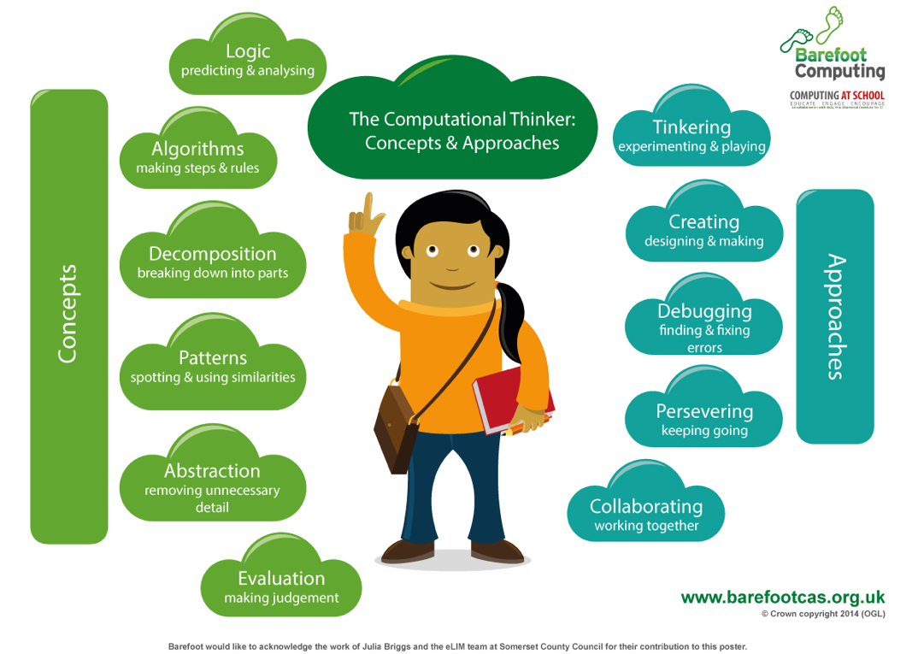
Algorithm
An algorithm is a sequence of instructions or a set of rules to get something done. Please note: a piece of code is not an algorithm.

Decomposition
The process of breaking down a problem into smaller manageable parts is known as decomposition. Decomposition helps us solve complex problems and manage large projects.

Sequences
This means that the computer will run your code in order, one line at a time from the top to the bottom of your program. It will start at the first block of code, then execute the next block of code then the next and so on until it reaches the last code block of your program.

Repetition
Sometimes you want the computer to execute the same lines of code several times. This is done using a loop. There are three types of loops: Forever loops, repeat n time loops and repeat until loops. That’s handy as it enables you not to have to copy the same blocks of code many times.
Debug
When code doesn’t work the way the user intended, we call the code buggy. To debug the code, the user looks at all the instructions and check to make sure every instruction is in the right order and any wrong instructions are removed or replaced with correct ones.

You may need to register and login to the Barefoot website for these resources. It’s quick and free to do.

Mastery example questions like maths | Planning Links
If you change the order of the blocks, does it have the same result?  What happens if you change..?  Can you get the same result with a different type of repeat block?  How do you make the conditional false? | Year 1- Autumn 1:  Year 1- Autumn 2:  Year 1 – Spring 1:  Year 1 – Summer 1:
App or software used within the year
Tynker Jr (iPad)
Scratch JR (iPad)
Digiduck's Big Decision PDF and (iPad)

Autumn 1 | 1 & 2 | 3 | 4 | 5 | 6 | 7 | 8
Topic | E-safety: | E-safety: | E-safety: | E-safety: | E-safety: | E-safety: | E-safety:
Lesson | Going Places Safely | Making the right decision. | Critical thinking and online relity | A-B-C Searching  Comparisons of topic-based images using different child-friendly search engines. | My Creative Work | Become an Internet Protector  That ‘uh-oh’ feeling. | I have the right to say NO
LO | To discuss how to stay safe online | To use the internet safely | To use the internet safely | To search the internet for suitable pictures | To describe how to take ownership of work online | To discuss how to stay safe online-Avatar and profile safety | To discuss how to stay safe online- keeping stuff safe
Planning | Childnet: Smartie the penguin.  Planning link: | Digi Duck’s Big Decision  Planning Link: | Digi duck's Famous Friend:  Planning Link: | Swiggle Search Engine  Google Safe Search:  Planning Link | Link | ChildNet-Lee and Kim. Lesson 1  Planning Link: | ChildNet-Lee and Kim. Lesson 2  Planning Link:

Autumn 2 | 1 | 2 | 3 | 4 | 5 | 6
Topic | Coding: Algorithms | Coding: Algorithms | Coding: Algorithms | Coding: Algorithms | E-safety | E-safety
Lesson | Tynker JR | Tynker JR | Tynker JR | Tynker JR: Debugging | Keep It Private | Keep It Private
LO | To Introduce the term Algorithm. To reinforce the meaning of an Algorithm (A List of instructions) | To use directional instructions to create algorithms to solve puzzles. | Plan and develop algorithms  To solve problems by splitting them into smaller parts. | To learn the term DEBUGGING. To Reinforce that debugging is fixing our code, so that it works. | To keep my information private | To keep my information private
Planning & Resources | Tynker JR App  Ocean Odyssey  Levels 1 –10  Getting Code in the right Order | Tynker JR App  Ocean Odyssey  Levels 12 –20  Giving a list of instructions to collect the coins. | Tynker JR App  Ocean Odyssey  Levels 12 – 22 | Tynker JR App  Ocean Odyssey  Levels 22 – End.  Model a list of instructions wrong and allow the children to correct you. | SMART Rules: ARS  Planning Link: | SMART Rules: MT  Planning Link:

Spring 1 | 1 | 2 | 3 | 4 | 5 | 6 | 7 | 8
Topic | Digital Literacy: using a computer | Digital Literacy: using a computer | Digital Literacy: using a computer | Digital Literacy: using a computer | Digital Literacy: using a computer | Digital Literacy: using a computer | Digital Literacy: using a computer | Digital Literacy: using a computer
Lesson | How a supermarket works | How a library works | Getting started in the computer lab | Your digital footprint | My robotic friends | Using a device | Using a device to touch type | Using a device to touch type
LO | To identify computers in everyday lives | To discuss how computers make our lives easier | To follow the rules when using computers | To discuss staying safe on and offline | Attend to precision when creating instructions.  Identify and address bugs or errors in sequenced instructions. | To safely use a device | To safely use a device | To safely use a device
Planning | Link | Link | Lesson Plan:  Pupil Puzzle Link | Lesson Plan  Pupil Worksheet | Lesson Plan: | This is space for children to practise switching on/off & logging in & typing passwords | BBC Dance Mat Level 1 | BBC Dance Mat Level 2

Spring 2 | 1 | 2 | 3 | 4 | 5 | 6
Topic | Digital Literacy: bug hunters | Digital Literacy: bug hunters | Digital Literacy: bug hunters | Digital Literacy: bug hunters | Digital Literacy: bug hunters | Digital Literacy: bug hunters
Lesson | Introduction to the topic and searching for images | Create an image gallery by holding finger down on image and adding to photos. | Organise images into a named folder on the iPad | Rename files to help organise them | Organise images into groups/fields: legs, shell can it fly? etc.  To be able to send (AirDrop) files to each other and to the teacher. | Create a presentation of organised images using suitable iPad software e.g., Piccollage. Add text labels.
LO | To use Google search to find images | To save images from the internet | To create and rename folders | To rename files | To move files | To present my image gallery
Planning & Resources | Insects | Link: | Link: | Link: | Link:  How to airdrop | Photo slideshow:  Keynote:

Summer 1 | 1 | 2 | 3 | 4 | 5 | 6 | 7
Topic | E-safety | Digital Literacy: potty painters | Digital Literacy: potty painters | Digital Literacy: potty painters | Digital Literacy: potty painters | Digital Literacy: potty painters | Digital Literacy: potty painters
Lesson | Think Before You Click pledge & E-safety assembly. | To introduce topic and discuss what an illustration is | Children choose a book to draw an illustration for | Use an illustration program (e.g., Publisher or drawing app) to create an illustration | Use the same program to edit an illustration | Introduction to eBooks | Continue to make the eBook
LO | To read and sign the Be Internet Awesome pledge | To describe what an illustration is | To plan an illustration | To create and save an illustration | To edit an illustration | To create an eBook | To add illustrations to an eBook
Planning & Resources | Pledge Link: |  | Austin’s butterfly | Publisher online  Drawing Pad app |  | Adobe Spark (Class login required)  Apple Pages

Summer 2 | 1 | 2 | 3 | 4 | 5 | 6 | 7
Topic | Coding: Scratch Jnr - Introduction and fundamentals | Coding: Scratch Jnr - Introduction and fundamentals | Coding: Scratch Jnr - Introduction and fundamentals | Coding: Scratch Jnr - Introduction and fundamentals | Coding: Scratch Jnr - Introduction and fundamentals | Coding: Scratch Jnr - Introduction and fundamentals | Coding: Scratch Jnr - Introduction and fundamentals
Lesson | Drive across the city | Run a race | Sunset | Moonrise after sunset | Spooky forest | Meet and greet | Conversation
LO | To understand an algorithm is a list of instructions.  To write an and program a sprite | To add sprites | To make a sprite move | To change the background | To make my program repeat | To use speech in a program | To use sequencing in a program
Planning | LINK | LINK | LINK | LINK | LINK | LINK | LINK

Computing
Year 2

Learning Intentions

Year 2
E-safety | Uses technology respectfully
 | Identifies where to go for help and support when they have concerns about content or contact on the internet or other online technologies
Computing /  Digital Literacy | Uses technology purposefully to organise digital content
 | Uses technology purposefully to manipulate digital content
Coding | Understands that algorithms are implemented as programs on digital devices
 | Understands that programs execute by following precise and unambiguous instructions
 | Debugs simple programs
 | Uses logical reasoning to predict the behaviour of simple programs
App Specific | To learn the basics of photo editing and how images are layered. (part of DL and Computing)

Computing Vocabulary
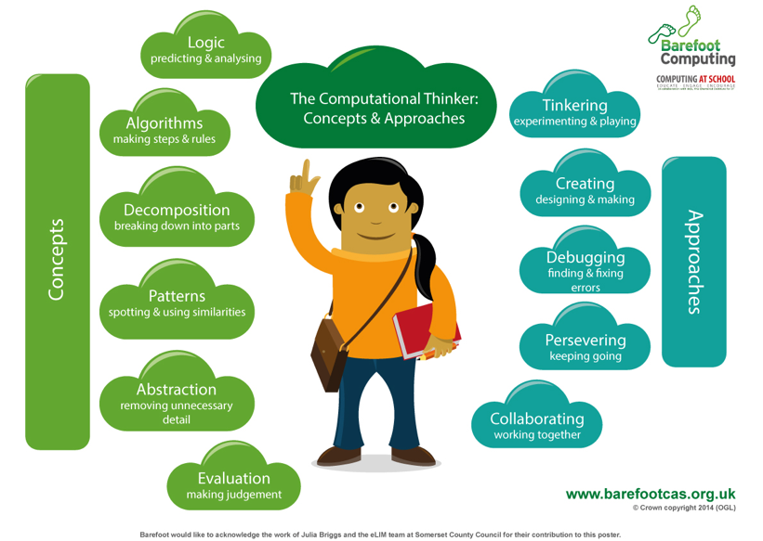

Algorithm
An algorithm is a sequence of instructions or a set of rules to get something done.
Please note: a piece of code is not an algorithm.

Decomposition
The process of breaking down a problem into smaller manageable parts is known as decomposition. Decomposition helps us solve complex problems and manage large projects.

Sequences
This means that the computer will run your code in order, one line at a time from the top to the bottom of your program. It will start at the first block of code, then execute the next block of code then the next and so on until it reaches the last code block of your program.

Repetition
Sometimes you want the computer to execute the same lines of code several times. This is done using a loop. There are three types of loops: Forever loops, repeat n time loops and repeat until loops. That’s handy as it enables you not to have to copy the same blocks of code many times
Debug
When code doesn’t work the way the user intended, we call the code buggy. To debug the code, the user looks at all the instructions and check to make sure every instruction is in the right order and any wrong instructions are removed or replaced with correct ones.
.

You may need to register and login to the Barefoot website for these resources. It’s quick and free to do.

Mastery example questions like maths | Exemplar lesson and planning material
If you change the order of the blocks, does it have the same result?  What happens if you change..?  Can you get the same result with a different type of repeat block?  How do you make the conditional false? | Exemplar complete unit, including planning, scaffolding, questioning and assessment  Lesson plan for a similar maths game, including slides (requires registration)  Scratch Jnr Slides from Twinkl  Example slides using PRIMM in resource folder.  Year 2- Autumn 1:  Year 2- Autumn 2:  Year 2 – Spring 1:  Year 2- Summer 1:
App or software used within the year
Scratch Jr (iPad)
Piccollage (iPad)
Paint.net (Windows 10)

Autumn 1 | 1 & 2 | 3 | 4 | 5 | 6 | 7 | 8
Topic | E-safety: | E-safety: | E-safety: | E-safety: | E-safety: | E-safety: | E-safety:
Lesson | Jessie and Friends  Episode 1 –Watching Videos | Jessie and Friends  Episode 2- Sharing Pictures | Jessie and Friends  Episode 2- Sharing Pictures | Jessie and Friends  Episode 2- Sharing Pictures | Jessie and Friends  Episode 3- Playing Games. Session 1 | Jessie and Friends  Episode 3- Playing Games. Session 2 | I am internet awesome
LO | To use the rules to discuss a story  • I can explain how something online might make someone feel worried or sad.  • I can recognise different feelings.  • I can identify up to four adults in my life who can help me if I have a problem online. | To discuss how to stay safe on the internet.  I can explain what might happen if we share a picture. | To use technology safely  I can identify the effect of people’s actions online and consider ways of keeping others and myself safe. | To describe the rules for staying safe online  I recognise that I can be an ‘upstander’ by choosing not to join in. | To make safe choices when using the internet  I can identify what personal information is and the importance of not sharing this.  I can recognise different feelings I might encounter online and how my body might tell me something ‘doesn’t feel right’. | To describe positive behaviour on the internet  • I can talk about the qualities that make a good friend.  • I can identify that people online may not tell the truth.  • I can explain the difference between a secret and a surprise. | An e-safety lesson appropriate for your class
Video | Episode 1 –Watching Videos | Episode 2- Sharing Pictures |  |  | Episode 3- Playing Games
Planning | Resources Link:  Lesson Plan and Resources  Page 16-29 | Resources Link:  Lesson Plan and Resources  Page 30-47 |  |  | Resources Link:  Lesson Plan and Resources  Page 48-52 | Resources Link:  Lesson Plan and Resources  Page 53-77

Spring 1 | 1 | 2 | 3 | 4 | 5 | 6 | 7 | 8
Topic | Digital Literacy: using a computer | Digital Literacy: using a computer | Digital Literacy: using a computer | Digital Literacy: using a computer | Digital Literacy: using a computer | Digital Literacy:  Using a computer | Digital Literacy: using a computer | Digital Literacy: using a computer
Lesson | Staying Safer Online | Follow the Digital Trail | Screen Out the Mean | Using Keywords | Sites I Like | Typing – Finger placement. | Typing – Finger placement. | Typing – Finger placement.
LO | To discuss which websites are appropriate for my age | To describe my digital footprint | To treat others with respect online | To use search engines effectively | To rate my favourite websites | To type without looking at the keyboard with correct finger placement | To be able to move our typing hands | To Improve touch typing.
Planning | Digital Literacy & Citizenship  Link |  |  |  |  | Link (Typing Club) | BBC Dance Mat  Level 3: | BBC Dance Mat  Level 4:

Autumn 2 | 1 | 2 | 3 | 4 | 5 | 6
Topic | Coding: Scratch Jnr - introduction and fundamentals | Coding: Scratch Jnr - introduction and fundamentals | Coding: Scratch Jnr - introduction and fundamentals | Coding: Scratch Jnr - introduction and fundamentals | E-safety | E-safety
Lesson | Grow and Shrink | Time to Move | Repeat | Sounds | Being Kind Online | Follow the Digital Trail
LO | To program a character to grow and shrink. | To use instructions to make characters move at different speeds and distance. | To use a repeat instruction to make a sequence of instructions run more than once and predict the behaviour. | To create programs that play a recorded sound. | Identifying unkind behaviour online.  Knowing what to do if someone is unkind online. | What information is appropriate in a digital footprint?
Planning | LINK |  |  |  | Planning Link: | Planning Link:

Spring 2 | 1 | 2 | 3 | 4 | 5 | 6
Topic | Digital Literacy - using a computer | Digital Literacy - using a computer | Digital Literacy - using a computer | Digital Literacy - using a computer | Digital Literacy - Introduction to photo editing. (Halibut Jackson)  (PAINT.NET Needed) | Digital Literacy - Introduction to photo editing. (Halibut Jackson)
Lesson | What is the internet? | What is a computer?  How can computers help you learn? | How do people use computers at work?  How can you use the internet? | How do you take care of your personal information?  How can you use the web safely? | The first concepts of photo editing. | To find images from the internet to insert into the Image on separate layers.
LO | To describe how the internet works | To understand that computers are in lots of different inventions.  To identify computers’ icons. | To discuss the different uses of computers. | Understanding how we use computers to stay safe while we’re online. | To understand photo editing is done in layers.  To understand the concept of transparent in photo editing. | To add and edit layers. Copy paste.  Change visibility of layers
Video |  |  |  |  | Video – Introduction of photo editing – Paint.NET  Video – Introduction of photo editing – AutoDesk SB  Video – Halibut Jackson Story on YouTube
Presentation |  |  |  |  | PowerPoint – Introduction to photo editing
Planning &  Resources | Link: | What is a computer?  How does a computer help you learn? | How do people use computers at work?  How can you use the internet? | How do you take care of your personal information?  How can you use the web safely? | Halibut Jackson template- Paint.NET (Windows)  Halibut Jackson template- AutoDesk (iPad)  For Lesson Plan – Go through the PowerPoint and then the Video. Demonstrate the different layers on the files provided. Drawing and importing layers is demonstrated in the videos.

Summer 1 | 1 | 2 | 3 | 4 | 5 | 6 | 7
Topic | E-safety | E-safety | Digital Literacy: taking and using photos | Digital Literacy: taking and using photos | Digital Literacy: taking and using photos | Digital Literacy: taking and using photos | Digital Literacy: taking and using photos
Lesson | Screen out the Mean | Using Keywords | We are photographers | We are photographers | Edit Photos on iPad apps. | We are photographers | We are photographers
LO | Digital rights and a better internet. | Understand that  keyword searching is an effective way to locate information on the internet. | To discuss what a camera is and how it works | To take a good photo  To save and organise photos. To be able to use sending techniques such as airdrop. | Using a photo edit app | To create a Piccollage using edited photos. | To present my photos (use Airdrop to send to teacher. Either Apple classroom or airdrop Share function)
Planning & Resources | Planning: | Planning: | How a camera works  Pinhole Camera | LINK  How data is stored | Photography apps | Piccollage app. | Apple Classroom or  Airdrop.

Summer 2 | 1 | 2 | 3 | 4 | 5 | 6 | 7
Topic | Coding: Scratch Jnr - introduction and fundamentals | Coding: Scratch Jnr - introduction and fundamentals | Coding: Scratch Jnr - introduction and fundamentals | Coding: Scratch Jnr - introduction and fundamentals | Coding: Scratch Jnr - introduction and fundamentals | Coding: Scratch Jnr - introduction and fundamentals | Coding: Scratch Jnr - introduction and fundamentals
Lesson | Walk Along | Show and Hide | Gymnast Cat | Intersection | Big and Small | Messaging | Maze
LO | To animate a sprite | To make sprites appear and disappear | To use a repeat block | To control a sprite’s actions | To change the size of a sprite | To use messaging to control a sprite | To create a game
Planning &  Resources | LINK

Computing
Year 3

Learning Intentions

Year 3
E-safety | Uses technology responsibly
 | Identifies a range of ways to report concerns about contact
Computing /  Digital Literacy | Uses search technologies effectively
 | Uses a variety of software to accomplish given goals
 | Understands the opportunities computer networks offer for collaboration
 | Understands computer networks, including the internet
 | To understand and use Email Technology
Coding | Writes programs that accomplish specific goals
 | Uses sequence in programs
 | Works with various forms of input
 | Works with various forms of output
App Specific | Use word processing and presentation tools. (part of DL and Computing)

Computing Vocabulary
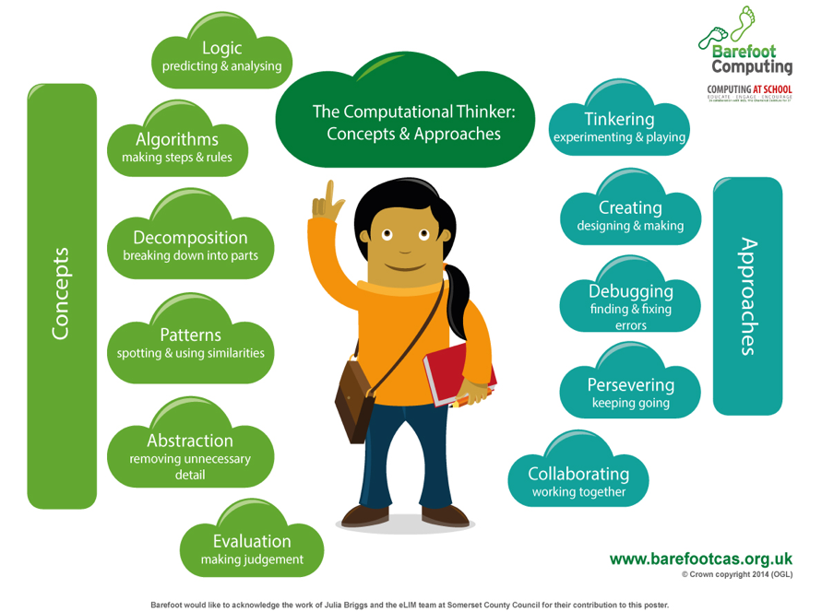
Algorithm
An algorithm is a sequence of instructions or a set of rules to get something done.
Please note: a piece of code is not an algorithm.

Decomposition
The process of breaking down a problem into smaller manageable parts is known as decomposition. Decomposition helps us solve complex problems and manage large projects.
Sequences
This means that the computer will run your code in order, one line at a time from the top to the bottom of your program. It will start at the first block of code, then execute the next block of code then the next and so on until it reaches the last code block of your program.

Repetition
Sometimes you want the computer to execute the same lines of code several times. This is done using a loop. There are three types of loops: Forever loops, repeat n time loops and repeat until loops. That’s handy as it enables you not to have to copy the same blocks of code many times.

Selection
Sometimes you only want some blocks of code to be run only if a condition is met, otherwise you want the computer to ignore these blocks and jump over them. This is achieved using IF statements. e.g. If a condition is met, then blocks contained within the IF block are executed otherwise the computer jumps to the next code blocks without even looking at them.
Debug
When code doesn’t work the way the user intended, we call the code buggy. To debug the code, the user looks at all the instructions and check to make sure every instruction is in the right order and any wrong instructions are removed or replaced with correct ones.

You may need to register and login to the Barefoot website for these resources. It’s quick and free to do.

Mastery example questions like maths | Exemplar lesson and planning material
If you change the order of the blocks, does it have the same result?  What happens if you change..?  Can you get the same result with a different type of repeat block?  How do you make the conditional false? | Exemplar complete unit, including planning, scaffolding, questioning and assessment  Lesson plan for a similar maths game, including slides (requires registration)  Example slides using PRIMM in resource folder.  Autumn 2- Digital Literacy:  Spring 1:  Summer 1:
App or software used within the year
Tynker (iPad)
Microsoft Word (Windows 10)
Microsoft PowerPoint (Windows 10)

Autumn 1 | 1 & 2 |  | 3 | 4 | 5 | 6 | 7 | 8
Topic | E-safety:  Google: Share with Care | Link | E-safety: Google: Share with care | E-safety: Google: Share with care | E-safety: Google: Share with care | E-safety: Google: Share with care | E-safety: Google: Share with care | E-safety:
Lesson | When not to share (1) | Whose profile is this, anyway? (2) | How do others see us? | Keeping it private | That’s not what I meant! | Frame it | Interland: Mindful Mountain | I am internet awesome
LO | To discuss what information should be kept private. (1) | To identify ways information can be found online about people. (2) | To create a positive online presence | To discuss different levels of privacy | How do we make sure that other people will understand what we mean when we post online? | Thinking about what to keep ‘outside the frame’ when we post online. | To put my learning into practice | To agree to the Be Internet Awesome pledge & E-safety assembly
Presentation | Slideshow 1 | Slideshow 2 | Slideshow 3 | Slideshow 4 | Slideshow 5 | Slideshow 6 | Slideshow 7
Planning | Link  Page 12-13 | Link  Page 14-16 | Link  Page 17-18 | Link  Page 19 | Link  Page 20-23 | Link  Page 24-26 | Link  Page 27-28 | To read and sign the pledge

Autumn 2 | 1 | 2 | 3 | 4 | 5 | 6 | 7 | 8
Topic | Digital Literacy: using a computer | Digital Literacy: using a computer | Digital Literacy: using a computer | Digital Literacy: using a computer | Digital Literacy: using Email. | Digital Literacy: using Email. | Digital Literacy: using Email. | Digital Literacy: using Email.
Lesson | Networks 1 – Map | Networks 2 - Router and messages game. | Networks 3 – Net | Networks 4 – Address | Email 1- Retrieve | Email 2 - Sending | Email 3 – Attaching | Email 4 – Collaborating.
LO | To understand what a computer network is, and how they can provide multiple services, such as the world wide web, and opportunity's for collaboration and communication. | To understand the components of a computer network.  To show how information is exchanged between devices. | To understand that the internet is the physical connection between computers and networks.  To understand how data travels throughout a network. | To understand that devices on a network have a unique address. | To understand how email travels and how to retrieve it. | To send and reply to emails. | To attach a file/photo to an email.  To understand the advantages of attaching files/photos to emails. | To use emails to communicate ideas.
Presentation | Connections Around the Home and School | Plan and resources for game.
Video | Introduction to Networks - Video explanation of PowerPoint for the week. |  | Video – What is the Internet (BBC) |  | Video – How Email Works | Video – The Story of send
Planning | Lesson Plan, Objectives, Vocabulary and Success Criteria  Worksheet 1 – Wi-Fi Vs Wireless.  Worksheet 2 – Home devices | Use Lesson plan 3.5.2 | Use Lesson Plan 3.5.3  Worksheet 3.5.3a | Use Lesson Plan 3.5.4  Worksheet 3.5.4a  Resource 3.5.4a  IP (Internet Protocol) Lookup Tool  Task – Find Website IP addresses | Lesson Plan, Objectives, Vocabulary and Success Criteria  Use lesson Plan 4.5.2 | Use Lesson Plan 4.5.3 | Use Lesson Plan 4.5.4 | Use Lesson Plan 4.5.5

Spring 1 | 1 | 2 | 3 | 4 | 5 | 6
Topic | E-safety:  Trust Me Primary Pack | E-safety:  Trust Me Primary Pack | Digital Literacy: Explore a Topic with Research and Collaboration | Digital Literacy: Explore a Topic with Research and Collaboration | Digital Literacy: Explore a Topic with Research and Collaboration | Digital Literacy: Explore a Topic with Research and Collaboration
Lesson | Trust me- lesson 1 | Trust- me lesson 2 | Real Vs fake news | Checking the story | Exploring Social Media | Selecting Search Activity
LO | Can you trust everything you see/read online? | Can you trust everyone who contacts you online? | To describe the features of a fake news article | Sources and who to trust | Social media, images and data | How search engines select and rank results
Video |  |  |  | BBC Video: |  | BBC Video:
Planning | Planning Link: | Planning Link: | Planning Link: | Planning Link: | Planning Link: | Planning Link:

Spring 2 | 1 | 2 | 3 | 4 | 5 | 6
Topic | Coding: Getting Started | Coding: You Can Order It | Coding: You Can Order It | Coding: You Can Step It | Coding: You Can Step It | Coding: You Can Choose
Lesson | Working Wall | Introduction to Sequencing | Introduction to Sequencing | Creating Sequences | Creating Sequences | Flexible Sequencing
LO | To understand the concept of coding, and describe key terms | Describe sequences, construct simple sequences | Describe sequences, construct simple sequences | Build sequences and understand orders | Build sequences and understand orders | Re-ordering steps in a sequence and create flexible sequences
Planning | Getting Started with Code 1 – lesson 0 – Working Wall and Practice | Getting Started with Code 1 – lesson 1 – Story Time and Practice | Getting Started with Code 1 – lesson 1 – App Practice and reflection | Getting Started with Code 1 – lesson 2 – My Crazy Dance | Getting Started with Code 1 – lesson 2 – App Practice and reflection | Getting Started with Code 1 – lesson 3 – Build a Face and App Practice
Example Screenshot | Week 1.1 Week 1.2  (For the full planning, download the iBook) | Week 2.1 | Week 3.1 | Week 4.1 | Week 5.1 | Week 6-1 Week 6.2  Week 6.3 Week 6.4
App Level/World  Or real-world resource | Tynker – Community tab on main menu screen  Home Learning Link Hour of code | Pen and paper, or Notes or Sketches School | Tynker – Space Cadet Level 1 – Crash Landed!  Home Learning Link 1-6 | Keynote in iBook | Tynker – Space Cadet Level 2 – Dance Party  Home Learning Link 7-8 | Tynker – Space Cadet Level 3 – Stay the Course

Summer 1 | 1 | 2 | 3 | 4 | 5 | 6 | 7
Topic | E-safety | Coding: You Can Do it over and over | Coding: You Can Do it over and over | Coding: You Can Fix it | Coding: You Can Fix it | Coding: You Can Prompt It | Coding: You Can Prompt It
Lesson | Your Digital Footprint | Loops | Loops | Debugging | Debugging | Events and Actions | Events and Actions
LO | Leaving a positive Digital Footprint behind you | Understand what a loop is, coding with loops | Understand what a loop is, coding with loops | Understand basic debugging | Understand basic debugging | Understand events and actions | Understand events and actions
Planning | Planning Link: | Getting Started with Code 1 – lesson 4 – Body Percussion | Getting Started with Code 1 – lesson 4 – App Practice, apply skills and reflection | Getting Started with code 1 – Lesson 5 – Robot Fun | Getting Started with code 1 – Lesson 5 – App Practice, apply skills and reflection | Getting Started with Code 1 – Lesson 6 – Robot Remote Control | Getting Started with Code 1 – Lesson 6 – App Practice apply skills and reflection
Example Screenshot
App Level/World  Or real world resource |  | Keynote in iBook | Tynker – Space Cadet Level 4- Walk jump repeat.  Home Learning Link 9-13 | Lesson Resources Printed | Tynker – Space Cadet Level 5 – Glitchy Code  Home Learning Link 14-19 | Lesson Resources Printed | Tynker – Space Cadet Level 5 – Asteroids  Home Learning Link 14-19

Summer 2 | 1 | 2 | 3 | 4 | 5 | 6 | 7
Topic | Coding: You Can if you Follow the Rules | Coding: You Can if you Follow the Rules | Coding: You Can Solve it | Coding: You Can Solve it | Coding Phone Apps | Coding Phone Apps | Coding Phone Apps
Lesson | ‘If’ Statements | ‘If’ Statements | Algorithms | Algorithms | HTML Code introduction  Bitbox Food Fight | HTML Code introduction  Bitbox Dancin’ Hal | HTML Code introduction  Bitbox BlockCraft
LO | Understanding basic conditions | Understanding basic conditions | Create a simple algorithm | Create a simple algorithm | To introduce HTML coding.  To show how phone/tablet apps are coded. | To use HTML code to show how phone/tablet apps are coded. | To introduce HTML coding.  To show how phone/tablet apps are coded.
Planning | Getting Started with Code 1 – Lesson 7 – Explain a Game | Getting Started with Code 1 – Lesson 7 – App Practice, apply skills and reflection | Getting Started with Code 1 – Lesson 8 – Solve the maze | Getting Started with Code 1 – Lesson 8 – App Practice, apply skills and reflection | Bitbox
Example Screenshot
App Level/World  Or real-world resource | iPad Video record function to make videos | Tynker – Space Cadet Level 7 – Shifty Aliens  Home Learning Link 19-End | Pen and paper, or Notes or Sketches School | Tynker – Space Cadet Level 8 – Blast Off!  Home Learning Link 19-End

Computing
Year 4

Learning Intentions

Year 4
E-safety | Identifies a range of ways to report concerns about content
 | Recognises acceptable/unacceptable behaviour
Computing /  Digital Literacy | Selects a variety of software to accomplish given goals
 | Selects, uses and combines internet services
 | Analyses and evaluates information
 | Collects and presents data
 | To understand how search engines work and how results are ranked.
Coding | Design, creates and debug programs that accomplish specific goals
 | Uses repetition in programs
 | Controls or simulates physical systems
 | Uses logical reasoning to detect and correct errors in programs
App Specific | Use word processing and presentation tools.
 | Use film editing software

Year 4 Computing Vocabulary
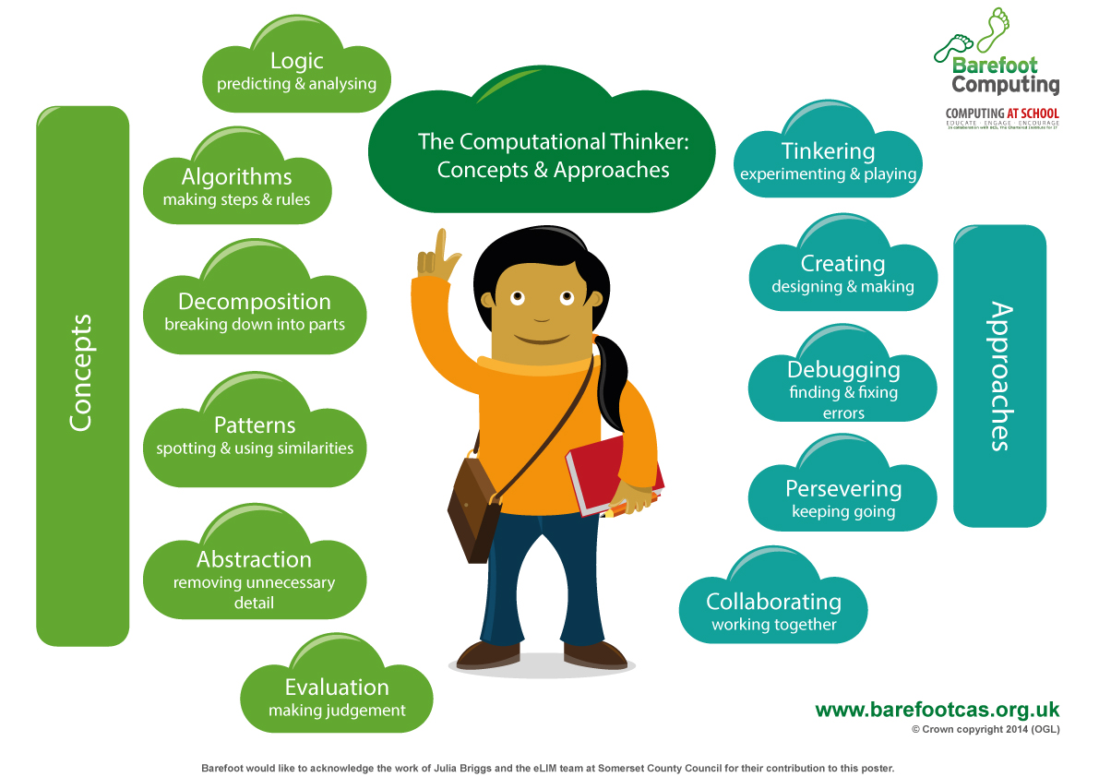
Algorithm
An algorithm is a sequence of instructions or a set of rules to get something done.
Please note: a piece of code is not an algorithm.

Decomposition
The process of breaking down a problem into smaller manageable parts is known as decomposition. Decomposition helps us solve complex problems and manage large projects.

Sequences
This means that the computer will run your code in order, one line at a time from the top to the bottom of your program. It will start at the first block of code, then execute the next block of code then the next and so on until it reaches the last code block of your program.

Repetition
Sometimes you want the computer to execute the same lines of code several times. This is done using a loop. There are three types of loops: Forever loops, repeat n time loops and repeat until loops. That’s handy as it enables you not to have to copy the same blocks of code many times.

Selection
Sometimes you only want some blocks of code to be run only if a condition is met, otherwise you want the computer to ignore these blocks and jump over them. This is achieved using IF statements. E.g. If a condition is met, then blocks contained within the IF block are executed otherwise the computer jumps to the next code blocks without even looking at them.
Debug
When code doesn’t work the way the user intended, we call the code buggy. To debug the code, the user looks at all the instructions and check to make sure every instruction is in the right order and any wrong instructions are removed or replaced with correct ones.

You may need to register and login to the Barefoot website for these resources. It’s quick and free to do.

Mastery example questions like maths | Exemplar lesson and planning material
If you change the order of the blocks, does it have the same result?  What happens if you change..?  Can you get the same result with a different type of repeat block?  How do you make the conditional false? | Exemplar complete unit, including planning, scaffolding, questioning and assessment  Lesson plan for a similar maths game, including slides (requires registration)  Example slides using PRIMM in resource folder.  Autumn 2:  Spring 1:  Summer 1:
App or software used within the year
Swift Playground (iPad)
Tynker (iPad)
iMovie (iPad)
Microsoft Word (Windows 10)
Microsoft PowerPoint (Windows 10)
Paint.net (Windows 10)

Autumn 1 | 1 & 2 | 3 | 4 | 5 | 6 | 7 | 8
Topic | E-safety: Google: Don’t fall for fake | E-safety: Google: Don’t fall for fake | E-safety: Google: Don’t fall for fake | E-safety: Google: Don’t fall for fake | E-safety: Google: Don’t fall for fake | E-safety: Google: Don’t fall for fake | E-safety:
Lesson | Don’t bite that phishing hook! | Who are you, really? | About those bots | Is that really true? | Spotting disinformation online | Interland: Reality River | I am Internet Awesome
LO | To recognize ways people, steal personal information | To recognize when someone is trying to steal personal info | To analyse how computer ‘bots’ can impact on daily life | To recognise if online information is credible. | To develop skills to detect fake news and disinformation | To put my learning into practice  Play the game | To agree to the Be Internet Awesome pledge & E-safety assembly
Presentation | Slideshow | Slideshow | Slideshow | Slideshow | Slideshow | Slideshow
Planning | Link  Page 32-36 | Link  Page 37-42 | Link  Page 43-44 | Link  Page 45-50 | Link  Page 51-57 | Link  Page 58 | To read and sign the Be Internet Awesome pledge

Autumn 2 | 1 | 2 | 3 | 4 | 5 | 6 | 7 | 8
Topic | Digital Literacy:  Exploring our Earth | Digital Literacy:  Exploring our Earth | Digital Literacy: Research and develop a topic | Digital Literacy: Research and develop a topic | Digital Literacy: Research and develop a topic | Digital Literacy: Research and develop a topic | Digital Literacy: Research and develop a topic | Digital Literacy: Research and develop a topic
Lesson | Getting started with Google Earth | Google Earth Projects  (Google Expeditions?? When unblocked) | Clarify- what information are you looking for? | Search- what words will give you the highest quality results? | Delve- which search results should you explore further? | Evaluate- how do you know if it is the info you need and is it reliable? | Cite- can you summarise the information, use direct quotes and cite sources? | Organisation- how can you keep the valuable information that you have gathered, organised?
LO | Use maps, atlases, globes and digital/computer mapping to locate countries and describe features studied | Create and experience stories about the world | To research and record information | To use search effectively, appreciate how results are selected and ranked, and be discerning in evaluating digital content | To be discerning in evaluating digital content | To assess the credibility of a source on the internet | Communication and collaboration on the World Wide Web | Collect, analyse, evaluate and present data and information
Planning | Overview and resources:  Geography NC: | Google Earth Voyager: | Kathleen Morris:  Mini Lesson plans: | Mini Lesson Plans: | Mini Lesson Plans: | Mini Lesson Plans: | Mini Lesson Plans: | Mini Lesson Plans:

Spring 1 | 1 | 2 | 3 | 4 | 5 | 6
Topic | Word processing: creating a document | Word processing | PowerPoint:  Creating a presentation | PowerPoint: Design and transition | Paint.net or Autodesk Sketchbook | Paint.net or Autodesk Sketchbook
Lesson | Creating a word document. Saving | Opening and editing a word document and Save As | Creating a presentation Saving | Opening and editing a PowerPoint and Save As | Photo editing – Changes and effects, | Photo editing – selecting and cropping.
LO | To create a word document and edit font | To open and edit word document | To create a PowerPoint and edit font | To re-open and edit PowerPoint | To layer images on top of each other.  To create image effects  To understand images can be changed or enhanced. | To understand the smart select function (Magic wand)  To use the crop function
Presentation |  |  |  |  | Create a custom name plate. PowerPoint.
Planning | Topic related  Basic tasks in word:  Basic tasks in Word Online: | Topic related  Design and edit in Word: | Topic related  Basic tasks in PowerPoint: | Changing fonts in a presentation:  Changing colour of text on a slide:  Adding bullets or numbers to text: | Using Paint.net

Spring 2 | 1 | 2 | 3 | 4 | 5 | 6
Topic | Getting Started | Think in Steps | Think in Fixes | Think in Circles | Think in Bits | Think in Sets
Lesson | Future Developer | Solving problems with Algorithms | Debugging | Looking for Loops | Composition and Decomposition | Abstraction
LO | Thinking like a developer | Understand and identify algorithms | Identify bugs and how to approach fixing them | Thinking efficiently and identifying loops | Understanding decomposition to solve problems | Understand abstraction to solve problems
Planning | Getting Started with Code 2 – Lesson 0 | Getting Started with Code 2 – Lesson 1 | Getting Started with Code 2 – Lesson 2 | Getting Started with Code 2 – Lesson 3 | Getting Started with Code 2 – Lesson 4 | Getting Started with Code 2 – Lesson 5
Video |  |  |  |  | Cup Song
Example Screenshot | (For the full planning, download the iBook) | Week 2.1 Week 2.2 Week 2.3 | Week 3.1 Week 3.2 Week 3.3 | Week 4.1 Week 4.2 | Week 5.1 Week 5.2 Week 5.3 | Week 6.1 Week 6.2 Week 6.3
App Level/World  Or real-world resource | Tynker – Community tab  Home Learning Link –  Hour of Code | Tynker – Dragon Spells Lesson 1 – Dragon Eggs  Keynote (Sandwich)  Powerpoint (Sandwich)  Home Learning Link 1-5 | Tynker – Dragon Spells Lesson 2 – Blast through  Keynote (Tunnel Bug)  Powerpoint (Tunnel Bug)  Home Learning Link 6-7 | Tynker – Dragon Spells Lesson 3 –Deja Vu  Keynote (Snake Pattern)  Powerpoint (Snake Pattern)  Home Learning Link 8-11 | Tynker – Dragon Spells Lesson 4 – Twisted Trees  Linked video file in Lesson – Cup song – requires plastic cups.  Home Learning Link 12 - 15 | Tynker – Dragon Spells Lesson 5 – Dragon Scrolls  Keynote – Silly Sets  PowerPoint – Silly Sets  Home Learning Link 16 - 18

Summer 1 | 1 | 2 | 3 | 4 | 5 | 6 | 7
Topic | Digital Literacy | iMovie – Trailers 1 | iMovie – Trailers 2 | iMovie – Stop Motion | iMovie – Stop Motion | Green Screen replacement | Green Screen replacement
Lesson | Perspective Photography | Create trailer using pictures | Create more complex video using a mixture of video and photo | Animation techniques  Creating simple Stop motion | Animation techniques  Creating simple Stop motion | Create a new report using a green screen | present and show final piece
LO | Select, use and combine a variety of software on a range of digital devices to design and create a range of content | To develop camera skills and manipulation | To develop camera skills and manipulation | practise simple photography skills | practise simple photography skills | Use a variety of method to create a news report with a replacement background | Use a variety of method to create a news report with a replacement background
Planning | Simon Haughton Planning PP: | Topic based if possible |  |  |  | Thunderstorm News Report Template  Using iMovie on iPads  Using Green Screen in iMovie

Summer 2 | 1 | 2 | 3 | 4 | 5 | 6 | 7
Topic | Think in Patterns | Think in Specifics | Think in Cycles | Think in and Outside the box | Think in Practice | App Design | App Design
Lesson | Forming Functions | Conditional Statements | While Loops and Nested Loops | Variables, Input and Output | Design User Interface | Design your own app | Create your own app
LO | Understand how functions can make coding efficient | Understand conditional statements for different contexts | Understanding Loops in simple conditions | Understanding Variables to change values | Understanding User Interface and User Experiences | Understanding the app development process | Understand app development
Planning | Getting Started with Code 2 – Lesson 6 | Getting Started with Code 2 – Lesson 7 | Getting Started with Code 2 – Lesson 8 | Getting Started with Code 2 – Lesson 9 | Getting Started with Code 2 – Lesson 10 | Getting Started with Code 2 – Lessons 1 – 5 optional activity – app development | Getting Started with Code 2 – Lessons 6 – 10 optional activity – app development
Video
Screenshot
App Level/World  Or real-world resource | Tynker – Dragon Spells Lesson 6 – Ancient Spells  Refers back to Getting started with code 2 lesson 1 | Tynker – Dragon Spells Lesson 7 – Catch me if you can.  Pages and Safari required, | Tynker – Dragon Spells Lesson 8 – The Long Road  Refers back to lesson 1 – creating a sandwich, requires Keynote, | Tynker – Dragon Spells Lesson 9 – Gem Collector  Requires Pages, | Tynker – Dragon Spells Lesson 10 – Dragon Maker  Download linked Keynote template, | Mock-up app design in Keynote | Mock-up app design in Keynote

Computing
Year 5

Learning Intentions
Year 5
E-safety | Understands how to keep sensitive data private
 | Is discerning in evaluating digital content
 | Understand, prevent and respond to Cyberbullying threats.
Computing /  Digital Literacy | Combines a variety of software to accomplish given goals
 | Selects, uses and combines software on a range of digital devices
 | Analyses and evaluates data
 | Designs and creates systems
Coding | Solves problems by decomposing them into smaller parts
 | Uses selection in programs
 | Works with variables
 | Uses logical reasoning to explain how some simple algorithms work
 | Uses logical reasoning to detect and correct errors in algorithms
App Specific | Create animations

Computing Vocabulary
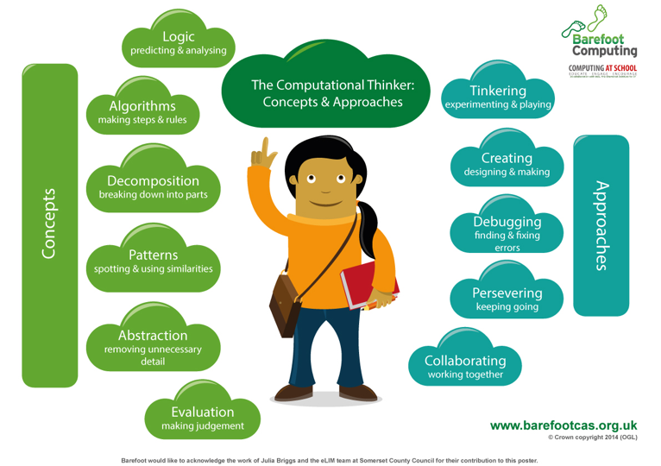
Algorithm
An algorithm is a sequence of instructions or a set of rules to get something done.
Please note: a piece of code is not an algorithm.

Decomposition
The process of breaking down a problem into smaller manageable parts is known as decomposition. Decomposition helps us solve complex problems and manage large projects.

Sequences
This means that the computer will run your code in order, one line at a time from the top to the bottom of your program. It will start at the first block of code, then execute the next block of code then the next and so on until it reaches the last code block of your program.

Repetition
Sometimes you want the computer to execute the same lines of code several times. This is done using a loop. There are three types of loops: Forever loops, repeat n time loops and repeat until loops. That’s handy as it enables you not to have to copy the same blocks of code many times.

Selection
Sometimes you only want some blocks of code to be run only if a condition is met, otherwise you want the computer to ignore these blocks and jump over them. This is achieved using IF statements. e.g. If a condition is met, then blocks contained within the IF block are executed otherwise the computer jumps to the next code blocks without even looking at them.

Variables
A variable is a simple way of storing one piece of information somewhere in the computer’s memory whilst a program is running and getting that information back later. Programs store, retrieve or change the value of a variable, such as a user’s name, the name of a product to be purchased in an online store and a score in a computer game.

Mastery example questions like maths | Exemplar lesson and planning material
If you change the order of the blocks, does it have the same result?  What happens if you change..?  Can you get the same result with a different type of repeat block?  How do you make the conditional false? | Exemplar complete unit, including planning, scaffolding, questioning and assessment  Lesson plan for a similar maths game, including slides (requires registration)  Example slides using PRIMM in resource folder.  Year 5 SharePoint Resources:
App or software used within the year
Swift Playground (iPad)
Scratch Desktop (Windows 10)
Microsoft PowerPoint (Windows 10)
Microsoft Excel (Windows 10)

Autumn 1 | 1 | 2 | 3 | 4 | 5 | 6 | 7 | 8
Topic | E-safety: Secure your secrets | E-safety: Secure your secrets | E-safety: Secure your secrets | E-safety: | Digital Literacy: Plan an event |  | Digital Literacy: Plan an event | Digital Literacy: Plan an event
Lesson | How to build a great password | Keep it to yourself | Interland: Tower of Treasure | I am internet awesome | Select and research an event |  | Create a logo | Create a flyer to advertise
LO | To create a strong password | To customize privacy settings | To put my learning into practice | To explore the rest of the Google Interland islands. To agree to the Be Internet Awesome pledge & E-safety assembly | To create docs and collaborate using Microsoft Word (online) |  | Use Microsoft Publisher (online) to create an image | To create an advert using Microsoft Publisher(online)
Video | Introduction to Interland |  |  |  |  |  | BBC Video: | BBC Video:
Presentation | Slideshow | Slideshow | Slideshow
Planning | Link  Page 62-64  Google Interland | Link  Page 65  Google Interland | Link  Page 66  Google Interland | To read and sign the Be Internet Awesome pledge | Basic tasks in Word: |  | Apple Slides:  Publisher | Apple Slides:

Autumn 2 | 1 | 2 | 3 | 4 | 5 | 6 | 7 | 8
Topic | Digital Literacy: Spreadsheets 1 | Digital Literacy: Spreadsheets 2 | Digital Literacy: Spreadsheets 3 | Digital Literacy: Spreadsheets 4 | Digital Literacy: Spreadsheets 5 | Digital Literacy: Spreadsheets 6 | Coding | Coding
Lesson | Introduction to Spreadsheets  Detailed Unit Planning: | Entering formulae into a spreadsheet  Formula Prompt: | The importance of using a cell reference for recalculation | Changing data in spreadsheets to answer, ‘what if?’ | SUM formula  Sum formula prompt: | Choosing the correct function | Christmas card competition
LO | To identify the key elements of a spreadsheet | How spreadsheets can be used to perform quick, accurate calculations | To enter labels and numbers into a spreadsheet | Exploring spreadsheet models that allow the exploration of possible outcomes | To use SUM to calculate a set of numbers in a range of cells | That mathematical problems can be explored using a spreadsheet | To create an animation in Scratch  Scratch  Scratch teacher programs
Video | Guide – Sending spreadsheets to pupils using Microsoft Teams  Video – 1 The Wizards Challenge | Video 2 – Gold Mine | Video 3 – Recap Challenge  Video 4 – Blank Spreadsheet | Video 5 – Sweet Problems | Video 6 – Race points  Video 7 Shopping Bills | Video 8 - Pocket Money  Video – 9 Register
Planning | Download link to all spreadsheet examples  Spreadsheet 1 – Wizard’s Challenge | Spreadsheet 2 – Gold Mine | Spreadsheet 3 – Recap Challenge  Blank Excel Spreadsheet | Spreadsheet 5 – Sweets Problem | Spreadsheet 6 – Race Points  Spreadsheet 7 – Shopping Bills/Lunch Box: | Spreadsheet 8 – Pocket Money  Spreadsheet 9 – Attendance Register: | Resource:  Lesson Plan  Scratch starter programs

Spring 1 | 1 | 2 | 3 | 4 | 5 | 6
Topic | E-safety:  Cyber bullying | E-safety:  Cyberbullying | Coding: Think Like a computer | Coding: Think like a Detective | Coding: Think Efficiently | Coding: Think Efficiently
Lesson | ‘Let’s fight it together’ | Behind the scenes | Commands and sequences | Debugging | Functions and a Bit of Loops | Functions and a Bit of Loops
LO | Understand, prevent and respond to Cyberbullying threats. | Becoming a responsible digital citizen | Describe, Demonstrate and code using commands and sequences | Describe, Demonstrate and Debug with code | Describe, Demonstrate and Code using functions and loops | Describe, Demonstrate and Code using functions and loops
Video | Let’s fight it together
Planning | Resources: | Character interviews:  Cyberbullying game: | Everyone Can Code 1 – lesson 1 | Everyone Can Code 1 – Lesson 2 | Everyone Can Code 1 – Lesson 3 Pattern Maker Activity | Everyone Can Code 1 – Lesson 3, practice in Swift Playgrounds

Spring 2 | 1 | 2 | 3 | 4 | 5 | 6
Topic | Coding: The Incredible Code Machine | Coding: Think Logically | Coding: Think Logically | Coding: Think Logically | Coding: Think Again and Again | Coding: 21 Questions
Lesson | Problem Solving | Conditional Code | Conditional Code Practice | Conditional Thinking | While Loops | Logic
LO | Design programmes to solve challenges with functions and loops | Demonstrate and code using algorithms | Describe, Demonstrate and Code using conditional code and logic | Demonstrating and coding with conditional code | Describe, Demonstrate and Code with ‘while’ loops | Demonstrate and code using Logic
Planning | Swift Playgrounds: Code Machine | Everyone Can Code 1 – lesson 4 – Scavenger Hunt | Everyone Can Code 1 – Lesson 4 – coding in Swift Playgrounds | Swift Playgrounds – Blink | Everyone Can Code – 1 – Lesson 5 | Everyone Can Code 1 – Lesson 5 Optional Activity – download 21 Questions from page 45.

Summer 1 | 1 | 2 | 3 | 4 | 5 | 6 | 7
Topic | Animation:  GIF Creation | Animation | Animation | Digital Literacy: Internet research and website design | Digital Literacy: Internet research and website design | Digital Literacy: Internet research and website design | Digital Literacy: Internet research and website design
Lesson | Create animated GIF’s using PowerPoint | Pivot Stick Animator | Pivot Stick Animator | What makes a good webpage? | Page Layout | Type the text  Images | Hyperlinks  Publishing the page
LO | Use still images to produce an animation | Combining individual frames to perceive movement | Creating custom-made, creative animations | I can evaluate webpages | I can create a webpage layout | I can add text to a webpage  I can add images to a webpage | I can add hyperlinks into a webpage  I can publish and share my webpage
Video |  |  |  | BBC Bitesize video: What makes a good website?
Planning | Animated gif’s using PP:  Adding an animated gif to a slide: | Pivot Animator Download:  Lesson plans: |  | Microsoft SharePoint:  Lesson plans and resources:

Summer 2 | 1 | 2 | 3 | 4 | 5 | 6 | 7
Topic | Coding: Think the Same Idea | Coding: Think the Same Idea | Coding: Shapes | Coding: Which Way to Turn | Coding: Rock Paper Scissors | Coding: Spirals | Coding: Mission to Mars
Lesson | Algorithms | Conquering the maze | Real Coding | Roll Right, Roll Left | Coding a game | Coding geometric patterns | Controlling a Mars Rover
LO | Describe, Demonstrate and code using algorithms | Demonstrate and code using algorithms | Demonstrate and code using algorithms | Demonstrate and code using algorithms | Demonstrate and understanding of code to create a game | Demonstrate an understanding of code and how parameters effect results | Using Code to control a VR robot.
Planning | Everyone Can Code 1 – Lesson 6 – who’s the tallest | Everyone Can Code 1 – Lesson 6 – Practice with Swift Playgrounds Learn to Code 1 – The Right-Hand Rule, Adjusting Your Algorithm and Conquering the Maze. | Everyone Can Code – Lesson 6 optional activity – Shapes – download from page 51 | Swift Playgrounds Learn to Code 1 – Which Way to Turn and Roll Right, Roll Left. | Swift Playgrounds – Rock, Paper, Scissors. | Swift Playgrounds – Spirals | Swift Playgrounds – Astrobot Mission to Mars

Computing
Year 6
Learning Intentions

Year 6
E-safety | Understand, prevent and respond to Cyberbullying threats.
 | Is discerning in evaluating digital content
Computing /  Digital Literacy | Combines a variety of software to accomplish given goals
 | Selects, uses and combines software on a range of digital devices
 | Understands computer networks, including the internet
 | Understands the opportunities computer networks offer for collaboration
 | Use different programming languages to create a program\app
Coding | Solves problems by decomposing them into smaller parts
 | Uses selection in programs
 | Works with variables
 | Uses logical reasoning to explain how some simple algorithms work
 | Uses logical reasoning to detect and correct errors in algorithms
App Specific | Create and manipulate 3D Models.

Year 6 Computing Vocabulary
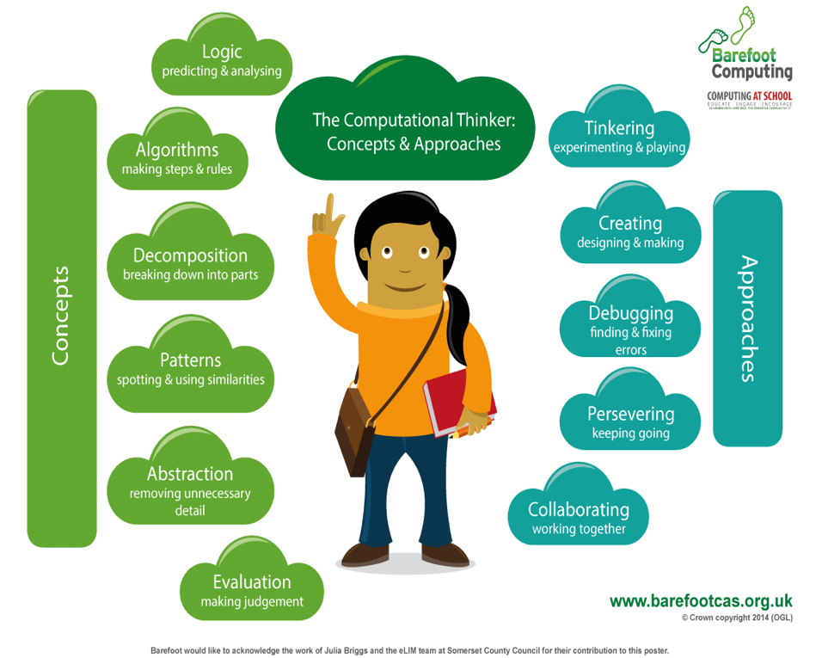
Algorithm
An algorithm is a sequence of instructions or a set of rules to get something done.
Please note: a piece of code is not an algorithm.

Decomposition
The process of breaking down a problem into smaller manageable parts is known as decomposition. Decomposition helps us solve complex problems and manage large projects.

Sequences
This means that the computer will run your code in order, one line at a time from the top to the bottom of your program. It will start at the first block of code, then execute the next block of code then the next and so on until it reaches the last code block of your program.

Repetition
Sometimes you want the computer to execute the same lines of code several times. This is done using a loop. There are three types of loops: Forever loops, repeat n time loops and repeat until loops. That’s handy as it enables you not to have to copy the same blocks of code many times.

Selection
Sometimes you only want some blocks of code to be run only if a condition is met, otherwise you want the computer to ignore these blocks and jump over them. This is achieved using IF statements. e.g. If a condition is met, then blocks contained within the IF block are executed otherwise the computer jumps to the next code blocks without even looking at them.

You may need to register and login to the Barefoot website for these resources. It’s quick and free to do.

Mastery example questions | Exemplar lesson and planning material
If you change the order of the blocks, does it have the same result?  What happens if you change..?  Can you get the same result with a different type of repeat block?  How do you make the conditional false? | Exemplar complete unit, including planning, scaffolding, questioning and assessment  Lesson plan for a similar maths game, including slides (requires registration)  Example slides using PRIMM in resource folder.  Year 6 SharePoint Resources:
App or software used within the year
Swift Playgrounds (iPad)
Microsoft PowerPoint (Windows 10)
X-Ray Goggles – (Browser Bookmark Program) Guide - Website

Autumn 1 | 1 | 2 | 3 | 4 | 5 | 6 | 7 | 8
Topic | E-safety: It’s cool to be kind | E-safety: It’s cool to be kind | E-safety: It’s cool to be kind | E-safety: It’s cool to be kind | E-safety: It’s cool to be kind | E-safety: It’s cool to be kind | E-safety: | E-safety:
Lesson | How can I be an upstander? | Upstander options | …but say it nicely! | Mind your tone | Walking the walk | Interland: Kind Kingdom | I am internet awesome | I am internet awesome
LO | To respond to bullying online | To discuss different ways to respond to bullying | To turn negative interactions not positive ones | To interpret emotions behind texts and messages | To model behaviour to others |  | To put my learning into practice | To explore the rest of the Google Interland islands.  To agree to the Be Internet Awesome pledge & E-safety assembly.
Presentation | Slideshow 1 | Slideshow 2 | Slideshow 3 | Slideshow 4 | Slideshow 5 | Slideshow 6 | Slideshow 7
Planning | Link  Page 70-73  Google Interland | Link  Page 74-76 | Link  Page 77-78 | Link  Page 79 | Link  Page 80 | Link  Page 81-85 | Google Interland  Page 86 | To read and sign the Be Internet Awesome pledge

Autumn 2 | 1 | 2 | 3 | 4 | 5 | 6 | 7 | 8
Topic | Digital Literacy:  SketchUp | Digital Literacy:  SketchUp | Digital Literacy:  SketchUp | Digital Literacy:  SketchUp | Digital Literacy: SketchUp | Digital Literacy:  SketchUp | Computer network lesson | Computer network real life
Lesson | Lesson 1: 2D to 3D  Drawing a 2D/3D shape.  SketchUp:LINK | Lesson 2: Detail  Adding detail to 3D drawings | Lesson 3: Inside  Inside a 3D shape | Lesson 4: Furniture  Adding and manipulating 3D models | Lesson 5: A Table  Creating a complex 3D model | Lesson 6: Your Room  Creating a 3D model of my own design | Battleships – Linear and Binary. | Battleships – Hashing.
LO | I can draw a 2D shape or line.  I can manipulate 2D shapes into 3D shapes. | I can use the measure tool to draw shapes.  I can use inference points to draw lines and shapes. | I can double click to copy, push/pull and offset. | I can import models from the 3D warehouse.  I can copy and manipulate 3D models. | I can select the tools I need for different features.  I can use the main tools independently. | I can use all the main tools on the SketchUp toolbar. | To understand how computer networks, find data using different searches | To understand how hashtag searching works.
Video | Video – Using Sketchup - Basics
Presentation | PowerPoint 1 | PowerPoint 2 | PowerPoint 3 | PowerPoint 4 | PowerPoint 5 | PowerPoint 6 | Battleship game.
Planning | How to set up SketchUp.  Lesson 1: | Lesson 2: | Lesson 3: | Lesson 4: | Lesson 5: | Lesson 6:

Spring 1 | 1 | 2 | 3 | 4 | 5 | 6
Topic | E-safety | E-safety | Think like a NewsBot | Think Like a NewsBot | Spiral Challenge | Think Like an Architect
Lesson | Why is Social Media Free? | Fake News in real life. | Variables – NewsBot Activity | Variables Practice | Coding Geometric Patterns | Types and Initialisation
LO | To understand why social media, web search and YouTube are free to use. | To understand bias and fake news in real life  To understand that real damage and pain can be caused by fake news. | Demonstrate and use variables, coding with variables | Demonstrate and use variables, coding with variables | Develop knowledge of coding with Variables | Demonstrate the use of types and initialisation
Presentation | PowerPoint SM. | PowerPoint FN
Planning | Kahoot Quiz – Why Free? | Kahoot Quiz 1 – 50 Million Users  Kahoot Quiz 2 – True or False | Everyone Can Code 2, lesson 7 (p58 – 60)  Swift Playgrounds, Learn to Code 2 - Variables Playground, Pages | Everyone Can Code 2, Lesson 7 (p61 – 62)  Swift Playgrounds | Everyone Can Code 2, Lesson 7 (p63)  Spirals Playground | Everyone Can Code 2, Lesson 8 (p65 – 67)  Swift Playgrounds - Types, Sketches School, Pages

Spring 2 |  | 1 |  | 2 |  |  | 3 |  | 4 |  | 5 |  | 6
Topic |  | Think Like an Architect |  | Rock Paper Scissors Challenge |  |  | Think Specifically |  | Think Specifically |  | Think Specifically |  | Code practice
Lesson |  | Types and initialisation practice |  | Defining a game’s type and initialisation |  |  | Parameters |  | Parameters Practice |  | Parameters Practice Continued |  | Explore the additional challenges in small groups – Cipher, Battleship, Running the Maze, or LEGO Animal Rescue (if available)
LO |  | Demonstrate the use of types and initialisation in code |  | Demonstrate the use of types and initialisation in code |  |  | Demonstrate the use of Parameters |  | Demonstrate the use of Parameters |  | Demonstrate the use of Parameters |  | Demonstrate a range of coding and problem-solving skills
Planning |  | Everyone Can Code 2, Lesson 8 (p68 – 69)  Swift Playgrounds |  | Everyone Can Code 2, lesson 8 (p70)  Swift Playgrounds, Rock Paper Scissors Playground |  |  | Everyone Can Code 2, Lesson 9 (p71 – 73)  Swift Playgrounds - Parameters, Pages |  | Everyone Can Code 2, Lesson 9 (p74 – 75)  Swift Playgrounds |  | Everyone Can Code 2, Lesson 9 (p74 – 75)  Swift Playgrounds |  | Swift Playground Challenges, Cipher, Battleship, Running Maze, and LEGO Animal Rescue (if LEGO EV3 available in school)
Summer 1 | 1 |  | 2 |  |  | 3 |  | 4 |  | 5 |  | 6 |  | 7
Topic | E-safety |  | Digital Literacy:  HTML Coding |  |  | Digital Literacy:  Python Coding |  | Digital Literacy: ChildNet video competition |  | Digital Literacy: ChildNet video competition |  | Digital Literacy: ChildNet video competition |  | Digital Literacy: ChildNet video competition
Lesson | Password security and scam emails. |  | Introduction to HTML |  |  | Introduction to Python- The difference between visual and scripted programming languages. |  | Initial lesson to explain the project  To create and plan the contents of the video |  | Script writing (Literacy links)  Making props (DT/Art) |  | Using iMovie or similar |  | Using iMovie or similar
LO | To discuss identity theft and how to protect about it.  To understand 2 factor authentications. |  | I can explain that web pages are written using HTML; use basic HTML tags; remix webpages using X-Ray Goggles |  |  | Understand that Python is the language that powers websites and apps. |  | To discuss the video competition and the theme  To plan a storyboard |  | To write a script  To create props |  | To record a video |  | To record a video
Presentation | PowerPoint - Password
Planning | LINK  PowerPoint  Google Interland |  | Barefoot Computing:  Resources |  | X Ray Googles  Guide | A visual introduction to Python: |  | Link:  6 Frame Storyboard:

Summer 2 | 1 | 2 | 3 | 4 | 5 | 6 | 7
Topic | Think Organised | Think Organised | Think Organised | Starting Points | Milestone Project | Milestone Project | Milestone Project share and review
Lesson | Arrays | Arrays Practice | Arrays Practice Continued | Graphing data with arrays | Build your own world - planning and story creation | Build your own world – world creation | Build your own world – share and review
LO | Demonstrate the use of Arrays in coding | Demonstrate the use of Arrays in coding | Demonstrate the use of Arrays in coding | Demonstrate the use of arrays to visualise data | Demonstrate a range of coding concepts | Demonstrate a range of coding concepts | Demonstrate a range of coding concepts
Planning | Everyone Can Code 2, Lesson 10 (p77 – 79)  Swift Playgrounds – World building and Arrays, Keynote, Pages | Everyone Can Code 2, Lesson 10 (p80 – 81)  Swift Playgrounds – World building and Arrays | Everyone Can Code 2, Lesson 10 (p80 – 81)  Swift Playgrounds – World building and Arrays | Everyone Can Code 2, Lesson 10 (p82)  Swift Playgrounds, Graphing Starting point file (download from p82) | Everyone Can Code 2, Milestone project, (p83 – 85)  Pages, Swift Playgrounds | Everyone Can Code 2, Milestone project, (p83 – 85)  Pages, Swift Playgrounds | Everyone Can Code 2, Milestone project, (p83 – 85)  Pages, Swift Playgrounds

Equivalent Programs

It is good practice to mention the equivalent services from competing companies, as real world will use different software suites. Functions and skills learned in one are often transferable to others.
Vendor
Word Processing | Microsoft Word | Apple Pages |  | WPS Office
Spreadsheet | Microsoft Excel | Apple Numbers |  | WPS Office
Presentation | Microsoft PowerPoint | Apple Keynote |  | WPS Office
Online storage | Microsoft OneDrive | Apple iCloud
Website Creation | Microsoft SharePoint
Page layout publishing | Microsoft Publisher | Apple Pages |  | WPS Office
Photo Editing | Photos | Apple Photos |  | Paint.net
Other Coding Apps | Kodable | Microsoft Kodu | Lightbot | 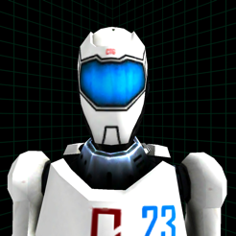  A.L.E.X
 | Little Red Coding club
Useful apps | Google Earth |  | Epic Reading app. | AR-Kid Space.
Computing
Supplemental/After School Computer Club Lessons

KS1
iPad Apps | 1 | 2 | 3 | 4 | 5 | 6 | 7
Topic | Coding: Algorithms | Coding: Algorithms | Coding: Algorithms | Coding: Algorithms | Coding: Algorithms | Coding: Algorithms | Coding: Algorithms
Lesson | Kodable | Kodable | Kodable | Kodable | Introduction to Lightbot | Lightbot: Procedures | Lightbot: Procedures
LO | To use directional instructions to create algorithms to solve puzzles.  To learn the team DEBUGGING and how we fix code. |  | To understand the IF condition.  To understand the repeat function.  To understand the procedure function |  | Plan and develop algorithms  To solve problems by splitting them into smaller parts. | To understand one block (instruction) can run multiple other blocks (instructions) | To understand one block (instruction) can run multiple other blocks (instructions)
Planning | Kodable Online  Create Free Kobable Classroom codes HERE.  Lesson Plans |  |  |  | Planning Introduction  Lightbot levels 1-1 to 1-8  Lightbot Online | Lightbot levels 2-1 to 2-6 | Lightbot levels 3-1 to

LKS2
 | Scratch | 1 |  | 2 | 3 |  | 4 | 5 | 6 | 7
 | Topic | Coding: |  | Coding: | Coding: |  | Coding: | Coding: | Coding: | Coding:
 | Lesson | Movement bounce and forever. |  | X and Y | If, repeat and Random |  | Variables 1 | Variables 2 | Music | Presentation
 | LO | To understand how to create simple movement with blocks.  Bounce on edge.  How to make sprites to follow the mouse pointer. |  | To understand the 2 axis of the workspace.  To understand what minus numbers do to code.  To move the spite using direction code. | To create a sprite that is computer controlled.  To use the random value.  To use the wait function and the hide and show blocks.  To use the if button to code the sprites to complete code when a criteria has been fulfilled. (one sprite touching another) |  | To understand the meaning of a variable.  To be able to use variables for a game score, and other values.  How to copy code from one sprite to another.  To play test the game and debug any problems |  | To create a music file.  To export the music file.  To import the music file to our program. | To create a title screen and a game over screen.  Code the game so these appear when needed.  Code the sprites to hide and show when needed to not obscure the new screens.
 | Planning | PowerPoint (Fish Level) Slides 1-4  LINK YouTube |  | PowerPoint (Fish Level) Slides 5-6  LINK YouTube | PowerPoint (Fish Level) Slides 7-9 |  | PowerPoint (Fish Level) Slides 10 -16 |  | PowerPoint (Fish Level) Slides 17 – 18  LINK BeepBox | PowerPoint (Fish Level) Slides 18 – 20

.
UKS2
Kodu | 1 | 2 | 3 | 4 | 5 | 6 | 7
Topic
Lesson
LO
Planning

Home Learning – Coding
Or Click HERE

