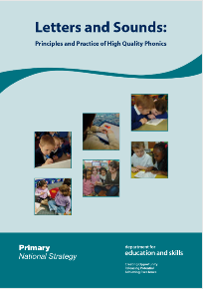

*Application of phonics (both encoding and decoding) will be supported through authentic and purposeful writing tasks in daily Power of Reading sessions.

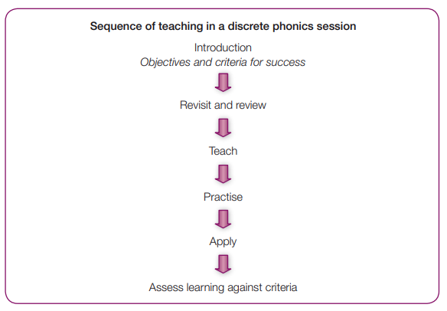

Monday
Spellings
Tuesday
*Phoneme/Grapheme
Wednesday
*Phoneme/Grapheme
Thursday
*Phoneme/Grapheme
Friday
Reading High Frequency Words

*The split vowel digraphs and alternative pronunciation will be taught over two days.

Note: Daily alphabet will happen at the start of every English and SPaG lesson, helping with language for learning e.g. consolidation of grapheme, phoneme, vowel, consonant etc.
Autumn 1
Phase 3/4 consolidation and Phase 5a
Autumn 1  Week 1 | Recall all GPC’s from phase 3 and 4 and learnt high frequency words  Phase 3/4 assessment point
Autumn 1  Week 2 | Recall all GPC’s from phase 3 and 4 and learnt high frequency words  Phase 3/4 assessment point
Autumn1  Week 3 | Consolidate and practice of phase 3 letters/sounds ch sh th ng (consonant diagraphs)*  Consolidate and practice of phase 3 letters/sounds ai ee igh oa oo/oo (vowel digraphs)*  Practice blending for reading p.113  Revisit learning to read high frequency words p.118 said so have like some come  *other letters/sound can be revisited based off assessment
Autumn 1  Week 4 | Consolidate and practice of phase 3 letters/sounds ar or ur ow oi ear air ure er (vowel digraphs) *  Practise reading two-syllable words p.121  Revisit reading of phase 4 high frequency words p.119 were there little one do when out what  *other letters/sound can be revisited based off assessment
Autumn 1  Week 5 | Recall all GPC’s from Phase 3 and HFWs daily  Spellings:  Learn and practise letter/sounds: ay ou ie p.134  Teach to read High Frequency Words: oh their p.140
Autumn 1  Week 6 | Recall all GPC’s from Phase 3 learnt graphemes and HFWs daily  Spellings:  Learn and practise letter/sounds: ea oy ir p.134  Teach to read High Frequency Words: people p.140
Autumn 1  Week 7 | Recall all GPC’s from Phase 3, learnt graphemes and HFWs daily  Spellings:  Learn and practise letter/sounds: ue aw p.134  Teach to read High Frequency Words: Mr Mrs p.140
Autumn 1  Week 8 | Recall all GPC’s from Phase 3, learnt graphemes and HFWs daily  Spellings:  Learn and practise letter/sounds: wh ph ew p.134  Teach to read High Frequency Words: looked called asked p.140  RAG – Phonics screening

Autumn 2
Phase 5a
Autumn 2  Week 1 | Recall all GPC’s from Phase 3, learnt graphemes and HFWs daily  Spellings:  Consolidate all sounds learnt in Autumn 1  Consolidate all High Frequency Words learnt in Autumn 1
Autumn2  Week 2 | Recall all GPC’s from Phase 3, learnt graphemes and HFWs daily  Spellings:  Learn and practise letter/sounds: oe au a_e p.134  Teach to read High Frequency Words: water where who p.140
Autumn 2  Week 3 | Recall all GPC’s from Phase 3, learnt graphemes and HFWs daily  Spellings:  Learn and practise letter/sounds: a_e e_e p.134  Teach to read High Frequency Words: thought through p.140
Autumn 2  Week 4 | Recall all GPC’s from Phase 3, learnt graphemes and HFWs daily  Spellings:  Learn and practise letter/sounds: i_e o_e p.134  Teach to read High Frequency Words: again any many p.140
Autumn 2  Week 5 | Recall all GPC’s from Phase 3, learnt graphemes and HFWs daily  Spellings:  Learn and practise letter/sounds: o_e u_e p.134  Teach to read High Frequency Words: work mouse eyes p.140
Autumn 2  Week 6 | Recall all GPC’s from phase 3 and 5 and learnt high frequency words  Learn and practise new phoneme zh where the ‘s’ is making the sound e.g. treasure  Consolidate all learnt High Frequency Words  RAG – Phonics screening
Autumn 2  Week 7 | Recall all GPC’s from phase 3 and 5 and learnt high frequency words  Phase 5a assessment point
Spring 1
Phase 5b
Spring 1  Week 1 | Recall all GPC’s from Phase 3, learnt graphemes and HFWs daily  Consolidate all learnt High Frequency Words  Phase 5a assessment point
Spring 1  Week 2 | Recall all GPC’s from Phase 3, 5a and HFWs daily  Spellings:  Learn and practise alternative pronunciation: a e p.152  Teach to read High Frequency Words: laughed because different p.141
Spring 1  Week 3 | Recall all GPC’s from Phase 3, 5a and HFWs daily  Point to the letters in the alphabet while singing alphabet song p80 twice weekly  Spellings:  Learn and practise alternative pronunciation: e i p.152/53  Teach to read High Frequency Words: friends once please p.141
Spring 1  Week 4 | Recall all GPC’s from Phase 3, 5a and HFWs daily  Point to the letters in the alphabet while singing alphabet song p80 twice weekly  Spellings:  Learn and practise alternative pronunciation: o u p.152/53  Consolidation reading HFWs
Spring 1  Week 5 | Recall all GPC’s from Phase 3, 5a and HFWs daily  Point to the letters in the alphabet while singing alphabet song p80 twice weekly  Spellings:  Learn and practice alternative pronunciation: u ow p.152/53  Consolidation reading HFWs
Spring 1  Week 6 | Recall all GPC’s from Phase 3, 5a and HFWs daily  Point to the letters in the alphabet while singing alphabet song p80 twice weekly  Spellings:  Learn and practise alternative pronunciation: ie ea p.153  Consolidation reading HFWs

Spring 2
Phase 5b
Spring 2  Week 1 | Recall all GPC’s from Phase 3, 5a and HFWs daily  Point to the letters in the alphabet while singing alphabet song p80 twice weekly  Spellings:  Learn and practise alternative pronunciation: ea p.153  Consolidation learnt alternative pronunciation and reading HFWs
Spring 2  Week 2 | Recall all GPC’s from Phase 3, 5a and HFWs daily  Point to the letters in the alphabet while singing alphabet song p80 twice weekly  Spellings:  Learn and practise alternative pronunciation: er ou p.153  Consolidation reading HFWs
Spring 2  Week 3 | Recall all GPC’s from Phase 3, 5a and HFWs daily  Point to the letters in the alphabet while singing alphabet song p80 twice weekly  Spellings:  Learn and practise alternative pronunciation: ou y p.153  Consolidation reading HFWs
Spring 2  Week 4 | Recall all GPC’s from Phase 3, 5a and HFWs daily  Point to the letters in the alphabet while singing alphabet song p80 twice weekly  Spellings:  Learn and practise alternative pronunciation: ch c p.153  Consolidation reading HFWs
Spring 2  Week 5 | Recall all GPC’s from Phase 3, 5a and HFWs daily  Point to the letters in the alphabet while singing alphabet song p80 twice weekly  Spellings:  Learn and practise alternative pronunciation: c g p.153  Consolidation reading HFWs

Summer 1

Summer 1  Week 1 | Recall all GPC’s from Phase 3, 5a and HFWs daily  Point to the letters in the alphabet while singing alphabet song p80 twice weekly  Spellings:  Learn and practise alternative pronunciation: ey p.153  Consolidation learnt alternative pronunciation and reading HFWs  RAG – Phonics screening
Spring 2  Week 2 | Recall all GPC’s from Phase 3, 5a and HFWs daily  Point to the letters in the alphabet while singing alphabet song p80 twice weekly  Consolidate all learnt High Frequency Words  Phase 5a including alternative pron. assessment point
Summer 1  Week 3 | Recall all GPC’s from Phase 3, 5a and HFWs daily  Point to the letters in the alphabet while singing alphabet song p80 twice weekly  Consolidate all learnt High Frequency Words  Phase 5a including alternative pron. assessment point
Summer 1  Week 4 | *Phonic application – plugging gaps ready for the phonics screening.
Summer 1

Week 5
Summer 1
Week 6
Summer 1
Week 7

Summer 2
Summer 2

Week 1
Summer 2  Week 2 | Phonics screening -
Summer 2  Week 3 | *Phonic application – Preparing for Year 2.
Summer 2

Week 4
Summer 2

Week 5
Summer 2

Week 6
Summer 2

Week 7
Summer 2
Week 8

*Children who achieve ‘pass’ will continue to engage in phonic activities and a wide range of reading which will help them to master early reading.

They will also work on Year 1 spelling patterns and High Frequency Words that should be mastered in order to access Year 2.

Children who did not pass will continue phonic sessions with a robust individualised plan.

