Stakesby Music
Overview and Vocabulary

Scheme Overview
At Stakesby Academy we have taken the decision to use the Charanga Music School Scheme of learning in Music.
The scheme provides teachers with week-by-week lesson support for each year group in the school. It is ideal for specialist and non-specialist teachers and provides lesson plans, assessment, clear progression, and engaging and exciting whiteboard resources to support every lesson. The Scheme supports all the requirements of the national curriculum. In line with the curriculum for music and guidance from Ofsted, this Scheme moves away from the previous levels and learning objective/outcome concepts to an integrated, practical, exploratory and child-led approach to musical learning. Ofsted have stated that “We will not always know the learning outcomes” so segregated learning objectives at the start of each lesson are not appropriate. Instead the interrelated dimensions of music weave through the units to encourage the development of musical skills as the learning progresses through listening and appraising, differing musical activities (including creating and exploring) and performing.
How the Scheme is structured
Each Unit of Work comprises the of strands of musical learning which correspond with the national
curriculum for music:
1. Listening and Appraising
2. Musical Activities
a. Warm-up Games
b. Optional Flexible Games
c. Singing
d. Playing instruments
e. Improvisation
f. Composition
3. Performing

Charanga Musical School Units of Work enable children to understand musical concepts through a repetition-based approach to learning. Learning about the same musical concept through different musical activities enables a more secure, deeper learning and mastery of musical skills. Musical teaching and learning is not neat or linear. The strands of musical learning, presented within the lesson plans and the on-screen resources, are part of the learning spiral. Over time,
children can both develop new musical skills and concepts, and re-visit established musical skills and concepts. Repeating a musical skill doesn’t necessarily mean their progress is slowing down or their development is moving backwards! It's just shifting within the spiral. Mastery means both a deeper understanding of musical skills and concepts and learning something new.

Key things to do
Each lesson is broken into three specific stages and the cycle should follow this throughout the school
Listen and Appraise
The children listen to range of music from different genres and time periods then discuss the pieces they hear.
2. Musical Activities
All activities are based around a song.
a. Games embed the Interrelated Dimensions of Music through repetition
b. Singing is at the heart of all the musical learning
c. Playing instruments with the song to be learnt – tuned/un-tuned classroom percussion and
an option to play any band instrument. A sound-before-symbol approach is used but
scores are provided as an understanding of notation is introduced to the children
d. Improvising with the song using voices and instruments occurs in some Units of Work
e. Composing with the song using instruments occurs in some Units of Work
3. Perform/Share
Share what has taken place during the lesson and work towards performing to an audience.

Scheme overview
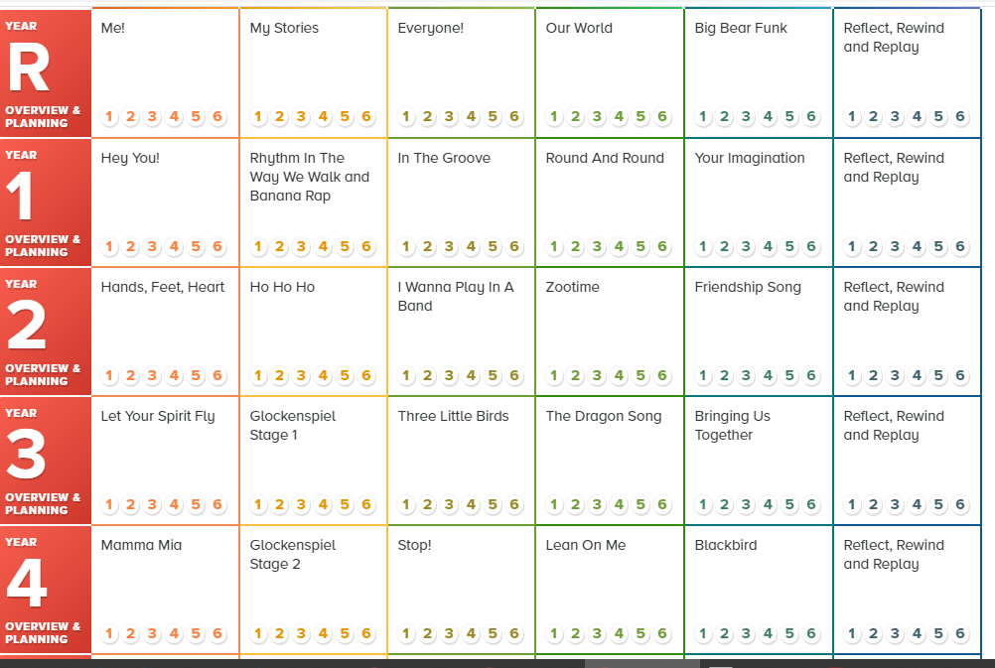

Key Vocabulary What are the essential words that all children must know and be able to explain
R | Pulse, rhythm, pitch, rap, clap, compose, melody, instrument, bass guitar, drums, decks, perform, singers, keyboard, percussion, trumpets, saxophones, pulse, rhythm, pitch, groove, audience, imagination
1 | Pulse, rhythm, pitch, rap, improvise, compose, melody, bass guitar,  drums, decks, perform, singers, keyboard, percussion, trumpets, saxophones, Blues, Baroque,  Latin, Irish Folk, Funk, pulse, rhythm, pitch, groove, audience, imagination
2 | Keyboard, drums, bass, electric guitar, saxophone, trumpet, pulse,  rhythm, pitch, improvise, compose, audience, question and answer, melody, dynamics, tempo,  perform/performance, audience, rap, Reggae, glockenspiel.
3 | Structure, intro/introduction, verse, chorus, improvise, compose, pulse, rhythm,  pitch, tempo, dynamics, bass, drums, guitar, keyboard, synthesizer, hook, melody, texture,  structure, electric guitar, organ, backing vocals, hook, riff, melody, Reggae, pentatonic scale,  imagination, Disco.
4 | Keyboard, electric guitar, bass, drums, improvise, compose, melody, pulse,  rhythm, pitch, tempo, dynamics, texture, structure, compose, improvise, hook, riff, melody,  solo, pentatonic scale, unison, rhythm patterns, musical style, rapping, lyrics, choreography,  digital/electronic sounds, turntables, synthesizers, by ear, notation, backing vocal, piano,  organ, acoustic guitar, percussion, birdsong, civil rights, racism, equality.
5 | Rock, bridge, backbeat, amplifier, chorus, bridge, riff, hook, improvise, compose,  appraising, Bossa Nova, syncopation, structure, Swing, tune/head, note values, note names,  Big bands, pulse, rhythm, solo, ballad, verse, interlude, tag ending, strings, piano, guitar, bass,  drums, melody, cover, Old-school Hip Hop, Rap, riff, synthesizer, deck, backing loops, Funk,  scratching, unison, melody, cover, pitch, tempo, dynamics, timbre, texture, Soul, groove, riff,  bass line, brass section, harmony, melody
6 | style indicators, melody, compose, improvise, cover, pulse, rhythm, pitch, tempo,  dynamics, timbre, texture, structure, dimensions of music, Neo Soul, producer, groove,  Motown, hook, riff, solo, Blues, J azz, improvise/ improvisation, by ear, melody, riff, solo,  ostinato, phrases, unison, Urban Gospel, civil rights, gender equality, unison, harmony.

