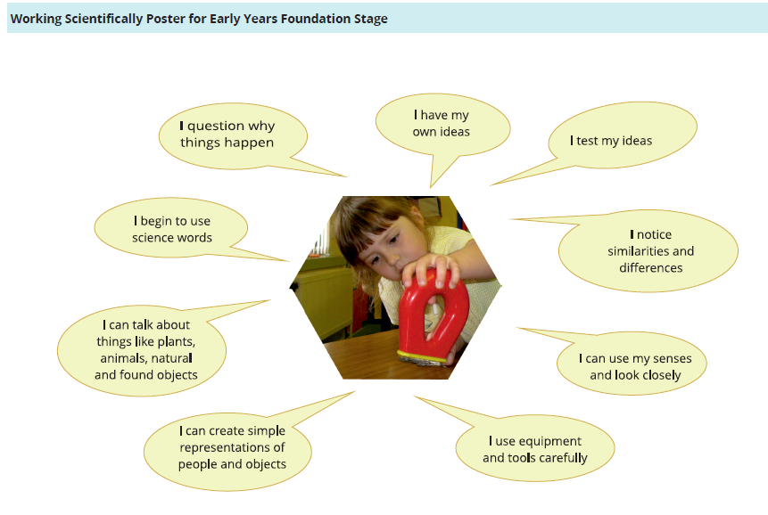
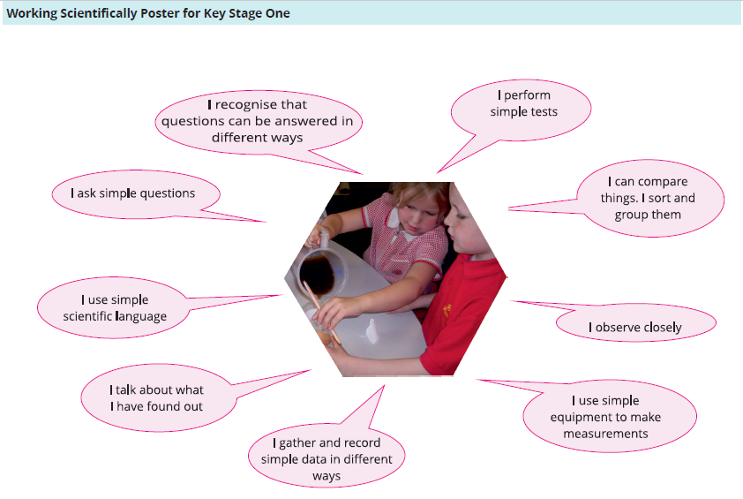
Stakesby Primary Academy
SCIENCE CURRICULUM OVERVIEW
Year 1 – 2020-21
National Curriculum objectives | Science Progression of skills Year 1
Topics/Knowledge to be covered | Suggested working scientifically approaches | Essential Vocabulary – displayed, used, read, spelt
Plants  - identify and name a variety of common wild and garden plants, including deciduous and evergreen trees  - identify and describe the basic structure of a variety of common flowering plants, including trees. | Pupils might work scientifically by: observing closely, perhaps using magnifying glasses, and comparing and contrasting familiar plants; describing how they were able to identify and group them, and drawing diagrams showing the parts of different plants including trees. Pupils might keep records of how plants have changed over time, for example the leaves falling off trees and buds opening; and compare and contrast what they have found out about different plants | 5 Local common wild flowers 5 local common trees 5 local common garden plants  leaf/leaves, flower (blossom), petal, fruit (berry), root (bulb), seed, trunk, branch, stem, bark
Animals, including Humans  - identify and name a variety of common animals including fish, amphibians, reptiles, birds and mammals  - identify and name a variety of common animals that are carnivores, herbivores and omnivores  - describe and compare the structure of a variety of common animals (fish, amphibians, reptiles, birds and mammals, including pets)  - identify, name, draw and label the basic parts of the human body and say which part of the body is associated with each sense. | Pupils might work scientifically by: using their observations to compare and contrast animals at first hand or through videos and photographs, describing how they identify and group them; grouping animals according to what they eat; and using their senses to compare different textures, sounds and smells  Investigation suggestions:  Something associated with the children themselves.  Who is the fastest runner? Who can jump the furthest? | fish, amphibian, reptiles, birds, mammals  (3 common examples of each)  carnivore, herbivores, omnivores  Human body parts incl, elbows, eyebrows, eyelashes, tongue, ankle, chest, shoulders, wrist  Animal parts incl tail, wing, claw, fin, scales, feathers, fur, beak  sight, hearing, touch, smell, taste
Everyday Materials  - distinguish between an object and the material from which it is made  - identify and name a variety of everyday materials, including wood, plastic, glass, metal, water, and rock  - describe the simple physical properties of a variety of everyday materials  - compare and group together a variety of everyday materials on the basis of their simple physical properties. | Pupils might work scientifically by: performing simple tests to explore questions, for example: ‘What is the best material for an umbrella? ...for lining a dog basket?  ...for curtains? ...for a bookshelf? ...for a gymnast’s leotard?’  Why is a chocolate fireguard no use? Or a window made of wood? Or a table made of wool?  Investigation suggestions:  Devise questions based around a property – strongest, stretchiest, | wood, plastic, glass, metal, rock  hard, soft, rough, smooth, shiny, dull  stretchy, stiff, bendy/floppy, waterproof, absorbent, rubber, paper, wool, clay, see through, not see through
Seasonal Changes  - observe changes across the four seasons  - observe and describe weather associated with the seasons and how day length varies. | Pupils might work scientifically by: making tables and charts about the weather; and making displays of what happens in the world around them, including day length, as the seasons change. Note: Pupils should be warned that it is not safe to look directly at the Sun, even when wearing dark glasses. | Season, spring, summer, autumn, winter  weather, cloud/cloudy, wind/windy, thunder, lightning  hot/warm, cool/cold, sun/sunny, rain/rainy, snow/snowing, hail/hailing, sleet, frost, fog/mist, ice/icy, rainbow, , storm

Stakesby Primary Academy
SCIENCE CURRICULUM OVERVIEW
Year 2 – 2020-21
National Curriculum objectives | Science Progression of skills Year 2
Topics/Knowledge to be covered | Suggested working scientifically approaches | Essential Vocabulary – displayed, used, read, spelt
Living Things and their Habitats  - explore and compare the differences between things that are living, dead, and things that have never been alive  - identify that most living things live in habitats to which they are suited  - describe how different habitats provide for the basic needs of different kinds of animals and plants, and how they depend on each other  - identify and name a variety of plants and animals in their habitats, including micro-habitats  - describe how animals obtain their food from plants and other animals  - understand a simple food chain and identify and name different sources of food. | Pupils might work scientifically by: sorting and classifying things according to whether they are living, dead or were never alive, and recording their findings using charts. They should describe how they decided where to place things, exploring questions for example: ‘Is a flame alive? Is a deciduous tree dead in winter?’ and talk about ways of answering their questions. They could construct a simple food chain that includes humans (e.g. grass, cow, human). They could describe the conditions in different habitats and micro-habitats (under log, on stony path, under bushes) and find out how the conditions affect the number and type(s) of plants and animals that live there. | Living, dead, never been alive  Name 3 local habitats – eg pond, woodland, beach  Name 3 micro-habitats – eg under log, stony path, under bush  damp/wet/dry, dark/light, hot/warm/cool/cold  use comparatives e.g. hotter  food-chain, predator, prey, depends on  evergreen, deciduous
Plants  - observe and describe how seeds and bulbs grow into mature plants  - find out and describe how plants need water, light and a suitable temperature to grow and stay healthy. | Pupils might work scientifically by: observing and recording, with some accuracy, the growth of a variety of plants as they change over time from a seed or bulb, or observing similar plants at different stages of growth; setting up a comparative test to show that plants need light and water to stay healthy. | seed, bulb, grow/growth, healthy  shoot, seedling, soil, earth  wither/limp, die, dry/crispy,
Uses of Everyday Materials  - identify and compare the suitability of a variety of everyday materials, including wood, metal, plastic, glass, brick, rock, paper and cardboard for particular uses  - find out how the shapes of solid objects made from some materials can be changed by squashing, bending, twisting and stretching. | Pupils might find out about people who have developed useful new materials, for example John Dunlop, Charles Macintosh or John McAdam.  Pupils might work scientifically by: comparing the uses of everyday materials in and around the school with materials found in other places (at home, the journey to school, on visits, and in stories, rhymes and songs); observing closely, identifying and classifying the uses of different materials, and recording their observations.  Investigation suggest: Devise questions based around a property eg strongest | object, material, property, fabric  rigid, flexible, waterproof, absorbent, opaque, transparent  twist/twisting, squash/squashing  bend/bending, stretch/stretching
Animals including Humans  - notice that animals, including humans, have offspring which grow into adults  - find out about and describe the basic needs of animals, including humans, for survival (water, food and air)  - describe the importance for humans of exercise, eating the right amounts of different types of food, and hygiene. | Pupils might work scientifically by: observing, through video or first-hand observation and measurement, how different animals, including humans, grow; asking questions about what things animals need for survival and what humans need to stay healthy; and suggesting ways to find answers to their questions. | offspring  baby/toddler/child/teenager/adult  survival, exercise, hygiene, breathing  health/healthy

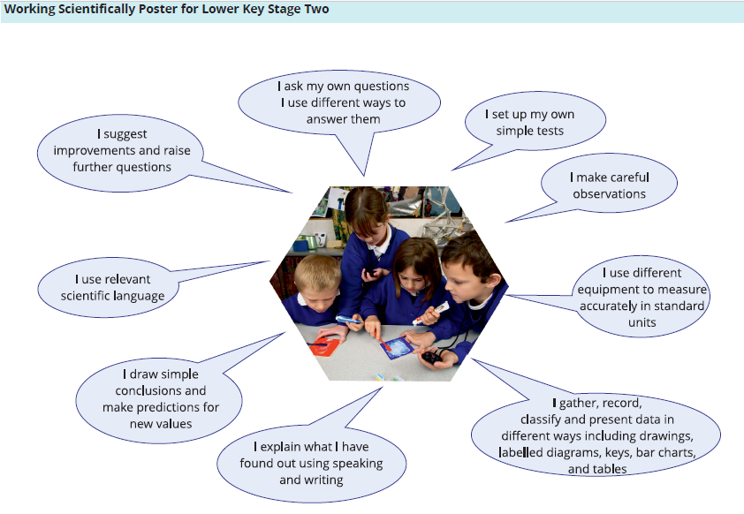

Stakesby Primary Academy
SCIENCE CURRICULUM OVERVIEW Year 3 2020-21
National Curriculum objectives | Science Progression of skills Year 3
Topics/Knowledge to be covered | Suggested working scientifically approaches | Essential Vocabulary – displayed, used, read, spelt
Plants  - identify and describe the functions of different parts of flowering plants: roots, stem/trunk, leaves and flowers  - explore the requirements of plants for life and growth (air, light, water, nutrients from soil, and room to grow) and how they vary from plant to plant  - investigate the way in which water is transported within plants  - explore the part that flowers play in the life cycle of flowering plants, including pollination, seed formation and seed dispersal.  - know that plants make their own food | Pupils might work scientifically by: comparing the effect of different factors on plant growth, for example, the amount of light, the amount of fertiliser; discovering how seeds are formed by observing the different stages of plant life cycles over a period of time; looking for patterns in the structure of fruits that relate to how the seeds are dispersed. They might observe how water is transported in plants, for example, by putting cut, white carnations into coloured water and observing how water travels up the stem to the flowers. | Nutrition, nutrients, soil, fertiliser  life-cycle  pollination, seed-formation, seed-dispersal, germination
Animals including Humans  - identify that animals, including humans, need the right types and amount of nutrition, and that they cannot make their own food; they get nutrition from what they eat  - identify that humans and some animals have skeletons and muscles for support, protection and movement. | Pupils might work scientifically by: identifying and grouping animals with and without skeletons and observing and comparing their movement; exploring ideas about what would happen if humans did not have skeletons. They might compare and contrast the diets of different animals (including their pets) and decide ways of grouping them according to what they eat. They might research different food groups and how they keep us healthy and design meals based on what they find out. | Nutrients, carbohydrates, protein, vitamins and minerals, fat, dietary fibre  nutrition, balanced diet  skeleton, skull, ribs, spine, joints, sockets, bones tendons, muscles, protection, movement, support vertebra
Rocks  - compare and group together different kinds of rocks (including those in the locality) on the basis of appearance and simple physical properties  - describe in simple terms how fossils are formed when things that have lived are trapped within rock  - recognise that soils are made from rocks and organic matter | Pupils might work scientifically by: observing rocks, including those used in buildings and gravestones, and exploring how and why they might have changed over time; using a hand lens or microscope to help them to identify and classify rocks according to whether they have grains or crystals, and whether they have fossils in them. Pupils might research and discuss the different kinds of living things whose fossils are found in sedimentary rock and explore how fossils are formed. Pupils could explore different soils and identify similarities and differences between them and investigate what happens when rocks are rubbed together or what changes occur when they are in water. They can raise and answer questions about the way soils are formed. | fossils, grains, crystals  marble, chalk, granite, sandstone, slate  pebble, boulder  sandy soil, clay soil, chalky soil  absorbent/absorb , non-absorbent
Light  - recognise that they need light in order to see things and that dark is the absence of light  - notice that light is reflected from surfaces  - recognise that light from the sun can be dangerous and that there are ways to protect their eyes  - recognise that shadows are formed when the light from a light source is blocked by a solid object  - find patterns in the way that the size of shadows change. | Pupils might work scientifically by: looking for patterns in what happens to shadows when the light source moves or the distance between the light source and the object changes. | Light (scientifically) light source,  names of light sources, incl laser  reflect/reflective/reflection  shadow, block, direct/ direction  transparent, opaque, translucent
Forces and Magnets  - compare how things move on different surfaces  - notice that some forces need contact between two objects, but magnetic forces can act at a distance  - observe how magnets attract or repel each other and attract some materials and not others  - compare and group together a variety of everyday materials on the basis of whether they are attracted to a magnet, and identify some magnetic materials  - describe magnets as having two poles  - predict whether two magnets will attract or repel each other, depending on which poles are facing. | Pupils might work scientifically by: comparing how different things move and grouping them; raising questions and carrying out tests to find out how far things move on different surfaces and gathering and recording data to find answers their questions; exploring the strengths of different magnets and finding a fair way to compare them; sorting materials into those that are magnetic and those that are not; looking for patterns in the way that magnets behave in relation to each other and what might affect this, for example, the strength of the magnet or which pole faces another; identifying how these properties make magnets useful in everyday items and suggesting creative uses for different magnets. | Force,  push/pushing, pull/pulling  magnetic force, attract, repel, north pole, south pole, magnetic field, strength  types of magnet - bar, ring, button, horseshoe,  magnetic material, metal, iron, steel  non-magnetic material

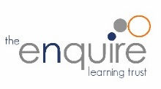
Stakesby Primary Academy
SCIENCE CURRICULUM OVERVIEW Year 4 – 2020-21
National Curriculum objectives | Science Progression of skills Year 4
Topics/Knowledge to be covered | Suggested working scientifically approaches | Essential Vocabulary – displayed, used, read, spelt
Living things and their Habitats  - recognise that living things (including those in the locality) can be grouped in a variety of ways  - explore and use classification keys to help group, identify and name a variety of living things in their local and wider environment  - recognise that environments can change and that this can sometimes pose dangers to living things. | Pupils might work scientifically by: using and making simple guides or keys to explore and identify local plants and animals; making a guide to local living things; raising and answering questions based on their observations of animals and what they have found out about other animals that they have researched. | (from Y1)fish, amphibian, reptiles, birds, mammals  classification keys  vertebrates, invertebrates, insects, molluscs  names of invertebrates from different families  environment, habitat, human impact
Animals including Humans  - describe the simple functions of the basic parts of the digestive system in humans  - identify the different types of teeth in humans and their simple functions  - construct and interpret a variety of food chains, identifying producers, predators and prey. | Pupils might work scientifically by: comparing the teeth of carnivores and herbivores and suggesting reasons for differences; finding out what damages teeth and how to look after them. They might draw and discuss their ideas about the digestive system and compare them with models or images. | (from Y2) carnivore, herbivore, omnivore, predator, prey, food chain  producer, consumer  digestive system, canine, incisor, molar, pre-molar  saliva, oesophagus (gullet), stomach, small intestine, large intestine, rectum, anus
States of Matter  - explore a variety of everyday materials and develop simple descriptions of the states of matter  - compare and group materials together, according to whether they are solids, liquids or gases  - observe that some materials change state when they are heated or cooled, and measure or research the temperature at which this happens in degrees Celsius (°C)  - identify the part played by evaporation and condensation in the water cycle and associate the rate of evaporation with temperature. | Pupils might work scientifically by: grouping and classifying a variety of different materials; exploring the effect of temperature on substances such as chocolate, butter, cream (for example, to make food such as chocolate crispy cakes and ice-cream for a party). They could research the temperature at which materials change state, for example, when iron melts or when oxygen condenses into a liquid. They might observe and record evaporation over a period of time, for example, a puddle in the playground or washing on a line and investigate the effect of temperature on washing drying or snowmen melting. | solid, liquid, gas,  states of matter, change state  temperature, freeze, melt, boil  heat/heating, cool/cooling, degrees Celsius, melting point, boiling point  evaporate/evaporation, condense/condensation  water cycle
Sound  - identify how sounds are made, associating some of them with something vibrating  - recognise that vibrations from sounds travel through a medium to the ear  - find patterns between the pitch of a sound and features of the object that produced it  - find patterns between the volume of a sound and the strength of the vibrations that produced it  - recognise that sounds get fainter as the distance from the sound source increases. | Pupils might work scientifically by: finding patterns in the sounds that are made by different objects such as saucepan lids of different sizes or elastic bands of different thicknesses. They might make earmuffs from a variety of different materials to investigate which provides the best insulation against sound. They could make and play their own instruments by using what they have found out about pitch and volume. | sound, sound source, vibrate/vibration, travel, pitch, volume, fainter, muffle, strength of vibrations
Electricity  - identify common appliances that run on electricity  - construct a simple series circuit, identifying/naming its basic parts, including cell, wire, bulb, switch and buzzer  - use their circuits to create simple devices  - draw the circuit as a pictorial representation (not necessarily using conventional circuit symbols)  - about precautions for working safely with electricity.  - identify whether or not a lamp will light in a simple series circuit/  - recognise that a switch opens and closes a circuit and associate this with whether or not a lamp lights in a simple series circuit  - recognise some common conductors and insulators, and associate metals with being good conductors. | Pupils might work scientifically by: observing patterns, for example, that bulbs get brighter if more cells are added, that metals tend to be conductors of electricity, and that some materials can and some cannot be used to connect across a gap in a circuit. | electricity, circuit  appliances/device, electrical circuit, complete circuit, short circuit  cell/battery, wire, connect/connection, bulb, switch, motor vs engine  conductor, insulator

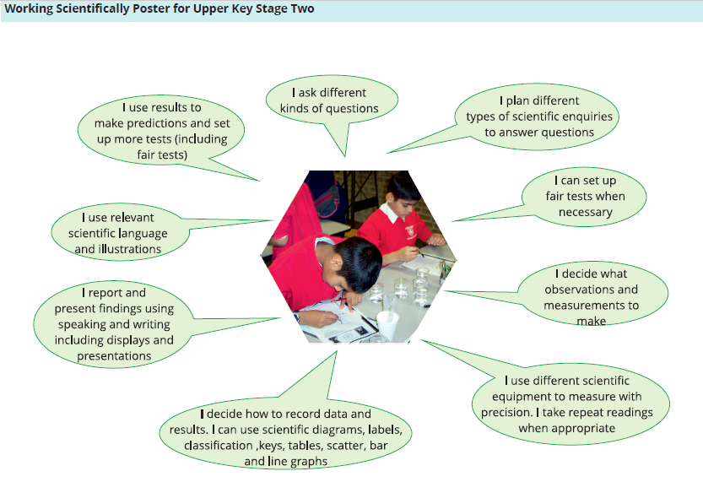
Stakesby Primary Academy
SCIENCE CURRICULUM OVERVIEW Year 5 – 2020-21
National Curriculum objectives | Science Progression of skills Year 5
Topics/Knowledge to be covered | Suggested working scientifically approaches | Essential Vocabulary – displayed, used, read, spelt
Living things and their Habitats  - describe the differences in the life cycles of a mammal, an amphibian, an insect and a bird  - describe the life process of reproduction in some plants and animals.  - raise questions about their local environment throughout the year.  - find out about the work of naturalists and animal behaviourists, for example, David Attenborough and Jane Goodall.  - find out about different types of reproduction, including sexual and asexual reproduction in plants, and sexual reproduction in animals. | Pupils might work scientifically by: observing and comparing the life cycles of plants and animals in their local environment with other plants and animals around the world (in the rainforest, in the oceans, in desert areas and in prehistoric times), asking pertinent questions and suggesting reasons for similarities and differences. They might try to grow new plants from different parts of the parent plant, for example, seeds, stem and root cuttings, tubers, bulbs. They might observe changes in an animal over a period of time (for example, by hatching and rearing chicks), comparing how different animals reproduce and grow. | reproduction, sexual, asexual, larva  life cycle, metamorphosis, live young, chrysalis  (from Y2) germination, seed formation, seed dispersal  (new) pollination, pollen, stamen, stigma
Animals, including Humans  - describe the changes as humans develop to old age.  - draw a timeline to indicate stages in the growth and development of humans.  - learn about the changes experienced in puberty. | Pupils could work scientifically by researching the gestation periods of other animals and comparing them with humans; by finding out and recording the length and mass of a baby as it grows. | foetus, embryo, womb, gestation, elderly,  puberty, hormones, penis, vagina, testicle/testes, ovary/ovaries
Properties and changes of materials  - compare and group together everyday materials on the basis of their properties, including their hardness, solubility, transparency, conductivity (electrical and thermal), and response to magnets  - know that some materials will dissolve in liquid to form a solution, and describe how to recover a substance from a solution  - use knowledge of solids, liquids and gases to decide how mixtures might be separated, including through filtering, sieving and evaporating  - give reasons, based on evidence from comparative and fair tests, for the particular uses of everyday materials, including metals, wood and plastic  - demonstrate that dissolving, mixing and changes of state are reversible changes  - explain that some changes result in the formation of new materials, and that this kind of change is not usually reversible, including changes associated with burning and the action of acid on bicarbonate of soda.  - explore reversible changes, including, evaporating, filtering, sieving, melting and dissolving, recognising that melting and dissolving are different processes.  - explore changes that are difficult to reverse, for example, burning, rusting and other reactions, for example, vinegar with bicarbonate of soda. | Pupils might work scientifically by: carrying out tests to answer questions, for example, ‘Which materials would be the most effective for making a warm jacket, for wrapping ice cream to stop it melting, or for making blackout curtains?’ They might compare materials in order to make a switch in a circuit. They could observe and compare the changes that take place, for example, when burning different materials or baking bread or cakes. They might research and discuss how chemical changes have an impact on our lives, for example, cooking, and discuss the creative use of new materials such as polymers, super-sticky and super-thin materials. | (from Y4) solid, liquid, gas, states of matter, change state  (new) reversible changes, new material, not reversible change  dissolve, solution  soluble, insoluble, solute, solvent  filter, sieve  (from Y4) evaporate/evaporation, condense/condensation  hardness, solubility, electrical conductivity, thermal conductivity, transparency
Earth and Space  - describe the movement of the Earth, and other planets, relative to the Sun in the solar  system  - describe the movement of the Moon relative to the Earth  - describe the Sun, Earth and Moon as approximately spherical bodies  - use the idea of the Earth’s rotation to explain day and night and the apparent  - movement of the sun across the sky.  - learn that the Sun is a star at the centre of our solar system and that it has eight  - planets: Mercury, Venus, Earth, Mars, Jupiter, Saturn,  - Uranus and Neptune (Pluto was reclassified as a ‘dwarf planet’ in 2006).  - understand that a moon is a celestial body that orbits a planet (Earth has one moon;  - Jupiter has four large moons and numerous smaller ones). | Pupils might work scientifically by: comparing the time of day at different places on the Earth through internet links and direct communication; creating simple models of the solar system; constructing simple shadow clocks and sundials, calibrated to show midday and the start and end of the school day; finding out why some people think that structures such as Stonehenge might have been used as astronomical clocks. | planets, moons, stars, solar system  meteors, meteorites, galaxies, universe, axis, rotate/rotation, orbit, revolve/revolution  celestial body, constellation
Forces  - explain that unsupported objects fall towards the Earth because of the force of gravity acting between the Earth and the falling object  - identify the effects of air resistance, water resistance and friction, that act between moving surfaces  - recognise that some mechanisms, including levers, pulleys and gears, allow a smaller force to have a greater effect.  - explore the effects of air resistance by observing how different objects such as parachutes and sycamore seeds fall.  - explore the effects of friction on movement and find out how it slows or stops moving objects.  - find out how scientists, for example, Galileo Galilei and Isaac Newton helped to develop the theory of gravitation. | Pupils might work scientifically by: exploring falling paper cones or cup-cake cases, and designing and making a variety of parachutes and carrying out fair tests to determine which designs are the most effective. They might explore resistance in water by making and testing boats of different shapes. They might design and make products that use levers, pulleys, gears and/or springs and explore their effects. | gravity, air resistance, water resistance, friction  moving surfaces, mechanisms  levers, pulleys, gears, springs  force, transfers

Stakesby Primary Academy
SCIENCE CURRICULUM OVERVIEW 2020-21
National Curriculum objectives | Science Progression of skills Year 6
Topics/Knowledge to be covered | Suggested working scientifically approaches | Essential Vocabulary – displayed, used, read, spelt
Living things and their Habitats  - describe how living things are classified into broad groups according to common observable characteristics and based on similarities and differences, including micro-organisms, plants and animals  - give reasons for classifying plants and animals based on specific characteristics.  - know that broad groupings, such as micro-organisms, plants and animals can be subdivided.  - should classify animals into commonly found invertebrates (such as insects, spiders, snails, worms) and vertebrates (fish, amphibians, reptiles, birds and mammals).  - find out about significance of the work of scientists such as Carl Linnaeus, a pioneer of classification. | Pupils might find out about the significance of the work of scientists such as Carl Linnaeus, a pioneer of classification.  Pupils might work scientifically by: using classification systems and keys to identify some animals and plants in the immediate environment. They could research unfamiliar animals and plants from a broad range of other habitats and decide where they belong in the classification system. | classification keys  (from Y1 and Y4) fish, amphibian, reptiles, birds, mammals (from Y4) vertebrates, invertebrates, insects, molluscs  (new) arachnid, crustacean  organism, micro-organisms  fungus/fungi, algae, bacteria, virus, spores, moulds, lichen, moss
Animals, including Humans  - identify and name the main parts of the human circulatory system, and describe the functions of the heart, blood vessels and blood  - recognise the impact of diet, exercise, drugs and lifestyle on the way their bodies function  - describe the ways in which nutrients and water are transported within animals, including humans.  - explore questions to understand how the circulatory system enables the body to function.  - learn how to keep their bodies healthy and how their bodies might be damaged – including how some drugs and other substances can be harmful to the human body.  - explore the work of scientists and scientific research about the relationship between diet, exercise, drugs, lifestyle and health. | Pupils should learn how to keep their bodies healthy and how their bodies might be damaged – including how some drugs and other substances can be harmful to the human body.  Pupils might work scientifically by: exploring the work of scientists and scientific research about the relationship between diet, exercise, drugs, lifestyle and health. | circulatory system, blood vessels, artery, vein  respiratory system, oxygen, carbon dioxide, lungs  healthy diet, exercise, drugs (vs medicines), respiration, inhalation, exhalation
Evolution and Inheritance  - recognise that living things have changed over time and that fossils provide information about living things that inhabited the Earth millions of years ago  - recognise that living things produce offspring of the same kind, but normally offspring vary and are not identical to their parents  - identify how animals and plants are adapted to suit their environment in different ways and that adaptation may lead to evolution.  - be introduced to the idea that characteristics are passed from parents to their offspring, i.e. different breeds of dogs, and what happens when, for example, labradors are crossed with poodles.  - appreciate that variation in offspring over time can make animals more or less able to survive in particular environments, for example, by exploring how giraffes’ necks got longer.  - find out about the work of palaeontologists such as Mary Anning and about how Charles Darwin and Alfred Wallace developed their ideas on evolution. | Pupils might work scientifically by: observing and raising questions about local animals and how they are adapted to their environment; comparing how some living things are adapted to survive in extreme conditions, for example, cactuses, penguins and camels. They might analyse the advantages and disadvantages of specific adaptations, such as being on two feet rather than four, having a long or a short beak, having gills or lungs, tendrils on climbing plants, brightly coloured and scented flowers. | evolution, adapted/adaptation, characteristics  vary/variation, inherit/inheritance  gene/genetics, DNA

Continued on next page Y6
Light  - recognise that light appears to travel in straight lines  - use the idea that light travels in straight lines to explain that objects are seen because they give out or reflect light into the eye  - explain that we see things because light travels from light sources to our eyes or from light sources to objects and then to our eyes  - use the idea that light travels in straight lines to explain why shadows have the same shape as the objects that cast them.  - work scientifically by: deciding where to place rear-view mirrors on cars; designing and making a periscope and using the idea that light appears to travel in straight lines to explain how it works.  - look at a range of phenomena including rainbows, colours on soap bubbles, objects looking bent in water and coloured filters (they do not need to explain why these phenomena occur). | Pupils might work scientifically by: deciding where to place rear-view mirrors on cars; designing and making a periscope and using the idea that light appears to travel in straight lines to explain how it works. They might investigate the relationship between light sources, objects and shadows by using shadow puppets. They could extend their experience of light by looking a range of phenomena including rainbows, colours on soap bubbles, objects looking bent in water and coloured filters (they do not need to explain why these phenomena occur). | (from Y3) Light (scientifically) light source,  reflect/reflective/reflection  shadow, transparent, opaque, translucent  (new) spectrum, refraction  prism, visible spectrum, infra-red, ultra-violet
Elecricity  - associate the brightness of a lamp or the volume of a buzzer with the number and voltage of cells used in the circuit  - compare and give reasons for variations in how components function, including the brightness of bulbs, the loudness of buzzers and the on/off position of switches  - use recognised symbols when representing a simple circuit in a diagram.  - construct simple series circuits, to help them to answer questions about what happens when they try different components, for example, switches, bulbs, buzzers and motors.  - learn how to represent a simple circuit in a diagram using recognised symbols. | Pupils might work scientifically by: systematically identifying the effect of changing one component at a time in a circuit; designing and making a set of traffic lights, a burglar alarm or some other useful circuit. | (from Y4) electricity, circuit  cell/battery, wire, connect/connection, bulb, switch,  conductor, insulator  circuit diagram, circuit symbol, positive/negative  terminal, voltage, motor vs engine, components,  complete circuit, short circuit

