

St Andrew’s Out of School Clubs

EYFS Oral Health Policy
September 2026

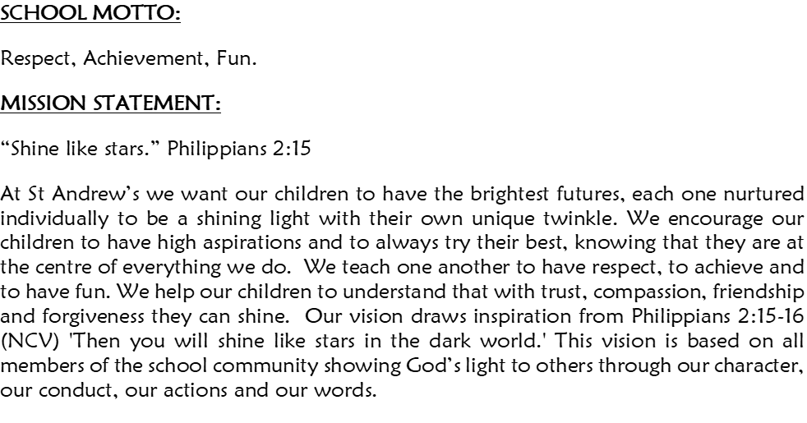

1. Policy Statement
St Andrew’s recognises that good oral health is an important part of children's overall health, wellbeing and development.
Good oral health habits should be established from the earliest age. Healthy teeth and gums support children to eat, drink, speak, smile and participate confidently in everyday activities. Poor oral health and tooth decay can cause pain, infection and difficulties with eating, sleeping, socialising and learning. The Department for Education identifies the promotion of oral health as part of the EYFS requirement for providers to promote children's good health.
St Andrew’s is committed to promoting good oral health through everyday practice, healthy food and drink choices, positive conversations, educational activities and partnership with parents/carers.
The setting recognises that children and families have different experiences, cultures, circumstances and levels of access to dental care. We will promote oral health in an inclusive, sensitive and non-judgemental way.

2. Aims
This policy aims to:
- Promote good oral health from an early age.
- Help children develop positive lifelong oral-health habits.
- Reduce children's exposure to unnecessary sugar.
- Encourage healthy food and drink choices.
- Provide children with age-appropriate knowledge about looking after their teeth.
- Support children to develop independence in oral hygiene.
- Work in partnership with parents/carers to promote good oral health at home.
- Provide information about dental services and sources of support where appropriate.
- Ensure staff understand their responsibilities in promoting oral health.
- Recognise and respond appropriately where a child may be experiencing dental pain or other oral-health concerns.
- Ensure oral-health provision is inclusive and appropriate to children's individual needs.

3. EYFS Requirements
St Andrew’s will meet the requirements of the Early Years Foundation Stage by promoting the good health of children attending the setting, including their oral health.
The current EYFS framework confirms that promoting oral health is part of providers' wider responsibility to promote good health. The DfE's early-years guidance explains that settings can meet this requirement through activities such as talking with children about the effects of sugary foods and the importance of brushing their teeth. The EYFS does not require every setting to provide supervised toothbrushing, although settings may choose to do so where appropriate.
St Andrew’s will provide a range of age-appropriate oral-health education and practical experiences and supervised toothbrushing.

4. Healthy Food and Drink
St Andrew’s will promote healthy choices that support children's overall health and oral health.

Drinks
- Fresh drinking water will be available and easily accessible throughout the session.
- Children will be encouraged to drink water regularly.
- Milk may be provided as an appropriate drink.
- Water and milk will be offered with snacks wherever appropriate.
- Sugary drinks will not normally be provided by the setting.
- Where a sugary drink is provided as part of an agreed individual arrangement, it should be restricted to mealtimes and managed in accordance with the child's individual needs.
- Fruit juice and smoothies will not routinely be provided as drinks at the setting.
- Staff will encourage children to understand that water and plain milk are healthy choices for their teeth.
NHS guidance identifies water and milk as the best drinks for young children and advises avoiding sugary drinks because the sugar can contribute to tooth decay.

Food and snacks
St Andrew’s will:
- Provide healthy and nutritious snacks.
- Avoid unnecessary added sugar in snacks provided by the setting.
- Offer a variety of fruit, vegetables and other nutritious foods.
- Consider the sugar content of food provided to children.
- Avoid using sweets or sugary foods as rewards.
- Encourage children to make healthy choices.
- Talk positively with children about foods that help keep their bodies and teeth healthy.
- Discourage parents/carers from providing confectionery and other high-sugar foods as part of packed lunches.
- Ensure any food provided takes account of children's allergies, dietary requirements and individual needs.
Sugary foods and drinks should be limited and, where consumed, are best offered with meals rather than frequently between meals.

5. Promoting Oral Health Through the Curriculum
Oral-health education will be incorporated naturally into children's learning and everyday experiences.
Staff may:
- Read stories about teeth, dentists, brushing and smiling.
- Sing songs and rhymes about teeth and oral hygiene.
- Use role play, including dentist and doctor's surgery role play.
- Talk about healthy food and drinks.
- Discuss foods that help children grow strong and healthy.
- Encourage children to learn about the importance of brushing their teeth.
- Provide opportunities for children to talk about their experiences of visiting the dentist.
- Use appropriate books, games, visual resources and activities.
- Use resources from recognised oral-health organisations.
- Provide opportunities for children to develop independence in self-care.
- Encourage children to talk about how they look after their teeth at home.
Children should never be made to feel embarrassed or ashamed about the condition of their teeth or their family's circumstances.

6. Toothbrushing
St Andrew’s recognises the importance of twice-daily toothbrushing.
Children and families will be encouraged to establish a consistent toothbrushing routine at home.
St. Andrews provides toothbrushes or toothbrushing activities, these will be managed in accordance with appropriate infection-control, hygiene and safeguarding procedures.
Children may be provided with an individual toothbrush/toothbrushing kit as part of an organised oral-health programme.
Staff will:
- Explain toothbrushing in an age-appropriate and positive way.
- Encourage children to develop independence.
- Demonstrate appropriate brushing techniques through play, modelling and educational activities.
- Encourage children to understand that brushing removes plaque and helps keep teeth healthy.
- Ensure individual toothbrushes are clearly identifiable and are not shared.
- Store toothbrushes hygienically and in accordance with the setting's procedures.
- Replace toothbrushes in accordance with the setting's oral-health arrangements and sooner if damaged.
- Follow relevant guidance for supervised toothbrushing.

7. Dental Visits and Professional Support
St Andrew’s will promote the importance of regular dental care and encourage parents/carers to register their children with a dentist.
Where appropriate, the setting may invite health professionals, dental professionals, school nurses or other appropriately qualified practitioners to provide oral-health education.
Visits may include:
- Talks about healthy teeth.
- Demonstrations of toothbrushing.
- Stories and activities.
- Information for parents/carers.
- Advice about accessing dental services.
Staff will not provide dental advice beyond their level of training and will signpost parents/carers to appropriate health professionals when further advice is required.

8. Dental Pain, Toothache and Concerns
Staff should be alert to signs that a child may be experiencing dental pain or discomfort.
Possible signs may include:
- Complaining of toothache or mouth pain.
- Crying or becoming distressed when eating.
- Avoiding certain foods.
- Difficulty chewing.
- Swelling around the mouth or face.
- Changes in behaviour.
- Difficulty sleeping.
- Increased irritability.
- Sensitivity when eating or drinking.
- A child telling an adult that their tooth or mouth hurts.
If a child appears to be in pain:
- Staff should reassure the child.
- Parents/carers should be informed as soon as reasonably possible.
- The setting should follow its illness and medication procedures.
- Staff must not administer medication unless this is permitted under the setting's Medication Policy and appropriate consent and documentation are in place.
- Parents/carers should be encouraged to seek appropriate dental or medical advice where necessary.
- Any urgent medical concern must be dealt with in accordance with the setting's emergency procedures.

9. Children with Additional Needs
St Andrew’s recognises that some children may need additional support with oral-health routines.
This may include children with:
- SEND.
- Physical disabilities.
- Sensory processing differences.
- Communication difficulties.
- Medical conditions.
- Oral-motor difficulties.
- Anxiety around toothbrushing or dental visits.
Staff will work with parents/carers and relevant professionals to identify appropriate strategies.
Where necessary, an individual plan may be developed to support a child's oral-health needs.
Staff will adapt communication, resources and activities to ensure children can participate as fully as possible.

10. Pacifiers and Dummies
St Andrew’s recognises that dummies can provide comfort and reassurance for some young children, particularly during periods of settling, transition, sleep or distress.
The setting will adopt a sensitive and gradual approach to reducing dummy use.
Dummies will:
- Only be used where appropriate for comfort or sleep.
- Not be used routinely throughout the child's waking day.
- Not be dipped or coated in sugar, honey or any other sweet substance.
- Be stored safely and hygienically when not in use.
- Be returned to the child when appropriate in accordance with their individual needs.
Staff will encourage children to develop alternative methods of comfort and self-regulation.
Where a child is using a dummy during waking hours, staff will:
- Ensure the child knows where their dummy is stored.
- Provide reassurance and comfort when the dummy is put away.
- Explain sensitively, where developmentally appropriate, why the dummy is being stored.
- Offer alternative comfort items such as a teddy, comforter or blanket where appropriate.
- Distract the child with suitable activities.
- Ensure the child is settled before moving on to play.
- Explain when the child can have their dummy again, such as at sleep time or when they go home.
Staff will work in partnership with parents/carers and will provide supportive information about gradually reducing dummy use where appropriate.
NHS-linked guidance advises trying to stop dummy use after around 12 months because prolonged dummy use can affect the development and positioning of teeth and may affect speech.
St Andrew’s will therefore encourage families to reduce dummy use during waking hours as children become older, while recognising that individual children may require a gradual approach.

11. Damaged Dummies
Dummies must be checked regularly for signs of damage.
If a dummy is damaged or unsafe:
- It must not be given back to the child.
- It must be disposed of safely.
- Parents/carers will be informed that the dummy has been disposed of.
- Parents/carers may provide a replacement if they wish.
Staff must never attempt to repair a damaged dummy.

12. Partnership with Parents and Carers
Parents/carers are essential partners in promoting children's oral health.
St Andrew’s will:
- Share information about oral health.
- Provide practical advice and signposting where appropriate.
- Encourage parents/carers to establish good toothbrushing routines at home.
- Encourage regular dental attendance.
- Share information about healthy food and drink choices.
- Discuss concerns sensitively.
- Respect differences in family circumstances, culture and individual needs.
- Avoid judgement or criticism of families.
Information may be shared through:
- Parent/carer meetings.
- ClassDojo or the setting's approved communication system.
- Information leaflets.
- Displays.
- Workshops or events.
- Conversations with the key person.

13. Staff Training
St Andrew’s will ensure that staff have access to appropriate information and training to support their understanding of children's oral health.
Where available, staff will participate in recognised oral-health training and local oral-health initiatives.
Staff should understand:
- The importance of early oral-health habits.
- The relationship between sugar and tooth decay.
- Healthy drink choices.
- The importance of toothbrushing.
- The role of fluoride toothpaste.
- The importance of regular dental care.
- How to promote oral health through everyday learning.
- How to respond appropriately if a child appears to have dental pain.
- When to signpost parents/carers to dental or medical professionals.

14. Equality and Inclusion
Oral-health education will be accessible to all children.
Staff will consider:
- Age and developmental stage.
- SEND.
- Communication needs.
- Cultural and family practices.
- Sensory needs.
- Language needs.
- Physical needs.
- Individual dietary requirements.
Children will not be excluded from oral-health activities because of their additional needs. Activities will be adapted where necessary.

15. Safeguarding
Any concerns relating to a child's welfare, neglect, lack of access to necessary healthcare or other safeguarding concerns must be dealt with in accordance with St Andrew’s Child Protection and Safeguarding Policy.
Poor oral health alone should not automatically be interpreted as evidence of neglect. Staff should consider the child's wider circumstances and seek appropriate guidance from the DSL where concerns arise.
Staff must record and report safeguarding concerns appropriately.

16. Confidentiality
Information about a child's dental health or medical needs will be treated confidentially.
Information will only be shared with staff who need it to care for the child or safeguard their welfare.
Parents/carers will be informed sensitively of any concerns that arise during the child's time at the setting, unless doing so would conflict with safeguarding procedures.

17. Monitoring and Review
The Foundation Stage Leader and Room Managers will monitor the implementation of this policy.
Monitoring will consider:
- Availability of healthy drinks.
- Healthy snack provision.
- Oral-health activities.
- Staff knowledge and training.
- Information provided to parents/carers.
- Children's understanding of healthy choices.
- Appropriate management of dummies.
- Hygiene arrangements for toothbrushing equipment where applicable.
- Inclusion of children with additional needs.
The policy will be reviewed annually or sooner if:
- There are changes to the EYFS statutory framework.
- NHS or public-health recommendations change.
- The setting changes supervised toothbrushing arrangements.
- There are changes to food and drink provision.
- Staff or parents/carers identify a need for amendment.

