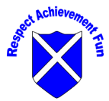

Spanish Subject 2 Year Cycle Overview
Mixed classes follow the two year cycle.

 | Autumn 1 | Autumn 2 | Spring 1 | Spring 2 | Summer 1 | Summer 2
Y3/Y4 CYCLE A | Phonetics lesson 1 and I’m learning Spanish | Seasons | Music Instruments | Fruits | Ice-Cream | Animals
Y3/Y4 CYCLE B | Phonetics lesson 2  And presenting myself | Family | My Home | Classroom | Habitats | Vegetables
Y5 | Phonetics lesson 3  And At the cafe | What is the date? | Do you have a pet? | Clothes | What is the weather? | Traditions and celebrations
Y6 | Phonetics lesson 4 and at school | The weekend | Around town | Habitats | World War 2 | Healthy Lifestyles

