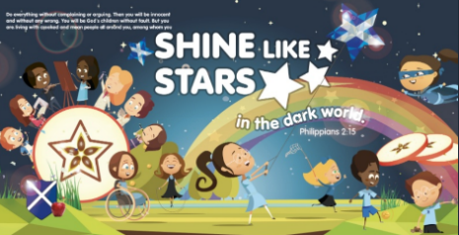


Music

Intent
Music education should engage and inspire pupils to develop a love of music and their talent as musicians, and so increase their self-confidence, creativity and sense of achievement. (Department for Education, National Curriculum)
At St Andrew’s School, our aim is to provide a music curriculum that enables each child to ‘shine like stars’ in music — helping them reach their full potential while developing enjoyment in singing, composing and performing.
We want our curriculum to nurture creativity, self-expression and confidence, while promoting an appreciation of music from different times, places and cultures. Through progressive, high-quality teaching, children develop their ability to listen critically, perform confidently, and compose creatively.
Our music curriculum explores the key elements of music, teaches important vocabulary and builds understanding of how music has evolved throughout history. It provides every child with opportunities to express themselves, collaborate with others and take pride in their musical achievements.
Our intent is for children to leave primary school with the skills, knowledge and enthusiasm to continue exploring music both academically and personally, recognising its power to bring people together and enrich lives.

Implementation
Music is taught through carefully planned, progressive lessons that build on prior learning and develop key musical skills in listening, appraising, composing, and performing. Lessons are sequenced to ensure full National Curriculum coverage and allow children of all abilities to achieve success.
Our whole-class teaching provides engaging, practical experiences that encourage participation, creativity and enjoyment. Children explore a wide range of musical genres, traditions and styles, and use instruments, voice and technology to express their ideas. Teachers model a love of music and promote curiosity through discussion, questioning and active music-making.
Cross-curricular links are planned to reinforce musical understanding within other subjects and wider school life. Opportunities such as singing in assemblies, performing in class, and joining the school choir (Years 3–6) further develop pupils’ confidence and performance skills.
Regular assessment informs future planning and ensures progression in knowledge, vocabulary and practical skills as children move through the school.

Impact
Our music curriculum enables all pupils to develop confidence, creativity and a lifelong love of music. Through high-quality teaching, children build on prior learning and develop their skills in listening, appraising, composing and performing.
Pupils gain a secure understanding of musical elements and vocabulary, appreciate music from different cultures and traditions, and apply their skills across the wider curriculum.
Opportunities such as class performances, Christmas productions and the school choir (Years 3–6) enhance enjoyment and confidence, allowing children to share their achievements and develop teamwork.
By the end of primary school, pupils leave with strong musical knowledge, the ability to express themselves through performance and composition, and an enthusiasm for music that continues beyond school.
Impact is measured through ongoing teacher assessment, pupil voice, performance opportunities and evidence of progression in skills, knowledge and confidence across year groups.

