British Values at St Anne’s

The DfE have reinforced the need “to create and enforce a clear and rigorous expectation on all schools to promote the fundamental British values of democracy, the rule of law, individual liberty and mutual respect and tolerance of those with different faiths and beliefs.”
The Government set out its definition of British values in the 2011 Prevent Strategy, and these values have been reiterated each year. At St Anne’s Primary School- these values are promoted regularly and in the following ways.
Democracy
At St Anne’s, we work really hard to raise the awareness of the UN Convention on the Rights of the Child across our entire school as part of our work as a Bronze Unicef’s Rights Respecting school.
The children’s understanding of their rights has been developed through creating Class Charters. All the children contribute to the drawing up of their bespoke charter.
Children have many opportunities for their voices to be heard- pupil voice- is instrumental in moving our school forward. We have a school council which meets to discuss issues raised in school. They also interviewed and were integral in the appointment of our Head- teacher. The school council members for each year group were voted in by their classmates.

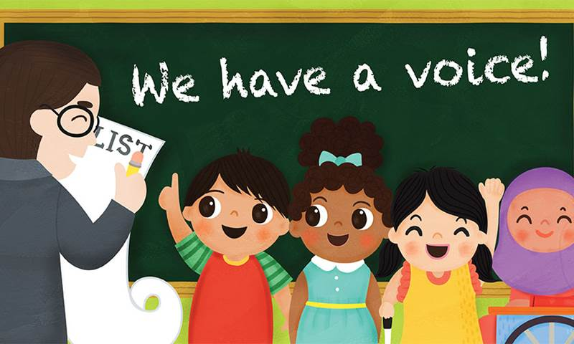

The Rule of Law
The importance of Laws, whether they be those that govern the class, the school, or the country, are consistently reinforced throughout regular school days, as well as when dealing with behaviour and through school assemblies.
Pupils are taught the value and reasons behind laws, that they govern and protect us, the responsibilities that this involves and the consequences when laws are broken. Visits from authorities such as the Police and Fire Service help us to reinforce this message.
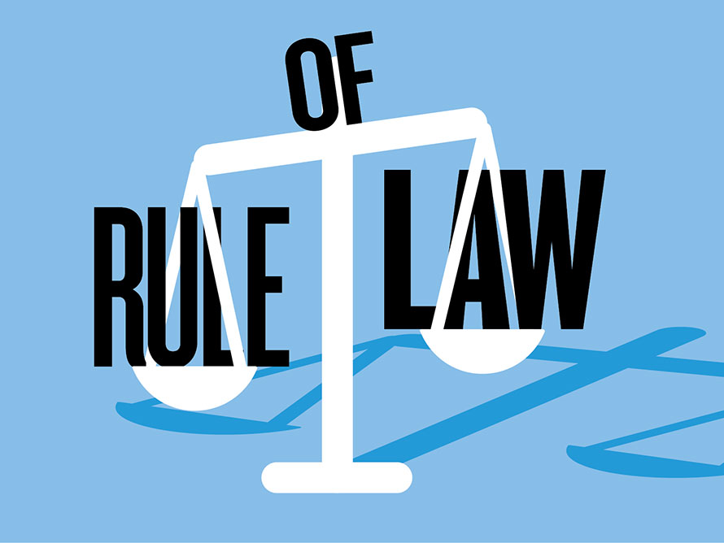

Individual Liberty
Within our school, our pupils are actively encouraged to make choices, knowing that they are in a safe and supportive environment. One of our 3 school expectations is to ‘BE safe ‘and we actively remind the children about the importance of this message. As a school we educate and provide boundaries for pupils to make choices safely, through provision of both a safe environment and empowering education. Our pupils are encouraged to know, understand and exercise their rights and personal freedoms and advised how to exercise these safely, for example through our E-Safety and our PSHE lessons.
Whether it be through choice of learning challenges, what particular interests the children have or deciding the direction of lessons in our curriculum, children are able to express their views. Our Children can also participate in wide and varied enrichment clubs and opportunities- pupils are given the freedom to make choices. 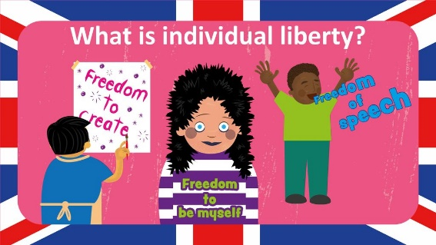

Mutual Respect and Tolerance of those of Different Faiths and Beliefs
As a Rights Respecting School, mutual respect is at the heart of our values. Children learn that their behaviours have an effect on their own rights and those of others. All members of St Anne’s school community treat each other with respect. Another of our school expectations is to be respectful and children are reminded of this expectation throughout the day.
We also seek to embed the UN Convention on the Rights of the Child (CRC) into our curriculum as widely as possible to help our children learn about the diverse world in which we live and the community that we serve here at St Anne’s.
Our Assemblies are regularly planned to address this - either directly or through the inclusion of stories and celebrations from a variety of faiths and cultures. Our RE and PSHE teaching reinforce this.
Our school members of different faiths or religions are readily encouraged to share their knowledge to enhance learning within classes and the school. Children also have the opportunity to visit places of worship that are important to different faiths.

