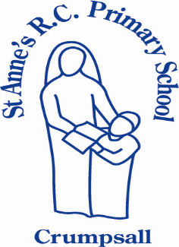

Catholic Life and Religious Education
Policy

Date Policy Created; | January 2023
Policy Created by; | Gemma Shakespeare Regan
Policy Agreed by Governors; | 17th January 2023
To be reviewed; | July 2024
UNCRC (United Nation Convention of the Rights of a Child) Articles included in this policy; | 1, 2, 3, 4, 5, 6, 12, 15, 16, 17, 23, 24, 28, 34, 36 and 39
Our Mission Statement
At St Anne’s RC Primary School, we work together, learn together, play and care together in God’s love to enable each unique person to achieve their full potential.
We aim to meet the needs of every child through a challenging, enriched curriculum, where everyone feels valued and respected. Providing a safe, secure and stimulating learning environment through an inclusive partnership between children, parents, our school, our church and the wider community.

The Catholic Life of Our School

Catholic schools are established to be part of the Church’s mission in education, to place Christ and the teaching of the Catholic Church at the centre of people’s lives. Catholic schools are a place where children can encounter Jesus Christ and His love and truth. It is a unique journey through education as it puts all learning and teaching in a Catholic moral context ultimately both challenging and supporting young people to develop in mind, body and spirit.
At St. Anne’s, we are a school of love and hope- this is reflected by our Mission and vision statement and is apparent in all that we do. We believe that a Catholic education develops the full potential of all young people, leading to their life-long activities being guided by the Spirit and presence of Christ, in the service of God and of others. Our School is a friendly and nurturing environment -with an innate sense of community and belonging. Our children are encouraged to develop their spiritual, cultural and personal lives enabling them to flourish into well rounded individuals with values, motivations and aspirations.
Our Catholic faith underpins all that we do – it is at our core and our faith is lived throughout our children’s daily experiences, permeating every aspect of school life and rooted in Gospel values. We provide rich and purposeful opportunities for our children to encounter God and to deepen their relationship with Him.
Our parents/carers are the first educators of their child in faith and a strong home-school link is fundamental in supporting the school in its mission. Together, we provide support for the faith community, helping to form a Christian conscience, and in addressing the increasingly secular influences of popular culture

Prayer and Worship
“When you pray, God listens. When you listen, God talks. When you believe, God works.” (Unknown)
Prayer is an integral part of the school day at St Anne’s and all children are invited to participate in their own personal way. We strive to help our children to value and recognise the importance and power of prayer. Prayer is an essential part of the Catholic life of our school as we put our mission statement into practice. Children are taught traditional prayers and they are introduced to a variety of ways to pray allowing them to spontaneously express their praise and thanks to God.
Each classroom has a display and sacred space to enable children to explore faith and spirituality in a safe, creative and interactive way. Children are able to interact with artefacts, images, prayer cards and Bibles within the areas. The areas change according to the Come and See topic, the Church’s year or special feast day or month.
(See also separate Collective Worship Policy)

Collective Worship
“God speaks in the silence of the heart. Listening is the beginning of prayer.” (Mother Teresa)
Collective Worship is central to the life of our school. We join as a school family and pray together, share and hear the Good News, celebrate our talents and gifts and praise God through song. Children show reverence during worship and an atmosphere of reflection and stillness is created.
Children join together for communal prayer in Key stages (EYFS/Key Stage 1 / Key Stage 2) once a week. Children engage in Bible stories or explore Global issues. Children are actively involved in planning and delivering collective worships in their classrooms weekly.
Further celebrations include:
Class led ‘Gather together ‘to celebrate the end of a Come and See topic
Class Masses
Children lead Mass at St Anne’s church on a rota basis
Nativities
Advent service
Ash Wednesday service – burning of palms and distribution of ashes
Holy Week celebration
Penitential services
Sacrament of Reconciliation
Travelling Nativity/Rosary bags
Building the Kingdom planned events i.e. Day of the Dead, Mardi Gras, St Nicholas Coins
(See also separate Collective Worship Policy)

Religious Education

Religious Education at St Anne’s is central to all that we do . RE is the foundation of our entire education process and permeates all areas of our curriculum and indeed our school life.
Here at St. Anne’s, we want every child to be happy and enthusiastic learners of RE, and to be eager to achieve their very best in order to fulfil their God-given talents. We firmly believe that the recipe for success is high quality first-wave teaching in RE, which is central to the life of our happy, caring school.

Our Aim
The aim of Religious Education provision at St. Anne's, is to promote an enriching R.E. programme with clear objectives which consider and take into account the religious and educational needs of our children.
These include but are not limited to-
- those from supportive Catholic homes.
- those for whom our school may be their first and perhaps only experience of church.
- those from other Christian traditions.
- those from other faith backgrounds.

R.E at St Anne’s is for 'all'. It is both inclusive and collaborative- respecting and promoting our children’s innate capacity for wonder, awe, reverence and imagination for the spiritual.

Through our Religious Education provision, we aim to –

- To encourage an atmosphere of Christian understanding, care, friendliness and devotion throughout our school in every aspect of school life.
- To identify our school as distinctively Catholic ... through its teaching, liturgy, displays and ethos.
- To build upon and develop our children's knowledge and appreciation of Holy Scripture as the word of God
- Enable our children to develop an awareness of God’s presence in their lives and the lives of others, developing the spiritual life of each of our children through opportunities for purposeful prayer and reflection.
- Enable our children to develop a well-formed conscience allowing them to make sound moral judgements in the light of their personal commitment to God.
- Enable our children to develop the knowledge, understanding and appreciation of the Sacraments.
- Enable each child to develop a deeper understanding of the Catholic faith, promote respect for religious and moral values and tolerance of other races and religions
- Foster the growth of each child’s potential through the development of respect for both self and others
- Promote the individual talents and abilities of our pupils to ensure that each child fulfils his or her full potential.
- Promote an understanding and care of the environment in which each of our children find themselves
- Promote a close and co-operative relationship between home, parish and school.
- Our children will be prepared for life in a multi-faith society by fostering respect for and understanding of rich cultural diversity.

We are committed to allowing pupils to explore their own faith and develop their relationship with God and what He wants them to be.
Our Mission Statement complemented by our pupil vision statement reflects this.

Our Vision statement guides us in-

‘Working, Learning, Caring and Playing together in God’s love…’
We want our children leave St. Anne’s School, with both rich and varied RE experiences, formed through interesting and exciting experiences which are driven through our engaging and comprehensive
curriculum ;the basis of knowledge and understanding of the Catholic faith, enabling them to develop a living and personal faith in Jesus Christ, whilst allowing them to know and to love God.

Our RE Provision

RE is a core subject of the curriculum and all children will study RE for the 10 % allocated time-
our RE curriculum coverage time is a non-negotiable and is followed by all staff in our school.
Our children will develop a deep understanding of the RE unit they are studying. They will increasingly use their prior knowledge to develop into religiously literate young people. In RE, our children will develop the skills to make links and connections, engage and respond, analyse and evaluate using a wealth of sources of evidence.
The skills acquired in other subjects are transferable in RE and vice versa-our children will be encouraged to investigate their faith with enthusiasm and rigour- through use of Big Question books and other methodology. Our children will develop a real understanding and appreciation of their wider community and their world- learning from a range of sources and experiences.
Across our school, we follow the ‘Come and See’ developed through three themes. These include Church, Sacrament and Christian Living.

Come and See

Come and See themes and topics overview

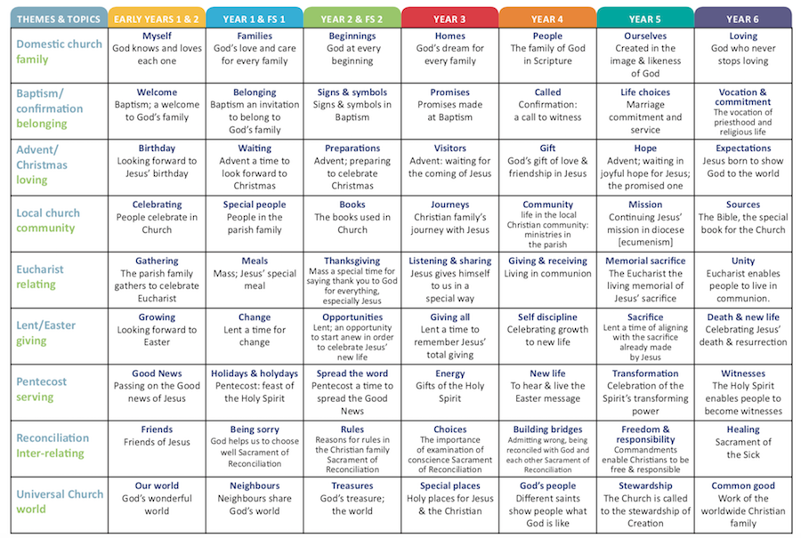

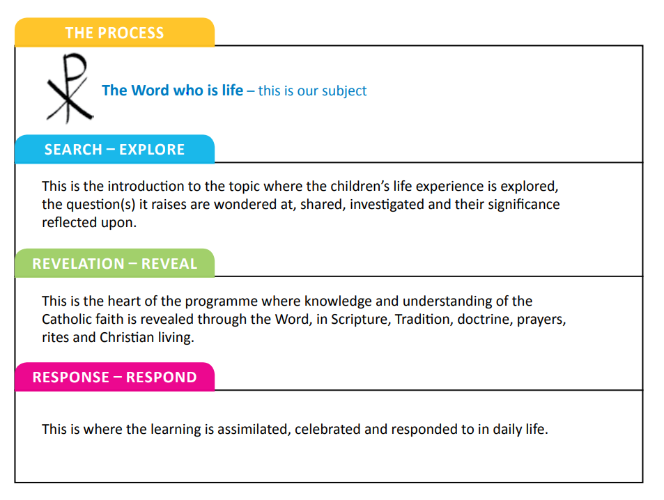
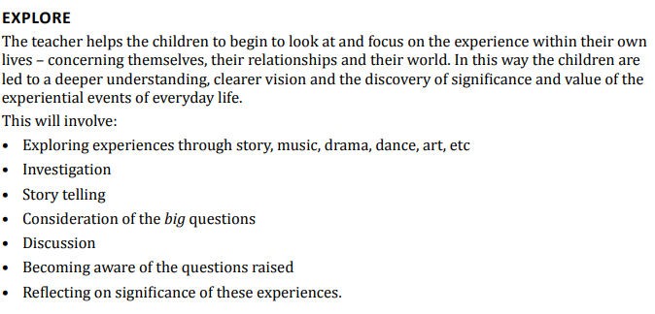

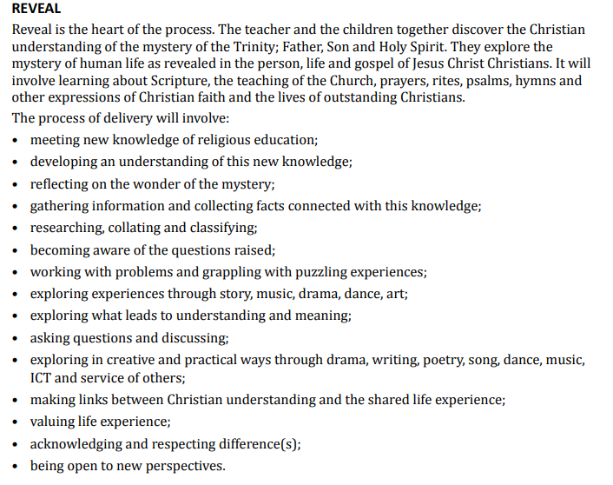

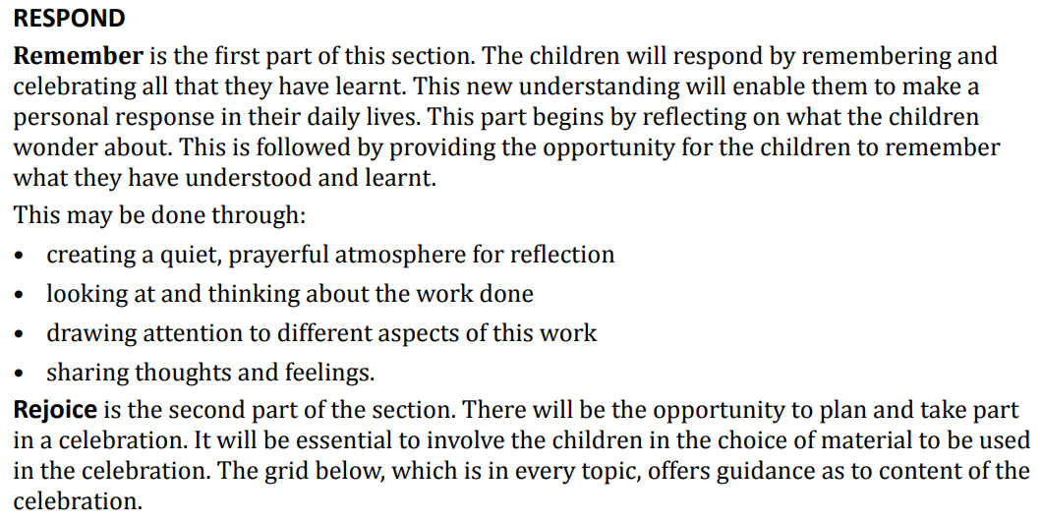

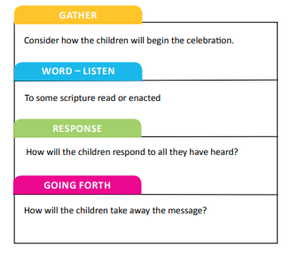

EYFS provision
Running along the Come and See and Caritas Resources, which EYFS adhere to, there are further Religious education opportunities provided within the school day, these include but are not limited to –

Nursery:
-weekly RE carpet session (building up to 15-minute session)
-weekly focus activity x1 per week (working in small groups with a teacher)
-weekly collective worship (in key worker groups)
-daily prayer x4 per day
-half termly display linked to RE topic
-altar updated linked to learning
-singing practice

Reception:
-weekly RE carpet session (building up to 20 minutes)
-weekly focus activity x1 per week (working in small groups with a teacher)
-daily prayer x4 per day (including ten: ten)
-half termly display linked to RE topic
-altar updated linked to learning
-singing practice (using hymns LTP-long term plans)
-attending singing assembly from Autumn 2 (fortnightly)

Provision:
Our Provision reflects the children's learning. for example- at Christmas the children have a stable and inn role-play area. When learning about Baptism the children re-enact the sacrament and the resources are available to learn and imbed this knowledge. Creative, malleable, writing, role-play reflect weekly focus with activities planned around the children's skills and knowledge. for example:
-writing about family
-drawing pictures of Mary and St Anne
-drawing birthday cards for Jesus
-celebrating God's world by exploring natural resources (leaves, acorns, pinecones)

Other Religions
Why teach about other Faiths or Religions?
“In Meeting God in Friend and Stranger” an article produced by the Bishops of England and Wales, it outlines that;
“Within our schools we are seeking to educate all pupils of whatever religion to be able to live a way of life that integrates their beliefs with all other aspects of what it means to be human. As part of this, they must learn to live alongside others who are different and hold alternative views, including religious views.”
At St Anne’s, we refer to Judaism as another faith because of our shared Christian and Jewish heritage. Jesus was a Jew. We refer to Islam, Hinduism and Sikhism as other religions. These are studied because they have a belief in one God. Judaism and Islam are studied for one week every year.
We want our children to have a rich and varied experience so visitors and visits to other places of worship are welcomed and encouraged. Each unit is taught discretely and not in any way comparatively with Christianity.

Catholic Social Teaching

Alongside Come and See, we have weaved in Catholic Social teaching themes which call us to work for the common good, help build a just society, uphold the dignity of human life and work for justice and dignity of all our brothers and sisters, especially those in the greatest need – (through Caritas in Action).
The Caritas in Action scheme is a response to Catholic Social Teaching, which calls us all as Catholics to work for the common good, help build a just society, uphold the dignity of human life and work for justice and the dignity of all our brothers and sisters, especially those in the greatest need. Each year group will study a number of themes over the year. These are developmental, building on previous knowledge and experience and considering the children’s age and understanding.
Throughout the Academic year, Caritas in Action provides our children with a unique and engaging set of teaching and learning opportunities for the seven themes of Catholic Social Teaching.

Dignity of the Human Person
Every human person is created in the image and likeness of God. Therefore, every person’s life and dignity must be respected and supported from conception until the end of their natural life on earth.

Family and Community
The human person is not only sacred, but social. How society is organized, be it socially, economically, legally or politically has a direct impact on the dignity and growth of every human person and community. Marriage and family should be supported and strengthened. Every person has a right to work to support themselves and their families as well as the building up of the common good for all.

Solidarity and the Common Good
We are all People of God, one family. Therefore, what happens to one has an impact on all, locally, nationally and globally. At the heart of solidarity is the pursuit of peace and justice. Our love for all calls us to work for a peaceful and just society where everyone has a fair share of the goods needed for a sustainable life, and opportunities for growth and development are offered equally. The dignity of every person is respected.

Dignity of Work
Work is a way in which we can continue to participate in God’s creation. Work gives dignity to life and must be carried out in such a way that the basic rights of workers are respected. Everyone has the right to productive work, to fair and liveable wages, and to organize and join a union. The economy must be conducted so that it serves the needs of the people.

Rights and Responsibilities
Every person has a fundamental right to life. It is this right that makes all other rights possible. Everyone has the right to food, health care, housing, education and employment. We all need to strive to secure and respect these rights for others both locally and globally.

Option for the Poor and Vulnerable
Society is judged on how it cares for the poor and vulnerable – our brothers and sisters. We read in scripture how God has a special concern for the oppressed, poor, vulnerable and those forced to the margins of society. The Church calls us to respond to the cry of the poor and put their needs first. This preferential treatment for the poor and vulnerable must be seen in action in our daily lives.

Stewardship
The world God has created for us has been entrusted to everyone and we are responsible and accountable to God as stewards of the earth. The world has been given to us as a gift, to enjoy and care for so that future generations can enjoy it too. It is in caring for creation that we show our love and respect for its creator.

RE provision is enhanced in a number of ways; through incorporating ‘Building the Kingdom’ ideas, whole school themed days/weeks and developing the ‘Big Questions’ - Big Questions ensure that children can be inquisitive about their faith and tackle some of the more stimulating questions. In addition, there are elements of study and experience that are included because they have special importance to our school, for example a special interest and focus on St Anne.

Our RE curriculum will further be enriched by speakers from Catholic charities who also visit schools such as CAFOD / Cornerstones
The life and work of key figures in the History of the people of God will be studied for example, lives of the saints- especially St Anne, through person on a page.

Pupils will actively participate in Mass, feast days, Holy days and collective worship which will involve religious actions and worship including the celebration of the sacraments.

Teaching of R.E.

Each class teacher is responsible for the high quality teaching and learning of RE in his/her class.
Lessons constitute 10% of teaching time each week- this is a non- negotiable
Our children will be actively engaged in RE lessons through the use of a variety of sources such as religious stories, scripture, religious artwork, reflection, songs, music, drama, dance and religious signs and symbols.
Grouping will vary according to the content and style of the lesson and will be decided by the teacher.

Teaching and learning experiences will be planned and delivered in as many ways as possible. Pedagogy will include whole class teaching, group activities and individual work. Children will have opportunities to work individually as well as cooperatively and collaboratively, developing their own knowledge and expertise as well as sharing experiences with others.

Whole school themed days will be planned for to link with the liturgical year, such as All Souls Day, Advent, Lent , Pentecost .Alongside this and through Building the Kingdom provision, we explore the big questions of purpose and meaning that arise throughout the Liturgical year- children are engaged through lessons and events which equip them with the skills needed to be agents for a Spirit fuelled transformation of society.

RE Curriculum Planning

We ensure that the topics studied in RE build on prior learning. The RE subject leader has planned an overview of topics/themes for the Academic Year- using the online Come and See resources and those from Caritas in Action- it is the responsibility of the class teacher to adapt the same, to ensure that they are progressive and bespoke to the needs of their individual classes- this may include some flexibility around when certain units are taught and takes into consideration how they can be linked to other Curriculum subject planning for a ‘best-fit’ . The yearly overview is a working document which is then reviewed annually through discussions with the class teachers to ensure best provision is given.

Contribution of RE to the Teaching in Other Curriculum Areas – (these include but are not limited to )

English
RE contributes significantly to the teaching of English in our school by actively promoting the skills of reading, writing, speaking and listening. Some of the texts that we use, have religious themes or content, which encourages discussion, and this is RE’s way of promoting the skills of speaking and listening-including debate and discussion. We encourage the children to use planned extended writing opportunities in RE to write letters, leaflets, comparisons, interview notes and record information in other ways.

Personal, Social and Health Education (PSHE) and Citizenship
Through our RE lessons, we teach the children about the values and moral beliefs that underpin individual choices of behaviour. So, for example, we contribute to the discussion of topics such as smoking, drugs and health education. We also promote the values and attitudes required for citizenship in a democracy by teaching respect for others and the need for personal responsibility. In general, by promoting tolerance and understanding of other people, we enable children to appreciate what it means to be positive members of our pluralistic society.

Spiritual, Moral, Social and Cultural Development
Through RE in our school, we provide opportunities for spiritual development. Children consider and respond to questions concerning the meaning and purpose of life. We help them to recognise the difference between right and wrong, through the study of moral and ethical questions. We enhance their social development by helping them to build a sense of identity in a multicultural society. Children explore issues of religious faith and values and, in so doing, they develop their knowledge and understanding of the cultural context of their own lives.

RE and Relationships and Sex education (RSE)
At St Anne’s we have invested in a Diocesan and CES approved scheme produced by a Catholic company called Ten: Ten -‘Life to the Full’. It is a fully resourced Scheme of Work for Catholic Primary Schools which embraces and fulfils the new RSE statutory curriculum. Taught with a spiral approach to learning, in which pupils will revisit the same topics at an age-appropriate stage through their school life, the programme includes teaching about personal health, physical and emotional wellbeing, strong emotions, private parts of the body, personal relationships, family structures, trusted adults, growing bodies, puberty, periods, life cycles, the dangers of social media, where babies come from, an understanding of the Common Good and living in the wider world. The entire teaching is underpinned with a religious understanding that our deepest identity is as a child of God – created, chosen and loved by God. By using the programme, staff and parents will deliver a fully integrated, inclusive and holistic programme which enables children to ‘live life to the full’ (John 10:10).
(See also separate RSE Policy)

Resources

RE resources are available to all staff and are kept both in school storage and individual classrooms. The Come and See Programme is available online and Caritas in Action books are available for all Year Groups. There is an annual agreed allocated RE budget.

Parish Links

As a school, we are united with our St Anne’s Church Community through our joint celebrations of Holy Mass; including Feast Days and timetabled daily Masses/Confessions. We also help support Parish events including the Summer and Christmas Fairs-through fundraising and donations. We support our Sacramental Programme children through their preparations and Programme Masses.

Charitable giving

As a school, we endeavour to support charities through donations of gifts and monies. We work alongside our Church and as part of the mission to reach out to those in need by providing food and non-perishable donations to Cornerstones during Harvest time. We have also provided donations for Rainbow Surprise-a community-based charity working in the Crumpsall and wider areas of Manchester, who support our local community by providing help and bringing communities together; out charity’s mission, by sourcing food produce, personal hygiene items, and household items that are essential for families in our area. We also fundraise for CAFOD who run Catholic Social Teaching workshops and Assemblies in school

Assessment

Much of RE is a development of personal values and attitudes and can be assessed through the children attitude and approach to life. Children are assessed in a range of ways; through written work, art work, role play, QR code videos and teacher dialogue.

Assessment of standards is carried out according to Salford Diocesan guidelines . Children demonstrate their ability in RE through a variety of different ways. Younger children might, for example, act out a famous story from the Bible, whilst older children might produce a PowerPoint presentation based on their investigation of sacred texts. Teachers will assess children’s work in RE by making informal judgements as we observe them during lessons. On completion of planned assessments that are in line with specific learning objectives outlined in Come and See, the teacher assesses the work and gives the child written or verbal feedback to help guide progress. Older children are encouraged to make judgements about how they might improve their work in the future.

At the end of each term, the teacher makes a summary judgement about the work of each child in relation to his or her expected level of attainment- this assesses each of the 3 Come and See Themes - Church, Sacrament and Christian Living . We use these grades-‘below’, ‘in line’ and ‘exceeding’ expectation, as a basis for assessing the progress of the child. Our children are given a range of tasks to facilitate the process of moderation within Primary Religious Education within AT 1 (ii). These have been designed in a format which is hoped will assist the teachers and provide them with the necessary detail and context.
The tasks have been revised to align with the Salford Diocesan End of Year Expectations document and written using the related language.
For each year group there is a commentary section which highlights attainment with regard to ‘below’, ‘in line’ and ‘exceeding’ expectation.
The tasks are further used to substantiate the reasons for teacher judgement in terms of moderation.

Progress and achievement in Religious Education is reported to parents/carers in a written report at the end of each academic year.

Parents receive information regarding their child’s effort, attainment and progress in parents’ evenings and in a written report at the end of the academic year-this includes feedback on their contributions to both the Catholic life of the school and Religious Education.

Monitoring and Review

The coordination and planning of the RE curriculum are the responsibility of the RE team who have their own lead focuses and who also:
- Support their colleagues in their teaching, by keeping them informed about current developments in RE and providing a strategic lead and direction for this subject.
- Give the Headteacher an annual summary report in which she evaluates the strengths and weaknesses in RE and indicates areas for further improvement.
- Uses specially allocated regular management time to review evidence of the children’s work, teacher planning and to monitor work across our school.

The quality of teaching and learning in RE is reviewed and evaluated by the Headteacher as part of our school’s agreed cycle of monitoring and moderation.

