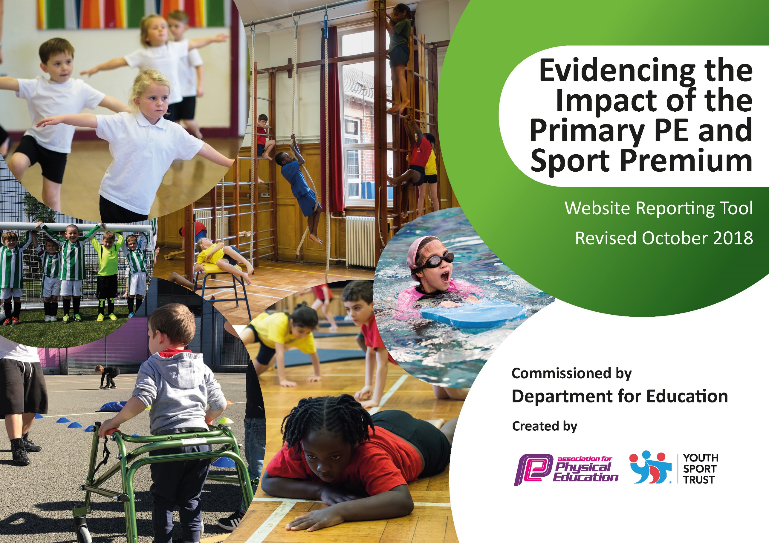
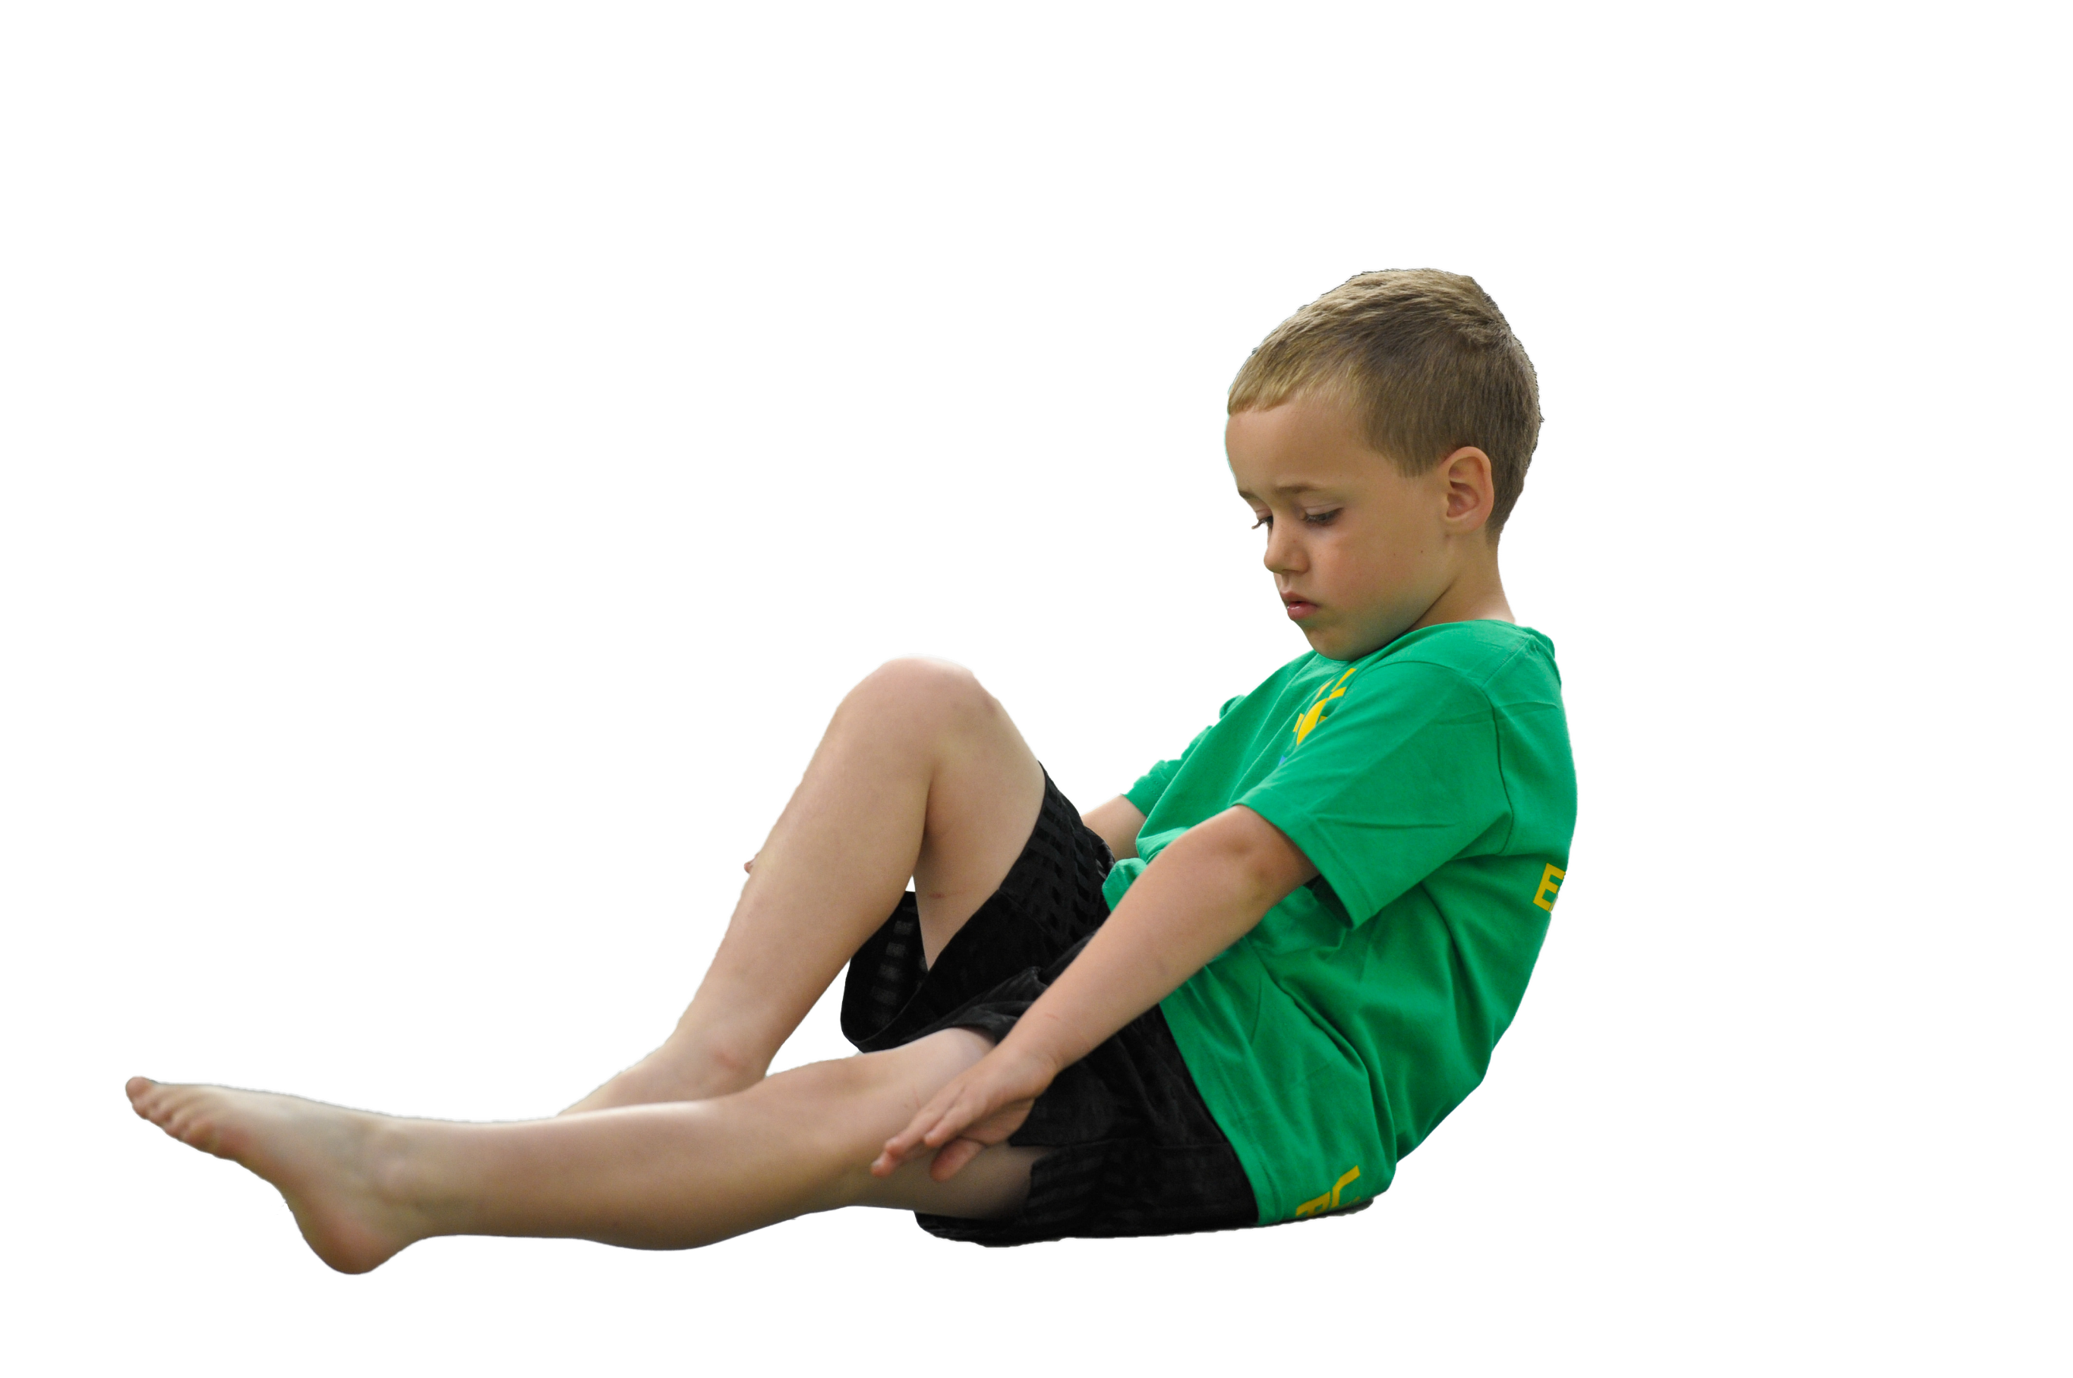
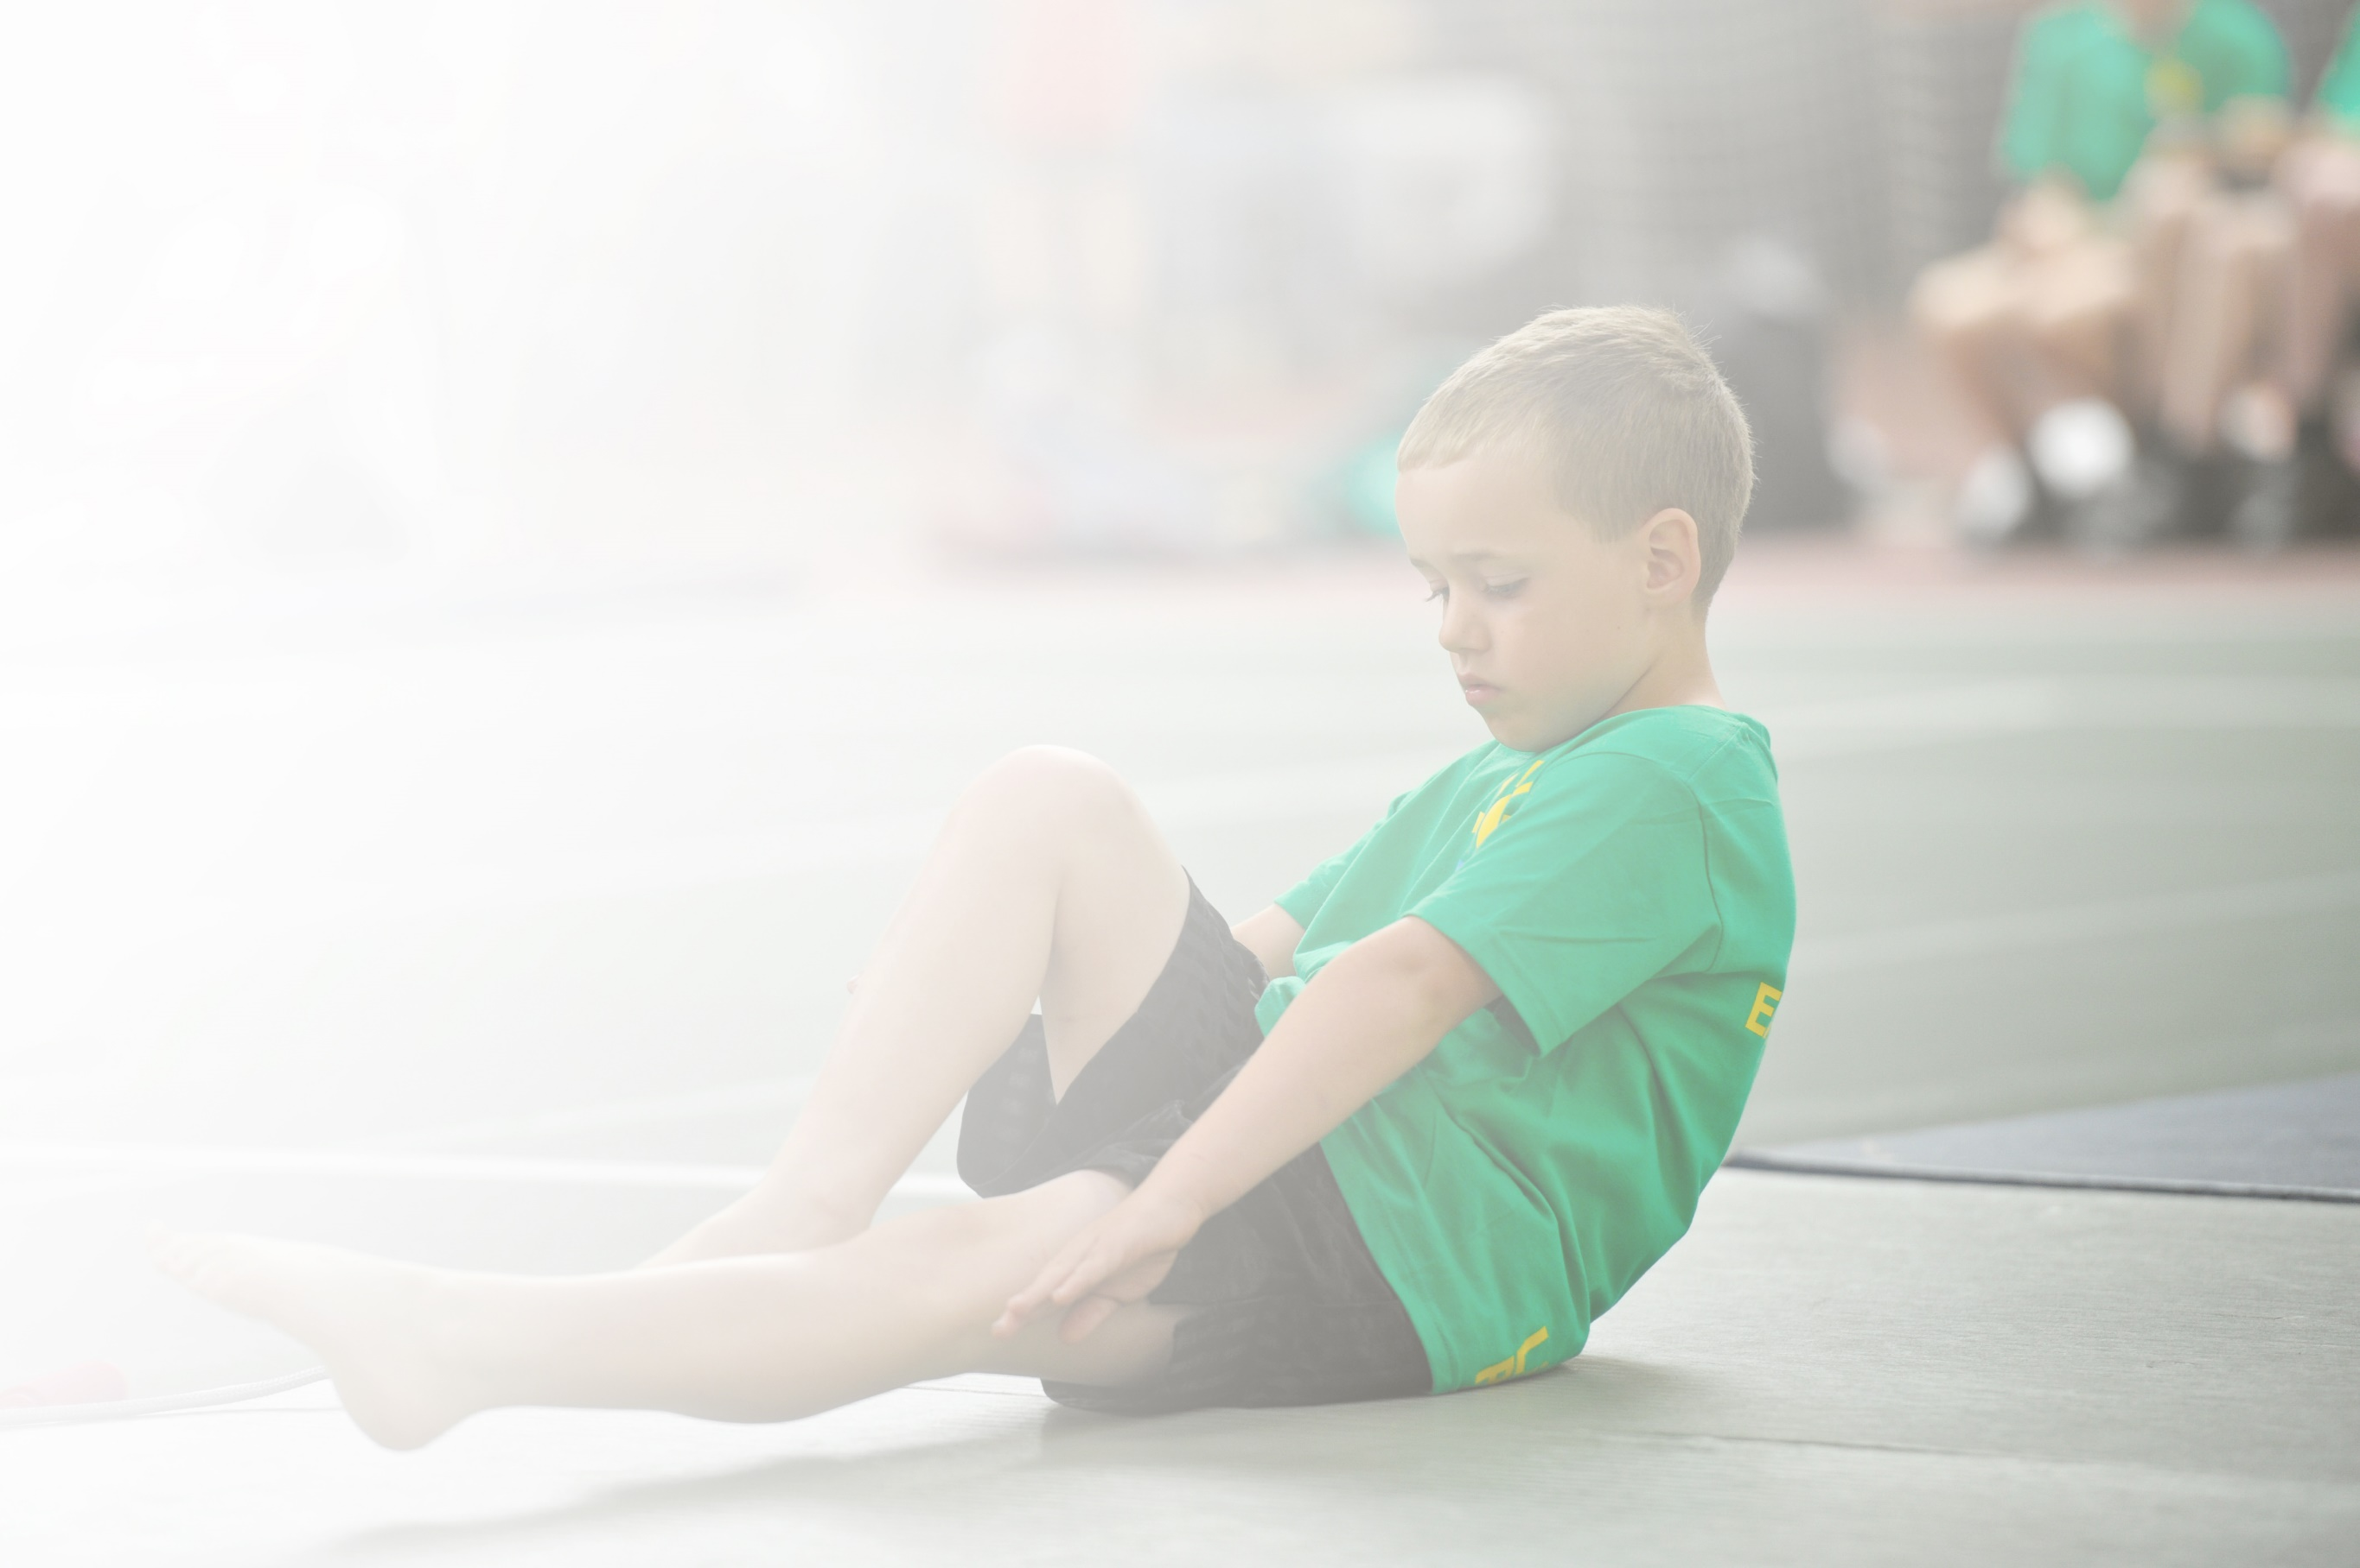
Schools must use the funding to make additional and sustainable improvements to the quality of Physical Education, Sport and Physical Activity (PESPA) they offer. This means that you should use the Primary PE and Sport Premium to:

- Develop or add to the PESPA activities that your school already offer
- Build capacity and capability within the school to ensure that improvements made now will benefit pupils joining the school in future years

Please visit gov.uk for the revised DfE guidance including the 5 key indicators across which schools should demonstrate an improvement. This document will help you to review your provision and to report
your spend. DfE encourages schools to use this template as an effective way of meeting the reporting requirements of the Primary PE and Sport Premium.

We recommend you start by reflecting on the impact of current provision and reviewing the previous
spend. Under the Ofsted Schools Inspection Framework, inspectors will assess how effectively leaders use the Primary PE and Sport Premium and measure its impact on outcomes for pupils, and how effectively governors hold them to account for this.

Schools are required to publish details of how they spend this funding as well as on the impact it has on pupils’ PE and sport participation and attainment by the end of the summer term or by 31 July 2019 at the
latest.
We recommend regularly updating the table and publishing it
on your website throughout the year, as evidence of your
ongoing review into how you are using the money to
secure maximum, sustainable impact. To see an
example of how to complete the table please
click HERE.

Support for review and reflection - considering the 5 key indicators from DfE, what development needs are a priority for your setting and your students now and why? Use the space below to reflect on previous spend, identify current need and priorities for the future.

Key achievements to date: | Areas for further improvement and baseline evidence of need:
- Increased physical activity at playtimes and lunchtimes due to gym equipment  - Leadership roles developed with leaders leading a healthy lifestyle after-school club  - Two Key-stage 2 sports days to improve athletic skills at the Etihad Indoor Arena. | - To target more girls and low self-esteem groups.  - To develop more active learning across the curriculum.  - To introduce new and exciting physical activities.  - To encourage family fitness.  - To use funding to help more children to swim more confidently in a range of stokes – to provide top up sessions for those who need it.

Meeting national curriculum requirements for swimming and water safety | Please complete all of the below:
What percentage of your current Year 6 cohort swim competently, confidently and proficiently over a distance of at least 25 metres?  N.B. Even though your children may swim in another year please report on their attainment on leaving  primary school. | *84 pupils, 62 pupils achieved -73.8%  *data does not include new children who arrived after the swimming lessons.
What percentage of your current Year 6 cohort use a range of strokes effectively [for example, front crawl, backstroke and breaststroke]? | *84 pupils, 3 pupils achieved - 3.57%
What percentage of your current Year 6 cohort perform safe self-rescue in different water-based situations? | NC not required at the time.
Schools can choose to use the Primary PE and Sport Premium to provide additional provision for swimming but this must be for activity over and above the national curriculum requirements. Have you used it in this way? | No

Action Plan and Budget Tracking
Capture your intended annual spend against the 5 key indicators. Clarify the success criteria and evidence of impact that you intend to measure to evaluate for students today and for the future.

Academic Year: 2018/19 | Total fund allocated: £19,690 | Date Updated: July 2019
Key indicator 1: The engagement of all pupils in regular physical activity – Chief Medical Officer guidelines recommend that primary school children undertake at least 30 minutes of physical activity a day in school |  |  |  | Percentage of total allocation:
 |  |  |  | 54.8%
School focus with clarity on intended impact on pupils: | Actions to achieve: | Funding allocated: | Evidence and impact: | Sustainability and suggested next steps:
Gym equipment  Sports Pitch contributions | - Installation of gym equipment  - Key Stage 2 rota of classes and children during playtimes and lunchtimes.  - Fitness after school club.  - Children to be involved in more sports on a safer surface | £6500  £4290 | - All Key Stage 2 children to access equipment on a rota during playtimes and lunch times.  - A range of fitness activities on the equipment as an after-school club.  Wider impact as a result from the above:  - Increased physical activities  - New and exciting workout to encourage and promote a healthy lifestyle.  - More sporting activities available due to surface.s | - Equipment to be used for cross curricular activities.  - Sustainable resource
Key indicator 2: The profile of PESSPA being raised across the school as a tool for whole school improvement |  |  |  | Percentage of total allocation:
 |  |  |  | 10.9%
School focus with clarity on intended impact on pupils: | Actions to achieve: | Funding allocated: | Evidence and impact: | Sustainability and suggested next steps:
Sports Days  Live Football and Basketball  Sports Leaders badges and after-school club.  Active rewards for sports leaders and sports day winners. | - Sports leaders to attend meetings to discuss hopes, wants and needs for PE.  - Sports leader badges and programme to be followed.  - Tickets and transport to be arranged.  - After-school club to be set up with sports leaders to lead. | - £1000  - £39  - £99  - £1000 | - Successful after school club strengthening leadership skills and confidence.  - Meetings led to after school club – pupil voice.  - Some children who went to see the live basketball participated in basketball competitions – helped to inspire. | - Leaders to support and mentor future leaders.  - Family fitness with pupil leaders to help target wider community.

Key indicator 3: Increased confidence, knowledge and skills of all staff in teaching PE and sport |  |  |  | Percentage of total allocation:
 |  |  |  | 6.2%
School focus with clarity on intended  impact on pupils: | Actions to achieve: | Funding  allocated: | Evidence and impact: | Sustainability and suggested  next steps:
NQT training days.  Man City CPD Nursery.  First Aid Course | - Ensure relevant staff are enrolled onto courses.  - Man City to provide CPD. | - £1150  - £80 | - Better subject knowledge and increased confidence for teachers.  - More staff members able to support after school clubs and competitions. | - Staff to use skills developed by Man City to confidently deliver PE in EYFS.  - Next steps to include teaching assistants’ skills to run lunchtimes and breakfast club activities.
Key indicator 4: Broader experience of a range of sports and activities offered to all pupils |  |  |  | Percentage of total allocation:
 |  |  |  | 9.1%
School focus with clarity on intended  impact on pupils: | Actions to achieve: | Funding  allocated: | Evidence and impact: | Sustainability and suggested  next steps:
Additional achievements:  To continue to offer a range of activities both within and outside of the curriculum.  Sports equipment to support activities. | - Pupil voice to find out activities that children are interested in.  - To work with sports coaches to offer a range of new PE activities.  - To purchase equipment to aid sports clubs and activities. | £1800 | - 20 year 3 children attended a Racket Festival focussed on developing skills for badminton.  - After school clubs and competitions for athletics, football, dodgeball, netball, swimming, basketball, rounders, kwik cricket | - Staff training in a range of sports.  - Sports equipment to support a range of sports.  - More school opportunities for creative physical activities like dance, gym and help increase more participation in physical activity.
Key indicator 5: Increased participation in competitive sport |  |  |  | Percentage of total allocation:
 |  |  |  | 19%
School focus with clarity on intended  impact on pupils:  To continue to increase the number of pupils in competitive physical activities.  To develop mixed teams to help support teamwork and sportsmanship.  This has included sports days, sports day and leadership active rewards. | Actions to achieve:  - To hold key stage 2 sports days in team athletic competitions.  - To provide transportation and hire a venue with sporting facilities  - To arrange inter key stage 2 school competitions.  - To develop a pupil led change for life club.  - To provide rewards to encourage. | Funding  allocated:  - £2000  - £750  - £847  - £135 | Evidence and impact:  - 240 children competed in twice in two sports days in a range of athletic activities. Key stage 2 spilt in to teams across the 4 year groups.  - Sports days helped create a buzz around school, children cheering on their teammates and trying their best for their team.  - Flip out rewards for winning team.  - Treetop nets reward for sports leaders.  - As part of MPETT attended a range of sports competitions and after school clubs to support the competitions. Achieved silver in the School Games Mark. | Sustainability and suggested  next steps:  - To develop relationships with local schools to provide further friendly competitions.  - To develop low cost/ local link rewards.  - To create more in school competitive competitions.

