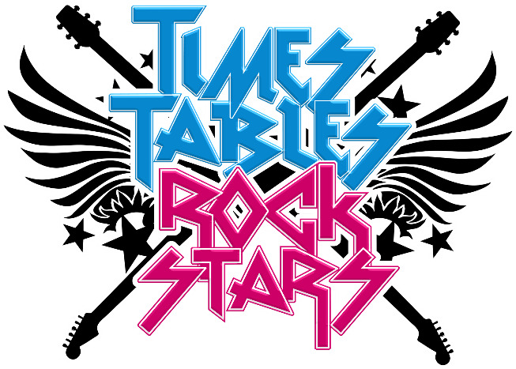

When it comes to times tables, speed AND accuracy are important – the more facts a child remembers, the easier it is for them to complete harder calculations. Times Table Rock Stars is a fun and challenging programme designed to help children master the times tables. To be a Times Table Rock Star they need to answer any multiplication fact up to 12×12 in less than 3 seconds!

World famous rock musicians are the best at what they do because they've spent hours practising guitar chords, writing music or playing on the drums. It's just the same with times tables – all Times Table Rock Stars need to practise and practise and practise.

Research shows that daily practice is the best strategy for children to learn these important facts. Short bursts of daily practice are much more effective than spending hours once a week.

https://ttrockstars.com/

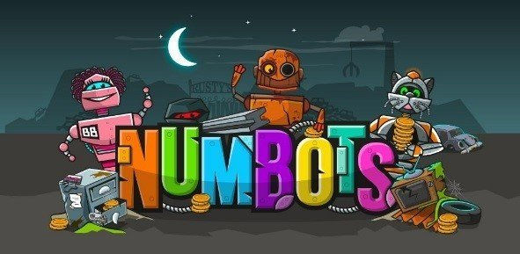
NumBots is all about every child achieving the “triple win” of understanding, recall and fluency in mental addition and subtraction, so that they move from counting to calculating. It uses intelligent practice and engaging game play to supercharge understanding and recall of addition and subtraction. Numbots focuses on 3 three main areas.
- Subitising number
- Number bonds
- Addition and subtraction
https://play.ttrockstars.com/numbots/dashboard

