Over the coming weeks we will support our families by posting advice and links on our school Twitter feed.

SMART users of the Internet  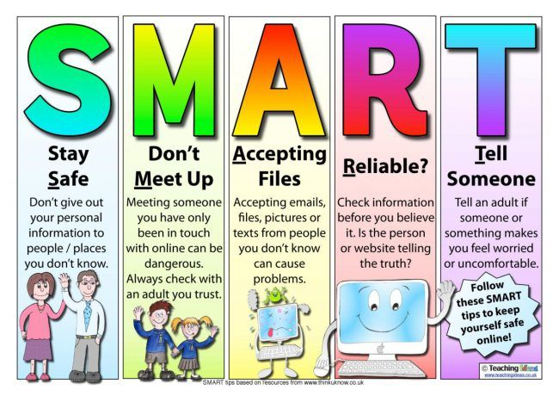 | Social Media age restrictions for UK | NSPCC  online safety links  https://www.nspcc.org.uk/keeping-children-safe/online-safety/  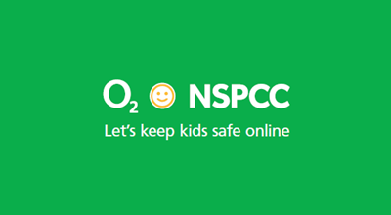
CEOP - using parental controls: www.thinkuknow.co.uk/parents/articles/Parental-controls/  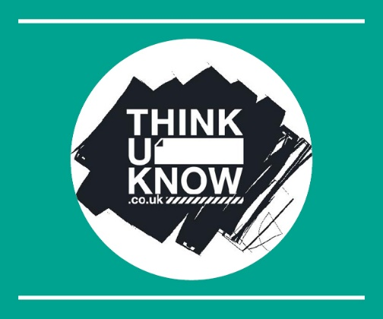 | Safety net kids  http://www.safetynetkids.org.uk/personal-safety/staying-safe-online/  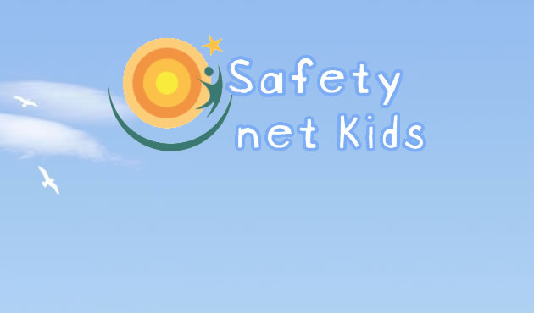 | Zip it, Block it, Flag it.  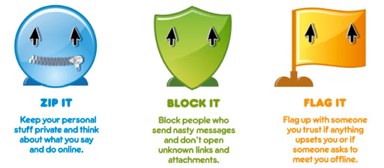
SMART users of the Internet  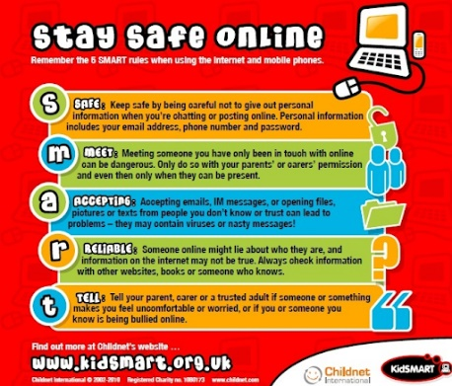 | Using social media - TikTok  https://nationalonlinesafety.com/guides  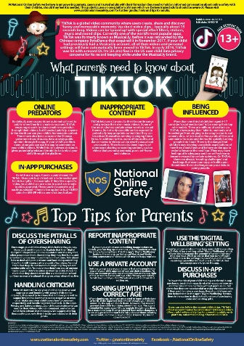 | Starting a conversation with your child about online safety.  https://nationalonlinesafety.com/guides  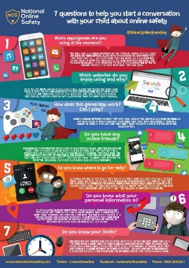
Top 10 safety tips for parents (image)  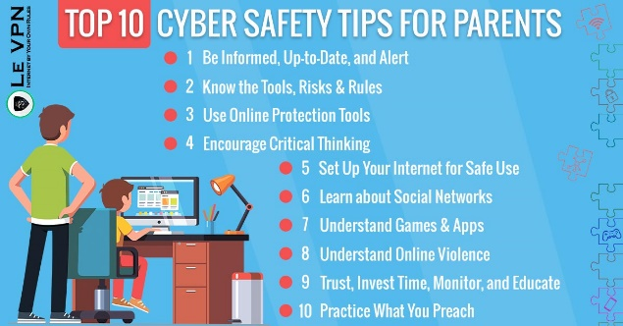 | apps to be aware of (image)  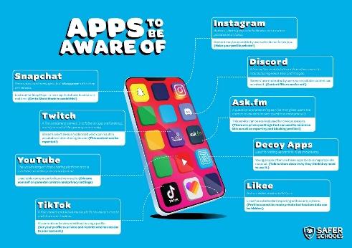 | Video streaming and chatting online  https://www.thinkuknow.co.uk/parents/articles/online-contact-and-staying-safe/  