Y2 Home Learning Ideas 30.3.20
English
- Choose an animal e.g. dog, cat, elephant and write a non-chronological report. Use these subtitles in your report – Appearance, Diet, Habitat. Or you could create a non-chronological report for a mythical creature like a unicorn, dragon or alien. (You can make up your own facts!)
- Choose an animal (maybe an African animal we have learnt about) and write clues for someone to guess which animal you are describing. See if someone in your house can guess!
E.g I mostly live in Africa
I spend most of my day sleeping
I usually have a long mane
And I’m known as the jungle’s king
- Write a book review for Biscuit Bear by Mini Grey. Consider the following points – What was the story about? Who were the main characters? What did you like about the book? Draw your favourite from the book. Rate your book out of five stars.
- Write an adventure story about another Biscuit that comes to life in the middle of the night. Instead of creating a circus with his friends, what other exciting things could he do? Perhaps create a funfair, turn the kitchen into an African safari or visit the North Pole
- Choose a common exception word (see below) and write it into a sentence. Can you use a conjunction like and, so, but or, because, when if? Can you write some different types of sentences like commands, questions, statements and exclamations?
- Write some instructions for washing your hands.
Maths
- Choose a times table and create some times table cards writing the calculation on one side and the answer on the other. Test how quick you and your family can work them out!
- Write down multiplication and division fact families from 2, 3, 5s and 10 times tables
e.g 5 x 7 = 35
7 x 5 = 35
35 ÷ 7 = 5
35 ÷ 5 = 7
How many can you do?
Challenge – can you create some number stories to go with them?
- Play Bingo with someone in your family. Create a bingo board on some paper and choose either the 2, 5 or 10-times table. Write some multiplies in the boxes and ask someone to call out some questions e.g. 3 x 10, 8 x 10? If you have an answer on your board you can cross it out. The first player to cross out all of their numbers wins!
Example bingo board.
80 | 40 | 100
70 | 20 | 10
- Go on a shape hunt around your house and garden. Can you spot any 2D shapes like circles, squares triangles, rectangles, pentagons, hexagons? Cn you spot any 3D shapes like spheres, cubes, cone, cylinders, cuboids, pyramids? Record what you find on paper.
- Complete a survey with your family e.g. What is your favourite snack? What is your favourite exercise? What is your favourite animal? Record your results in a tally chart or pictogram.
- Write some addition and subtraction number stories using your toys objects from home e.g. I had 36 pieces of Lego. I use 14 pieces to make a model. How many pieces did I have left? My sister has 18 pieces of pasta and I have 7. How many pieces of pasta are there in total?
- Using an analogue clock, learn how to tell these times.
O’clock 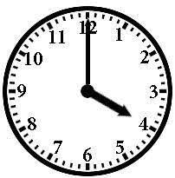

Half past the hour 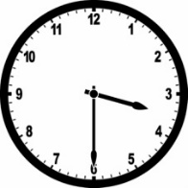

Quarter past the hour 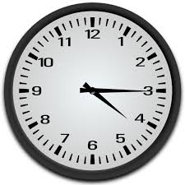
Quarter to the hour 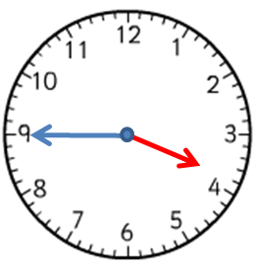
Science
- Complete some tests for example, how many times can you jump up and down in one minute? How many times can you write your name in one minute? How many hops can you do in one minute? Make a prediction first and then record your results in a table.
- Go on a hunt around your local area or garden – can you find a worm, spider, woodlouse, ant, ladybird, fly, butterfly? Record what you find.
- Choose ten objects from your home. Can you write what material each object is made from?
- Try and make a toy boat that floats. Try and use recycled items from around the house, like washing up liquid bottles, cardboard boxes etc. Be careful to choose the right materials, you don’t want the boat to sink. Can you think of a name for your boat?
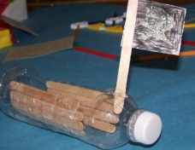
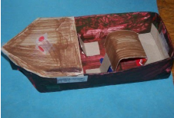

- Weather diary – create a diary of the weather each day. Can you notice any changes from day to day?
- Draw and label habitat and different animals that live there e.g rainforest – butterflies, snakes, lizards, frogs, parrots, sloths. Why are these animals suited to their habitat?
Humanities
- Create a poster showing what you have learn about going to school in the past.
- Write a list of 8 rules that you might find in a Victorian classroom.
- Can you name the seven continents and the five oceans?
- Design an information book describing what happened during the Great Fire of London in 1666.
- Florence Nightingale facts – are they true or false?
 | True | False
Florence was a nurse.
Florence Nightingale was born on the 12th May.
Florence only helped people in the daytime.
She was known as the ‘Lady with the Lamp’.
Florence wanted to be a nurse and studied really hard.
She helped to train other nurses.
Florence helped to make hospitals a much cleaner place.
Can you use these facts to help you make a poster about Florence Nightingale’s life?
Art & Design Technology
- Junk modelling – can you create your own alien using old packaging from your home e.g. cereal boxes, plastic bottles, yoghurt pots etc.
- Make a board game about a topic of your choice for example, maths or animals. See the pictures below for ideas. Design your board and then make some question cards. Play the game with your family.
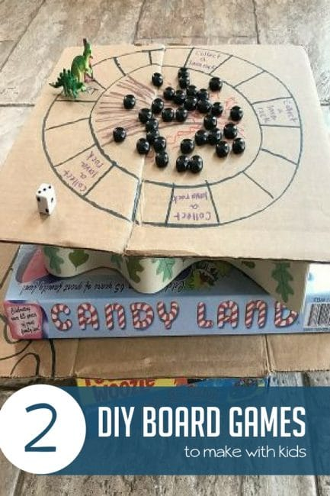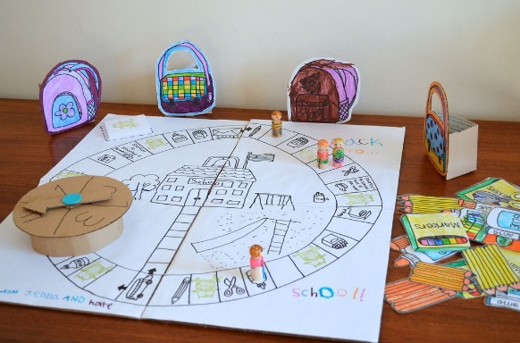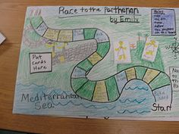
- Create a poster of a rainbow encouraging people to stay at home, stay safe and stay positive and stick it in your window for people to see!
Religion
- Write a prayer thanking God for our friends and family during this difficult time.
- Create a list of 10 kind things e.g. smile at someone when you go out for a walk, make your bed, tell your dad a joke and make him laugh, draw a picture for your neighbour. How many of these activities can you do?
Spelling
- Spell the Y1 and Y2 common exception words correctly. Use strategies such as pyramid writing, rainbow writing or quick write to help you learn any words that you don’t understand. See below.
Y2 Common Exception Words
door floor poor because find kind mind behind child children wild climb most only both old cold gold hold told every everybody even great break steak pretty beautiful after fast last past father class grass plant pass plant path bath hour move prove improve sure sugar eye could should would who whole any many clothes busy people water again half money Mr Mrs parent Christmas

Mindfulness activities
Shark fin
- Place the side of your hand on your forehead, with your palm facing out to the side.
- Close your eyes.
- Slide your hand down your face, in front of your nose.
- Say “shhh” as you slide your hand down your face
- If you are sitting down, you do the 5 Ss while you move your hand: Sit up straight, sit still, sit silently, soft breathing, shut eyes.
- If you are standing do the same but you are standing straight, still, silently, using soft breathing and shut eyes while you move your hand down your face.

Belly Buddies
- Ask your child to get a small teddy or light weight toy.
- Get your child to lie on their back on something comfortable such as a cover and place the toy or object on top of their belly buttons.
- Take your child through the guided breathing activity, asking them to watch the object as it moves up and down with their breath. Ask your child to focus on their breathing.

