Year 1 Learning Challenges- Week beginning 30.3.20
Write the bonds to 20. | Create a friend for Hattie Peck. What do they look like? | Draw and write about animals from a cold place.  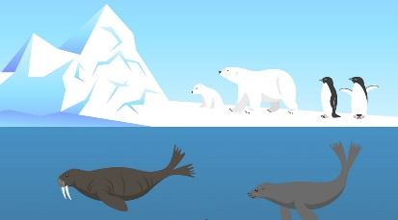 | Write a diary entry about what you did yesterday.  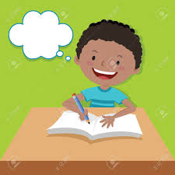 | How many birds can you spot outside?  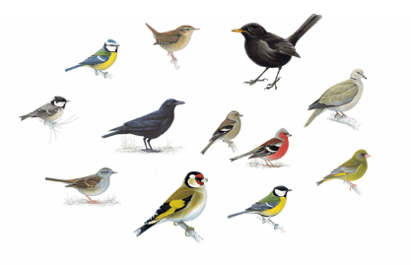
Read a story to your pet.  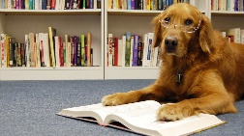 | How many ways can you make 15 using + and - ?  14+1=15  16-1=15 | Enjoy a story time with your toys.  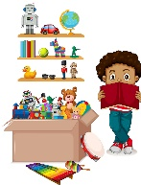 | Go on a material hunt at home. Which materials can you find?  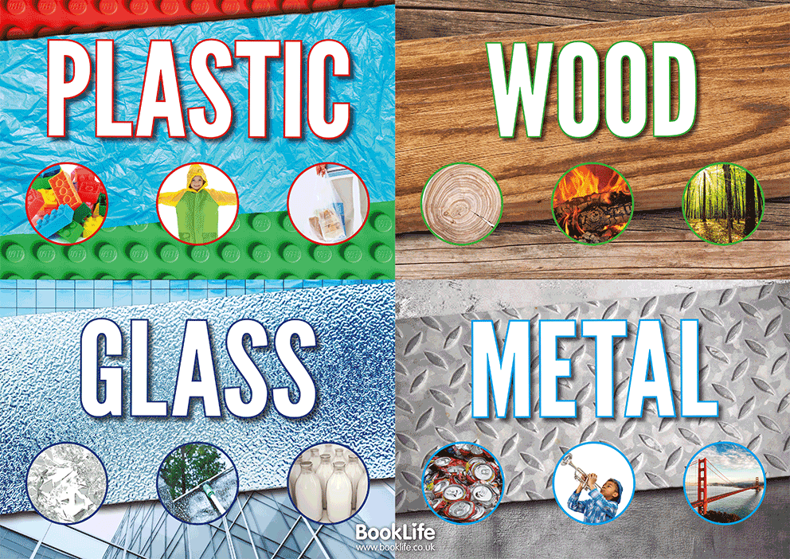 | Quiet time with God.  Write a prayer for ‘hope’ and with an adult light a candle.
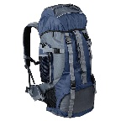  If you were going to explore the Arctic Circle, what would you wear and what would you pack to take with you?  Draw and label your pictures. | Make an eco brick!  Stuff a clean plastic bottle with non-recyclable plastics.  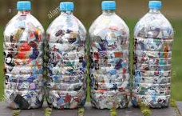 | How many can you find in your home? | Read your favourite book in an unusual place.  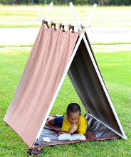 | 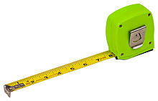  Use your hands, a ruler or a measuring tape to measure 10 objects at home.  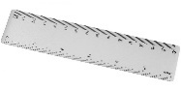
Write a letter to a friend from school. | Recycle your rubbish. Can you make a bird feeder or bug hotel from your rubbish?  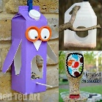 | Can you think of 50 words with /ai/ sounds?  Don’t forget you know lots of ways to spell /ai/!  play rain they baby name | How many cuboids can your find at home?  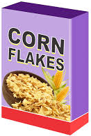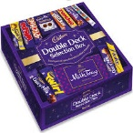 | Read for 20 minutes with someone from your family.

