Life Skills

Healthy Lifestyles

Look at the Eatwell guide below. Discuss this with your child focusing on the following points;
- Why is each section of the Eatwell guide important?
- Would it be a good idea to just eat from one group of foods every day? Why not?
- How can we maintain a balanced diet?
- When is it OK to eat the foods on the side (crisps, ice cream etc…)

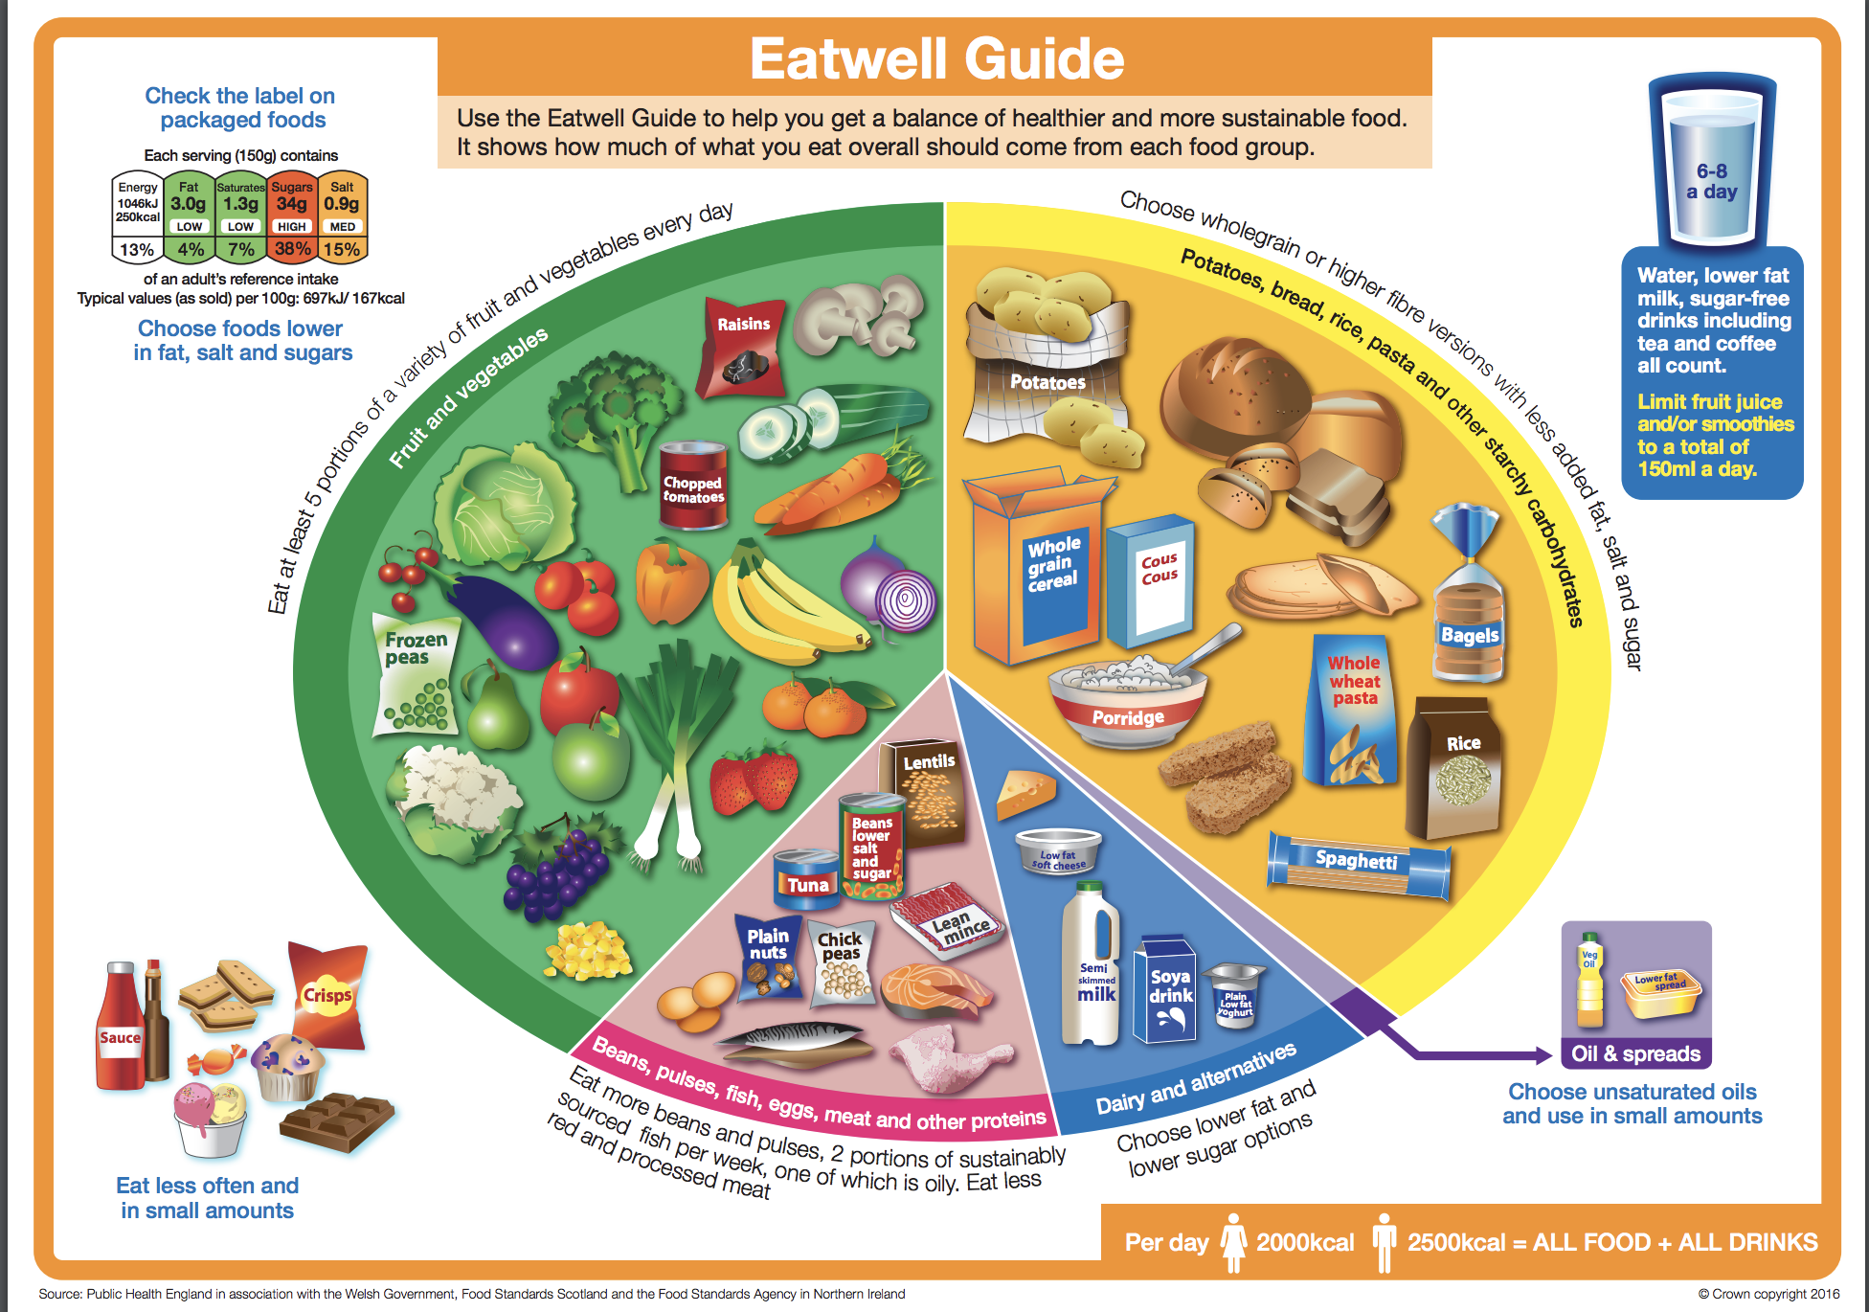

Once you have discussed these with your children, have a look at making a healthy lunchbox below.
When they have finished their lunchbox, your child can fill out the persuasive writing template below to persuade another member of the family to eat healthy.

Make a healthy lunchbox
Create an amazing healthy lunchbox.

Lunchbox checklist
plenty of a starchy food, e.g. thick wholemeal bread, chapatti, pasta or rice salad
plenty of fruit and vegetables
some dairy and alternatives, e.g. individual cheese portion or pot of yogurt
some lean meat, fish or alternative, e.g. ham, chicken, beef, tuna, egg, hummus or bean/lentil salad
a drink

Why did you choose these foods and drink?

Persuade me
How would you persuade your friends to eat a healthy lunch?

Use persuasive language to write an article for a school magazine.

Think about the important points

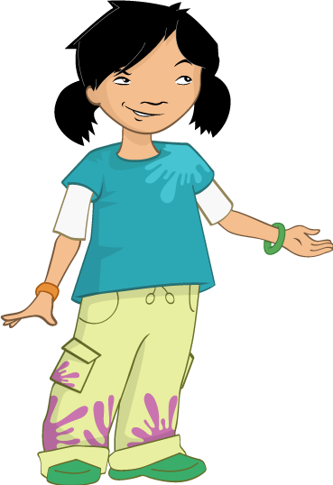
Understand why personal hygiene is important

Micro-organisms, also known as germs, bugs or microbes, are tiny living organisms too small to be seen with the naked eye. They are found almost everywhere on earth. Some microbes are beneficial and others can be harmful to humans (this will be explored in later sections). Although extremely small, microbes come in many different shapes and sizes. There are three main groups of microbes: Viruses are the smallest of the microbes and are generally harmful to humans. Viruses cannot survive by themselves. They need a ‘host’ cell in order to survive and reproduce. Once inside the host cell, they rapidly multiply and destroy the cell in the process! Fungi are multi cellular organisms that can be both beneficial and harmful to humans. Fungi obtain their food by either decomposing dead organic matter or by living as parasites on a host. Fungi can be harmful by causing infection or being poisonous to eat; others can be beneficial or harmless, e.g. Penicillium which produces the antibiotic penicillin. There are also fungi that are not microbes and some that can be eaten like Agaricus, commonly known as the white button mushroom. Bacteria are single-celled organisms that can multiply exponentially once every 20 minutes. During their normal growth, some produce substances (toxins) which are extremely harmful to humans and cause us disease (Staphylococcus); other bacteria are completely harmless to humans and others can be extremely useful to us (Lactobacillus in the food industry), some are even necessary for human life such as those involved in plant growth (Rhizobacterium). Harmless bacteria are called non-pathogenic, while harmful bacteria are known as pathogenic. Over 70% of bacteria are non-pathogenic. Bacteria can be simply divided into three groups by their shapes – cocci (balls), bacilli (rods) and spirals. Cocci can also be broken down into three groups by how the cocci are arranged: staphylococci (clusters), streptococci (chains) and diplococci (pairs). Scientists use these shapes to tell which infection a patient has.

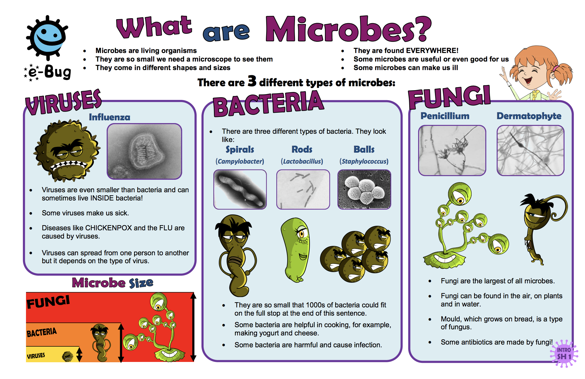

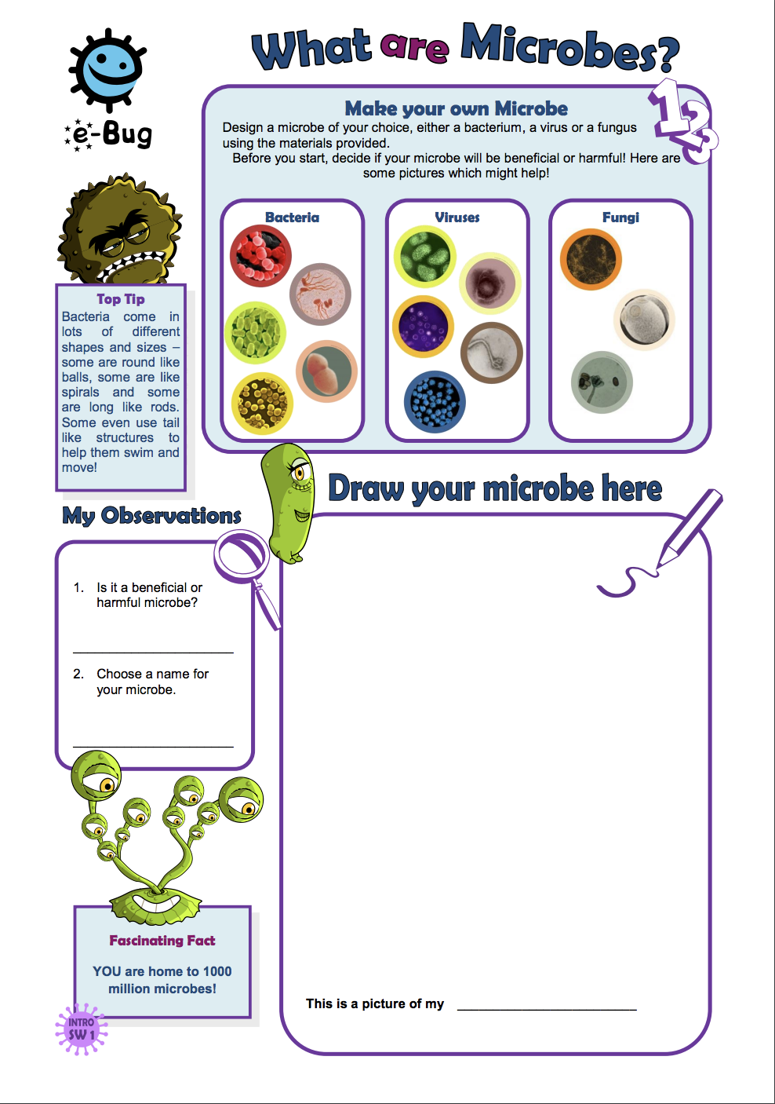
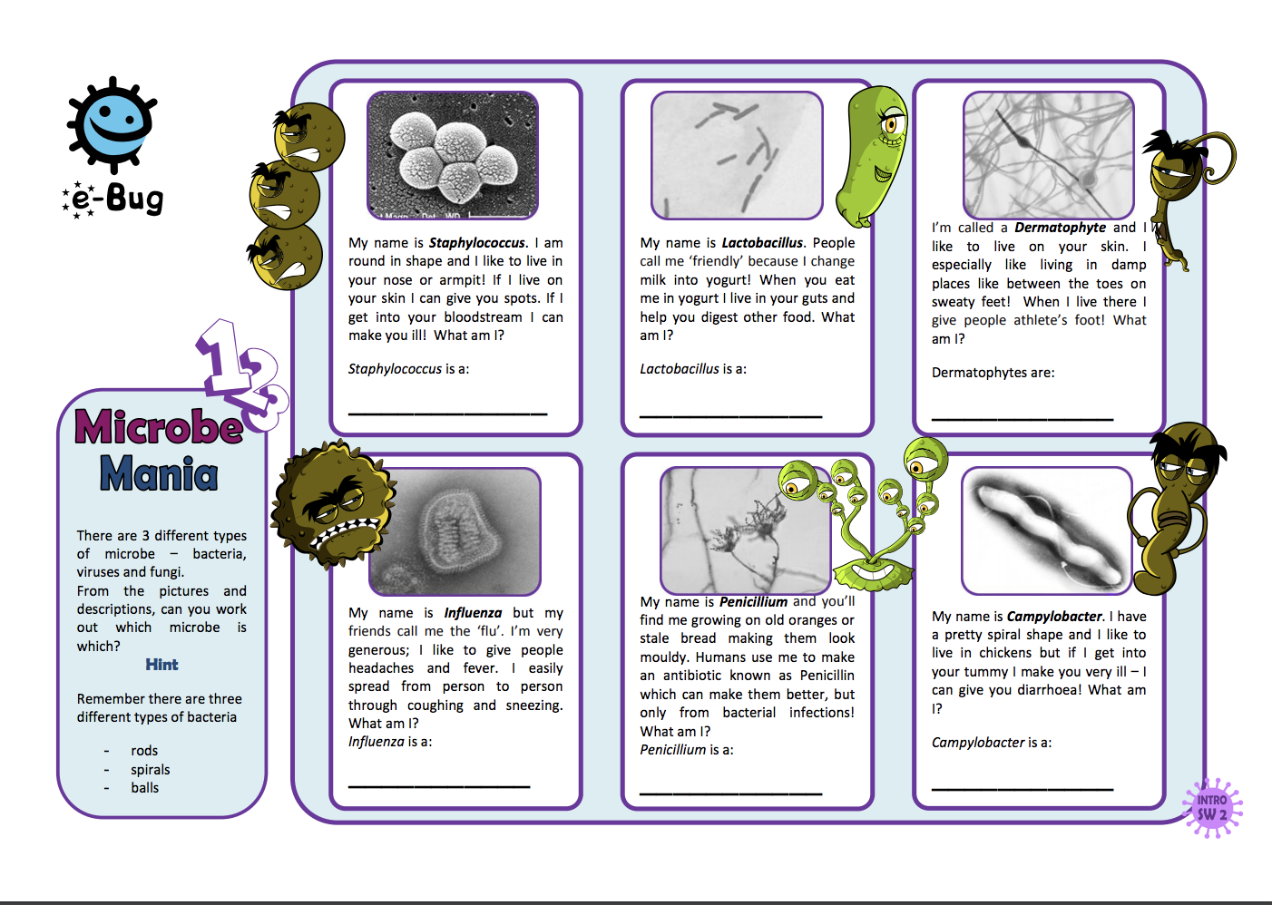
Can you and your child think of ways in which we ensure good personal hygiene to ensure that we don’t get sick from these microbes? Can you create a poster to show some of the things that you do? Eg: take a bath, wash our hands…

Keeping Safe

Managing Risk

Explain to your child that you are going to ask them to draw and write about something which different people describe in different ways. Tell them they are going to draw and write about what risk means to them.
- Ask them to draw someone their own age doing something risky. (It can be a stick person). Do not clarify what risky means, tell them to draw what they think it means or write "I don't know"
- Ask them to write, under the picture, what is happening in the picture
- Ask them to write what makes this risky
- Finally ask them to return to their drawing and draw themselves in the scene. What would they be doing or saying to help?

Often young people (and many adults!) equate risk with danger. Explain to your child that sometimes risk might not mean danger. It might be taking an opportunity like starting a new business.

With your child, see can you identify any hazards or risks in the home eg: the hob may be a hazard to the home if left on all night. Therefore, we make sure to turn this off when we are not using it.
See what other risks/hazards you may find and think of ways in which you manage these risks.

Bike Risk
Burglary Risk

Introduction
What are the benefits of having a bike? Discuss together. Would you find it hard to be without your bike now? Do you travel to school on their bike? When are they most likely to use their bike?
Talk about any safety measures they take when they are out and about on them. Can they
brainstorm any possible concerns they ever feel, make a note of these and save for later.
Using the sample scenario

1: Lauren received a new bike for her birthday. She is very excited and can’t wait to take
it out.

2: She rides round to her best friend’s house. He is fed up, his bike has been stolen!
Discuss the feelings of Lauren and her friend. Has it spoiled Lauren’s pleasure? What can they do now that only one of them has a bike?

3: His mum comes out to look at the bike. “It’s lovely, make sure you look after it.”

Discuss together the best ways of looking after your bike.

4: (Police officer enters with bike) Friend shouts, “My bike!”

Discuss the feelings of the two friends now, how have they changed? What would you say about Lauren’s friend now? Do you think he is lucky to have got his bike back? How often do you think people do get their stolen property back?

5: (Police officer) “Good job you had this bike marked, it made it much easier to find
for you.

What does the police officer mean by marked?

6: (Police officer to Lauren) “Make sure you get yours marked too, and keep it safe.”

7: go to www.immobilise.com

Explain that this website offers a free service for the general public to register details of any
personal property. By registering items it helps police forces all over the country to identify the
owners of lost and stolen goods every day.

Explain to your child that they are going to write a short story entitled ‘My life as a bicycle’. They should imagine they are a bicycle given as a birthday present. They should describe their owner and the treatment and care received. Ask them to comment as you write about any safety measures that could have been made.

First Aid

For some free first aid resources to do at home, visit https://www.sja.org.uk/get-advice/a-z-of-first-aid-teaching-courses/

What to do in an emergency

Introducing first aid
These assembly-time activities are the perfect way to introduce first aid education to pupils in your school. You can just use Activity 1 if you don’t have time for both activities.

Age group: This assembly kit is designed for 7–11-year-olds, if you would like to broaden out this learning to other age groups see our first aid resources for 5–11-year-olds: Life. Live it.

Curriculum subjects covered: PSHE. See the Life. Live it. lesson plans for curriculum links for all UK regions.

Activity 1: short story
- Introduce the session: ask the pupils ‘What is first aid?’ [First aid is the first help that someone is given when they have an injury or sudden illness.]
- Tell the following short story. You can tell your own story about a real first aid emergency if you prefer.

Short story
Seven-year-old Tom was in the car on his way to football practice, and the traffic was terrible. He was desperate not to be late: it was his turn to be captain of the blue team. So when his mum finally drove into the car park and dropped him off, Tom raced across the field to meet his friends and coach.

And then… THUMP and CRACK. Tom tripped over some logs and landed in a ball of pain on the grass. His left arm hurt… a lot. And his mum had already driven away. Where were his friends? He couldn’t see anyone and he was scared. Tom cried out, hoping that someone could hear.

Anni heard him! She looked out across the field and saw her friend crumpled on the ground. While telling the coach where she was going, she ran (carefully!) over to Tom. ‘It huuurts,’ Tom wailed.

Anni had learnt some first aid in school, and realised that Tom might have broken his arm as it was a funny shape. She knew he must keep his arm still, so she told him to hold it still and not move it.
By this time, the football coach had come over to find out what was happening. Anni borrowed his phone and called 999 for the emergency services. An ambulance was coming, they said, and they asked Anni and the coach to stay with Tom and keep him company until it arrived. Tom was very relieved to have Anni there chatting to him and keeping him company. His arm still hurt A LOT, but he felt much better now that Anni had taken charge and the ambulance was on its way.

Ask questions after the story, such as:
- How did Tom feel while no one was helping him?
- How did Tom feel when Anni came over to help him?
- What first aid did Anni give Tom? [Anni called 999, checked Tom’s arm was supported and still, and talked to Tom to comfort him.]
- How do you think Anni felt after helping Tom?

Activity 2: role play
- Role play with two pupils and a teacher (with you the teacher as a 999 operator). Pupil 1 has broken their arm and Pupil 2 is a helper. Pupil 1 acts falling off something and breaking an arm (lots of dramatized pain!). Pupil 2 calls 999.
- Use the script to act as the operator for the emergency phone call. Use props if possible (e.g. a headset and a mobile phone for the emergency call).
Operator script
Hello, emergency service operator. Which service do you require? Fire, police, or ambulance?

I’ll connect you now.

Hello, what is your name?

What number are you calling from?

Where are you?

What has happened?

Can you see any bleeding?

Can you make sure that he/she keeps his/her arm still and that it is supported?

Can you see any hazards or dangers around?

Please make sure you don’t put yourself in any danger while you’re helping.

The ambulance is on its way. Please don’t put the phone down until I say.

- Inform pupils that the operator’s questions and advice are likely to change according to individual situations.

Plenary
- Ask pupils which number they should call in an emergency.
- Ask pupils if they would like to know more about how to help people who are hurt or suddenly ill. If applicable, tell them that they will be learning more about first aid in their lessons using Life. Live it. First aid education for children.

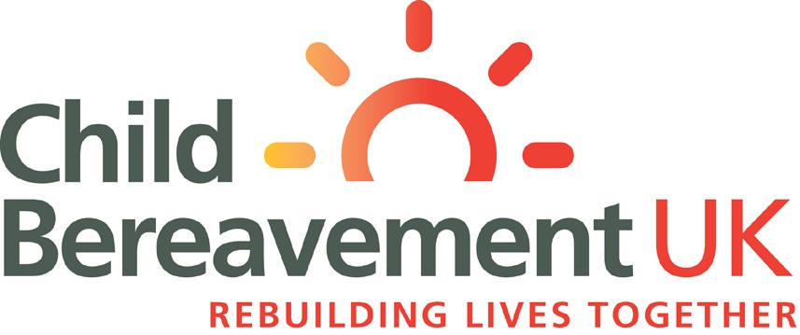
For children 7 - 11

When someone special dies

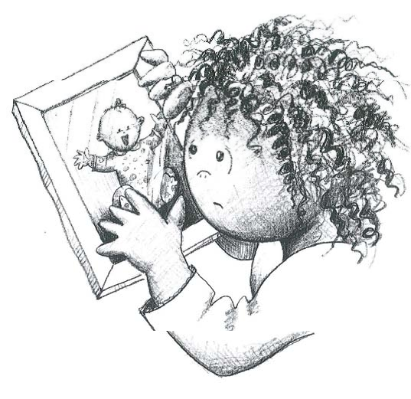

When someone special has died...

This booklet has been given to you because someone special to you has died.

When someone dies things can happen in a rush, and sometimes we can be left confused about what has happened, or have questions we would like answers to.

We hope that this booklet will help you to be clear in your mind about what has happened, and help you understand your feelings.

On the page opposite are some boxes you might
like to fill in - things that you might want to be able to
remember later on.

You could ask someone to help you with this - someone
in your family, a friend or a nurse at the hospital.

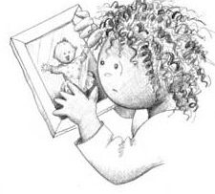
If there is anything you don’t know or don’t understand.......

...... ask someone!
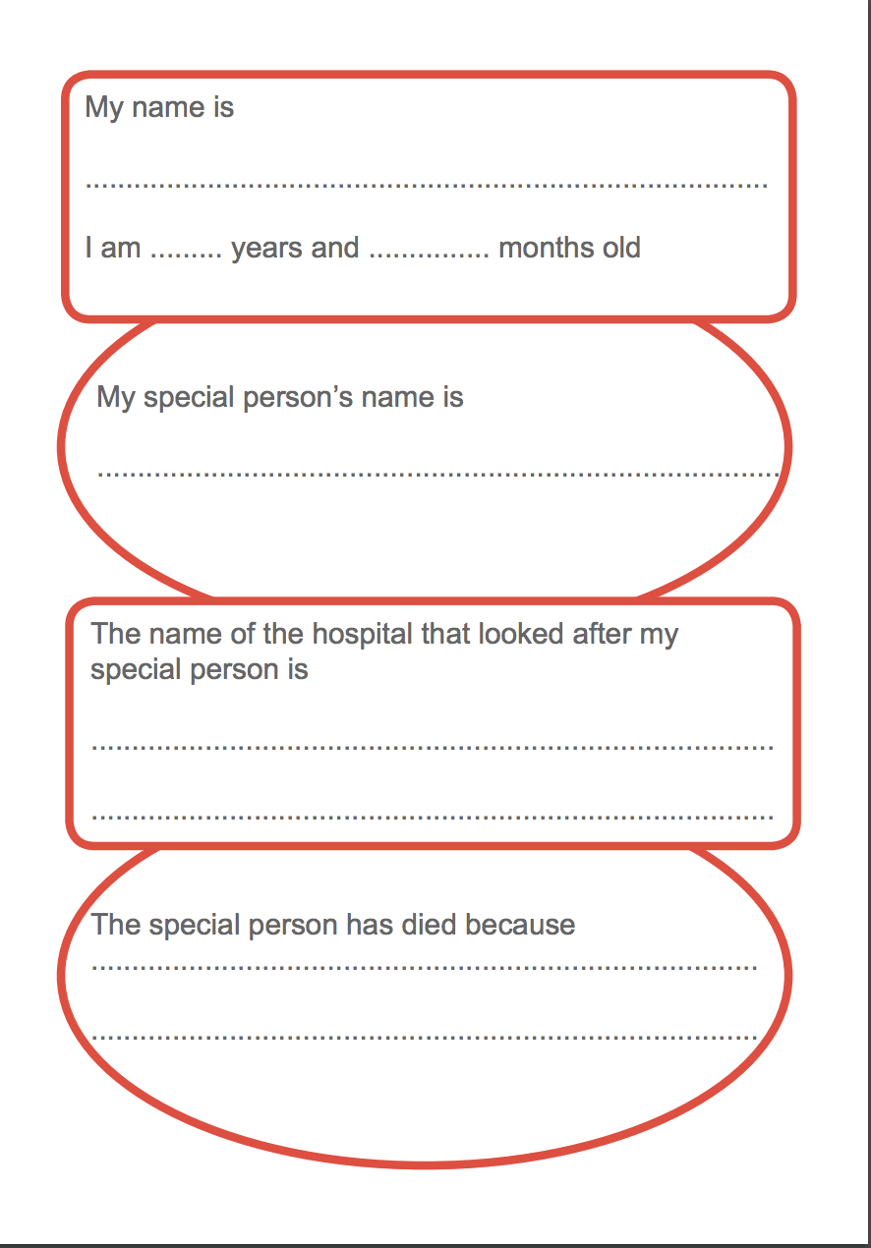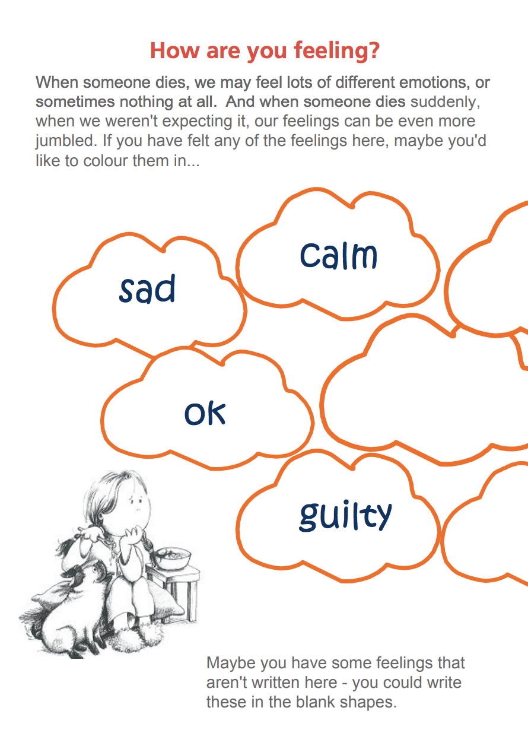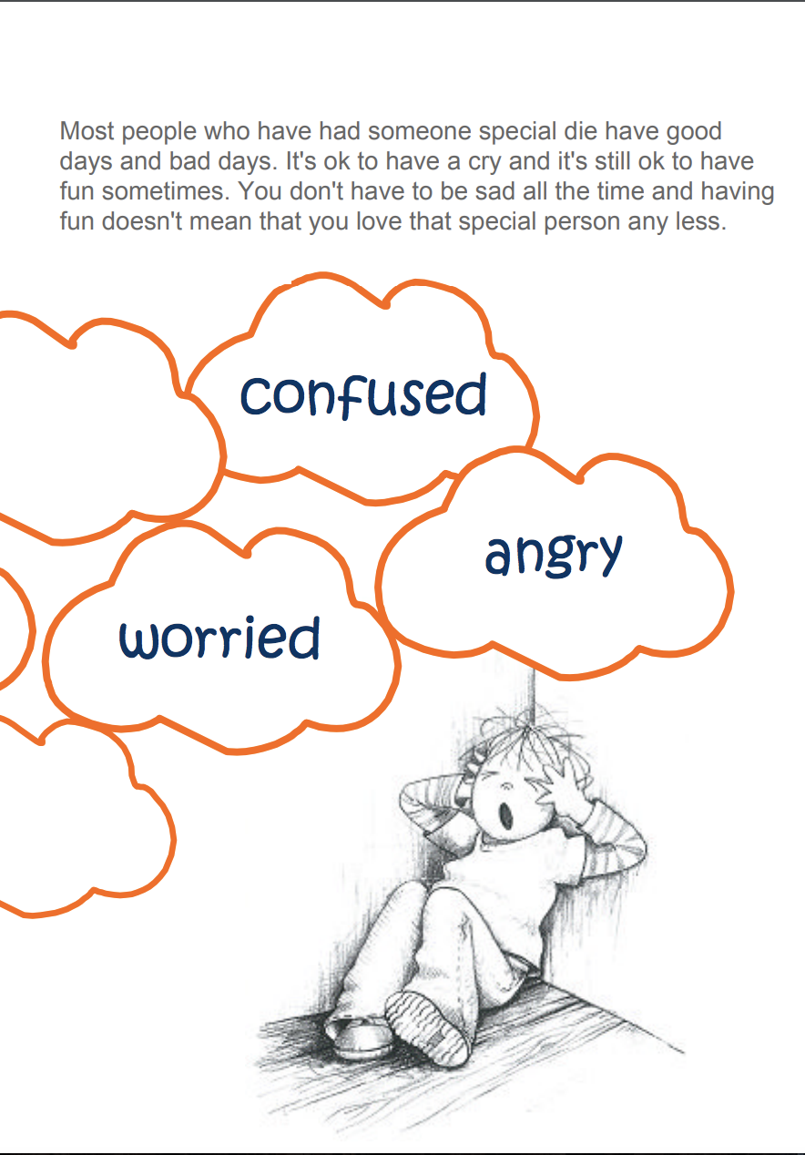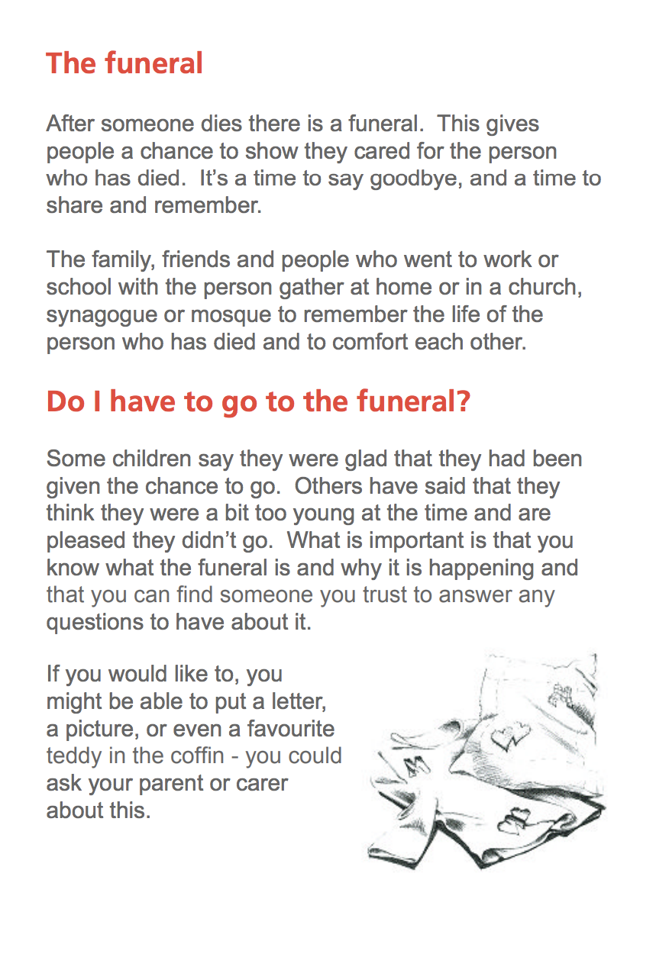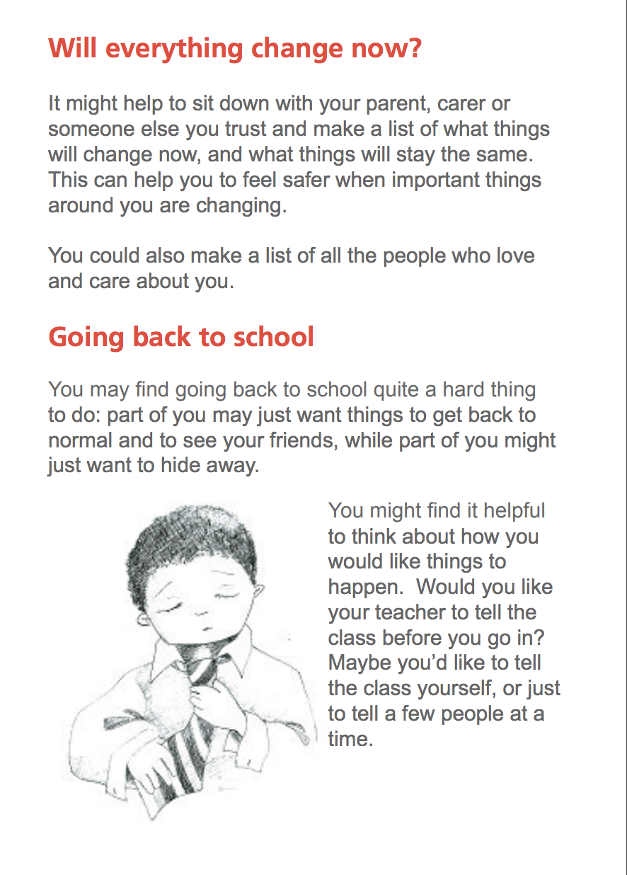

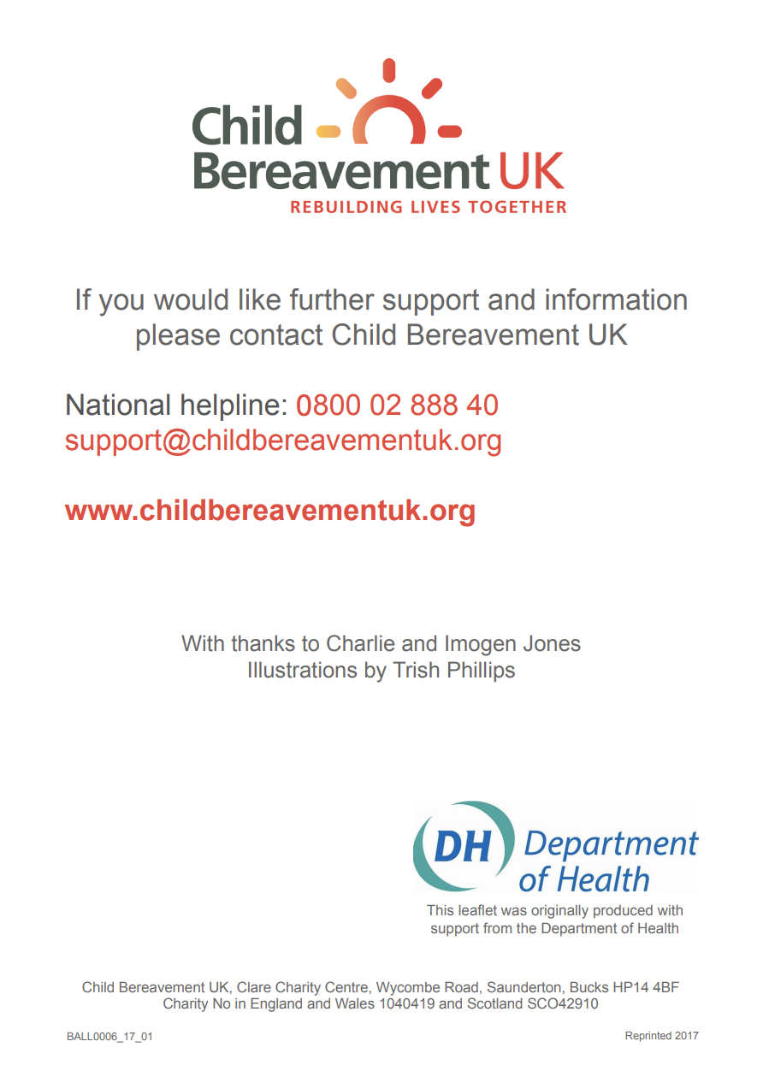

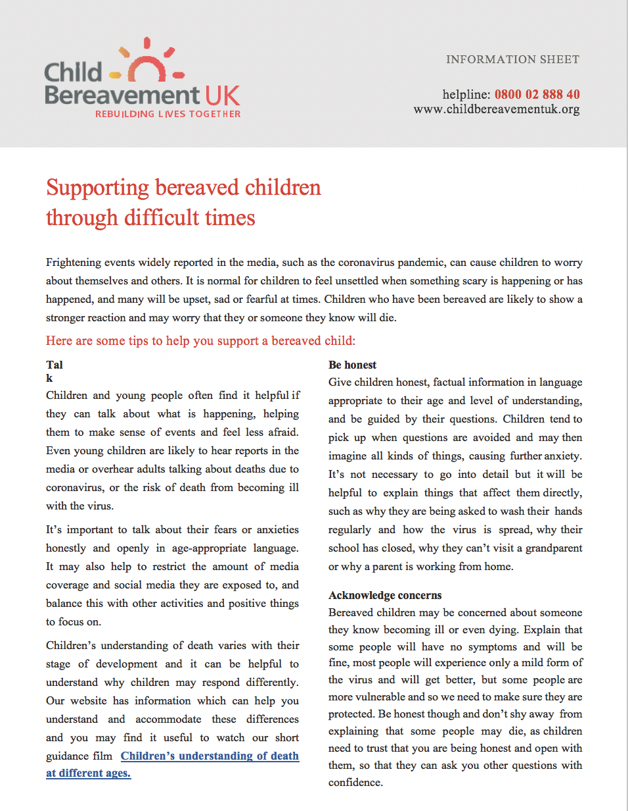
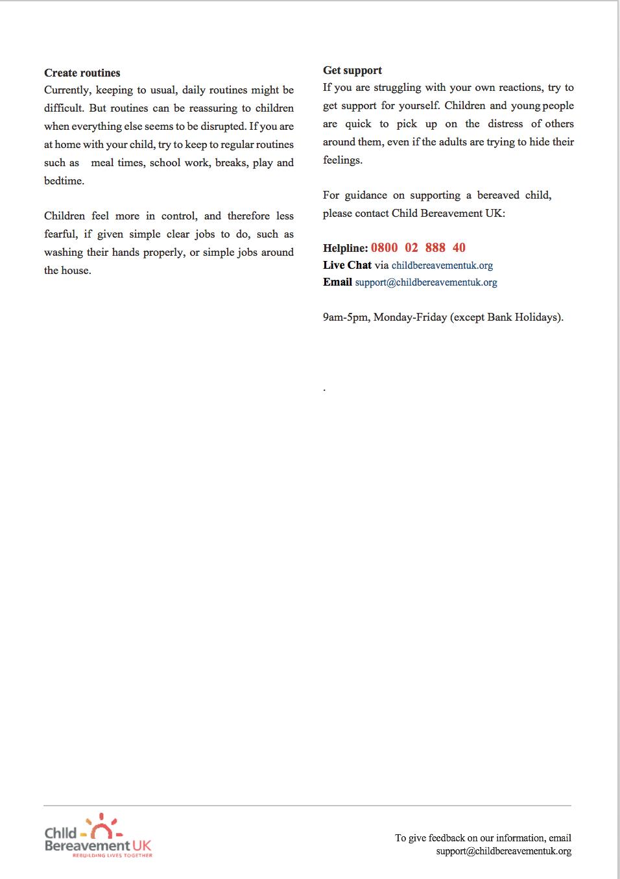

What I should do if I don’t feel safe?

If you are being hurt, treated in a way that makes you feel scared, uncomfortable or unsafe, or you feel very alone or unhappy, please tell someone about it so they can try to help you.
Talk to an adult you can trust. They will listen to you and support you, and talk through what can be done to help sort things out. Very often difficulties can be helped by trusted adults you already know.
Asking for help early on can help stop things getting worse. All adults working with children know that they have a responsibility to protect children from harm.
If you would like to talk to someone in confidence, you can call:
Childline - 0800 1111
You can call anytime for free, it's confidential and the call won't show on the phone bill.

