**Year 4: Home Learning Tasks.**

Here is a range of additional tasks planned by the year 4 teachers (Mr Bowman and Miss Hussey) that you can complete at home in your work from home exercise book.

**English**

**Writing**

* Write a detailed description of your perfect day out for when lockdown is over.
* Write a menu for your family during lockdown. It could be a real menu (describing what you actually eat) or a fantasy one including your favourite treats. Remember: keep it healthy!
* Write a non-fiction report on one of our humanities topics from this year: Romans, Greeks, Iceland, Wales, Mountains or Rivers.
* Write a detailed character description of your favourite TV character. You could describe: appearance, personality, skills or special powers, friends and family and even enemies.
* Write a description of a family pet or your favourite animal. You could illustrate it once you’ve finished the writing.
* Write a diary entry for each day that you are not in school. What did you get up to? How are you feeling? What are you looking forward to?

**Reading**

* Read aloud to someone in your house for 15 minutes a day. They could ask you some questions about the book at the end.
* Write a book review after each book you read. Tips: Briefly describe the plot (but no spoilers), talk about your favourite character, and explain whether you’d recommend the book and why.

**Spelling and word meanings**

* Learn 5 of the year 3 and 4 spelling words each day. Ask somebody at home to test you. (Look, cover, write, check).
* You can also use the spelling menu to help you to practise

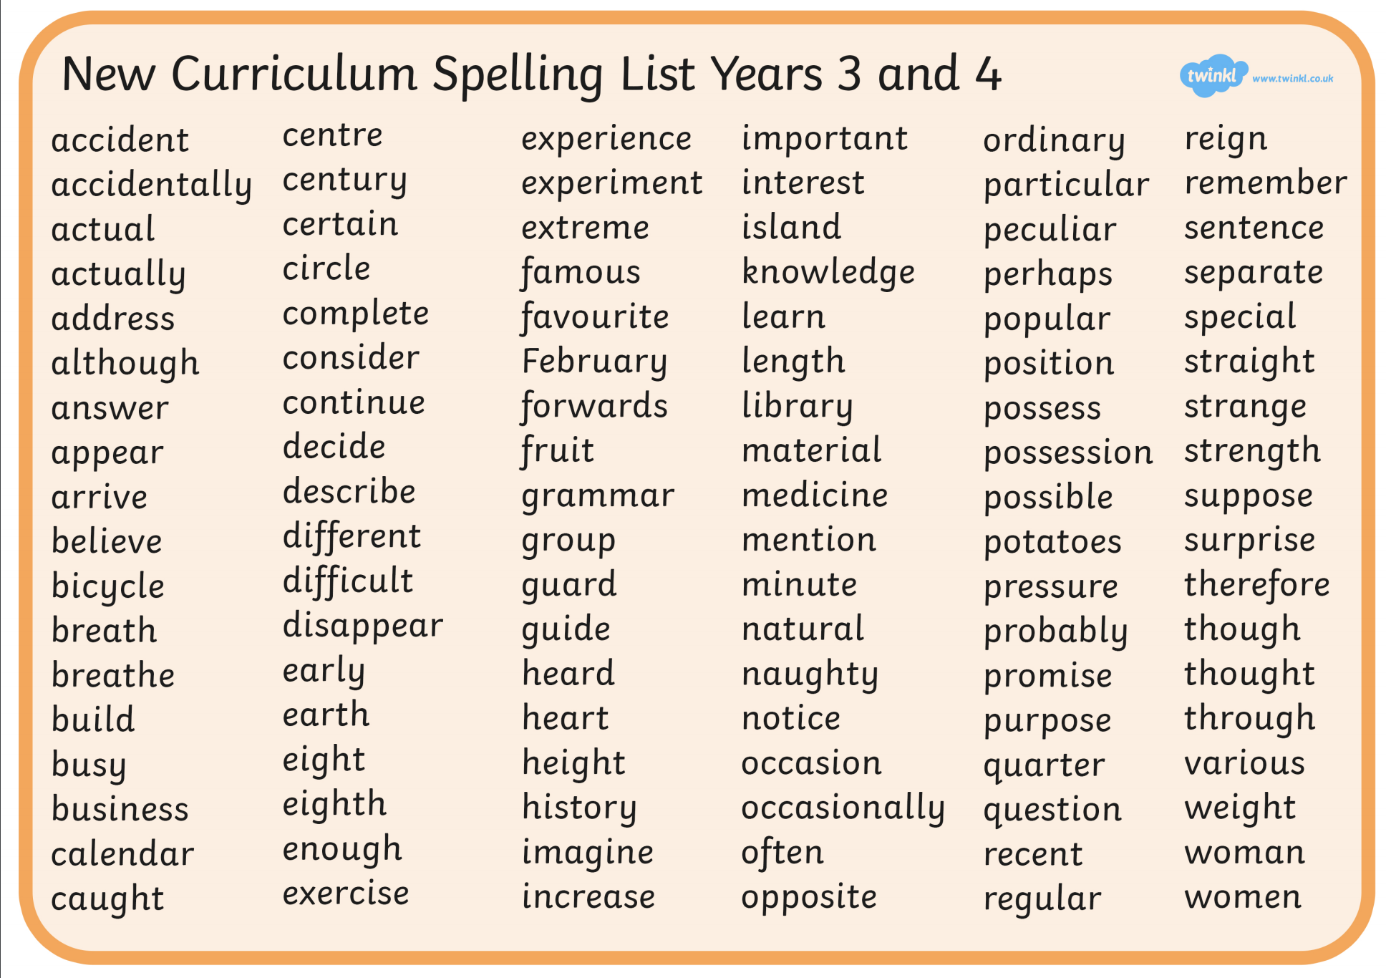

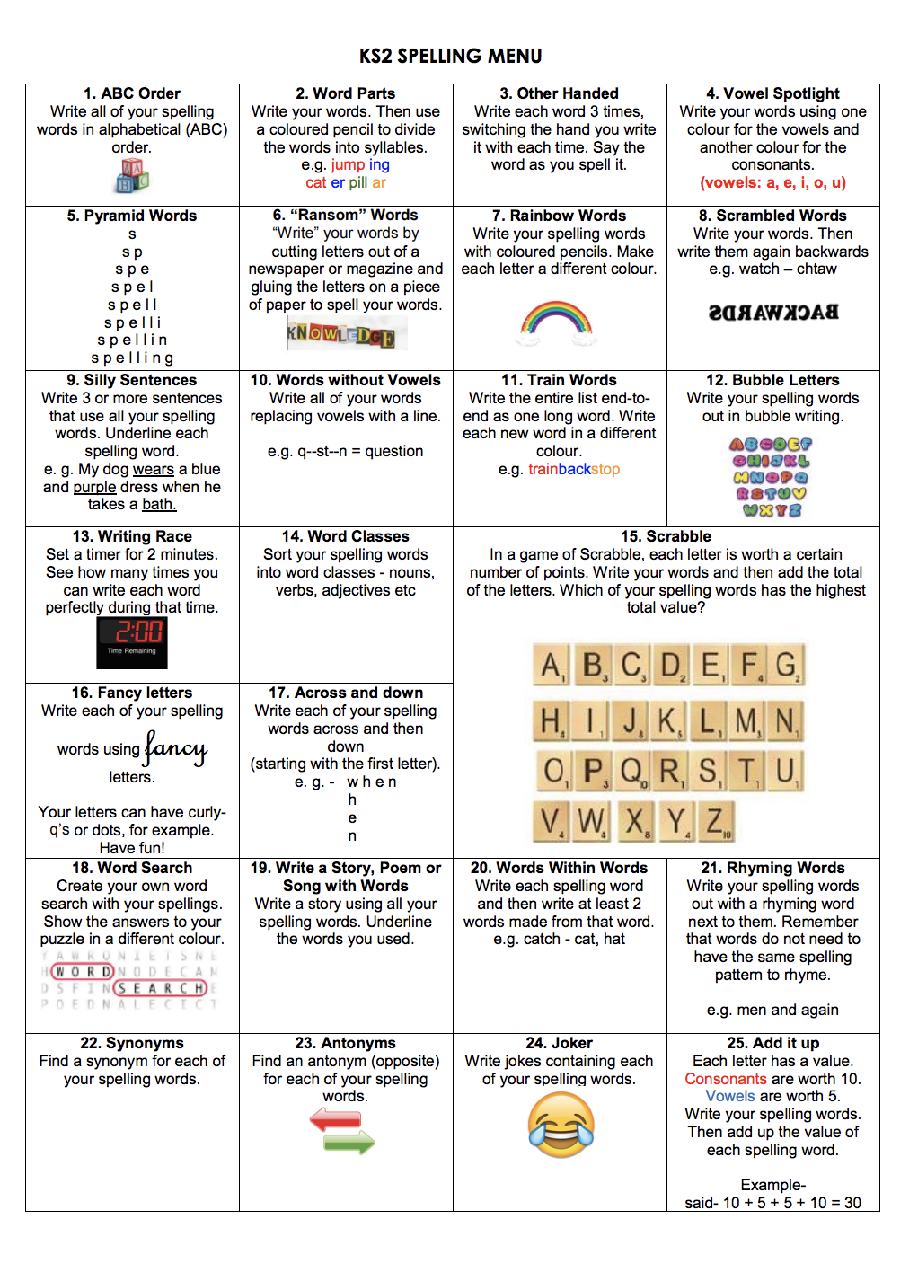

Look up a new word each day in the dictionary. Write 3 sentences which include the word. Use the word in a conversation with somebody else in your house. (You could also use a phone, tablet or computer for this).

**Maths**

* [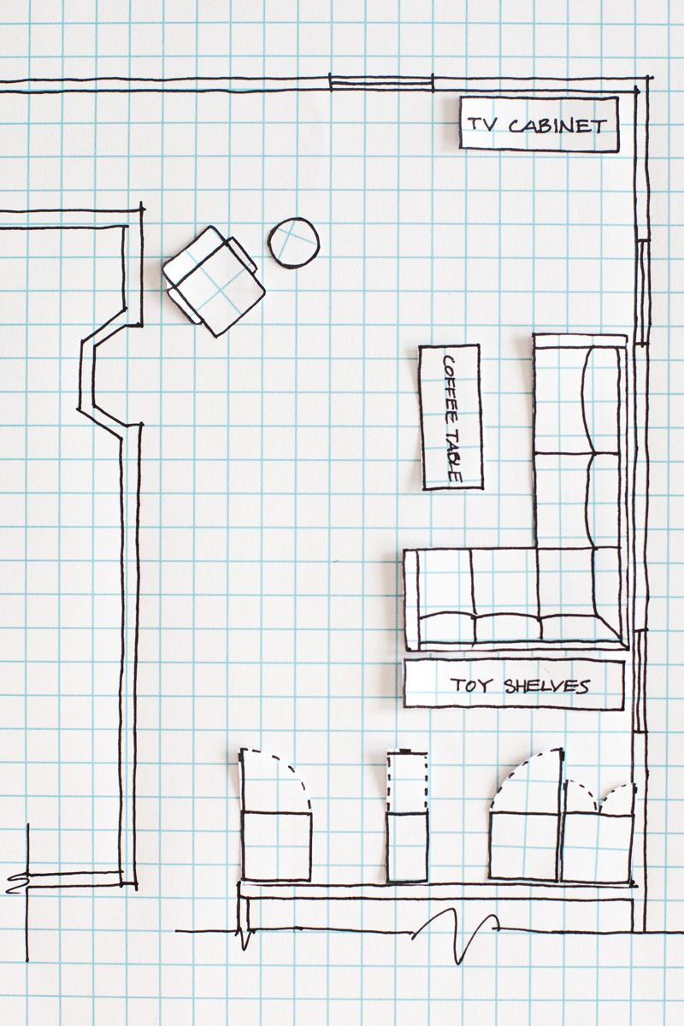](https://www.google.co.uk/url?sa=i&url=https://www.pinterest.com/pin/212091463678856348/&psig=AOvVaw1Zv11M5KtzX5QAktniYxZS&ust=1585670321587000&source=images&cd=vfe&ved=0CAIQjRxqFwoTCPjs-O_HwugCFQAAAAAdAAAAABAD)Choose a times table. Practice writing out the multiplication facts up to 12x. You could time yourself to see which multiplication facts you still need to work on. (e.g. 0x1=0, 1x1=1, 2x1=2… etc.)
* Design a floorplan of your ideal bedroom in your maths book using straight lines only. Try and make sure the drawings are to scale. Include measurements. (see example)

Take part in a shape hunt around the house. You do this by collecting different objects from around the house and then writing the following information in a table:

* Name of object
* Is it 2D or 3D?
* For 2D: How many corners/ sides?
* For 3D: How many edges/ faces/ vertices?
* Is it symmetrical?

Make a potion at home using a jug for measurements. Write down your recipe and explain how the potion works eg:

* 100ml of water
* 25ml of orange squash
* 6ml of blackcurrant squash

This potion is used for super strength

Measure different items that are a square or rectangle (bed, cupboard, frame, book etc…) around your house using a ruler or tape measure and record as a table.

Top tip – remember to get the measurement unit right!

|  |  |  |
| --- | --- | --- |
| Item | length | width |
| book | 30cm | 10cm |
| frame | 10cm | 5cm |

When you have created a table of various items, see if you can find the perimeter and area of your objects.

Example:

* **Book.** – **perimeter** = length + length + width + width

30cm + 30cm + 10cm + 10cm = 80cm

* **Area** = length x width

30cm x 10cm = 300cm2

**Humanities** (History/ Geography)

Design an information poster about your favourite country or city. (You could use Greece or Rome).

Make a holiday brochure about your dream holiday destination. It could be somewhere you’ve been (like London or Blackpool) or somewhere exotic like Hawaii or India.

Can you design your own building? Where in the world would you put it? Would it be in a city or in the country side? Why have you decided on your design? If you have materials at home such as a shoe box, see if you can have a go at making it?

What is your favourite myth? (Could it be Pandora’s Box? Jason and the Argonauts? Theseus and the Minotaur?). Can you create a fact file for the characters that you have created? Think about the name, strength, reaction to humans, where it lives?

Can you draw a Roman soldier and describe what they wear in battle? Can you describe how a Roman soldier fights?

Can you create a poster about the Romans? Think about the things they have invented, what they brought to Britain, how they dressed, what they ate.

**PE/ Physical Education**

Take part in the daily Joe Wicks workout via YouTube (9am every morning).

Go for a family walk for up to half an hour a day.

If you have outside space, play a ball game with a family member.

**Science**

Could you help an adult to look after any household plants you might have?

Find 5 household objects made of different materials. Make a table:

- Object

- Where did you find it?

- What is it made of?

- What are their properties? (hard, soft, smooth, rough)

- Why do you think it is made from this material?

Can you create an information text about how to look after your teeth? Can you include a diagram with the name of the different teeth in our mouth? Can you include top tips to look after our teeth?

Can you create a labelled diagram of the digestive system? Can you provide information how each part works? Eg: saliva in the mouth helps to moisten and break down food.

Can you create an instrument at home? How does it work? What is it made of? What does it sound like?

Can you make a table of different sounds that you hear around your house? (This can be inside or outside). Can you describe the sound? Is the pitch high or low? Is the volume loud or quiet?

Go on a search around your house. What items use electricity (mains or battery powered). Can draw a picture of each object you find (remember to label what it is!) and tell me if it is mains or battery operated.

**RE**

Remember the things that we have around us to be thankful for – family, friends, a home etc.. Write a prayer to thank God for all of the things that we are grateful for.

Think about the Easter story. Jesus went through a time of great hardship to help our lives. What things could we do during Easter to show how grateful we are eg: give mum a hug, help clean the house

Get the family involved and see can you have a go at acting out one or more scenes from the Easter story. You will need to create a script so everyone knows what to say and do!