Life Skills

Healthy Lifestyles

I know how we can stop the spread of infection

Micro-organisms, also known as germs, bugs or microbes, are tiny living organisms too small to be seen with the naked eye. They are found almost everywhere on earth. Some microbes are beneficial and others can be harmful to humans (this will be explored in later sections). Although extremely small, microbes come in many different shapes and sizes. There are three main groups of microbes: Viruses are the smallest of the microbes and are generally harmful to humans. Viruses cannot survive by themselves. They need a ‘host’ cell in order to survive and reproduce. Once inside the host cell, they rapidly multiply and destroy the cell in the process! Fungi are multi cellular organisms that can be both beneficial and harmful to humans. Fungi obtain their food by either decomposing dead organic matter or by living as parasites on a host. Fungi can be harmful by causing infection or being poisonous to eat; others can be beneficial or harmless, e.g. Penicillium which produces the antibiotic penicillin. There are also fungi that are not microbes and some that can be eaten like Agaricus, commonly known as the white button mushroom. Bacteria are single-celled organisms that can multiply exponentially once every 20 minutes. During their normal growth, some produce substances (toxins) which are extremely harmful to humans and cause us disease (Staphylococcus); other bacteria are completely harmless to humans and others can be extremely useful to us (Lactobacillus in the food industry), some are even necessary for human life such as those involved in plant growth (Rhizobacterium). Harmless bacteria are called non-pathogenic, while harmful bacteria are known as pathogenic. Over 70% of bacteria are non-pathogenic. Bacteria can be simply divided into three groups by their shapes – cocci (balls), bacilli (rods) and spirals. Cocci can also be broken down into three groups by how the cocci are arranged: staphylococci (clusters), streptococci (chains) and diplococci (pairs). Scientists use these shapes to tell which infection a patient has.

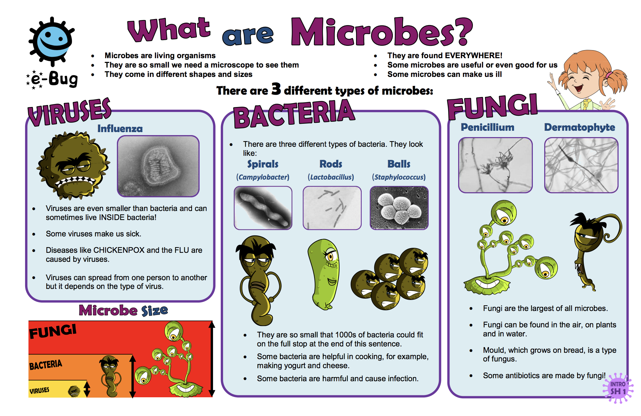
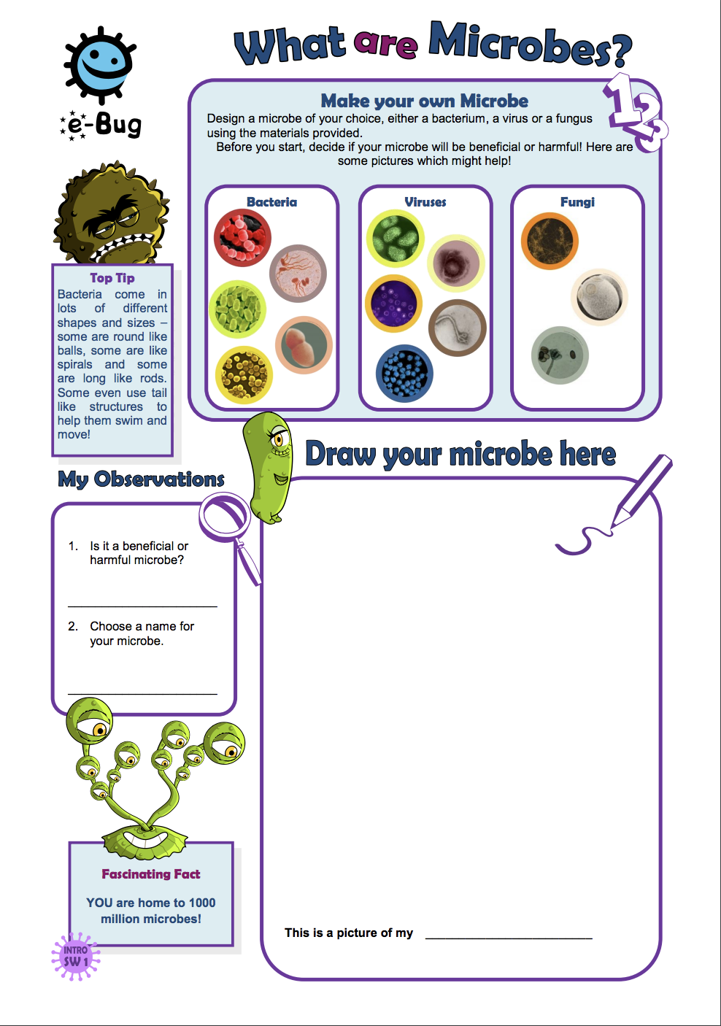
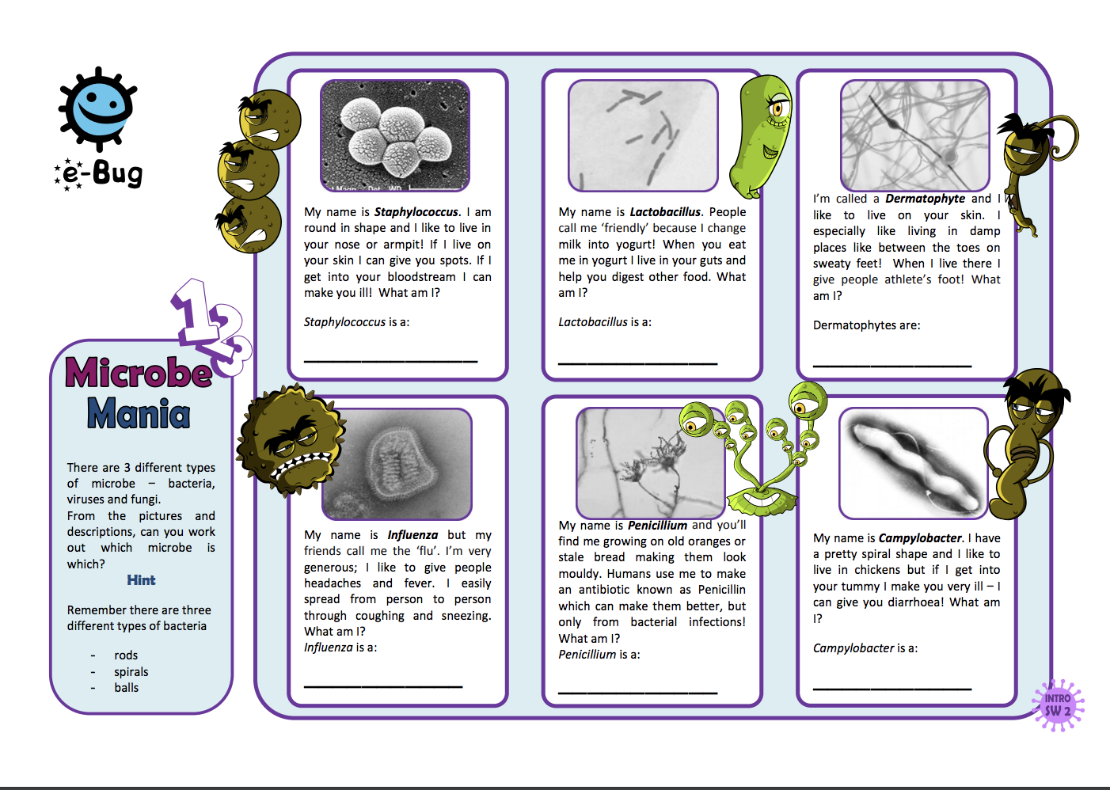
Can you and your child think of ways in which we ensure good personal hygiene to ensure that we don’t get sick from these microbes? Can you create a poster to show some of the things that you do? Eg: take a bath, wash our hands…

I understand the importance of good quality sleep

GETTING TO SLEEP
When you’re struggling to get to sleep it can have a big effect on you. It can make it harder to concentrate during the day, or make you feel low and less able to cope.
There are lots of things that might make it difficult to get to sleep, including:
- struggling with difficult feelings or memories
- worrying about homework or exams
- difficulties at home
- having an unhealthy routine or diet.
But there are ways you can cope.

CAN'T SLEEP BECAUSE OF STRESS?
When they are lots of things on your mind, getting to sleep can be hard. You might be worrying about exams or homework, struggling with things at home or feeling anxious.

Learning how to relax and manage stress can help you to cope when things are getting too much.

Try to:
- focus on your breathing
take deep breaths in through your nose and out through your mouth. Some people find it helps to close their eyes and count to 4 when they breathe in, and to 7 when they breathe out.
- turn off social media
it can tempting to look at your phone when you're worried or stressed. You might want to distract yourself or be worried about missing something. But taking a break can help you to relax.
- email a Childline counsellor
why not put all your worries in an email to a Childline counsellor? Once it's sent, you can rest easy, knowing someone's there to support you and will get back to you with help and advice. Counsellors reply to emails within 24 hours.

8 TIPS FOR BETTER SLEEP
Relax before going to bed
Some people find reading helpful. But stick to paper books - the light from computer screens and some e-readers can make it harder to fall asleep. It's best if you have no screen time for at least 30 minutes before you plan to sleep.
Make sure you're comfortable
Not too hot or cold, and that the room you're in isn't too noisy or bright.
Do some exercise
Don't overdo it, but try some regular swimming or walking. The best time to exercise is in the daytime – particularly late afternoon or early evening. Later than this can disturb your sleep. Exercise burns off excess energy and releases endorphins – natural chemicals that help you de-stress, feel less anxious and more relaxed.
Write it down
If something is troubling you and there’s nothing you can do about it right away, try writing it down before going to bed. Once it’s written down, you can tell yourself you’ll deal with it tomorrow.
List things that make you feel good
These don't have to be big things - they could include the weather, your favourite song or someone in your life that you enjoy seeing. Keep the list nearby.
Only use your bed for sleep
If you can't get to sleep after about 20 minutes, get up and do something that relaxes you. When you feel ready, go back to bed.
Turn off your phone
If you’re being kept awake by friends ringing or texting you, you could ask them to stop. Or just switch your phone to silent or ‘do not disturb’ – or even turn it off.
Picture yourself in your favourite place
Close your eyes and imagine you’re in your favourite place or where you want to be one day. Imagine yourself happy and relaxed. Slowly breathe in and out, relaxing your muscles until you feel a sense of calm.
Can you create a poster for someone in your family with tips about how to get a good nights sleep.

Keeping Safe

Managing Risk

Explain to your child that you are going to ask them to draw and write about something which different people describe in different ways. Tell them they are going to draw and write about what risk means to them.
- Ask them to draw someone their own age doing something risky. (It can be a stick person). Do not clarify what risky means, tell them to draw what they think it means or write "I don't know"
- Ask them to write, under the picture, what is happening in the picture
- Ask them to write what makes this risky
- Finally ask them to return to their drawing and draw themselves in the scene. What would they be doing or saying to help?

Often young people (and many adults!) equate risk with danger. Explain to your child that sometimes risk might not mean danger. It might be taking an opportunity like starting a new business.

With your child, see can you identify any hazards or risks in the home eg: the hob may be a hazard to the home if left on all night. Therefore, we make sure to turn this off when we are not using it.
See what other risks/hazards you may find and think of ways in which you manage these risks.

Cyberbullying

What is cyberbullying? How can we explain it?

Cyberbullying uses different technologies such as computers, mobile phones or digital cameras to offend, harass, or make somebody else’s life a misery.
It can be instant and shared across the internet at any time of the day or night.

There are some simple actions you can take if this happens to you.

- Change your contact details
- Block contacts
- Change your password
- Change your mobile number
- Tell an adult you trust
Home activity

Create a poster with clear guidelines on how to help other young people know what to do if they are ever a victim of being cyberbullied. The following points may help.

- Respect each other - Always think carefully before saying anything online or in a text.
- Don’t reply to a nasty message, keep it but ignore it.
- Keep evidence and learn how to take a screengrab if someone sends you a nasty message or picture
- News travels very fast on the internet, one tiny thought can last a lifetime.
- Keep all personal details private, only give out mobile numbers to people you trust.
- If someone makes you feel uncomfortable, block them.
- Tell an adult you trust or call Childline.
- If you see this type of bullying happening to someone else, don’t just stand there. Think how you would feel.
- Report it and help the victim.

First Aid

For some free first aid resources to do at home, visit https://www.sja.org.uk/get-advice/a-z-of-first-aid-teaching-courses/

What to do in an emergency

Introducing first aid
These assembly-time activities are the perfect way to introduce first aid education to pupils in your school. You can just use Activity 1 if you don’t have time for both activities.

Age group: This assembly kit is designed for 7–11-year-olds, if you would like to broaden out this learning to other age groups see our first aid resources for 5–11-year-olds: Life. Live it.

Curriculum subjects covered: PSHE. See the Life. Live it. lesson plans for curriculum links for all UK regions.

Activity 1: short story
- Introduce the session: ask the pupils ‘What is first aid?’ [First aid is the first help that someone is given when they have an injury or sudden illness.]
- Tell the following short story. You can tell your own story about a real first aid emergency if you prefer.

Short story
Seven-year-old Tom was in the car on his way to football practice, and the traffic was terrible. He was desperate not to be late: it was his turn to be captain of the blue team. So when his mum finally drove into the car park and dropped him off, Tom raced across the field to meet his friends and coach.

And then… THUMP and CRACK. Tom tripped over some logs and landed in a ball of pain on the grass. His left arm hurt… a lot. And his mum had already driven away. Where were his friends? He couldn’t see anyone and he was scared. Tom cried out, hoping that someone could hear.

Anni heard him! She looked out across the field and saw her friend crumpled on the ground. While telling the coach where she was going, she ran (carefully!) over to Tom. ‘It huuurts,’ Tom wailed.

Anni had learnt some first aid in school, and realised that Tom might have broken his arm as it was a funny shape. She knew he must keep his arm still, so she told him to hold it still and not move it.
By this time, the football coach had come over to find out what was happening. Anni borrowed his phone and called 999 for the emergency services. An ambulance was coming, they said, and they asked Anni and the coach to stay with Tom and keep him company until it arrived. Tom was very relieved to have Anni there chatting to him and keeping him company. His arm still hurt A LOT, but he felt much better now that Anni had taken charge and the ambulance was on its way.

Ask questions after the story, such as:
- How did Tom feel while no one was helping him?
- How did Tom feel when Anni came over to help him?
- What first aid did Anni give Tom? [Anni called 999, checked Tom’s arm was supported and still, and talked to Tom to comfort him.]
- How do you think Anni felt after helping Tom?

Activity 2: role play
- Role play with two pupils and a teacher (with you the teacher as a 999 operator). Pupil 1 has broken their arm and Pupil 2 is a helper. Pupil 1 acts falling off something and breaking an arm (lots of dramatised pain!). Pupil 2 calls 999.
- Use the script to act as the operator for the emergency phone call. Use props if possible (e.g. a headset and a mobile phone for the emergency call).
Operator script
Hello, emergency service operator. Which service do you require? Fire, police, or ambulance?

I’ll connect you now.

Hello, what is your name?

What number are you calling from?

Where are you?

What has happened?

Can you see any bleeding?

Can you make sure that he/she keeps his/her arm still and that it is supported?

Can you see any hazards or dangers around?

Please make sure you don’t put yourself in any danger while you’re helping.

The ambulance is on its way. Please don’t put the phone down until I say.

- Inform pupils that the operator’s questions and advice are likely to change according to individual situations.

Plenary
- Ask pupils which number they should call in an emergency.
- Ask pupils if they would like to know more about how to help people who are hurt or suddenly ill. If applicable, tell them that they will be learning more about first aid in their lessons using Life. Live it. First aid education for children
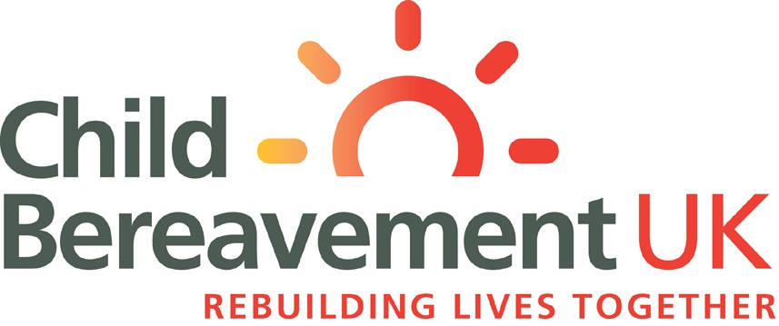

For children 7 - 11

When someone special dies
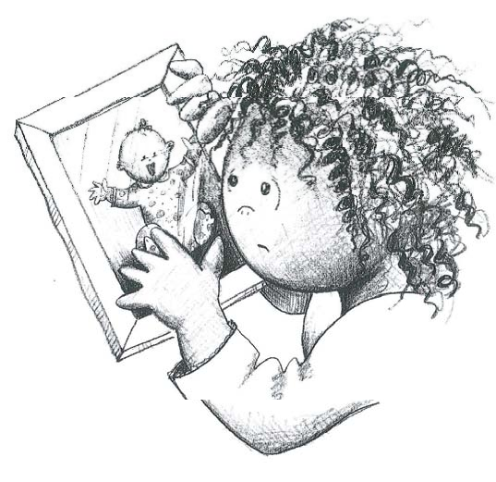

When someone special has died...

This booklet has been given to you because someone special to you has died.

When someone dies things can happen in a rush, and sometimes we can be left confused about what has happened, or have questions we would like answers to.

We hope that this booklet will help you to be clear in your mind about what has happened, and help you understand your feelings.

On the page opposite are some boxes you might
like to fill in - things that you might want to be able to
remember later on.

You could ask someone to help you with this - someone
in your family, a friend or a nurse at the hospital.

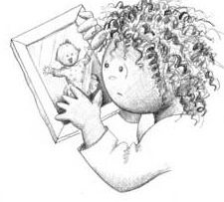
If there is anything you don’t know or don’t understand.......

...... ask someone!
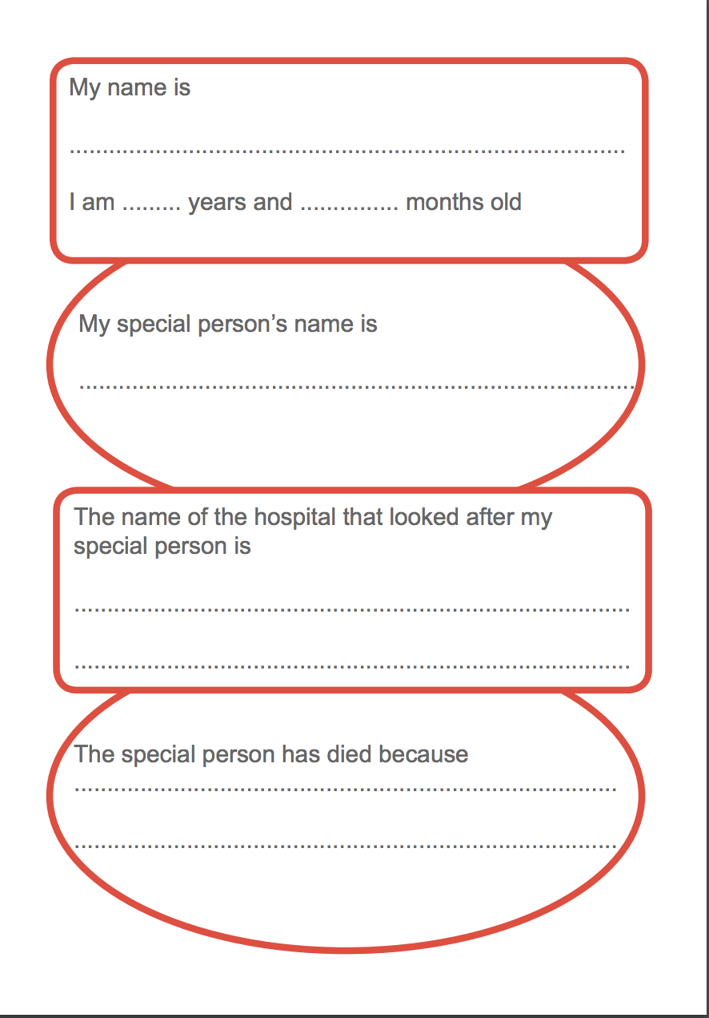

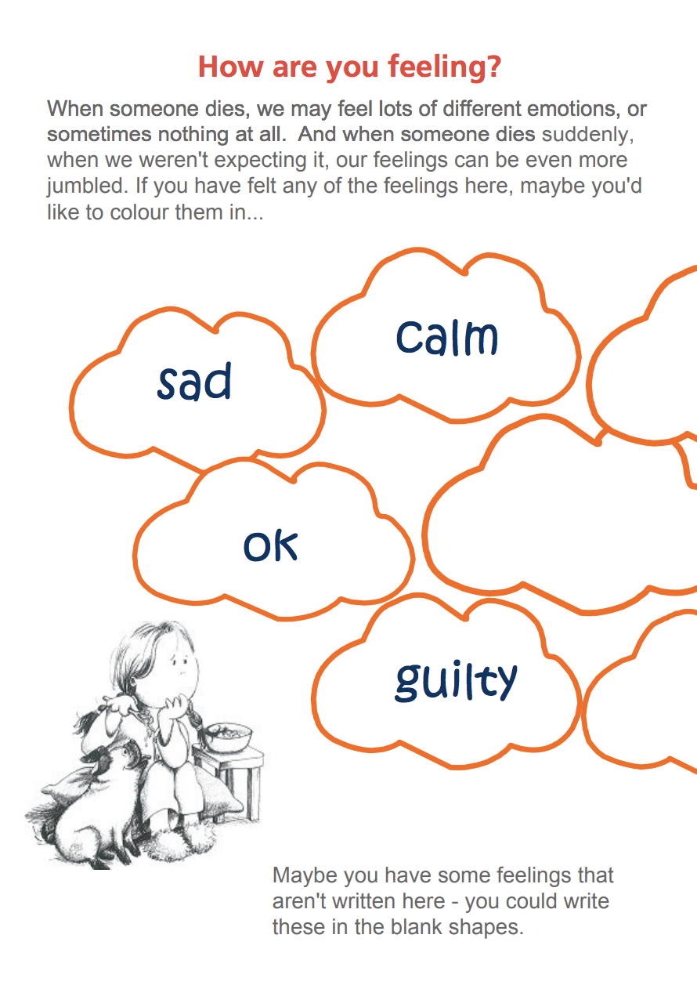

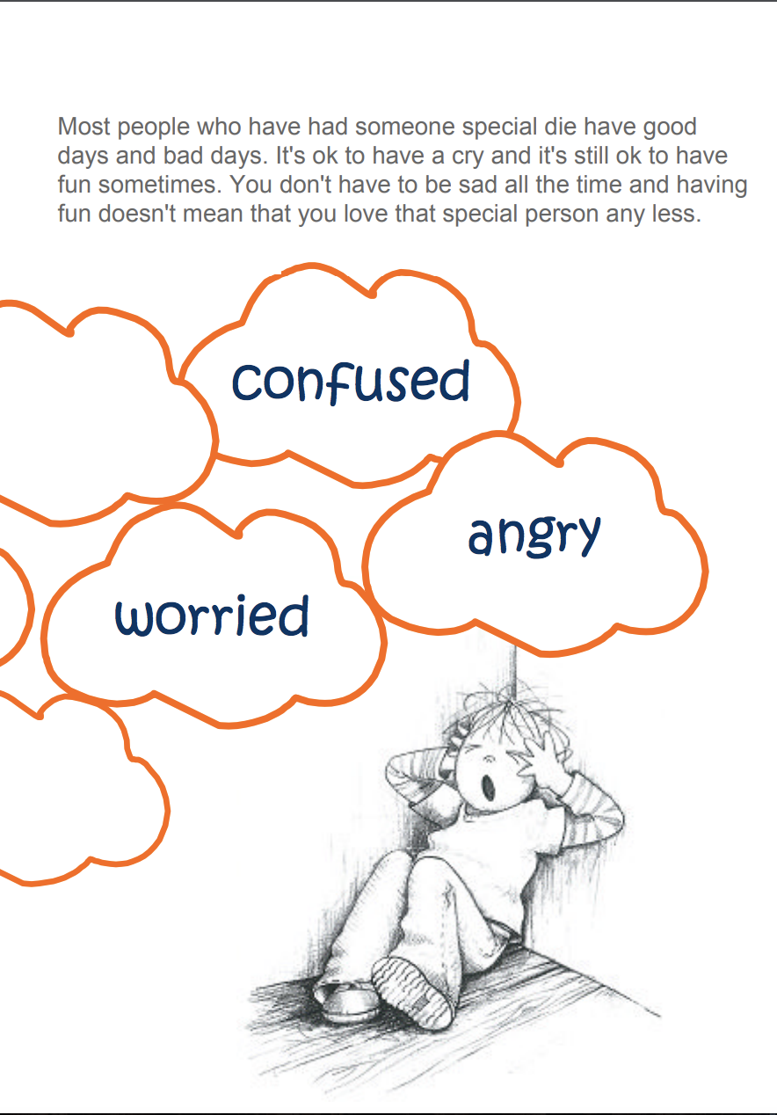

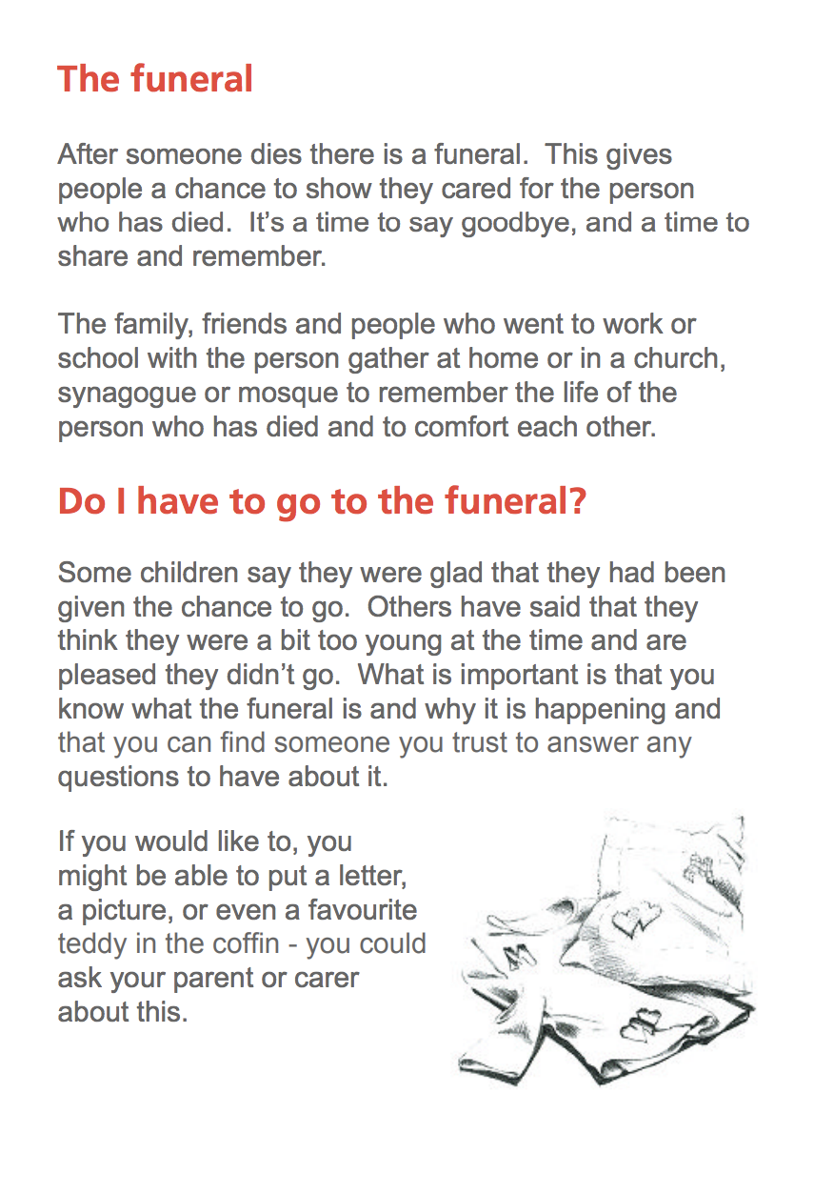

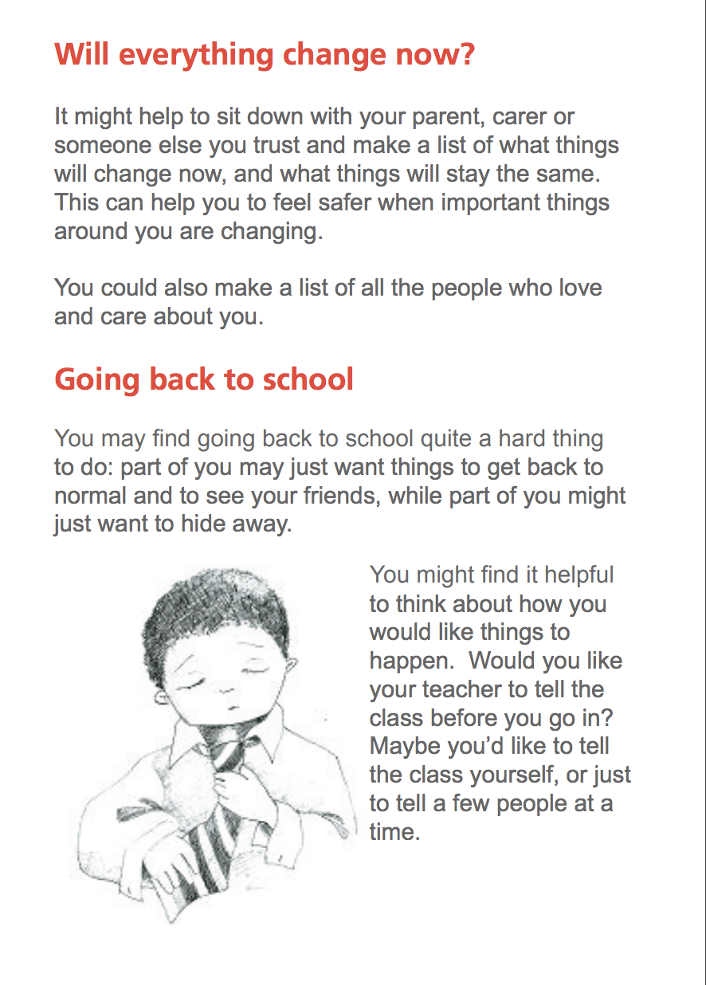

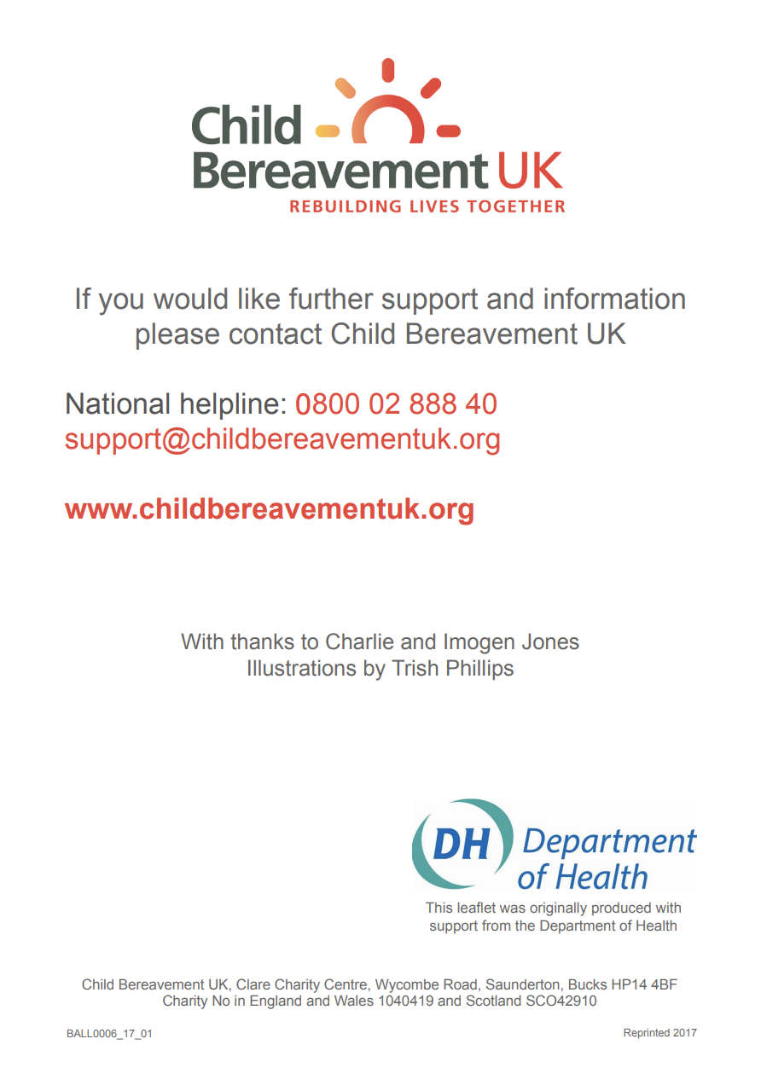

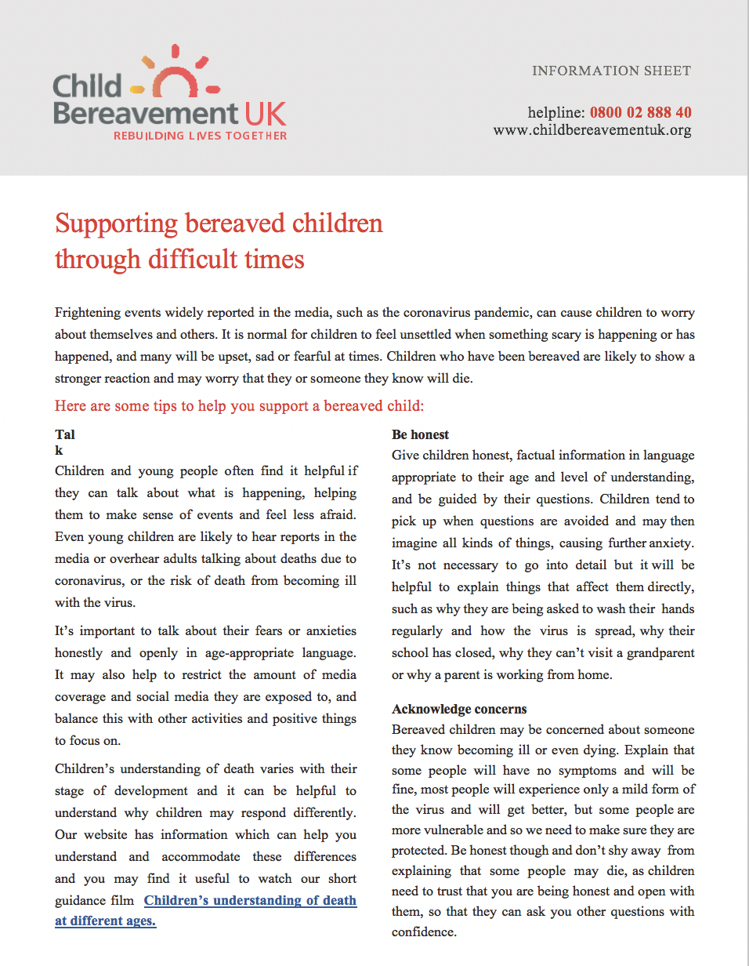

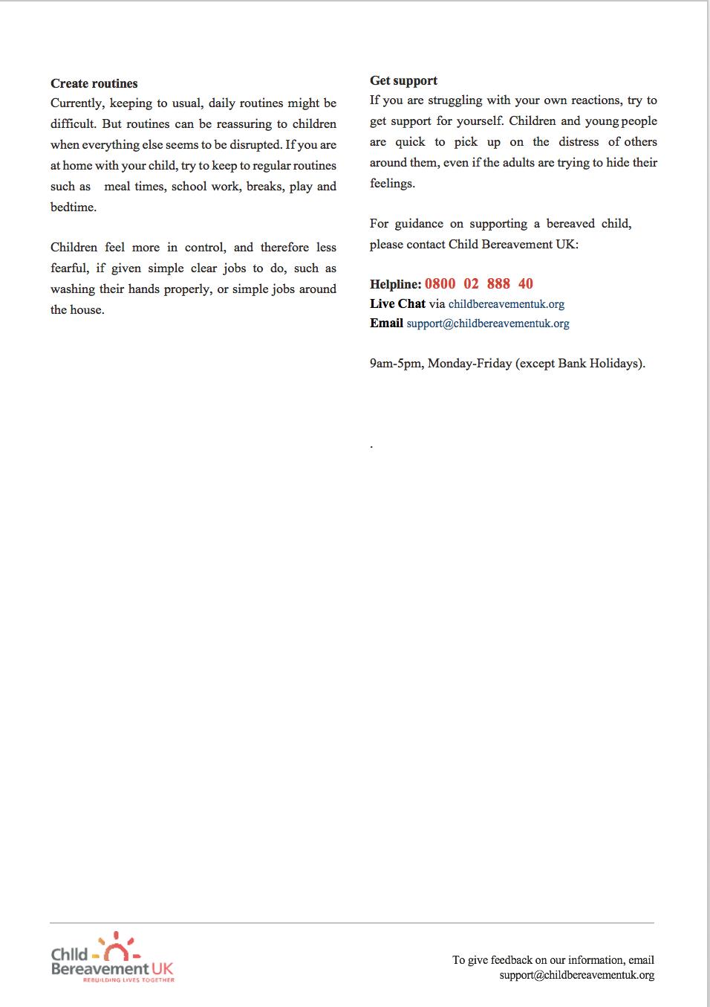
What I should do if I don’t feel safe?

If you are being hurt, treated in a way that makes you feel scared, uncomfortable or unsafe, or you feel very alone or unhappy, please tell someone about it so they can try to help you.
Talk to an adult you can trust. They will listen to you and support you, and talk through what can be done to help sort things out. Very often difficulties can be helped by trusted adults you already know.
Asking for help early on can help stop things getting worse. All adults working with children know that they have a responsibility to protect children from harm.
If you would like to talk to someone in confidence, you can call:
Childline - 0800 1111
You can call anytime for free, it's confidential and the call won't show on the phone bill.

