**Child Protection at St. Anne’s RC Primary School**



**What is child protection about?**

At St. Anne’s RC Primary School, all of the adults around you think that your health, safety and welfare are very important. In our school, we respect our children and want to keep you safe and help to protect your rights.

We do our best to help you to make good progress in your school work and to be happy.

We teach you how to recognise risks in different situations and how to protect yourselves and stay safe.



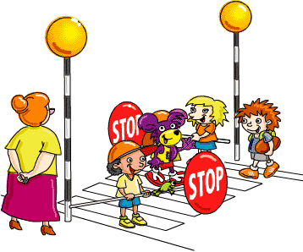**How will we try to protect you?**

* We try to provide a safe environment for you to learn in.
* We want to ensure that you remain safe, at home as well as at school.
* We think it is important for you to know where to get help if you are worried or unhappy about something.

**If you need to talk – we will listen!**

* You can talk to any adult in school - including ... (insert teacher and teaching assistant name)
* You can also talk to any member of staff on the yard or in the dinner hall.
* It is Mrs Haggett’s, Mrs Clegg’s, Mrs Parker’s important job to keep you safe - talk to any of these people if you are worried.
* Put something in the worry box.
* Tell a friend and then go with your friend to tell an adult.

**Don’t keep it a secret if someone is:**

* Bullying you;
* Saying funny things to you that you do not like or which upsets you;
* Touching you;
* Trying to give you tablets, cigarettes, drugs or alcohol;
* Hitting you or hurting you;
* Taking your things;
* 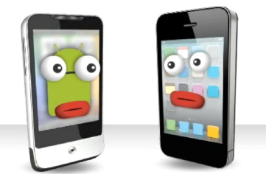Sending unkind messages on the internet or to your phone.