SAFEGUARDING AT ST. ANNE’S R.C. PRIMARY SCHOOL
Working, Learning, Caring together in God’s love.
SAFEGUARDING IS EVERYONE’S RESPONSIBILITY
St. Anne’s R.C. Primary School is committed to maintaining the safety and well-being of all children. If you have any concerns, queries or a child makes a disclosure to you, please contact one of the following IMMEDIATELY:
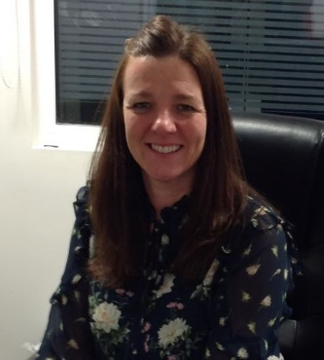  Mrs Parker  Acting Headteacher  Designated Safeguarding Lead | Mrs Haggett  Acting Deputy Headteacher  Safeguarding Team | Mrs Clegg  Acting Deputy Headteacher  Safeguarding Team | 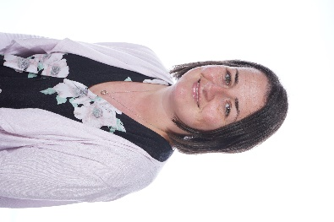  Mrs Delves  Acting SENCO  Safeguarding Team

Record of Concern forms are located in shared areas around the school, the school office and staffroom. If you have a concern about the safety of any child or young person, you can also contact Children’s Services.
Children’s Services
Where there is a concern about a child’s safety, the law says we must protect that child. A Social Worker will discuss with the family the best way to do this. Taking children away from the family is not usually the answer and rarely happens.
Telephone: MASH TEAM: 0161 234 5001 (For advice or a referral)
You can also contact the NSPCC with any concerns on 0808 800 5000 or visit the NSPCC website.
For allegations against staff contact the Designated Safeguarding Lead or contact the Local Authority Designated Officer (LADO) directly: 0161 234 1214.

