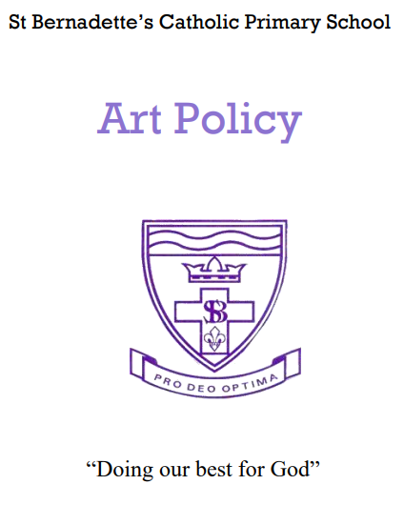

**St Bernadette’s Catholic Primary School - Art & Design Policy**

***– Our Vision –***

*Through the experiences a child has, we want them to understand an artist's way of seeing, their perspective, their talk in the type of work they do, the colours they use, the images and story they wish to convey.*

**Aims and objectives**

Through the teaching of Art, we hope the children will be engaged, inspired and challenged. They will learn skills to experiment, design and create their own works of art and craft.

We believe that Art forms an important part of the curriculum, where children are given the opportunity to stimulate and develop their creativity and imagination alongside developing emotional and intellectual confidence.

Art is an integral part of other curriculum areas as it helps with visualisation and spatial awareness.

As a result of this learning we hope that children who have the aspiration to follow a variety of career paths, including the Arts will be equipped with the skills, knowledge and passion to do so. We use the talents we have been given to achieve the best we can and aspire to greater things through the Arts.

**Teaching and learning style**

At St Bernadette’s Catholic Primary School all children will be given the opportunity to:

* Work creatively, exploring ideas using imagination and first-hand experiences to translate into their own work.
* Develop skills in drawing, painting, sculpture, printing, textiles and collage. These skills will be re-visited yearly.
* Develop their ability to use a variety of Art media, materials, tools and techniques with progressive skill and with safety.
* Work in a Sketchbook and an Art Book with includes sketches, designs, investigations and experiments prior to a finished piece of work.
* Evaluate their own and each other’s work and make developments and changes as a result.
* Take part in exhibiting their own work around school, in local exhibitions and, from time to time, in a whole school exhibition.

**Art and Design Curriculum Planning**

Our school uses the National Curriculum for the coverage required. To support planning, we use the Access Art pathways of their Split Curriculum.

The Art Leader supports colleagues in the planning, knowledge and teaching of Art and Design. Staff training is provided by Art Leader and sometimes via external providers.

**Teaching art and design to children with special educational needs**

We teach art and design to all children, whatever their ability, in accordance with the school curriculum policy of providing a broad and balanced education to all children. Teachers provide learning opportunities matched to the needs of children with learning difficulties, and our work in art and design takes into account the targets set for individual children.

**The Early Years Foundation Stage**

We teach art and design in reception classes as an integral part of the topic work covered during the year. As the reception class is part of the Early Years Foundation Stage of the National Curriculum, we relate the musical aspects of the children’s work to the objectives set out in the Early Learning Goals (ELGs) which underpin the curriculum planning for children aged three to five. There is an exemplar EYFS Art and Design plan available to support the teaching in this phase.

**Roles and Responsibilities**

The subject is led by the staff as a whole and each year time is set aside to review standards and monitor curriculum provision and ensure training and resources are up to date.

Signed: Laura Kirkpatrick (Art and Design Lead)

Date: September 2024

Review Date: September 2026