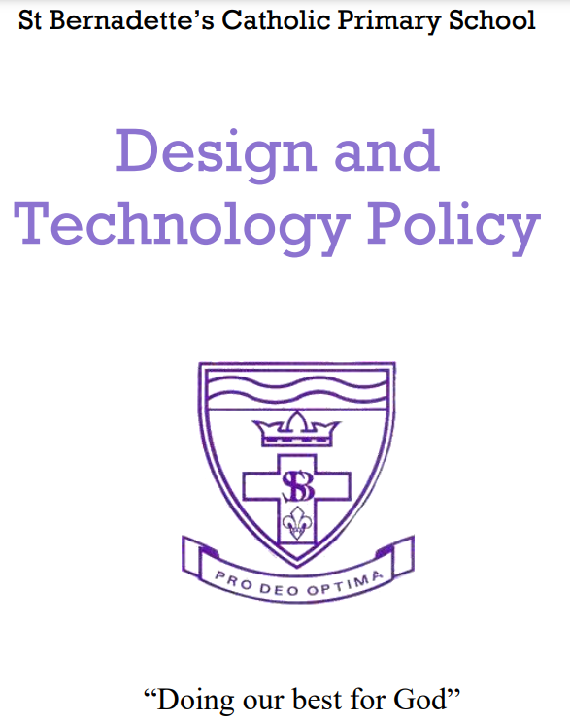

**St Bernadette’s Catholic Primary School – Design Technology Policy**

***– Our Vision –***

*In an increasingly technological world, we encourage our children to design and make products that solve real and relevant problems within a variety of contexts. DT is an inspiring, rigorous and practical subject which promotes the use of creativity and imagination.*

**Aims and objectives**

Through DT our children acquire a broad range of subject knowledge and draw on a range of disciplines, such as mathematics, science, engineering, computing and art.

They are supported in their exploration of a range of DT projects so that they are able to approach this curriculum area with confidence, enthusiasm and the appropriate level of skill.

We aim to develop critical understanding and the ability to question and evaluate the success of a product, considering its impact on daily life and the wider world.

At St Bernadette’s we aim to follow the National Curriculum to ensure that all

pupils:

* to design and make high quality prototypes.
* to test and evaluate their ideas and products and the work of others.
* to encourage children to select appropriate tools and techniques for making
* a product, whilst following safe procedures;
* to explore attitudes towards the increasingly technological world and how we
* live and work within it;
* to learn how to cook whilst developing and applying the principles of nutrition.

**Teaching and learning style**

The school uses a variety of teaching and learning styles in D&T lessons. We aim to develop the children’s knowledge, skills and understanding in technology and design via a broad and balanced curriculum. We ensure that the act of investigating and making something includes reading high quality information texts, exploring and developing ideas, and evaluating (including pupil evaluation) and developing work.

We do this best through a mixture of whole-class teaching and individual/group activities. Teachers draw attention to good examples of individual performance as models for the other children. They encourage children to evaluate their own ideas and methods, and the work of others, and say what they think and feel about them. We give children the opportunity within lessons to work on their own and collaborate with others, working with a wide range of materials and resources.

Each DT topic should include a product being designed for a user for a purpose. Children are encouraged to annotate their planning to adapt and improve their designs throughout the making phase.

**Design & Technology Curriculum Planning**

Design and technology is a foundation subject in the NC. Planning is in line with NC requirements for KS1 and KS2 and the foundation stage curriculum. At St Bernadette’s Catholic Primary School technology and design is taught on a continuous but flexible basis to allow for blocking within our year groups.

KS1, LKS2 and UKS2 use the Lancashire Key Learning Grids in Design and Technology and KLIPs grids. These are used to inform more detailed planning which focus on making a product, for a given user and for a specific purpose.

**Health and safety**

Teachers should ensure that all learning takes place within a safe environment with

special reference to the use of equipment, tools and artefacts. All personnel working

with pupils, within the context of DT, must be aware of their responsibilities and the

relevant health and safety procedures.

Children should be supervised at all times and any other adults working within the

classroom should be familiarised with safe practices. Protective clothing should be worn where appropriate.

Children will require specific training in safe ways to use potentially dangerous tools

and equipment. The best way to achieve this is by clear, confident demonstrations and

positive guidance. Only cool melt glue guns should be used.

We teach children how to follow proper procedures for food safety and hygiene.

Any faulty equipment must immediately be removed from circulation and given to

the DT co-ordinator.

**Teaching Design & Technology to children with special educational needs**

At St Bernadette’s we plan to provide for all pupils to achieve: boys and girls,

higher achieving pupils, more able pupils, those with SEND, pupils with

disabilities, pupils from all social and cultural backgrounds, children who are in

care and those subject to safeguarding, pupils from different ethnic groups and

those from diverse linguistic backgrounds. The school curriculum policy provides

a broad and balanced education for all children by matching the challenge of the

task to the ability of the child.

**The Early Years Foundation Stage**

We encourage the development of skills, knowledge and understanding that help

reception children make sense of their world as an integral part of the school’s

work.

As the reception class is part of the Early Years Foundation Stage of the

National Curriculum, we relate the development of the children’s knowledge and

understanding of the world to the objectives set out in the Early Learning Goals.

These underpin the curriculum planning for children aged three to five. This

learning forms the foundations for later work in design and technology. These

early experiences include asking questions about how things work, investigating

and using a variety of construction kits, materials, tools, techniques and

products, developing making skills and handling appropriate tools and

construction material safely and with increasing control.We provide a range of experiences that encourage exploration, observation,

problem solving, critical thinking, the making of props and discussion. These

activities, indoors and outdoors, attract the children’s interest and curiosity and

help to develop fine and gross motor control.

**Roles and Responsibilities**

The subject is led by the staff as a whole and each year time is set aside to review standards and monitor curriculum provision and ensure training and resources are up to date.

Signed: Laura Kirkpatrick (Design & Technology Lead)

Date: September 2024

Review Date: September 2026