Learning Project ideas Week 5/6- Animals
Year One
Weekly Maths Tasks (Aim to do 1 per day) | Weekly Reading Tasks (Aim to do 1 per day)
- Watch a Numberblocks clip each day at: BBC or CBeebies. Use this guide here to give you ideas on what to do with your children whilst watching an episode.  - Working on Numbots - your child will have an individual login to access this.  - Play this counting game. Count how many of each animal you can see.  - Practise counting backwards from 20. This can be done through playing hide and seek, singing number songs, chanting, board games etc.  - Use the ‘Tens Frames’ or ‘Five Frames’ on this game and practise recognising amounts. This can also be done by reading a dice when playing board games, playing with cards, identifying how many food items on the plate etc. This can be done by reading a dice when playing board games, playing with cards, identifying how many food items on the plate etc. | - Read a variety of books at home. Favourites can be repeated. Hearing the patterns of language in a story will support your child’s language development.  - Reception age children: Children to read to parents daily. Visit Oxford Owl for free eBooks that link to your child’s book band. You can create a free account.  Complete the linked Play activities for each book.  - With your child, look in magazines, newspapers and books for the tricky words they are currently learning. They could use a highlighter to highlight in magazines and newspapers.
Weekly Phonics Tasks (Aim to do 1 per day) | Weekly Writing Tasks (Aim to do 1 per day)
- Sing Nursery Rhymes and songs together. Add in actions and change the words. Can children think of different rhyming words to add in? Repeat old favourites and learn new rhymes. You can find an A-Z of Nursery Rhymes here.  - Daily phonics - Practice the sounds your child is working on and blend words. This can be oral blending (e.g. spoken out loud c-a-t) or written if appropriate. Interactive games.  Dig and plant word-sorting game  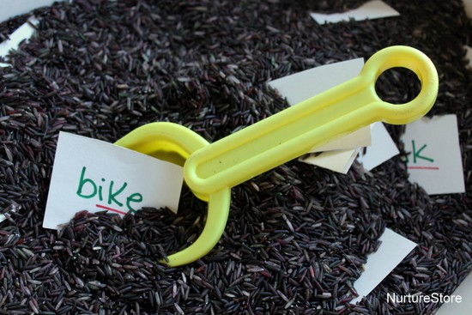  This sorting game uses a tub of dyed rice (or whatever mud substitute you prefer, sand, shaving foam, slime) in which you can hide a set of word cards.  So you might sort upper- and lower-case letters, or words beginning or ending with particular letters or sounds.  The idea of the game is to go digging, pull up a word, and plant it in the right plant pot. It’s a fun, hands-on activity that lets your child enjoy some spelling practice. | - Draw an animal of your choice. Label the parts of the animal. Reception children could create a fact file e.g. where does it live? What does it eat?  - Practice name writing. Can they write their first name? Middle name? Surname?  Practice forming the letters of the alphabet. Following St Bernadette’s handwriting scheme.
Learning Project - to be done throughout the week
The project aims to provide opportunities for your child to learn more about key animals they are interested in. Learning may focus on exploring the physical aspects of an animal, their habitat, categorising animals etc.

- Read the story, ‘Dear Zoo’ or watch the online video -
  - Visit the book’s website and play the interactive games
  - Add your own animal into the story and label it e.g. So they sent me a...hedgehog, but he was too prickly....so I sent him back.
  - Choose a soft toy animal or small animal figure and create a junk modelled container for it.

- Identify the birds in your garden-
  - Use the RSPB bird identifier website
  - Draw a picture of the birds you can see.

- Play animal charades-
  - Take it in turns to act as different animals. Add in noises as a clue…

- Learn the song, ‘The Animals Went in Two by Two’
  - Ask your child to draw out two of each animal and practice writing the numeral 2.

- Looking after your pet-
  - If you have a pet at home encourage your child to take part in their daily care. They could help feed, groom and clean up after your pet.

- Big and small animals-
  - Draw as many big animals as you can on one piece of paper and as many small animals as you can on another sheet of paper. Some children may be able to write a list as an alternative.

- Find all of the animal books in your house-
  - Ask your child to look through the books in your house and to find any with animals on the front cover. Ask them to sort the books into groups of their choice e.g. animals that can fly, swim, big, small, live on a farm/ at the zoo.

- Create an animal den-
  - Provide your child with blankets and sheets to make an animal den. Act out being an animal in the den.

Additional learning resources parents may wish to engage with
Classroom Secrets Learning Packs - These packs are split into different year groups and include activities linked to reading, writing, maths and practical ideas you can do around the home.
Twinkl - to access these resources click on the link and sign up using your own email address and creating your own password. Use the offer code UKTWINKLHELPS.

