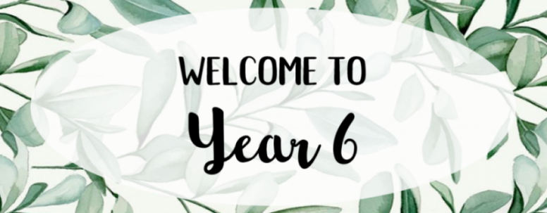

*September 2025*

***Teacher: Miss Jill Greenhalgh***

***Teaching Assistant: Mrs Michelle Walsh***

Dear Parents,

I would like to extend a very warm welcome to all our Year 6 pupils and parents in what promises to be a busy year. During this year, we will be preparing the children for their move to senior schools and helping them to establish strong routines, independence and resilience.

**Curriculum**

Detailed information regarding the Year 6 curriculum is available on the school website in the Year 6 area, alongside the associated age-related expectations. However, Year 6 can look forward to a broad and balanced curriculum where they will learn all about: World War Two, Evolution, Africa, a host of inspirational individuals, Shakespeare, images in the media vs reality, Extreme Earth, environmental issues, The Ancient Maya, famous artists, how to challenge stereotypes and (a guaranteed favourite) - the murky world of Crime and Punishment throughout the ages.

**Homework**

Year 6 weekly homework will consist of:

* A maths task linked to the week’s learning.
* An English task linked to the week’s learning (this may be SPAG-based or a reading comprehension).
* A spelling rule to learn with associated spellings through Spelling Frame- all pupils have an account - passwords will be re-sent as a reminder.
* Times Tables revision on TTRS- all pupils have an account- passwords will be re-sent as a reminder.
* Regular reading which will be recorded in the home/school diary.

Weekly homework will be set on a Thursday and is due in by the following Monday. If children are struggling with homework, they will need to ask for help before the day it is due in. The first batch of homework will be sent out on Thurs 11th September.

Every half term, revision activities will be set for the children.

By Year 6, we expect children to be challenging themselves with their reading choices. This includes choosing from a range of genres and levels of difficulty. Children should spend some time reading for enjoyment every day. Reading out loud is still important, not so much to test if they can read the words, but to help them understand what they are reading and to share their thoughts about it with someone else. Reading to children is also valuable and enjoyable, even when they are fluent readers themselves.

As well as being able to apply spelling patterns, the National Curriculum expects children to be able to spell 100 Common Exception words (words that do not follow a spelling pattern) by the end of Year 6. This list of spellings can be found on the school website and is also attached to this letter. Don't try to learn them all at once: check off the ones you can already do, and choose a few at a time to learn and practise at home.

Now that the children are in Year 6, it is vital that they are able to quickly recall their times tables to 12 x 12 to help them prepare for their SATs and, more importantly, for secondary school. It is an expectation from the National Curriculum that children should be able to rapidly recall their times tables up to 12 x 12 by the end of Year 4. If children are still working on this, then we would recommend practising little and often. 'Hit the Button' is a great app to help with this and every child also has an account for Times Tables Rockstars.

**P.E., Games and Forest School**

P.E. and games lessons will be every Thursday. On these days, children must come to school in a plain black pair of joggers or black shorts, white T shirt, purple jumper (depending on weather) and trainers. Children should have a water bottle in school with them every day but it will be particularly important that they have plenty to drink during these sessions. Please ensure the bottle has a sports cap and not a screw cap so that children are able to open their bottle themselves. Year 6 will participate in Outdoor Learning (date TBC). This is an all-year round and all-weather activity; it is important that the correct clothing is worn/ sunscreen where necessary. Waterproof clothing/ wellies can be placed over the games kit.

**Responsibilities**

Pupils in Year 6 are invited to take on various responsibilities within the school. Every pupil in Year 6 has a responsibility in the classroom and these jobs change on a regular basis with the children’s input. Year Six are also invited to apply for the role of an Ambassador within school. Please see attached letter.

**Residential Trip**

Year Six will be taking part in a residential trip to Borwick Hall in Carnforth from Wed 20th May – Fri 22nd.

**Assessment**

As well as ongoing day-to-day assessment, children in Year 6 complete formal assessments once every half term. Towards the end of Key Stage 2, Year 6 children take the KS2 SATs (Statutory Assessment Tests). These tests take place over one week (Mon-Thur) commencing on Monday 11th May 2026.

The timetable for this week is as follows:

*Monday 11th May: English grammar, punctuation and spelling papers 1 and 2*

*Tuesday 12th May: English reading*

*Wednesday 13th May: Mathematics papers 1 and 2*

*Thursday 14th May: Mathematics paper 3*

It is crucial that you avoid, where possible, taking holidays in term time during Year Six as your child will miss learning and revision. More information about SATs and Borwick Hall will be relayed in a meeting for Year 6 parents on Mon 6th October at 3.45pm in the school hall. During the Autumn Term, you will have the opportunity to purchase revision materials at a discounted rate. You will receive a letter about this in the coming weeks.

Please do not hesitate to contact me if you have any problems or queries. I look forward to working with you and your child in their final year of primary school.

Many thanks for your support.

Miss Greenhalgh