Year One DT Challenge

What is D&T?

Design and Technology education is learning about wonderful inventions, how they work and how we can design and make products for people for a particular purpose. It involves being creative and innovative using English, Science, Maths, IT and art and design skills and knowledge. The aim is to create quality products.

D&T involves four key steps:
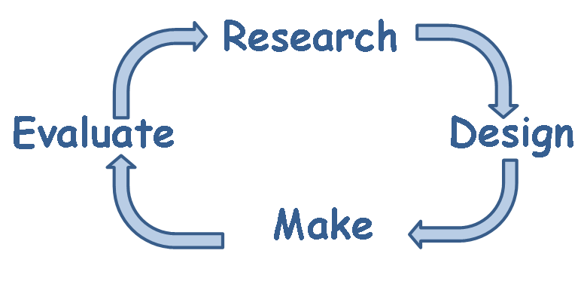

Who is your Design Technology Hero?
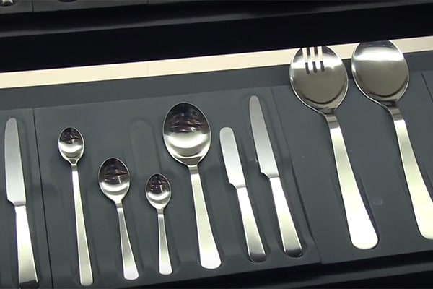
David Mellor?
He was once described as "Britain's greatest post-war product designer." He produced his first set of cutlery, "Pride” while he was still a student, the collection of cutlery is still in production and being purchased today. Not only did he help people eat their food politely but he also designed street lighting and rubbish bins.

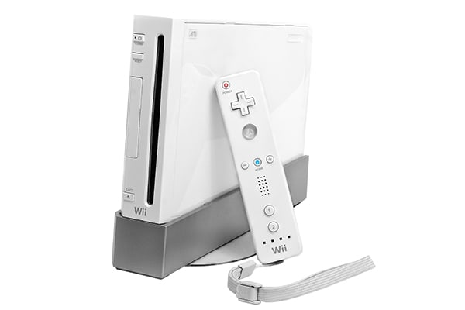
Kenichiro Ashida?
He is the man that we have to thank for all the time we have spent burning calories and time with the Nintendo Wii. His is the original designer of the Wii controllers which have truly changed the way that we interact with virtual games.

Are you going to be the designer that a Year One class will be discussing in 20 years’ time? Can you take on your
friends in class and use your skills and imagination to create
something super special?
Challenge time!
Task: Help design a piece of playground equipment for our new outside area.
- Can you write/make/construct a report on the inventor of the playground slide? This will require you to do some research or a parent’s computer, tablet or phone to help you with this.
- Can you write a list of different playground equipment that you would find in your local park?
- What material is commonly used and how is the material attached/secured to one another?
- Can you design your own playground equipment, thinking about the materials and structure to make sure it is strong. Your piece of equipment should be big and strong enough to hold one of your toys. If you’re unsure, test it!
Please take a photo of your design and send it in via Purple Mash. The best design will be chosen and will win a prize from my prize box on your return to school.
All entries to be in before the 7th June 2020.

Remember:
User: children at St Bernadette’s
Purpose: exciting play
Product: a piece of playground equipment

