Our Prayers

Sign of the Cross

In the name of the Father, the Son
and the Holy Spirit.
Amen

Morning Prayer

Father in heaven,
I give you today all that I think and do and say. Uniting it with all that was done,
By Jesus Christ, your Holy Son.
Amen

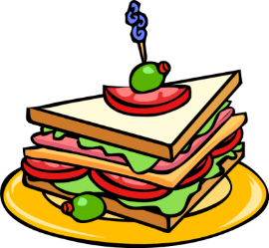
Grace before meals

Bless us, O’ Lord,
And these Thy gifts
Which we are about to receive
From Thy bounty,
Through Christ, our Lord,
Amen.

End of Day

O’ my God, I’ve come to say
Thank you for your love today.
Thank you for my family, and
All the friends you give to me.
Guard me in the dark of night
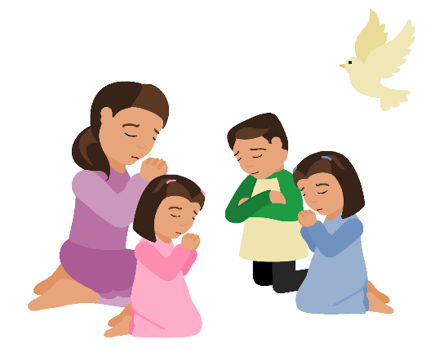
And in the morning,
send your light.
Amen

Now the day is over,
We lift our hands to say,
Thank you Heavenly Father
For today.

We’re sorry for the wrong things,
But glad about the right.
Keep us, Heavenly Father,
In your love tonight
Amen.

Our Father

Our Father,
Who art’ in Heaven
Hallowed be Thy name.
Thy kingdom come;
Thy will be done
On Earth as it is in Heaven.
Give us this day our daily bread;
And forgive us our trespasses
as we forgive those who trespass against us;
and lead us not into temptation,
but deliver us from evil.
Through Christ, Our Lord,
Amen.

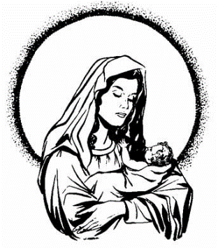
Hail Mary

Hail Mary
Full of Grace
The Lord is with thee.
Blessed art thou among women,
and blessed is the fruit
of thy womb, Jesus.
Holy Mary, Mother of God,
Pray for us sinners now,
And at the hour of our death.
Amen.

Act of Sorrow

O my God, because you are so good,
I am very sorry that I have
sinned against you
And with the help of your grace
I will not sin again
Amen
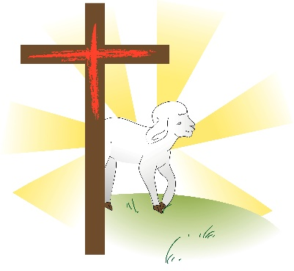

Lamb of God

Lamb of God,
You take away the sins of the world,
Have mercy on us.
Lamb of God,
You take away the sins of the world,
have mercy on us.
Lamb of God,
You take away the sins of the world,
Grant us peace.

…

Lord I am not worthy
That you should enter under my roof,
But only say the word
And my soul shall be healed.

