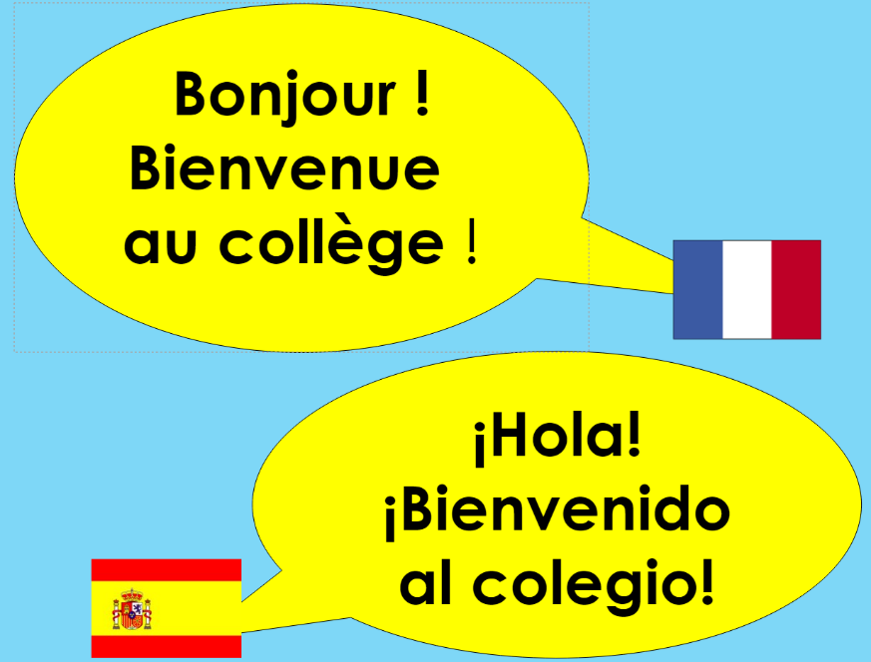

WELCOME TO OUR SCHOOL!
We are looking forward to seeing you in the Languages’ Department in September.
When you join us in Year 7, you will be able to try out both French and Spanish. It doesn’t matter which language you have learned before (or if you have not learned a language at primary school).
You can have a go at your first French lesson from home.
There are 2 activities:
- Looking at cognates
- Singing a French song

Activity 1: Cognates are words in two different language which share the same meaning, spelling and pronunciation. An example of a cognate in English and French is the word ‘sport’ which has the same meaning and spelling in both languages.
Instructions:
Look at the list of cognates on the worksheet and see if you can work out what the English meanings are for the words in the list. You can then check the answer sheet to see how many you got correct.

Activity 2: This is a song about an ice-cream seller. Glace = ice-cream
Instructions:
Listen to the song and try to fill in the missing words in the gap-fill. When you have completed the gaps, check your answers and sing along!
We are looking forward to meeting you in September!

