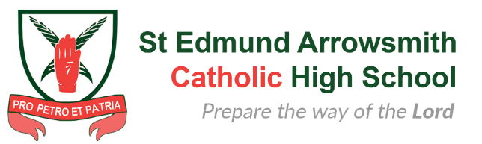
Parent Governor Nomination Form

Name: _____________________________________________

Name(s) child/children: _____________________________________________

Class / Year Group(s): ____________________________

I would like to stand for nomination as a parent governor.

Signed: _____________________________________________

Date: _____________________________________________

Statement (maximum 300 words):

Please return this form to Mrs P Lennon, Clerk to Governors at the school address no later than 12noon on Friday 1 December 2023
If you prefer, you can email this form to PLennon@arrowsmith.wigan.sch.uk

