St Edmund Arrowsmith
Catholic High School
Remote Learning

Pupil Guidance

Staying safe when learning at home
We have put together some guidance to help you with learning at home. It can help you to understand our expectations whilst you are learning from home, provide you with information about how to stay physically and mentally well, and give you some useful tips for staying safe online.
If you need some more help, please contact your form tutor, your class teacher or your Senior Learning Co-ordinator.

Learning at home
Even if you cannot attend school, we want to make sure that you can keep learning, even at home.
This is the plan for remote learning should St Edmund Arrowsmith be directed into lockdown or if pupils are advised to self-isolate.
What is remote learning?
Remote learning occurs when the student and teacher are not physically present in a traditional classroom. Teaching is relayed through technology.

Why would remote learning take place?

Remote learning will take place if pupils are directed to stay at home and learn. There are many reasons why this might occur. It might be because of a national or local lockdown or it might be because pupils are having to self-isolate because someone close to them has symptoms of COVID 19.

What remote learning will I receive in lockdown?
If pupils have to remain at home then they will receive live teaching or a pre-recorded lesson through Teams. Class teachers will teach pupils in their class groups.

How can I access Teams?

You can access Teams on any mobile device. You can even use your mobile phone. Make sure you download the Teams app first from the relevant App store.
How many hours of teaching will I receive in a day?
Pupils will follow their normal timetable. Pupils should log onto Teams before 8.55am to receive the first lesson of the day.
Break times and lunchtimes will stay the same.
The school day will end as normal at 3.05pm.

Will I receive training on how to use Teams?
All pupils will receive training on how to use Teams. If you are in Y7,8 or 9 then you will receive Teams training in IT lessons. If you are in Y10 or Y11 then pupils will receive some training in registration.
Subject teachers will also refer to Teams in lesson.
Homework will now be set through Teams.

If I have been directed to learn from home how do I know if I have a lesson?
Check your calendar on Teams every night. You will have received an invite for a scheduled meeting from your subject teachers. You must accept the invite. This scheduled meeting will now be recorded on your calendar in Teams. You will also receive a reminder on the morning of the lesson.

Will a register be taken in each lesson?
All pupils are expected to attend lessons from home. A register will be taken to monitor pupil engagement. If a pupil does not attend contact will be made with home.

What happens if I have technical problems or am unable to access Teams?
There will inevitably be some technical issues when first accessing lessons via Teams but hopefully these issues can be addressed and appropriate support given.
If pupils have any technical issues with Teams then pupils must contact their class teacher via email and explain that they cannot connect to the lesson. They must then contact the IT technicians for support – support@arrowsmith.wigan.sch.uk

Do I have to wear my uniform?

NO! You do not have to wear your uniform.
Do I have to turn on my camera?

Absolutely not.
What happens if I am sick and cannot attend the lesson?
If a pupil is sick then school does not expect them to attend a lesson. However, it would be very useful if pupils could let school know if they are too unwell to attend a lesson.

Who do I contact if I need extra help from school?

It is very important that pupils stay in contact with school so that support can be given where necessary. Some pupils may find it difficult to complete tasks at home or may find it hard to function without their peers.

If a pupil is struggling at home then it is imperative that they contact their form tutor or their Senior Learning Co-ordinator. They should be able to offer some guidance.

Pre-lockdown
Before you begin learning from home, we will make sure you are able to access all of the resources and the equipment you need to do this. If you are worried that you will be unable to access remote learning, speak to your form tutor as soon as possible.
We understand that there will be more distractions at home than in your classroom. However, it is important that you maintain a routine and ensure you are still learning, even during these circumstances.

How to stay well
It is important to make sure you look after your physical and mental health.
To avoid any unnecessary aches and pains, you should make sure you have a sensible place set up to learn from. If possible, you should sit at a table or desk, ensuring your back is supported, rather than laying on your bed or the sofa. If you think you are missing any important equipment or a suitable space to work, make sure you speak to your class teacher before you start learning from home.
If you ever feel unwell or unable to complete the work set, you should tell your parents and make sure you let your class teacher know as soon as possible, ideally before the start of the school day.
You must ensure you also look after your wellbeing while you are at home. To make sure you are staying mentally well, try some of these ideas:
- Get into a routine – you could make sure you wake up and go to bed at the same time each day
- Talk regularly with your friends or extended family
- Stay active – try getting out for a walk every day with your family
- Eat normally – make sure you have three meals a day at regular times
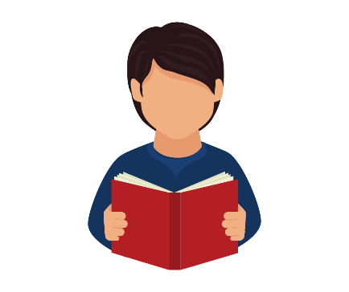
- Try practising breathing techniques – the charity Mind has lots of helpful information here: https://www.mind.org.uk/information-support/tips-for-everyday-living/relaxation/relaxation-exercises/
- Make sure you get some rest
- Keep your room tidy to make sure you feel relaxed
- Read more often
- Talk to someone if you have any worries or concerns – you can also find a whole list of places that can help if you don’t want to speak to your family here: https://www.mind.org.uk/information-support/for-children-and-young-people/useful-contacts/

Staying safe online
If you are spending all day at home, you will likely be spending more time online. Whilst there are many positive aspects of using the internet, such as keeping in contact with those you can’t see and staying entertained, you must also remember to use it sensibly.
While you are spending more time at home, you should consider the ways you can stay safe and maintain a healthy relationship with the internet by doing the following:
- Having tech-free mealtimes
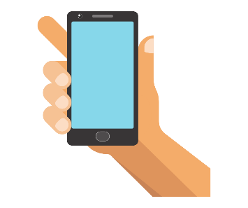
- Not keeping your phone or tablet in your bedroom
- If you are contacting anyone by phone or video, make sure you do it in a family space
- Making sure you know how to report anything on the apps you use – most of the popular apps have a reporting function. If you need help with this, please ask your parents
- If you need to report something that you’ve seen online, ensuring you use Child Exploitation and Online Protection command (CEOP) (https://www.ceop.police.uk/safety-centre/) and the UK Safer Internet Centre (https://www.saferinternet.org.uk/our-helplines)
- Telling your parents if you are worried about anything you have seen online

What to do if you’re worried
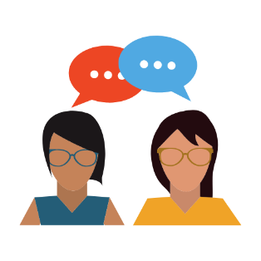
There may be times when you’re feeling worried or concerned about something. You should always tell someone if you feel this way – even if it doesn’t seem like an important thing. There are lots of different people you can talk to whilst you’re at home, including:
- Parents, carers or someone else in your family.
- Teachers or members of school staff.

We will stay in touch with you whilst you are learning from home. If there’s something that’s worrying you, or you want to talk to a specific member of staff who you feel more comfortable with, you can discuss this on the phone call – remember, every worry is relevant, whether it is big or small.

