Dear Mrs Wild
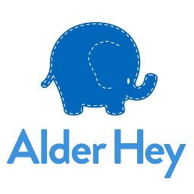
Thank you for your kind gift of £142.00 to support brave young patients at Alder Hey Children’s Hospital.
We have been reflecting on the incredible support that people like you continue to give, even when times are tough for families across the country. Your ongoing support will help 900 babies, children and young people who need Alder Hey each day, and their families join us in thanking you for your kindness.
Every penny you donate has the power to transform the hospital experience of a poorly child and their family. We simply call it ‘Alder Hey Magic’ but one patient’s mum told us last month;
“I honestly don’t know how our family would have got through the last few weeks without our son’s incredible team at Alder Hey. It really is a special place and we are grateful that his treatment will be under the care of this amazing hospital.”
You are helping us to go above and beyond for babies, children and young people and your generosity has a lasting impact on families who need our care.
Thank you again, your gift means the world to everyone here at Alder Hey and makes such a difference to what we can do for our brave young patients.
With best wishes for 2023. Please keep in touch!
With warm wishes,
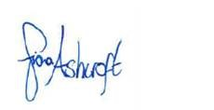
Fiona Ashcroft, Chief Executive

