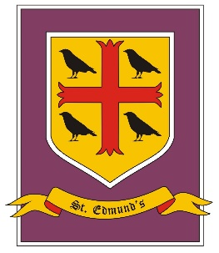
St. Edmund’s Catholic Primary School
Year XXX Curriculum Overview
Autumn Term

Autumn Term - Cycle B
Discover
Driver Subject: History

Skills: Explore issues/events or problems from different perspectives.
Consider the influence of circumstances, beliefs and feelings.
Support conclusions, using reasoned arguments and evidence.
Show empathy to others

 | Autumn 1 | Autumn 2
RE | 1 Y6 God who never stops loving you  2 Vocation and commitment | 3. Expectations  4 Judaism
PSHE/RSHE | Health & well-being – Looking after ourselves; growing up; becoming independent; taking more responsibility
RSE | Social and emotional
English | Y6 Recount & auto biography: Canute the Great  Legends - The Saga of Erik the Viking - Terry Jones & Michael Foreman, Illustrated chapter book  Poetry – songs /lyrics - symbolic language – simile/metaphor personification. Simile: Like a Rolling Stone - Bob Dylan Metaphor: Baby I’m a Firework - Katy Perry Personification: Mr Blue Sky - Electric Light Orchestra | Y6 novel as theme/ detective crime fiction - Enola Holmes series  Y6 instructions - how to make a long boat (linked to DT)
Maths | White rose Y5/6: Autumn  Number: Place Value, Number: Four Operations, Number: Fractions
Science | Y6 Light / Questioning | Y6 Electricity/ questioning
History | Recap Anglo Saxons – Vikings – Edward the Confessor – Battle of Hastings
Geography | Maps – Vikings - journeys
Art and Design | Viking - drawing Viking knots, sketching fierce warriors, creating their own Viking jewellery
Design Technology | Focus task - To make a Viking longship which is historically accurate.  It needed to be: watertight/able to float/ balance/ hold 10 playmobil men/ attractive to look at with a sail, oars and shields /research real and model longships and came up with our own designs, considering the tools and materials we had available then as a group we decided on our final design.
Computing | Multi-media presentations | Direct teaching - computing skills
Music | Charanga – Vikings Unit | Christmas
PE | West lancs SSP | West lancs SSP
MFL - French | Twinkl year 6 unit 1 let’s visit town | Twinkl year 6 unit 2 let’s go shopping

