The National Curriculum states that pupils should become fluent in the fundamentals of mathematics through varied and frequent practice.
We believe fluency in maths is about developing number sense and being able to use the most appropriate method for the task at hand; to be able to apply a skill to multiple contexts. We use the Mastering Number and Number Facts Fluency Programmes, supplemented by various other fluency materials.

Structure of our learning
- Our daily maths fluency lessons last 15 mins.
- Our fluency lessons follow the Mastering Number Programme in EYFS and KS1 and the Number Sense Programme in KS2.
- Mastering Number is aimed at strengthening the understanding of number, and fluency with number facts, among children in the first three years of school and through the number Sense Programme, lessons are taught systematically alongside the 12 calculation strategies (Appendix A), that can be used to solve them.
- We follow a systematic, whole class approach suggested by the NCETM to teaching times tables in KS2.
- We teach children to solve addition and subtraction facts by applying key visuals, models and calculation strategies.
- Children ‘use what they know to work out what they don’t know’.
- By using explicit teaching of derived fact strategies children will become fluent in addition, subtraction and times tables facts.
- All facts are taught comprehensively on the path to fluency.

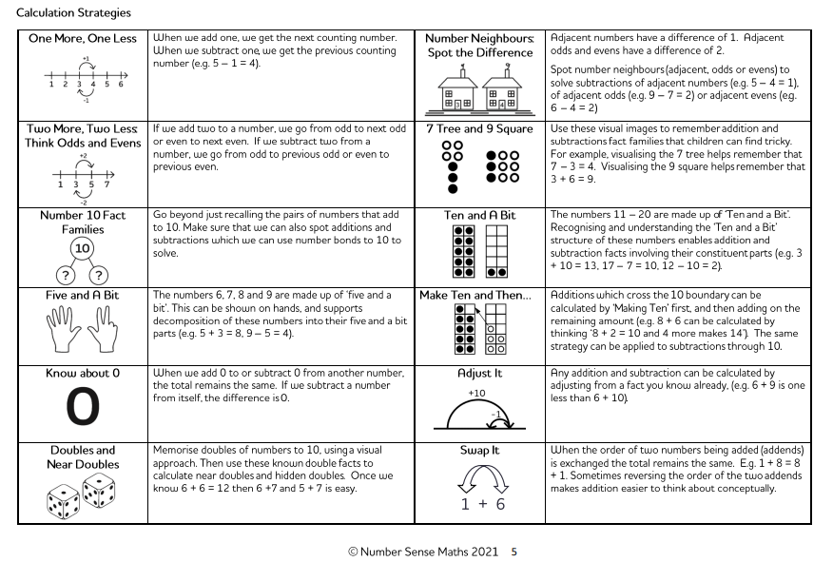Appendix A

