St Edmund’s Catholic Primary School

SEND Policy

Introduction
SENDCO: Mr D Fitzpatrick
E-mail: ddf@st-edmunds.lancs.sch.uk
Contact Number: 01695 724798
This policy explains how St Edmund’s Catholic Primary School makes provision for pupils with SEND, in line with the school ethos and with current legislative requirements.
This policy takes account of the Special Educational Needs and Disability Code of Practice: 0 to 25 years (June 2014). It has also been written with references to the following guidance and documents:
- Equality Act 2010: advice for schools
- SEN Code of Practice 0-25 years
- Schools SEN Information Report Regulations
- Statutory Guidance on supporting pupils at school with medical conditions.
- The National Curriculum in England Key Stage 1 and 2 framework documents.
- Child Protection Policy.
- Teacher Standards
Our aim to promote high aspirations and expectations for all pupils with SEND as well as creating an inclusive environment for all our learners. This policy focuses on the learning and progress of those children who have needs considered as falling under the four broad categories:
- Communication and Interaction
- Cognition and Learning
- Social, Mental and Emotional health difficulties
- Sensory and/or physical
Every pupil with a SEN or disability has an entitlement to fulfil their optimum potential. This is achieved by ensuring that our children receive the best possible education; through providing them with exciting opportunities and learning experiences; ensuring that they are equipped for life-long learning and are responsible members of our community. We teach our children to follow the school mission statement of “care, consideration and courtesy”.
Definitions of special educational needs and disabilities (SEND) taken from section 20 of the Children and Families Act 2014:
1. A child or young person has SEND if they have a learning difficulty or disability which calls for special educational provision to be made for them.
2. A child of compulsory school age or a young person has a learning difficulty or disability if they:
a) have a significantly greater difficulty in learning than the majority of others of the same age; or
b) have a disability which prevents or hinders them from making use of educational facilities of a kind generally provided for others of the same age in mainstream schools or mainstream post-16 institutions.
3. A child under compulsory school age has special educational needs if they fall within the definition at (a) or (b) above or would do so if special educational provision was not made for them.
Children must not be regarded as having a learning difficulty solely because the language or form of language of their home is different from the language in which they will be taught.
Aims and Objectives

Aims:
- Provide every child with access to a broad and balanced education. This includes the National Curriculum and the EYFS framework in line with the Special Educational Needs Code of Practice.
- Ensure all aspects of school life are accessible for every child, through academic, social and practical experiences.
- Promote high aspirations and expectations for all pupils with SEND.
- Promote independence, equality and consideration for others.
- Ensure that we celebrate the wide range of pupils’ achievement, and that all children experience success regardless of SEND, disability or other factors that may affect their attainment.
- Create an environment in which individuals are valued, have respect for one another and grow in self-esteem.
Objectives:
- To identify the provision required for pupils with SEND as early as possible.
- Monitor the progress of all pupils with SEND and provision map the provision required accordingly.
- Make appropriate provision to overcome all barriers to learning for pupils with SEND.
- Engage proactively with all parties to ensure the best interests of the child are met.
- Open door policy welcomes parents into school.

Identifying children with Special Educational Needs
The SEND Code of Practice (2014) sets out four areas of SEND:
- Communication and interaction
- Cognition and learning
- Social, mental and emotional health
- Sensory and or physical

The identification of SEN is built into the overall approach to monitoring the progress and development of all pupils through the school’s Policy on Teaching and Learning; It is really important that in school we identify pupils who experience difficulties accessing learning and general school life opportunities early. This is achieved through continual use of classroom observations and assessments of all pupils as well as discussions with parents/carers.
Progress is tracked on a termly basis and where appropriate, more frequently than this. The SENDCO will liaise closely with the assessment co-ordinator to analyse data and individually track pupils who are experiencing difficulties. Early intervention will be put in place as soon as a potential barrier arises.
Class teachers discuss any concerns with the SENDCO and Assessment Coordinator. If further action is deemed necessary, the parents are informed. All criteria for defining Special Educational Needs are in accordance with Lancashire Education Authority policy.
Despite appropriate, good quality teaching, intervention and differentiated learning experiences, considering the child's age and stage of development triggers for identification of a Special Educational Need could be:

- Little or no progress made when teaching approaches/learning styles are particularly targeted to improve the child's identified area of need;
- Working continues at levels significantly below those expected for a child of a similar age in certain areas of the Early Years Foundation Stage or in literacy and mathematics skills resulting in poor attainment in some framework or curriculum areas;
- Communication or interaction difficulties which create barriers to learning and specific interventions are needed;
- Social, emotional or mental health problems which are not improved by the techniques normally employed in the nurturing environment of the school;
- Sensory or physical problems create barriers to progress despite the provision of personal aids or specialist equipment.

If, following a period of additional support, the child continues to experience difficulties, the school may, with parental permission, seek the advice of external agencies. Additionally, some children may receive support from our National Health Service colleagues e.g. Speech Therapy, Occupational Therapy, Child & Adolescent Mental Health Services etc. Any plans shared with the school by these agencies are carried out by staff within school in liaison with the appropriate agency.
Factors which are not SEN but may affect a child’s progress and attainment are taken into consideration and adaptations are made accordingly. These may include:
- A disability under the Equality Act 2010 - all reasonable adjustments will be made in order that they can access the full curriculum.
- Attendance and Punctuality
- Health and Welfare
- English as an Additional Language (EAL)
- Being in receipt of Pupil Premium Grant
- Being a Looked After Child
- Being a child of Serviceman/woman
Persistent disruptive or withdrawn behaviour does not necessarily mean that a young person has SEN. Any concerns over a pupil’s behaviour will be investigated on the premise that the behaviour is an underlying response to a need. This may be a learning difficulty or another factor, as noted above. School staff will endeavour to recognise and quickly identify the reasons for the behaviour and take all reasonable steps to address the root cause.
Graduated Approach – Assess, Plan, Do, Review
The key principles:
- All class teachers are responsible and accountable for the progress and development of the pupils in their class, including where pupils access support from teaching assistants or specialist staff. All children are included in all lessons through an ethos of Quality First Teaching which is adapted to respond to their strengths and needs, as set out in the Teachers’ Standards (2012);
- High quality teaching, differentiated for individual pupils, is the first step in responding to pupils who have or may have SEN. However, despite this, some children need additional help to make progress in their learning;
- Additional intervention and support cannot compensate for a lack of good quality teaching;
- Pupils are only identified as SEN if they do not make adequate progress once they have been given good quality personalised teaching, access to adaptations and intervention;
- Pupils who join school (either from an Early Years setting or another Primary School) with an already identified SEND will be catered for in the same way as those identified by this school;
- When planning work for children with special educational needs, teachers give due regard to information and targets contained in the children's Pupil Passports or SEN Support Plans. Additionally, teachers modify teaching and learning as appropriate for children with disabilities.
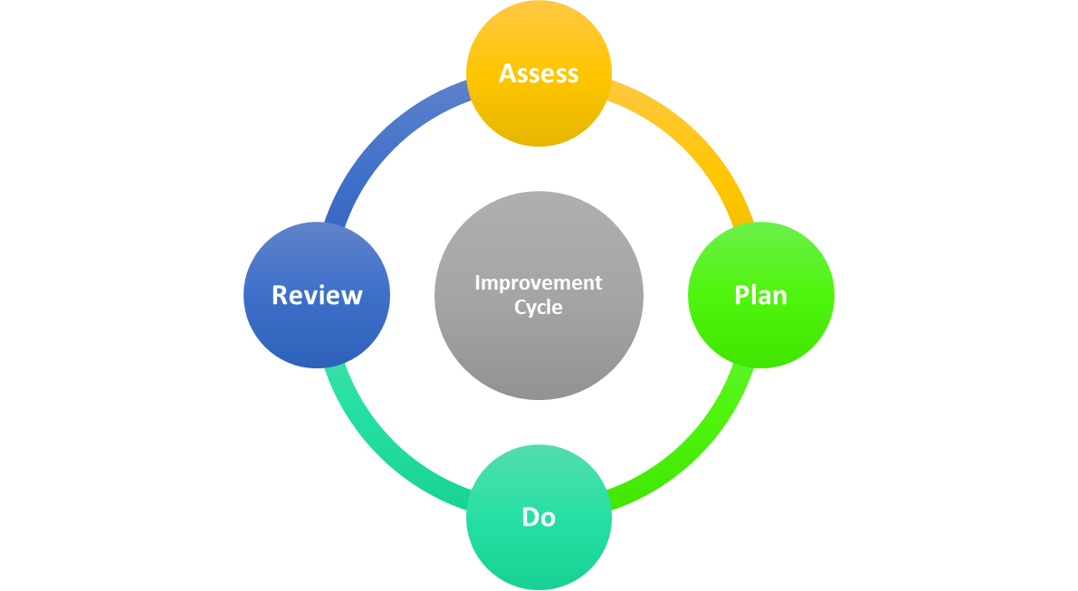
This is an ongoing cycle to enable the provision to be refined and revised as the understanding of an individual grows. This cycle enables the identification of those interventions, which are the most effective in supporting the pupil to achieve good progress and outcomes at their level.

Assess
In identifying a child as needing SEND support the class teacher, working with the SENDCO should carry out a clear analysis of the pupil’s needs. This should draw on subject assessments, teacher observations, details of previous progress and attainment, comparisons with peers and national data, as well as the views and experience of parents. The opinions and feelings of the individual and advice from external support services will also be considered. Any parental concerns will be taken seriously and recorded and compared with the school’s information and assessment data on how the pupil is progressing. This analysis will require regular review to ensure that support and intervention is matched to need; barriers to learning are clearly identified and being challenged and that the interventions being used are developing and evolving as required. Where external support staff are already involved their work will help inform the assessment of need. Where they are not involved they may be contacted, if this is felt to be appropriate, following discussion and agreement from parents.

Plan
When it is decided to provide a pupil with SEND support, parents will be informed. Planning will involve consultation between the teacher, SENDCO and parents to agree the adjustments, interventions and support that are required; the impact on progress, development and or behaviour that is expected and a clear date for review, this will be in the form of a learning plan. Parental involvement will be sought, to reinforce or contribute to progress at home, with activities and methods included in the plans. All those working with the pupil, including support staff, will be informed of their individual needs, the support that is being provided, any particular teaching strategies/approaches that are being employed and the outcomes that are being sought.

Do
The class teachers remain responsible for working with the pupil on a daily basis. They will retain responsibility even where the interventions may involve group or 1:1 teaching away from the mainstream classes. They will work closely with teaching assistants and relevant specialist staff to plan and assess the impact of support and interventions and links with classroom teaching. Support with further assessment of the pupil’s strengths and weaknesses, problem solving and advising of the implementation of effective support will be provided by the SENDCO.

Review
Depending on the level of support, pupil progress reviews will take place at a termly meeting. The review process will evaluate the impact and quality of the support and interventions. The SENDCO and Class Teacher will make any necessary amendments going forward, in consultation with parents, through the form of new targets and interventions. Where a pupil has an Educational Health Care Plan the local authority must review that plan as a minimum every 12 months.

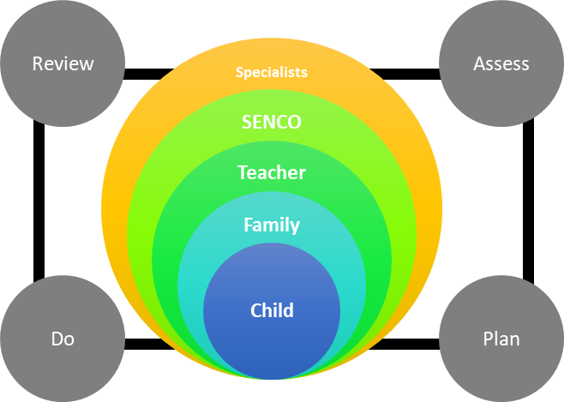
Levels of Support
The different interventions a school can put into place to dissect and overcome different barriers the children present are split up into three waves. Beginning at Wave 1 and ending at Wave 3, each wave in turn escalates and personalises the intervention in place for the child, ensuring that what is presented is unique to that individual.
- Wave 1: Quality first teaching; where good quality teaching and suiting work to individual children means that every pupil is included. The needs of all children are considered, with high expectations for them all.
- Wave 2: is more targeted at pupils with SEN specifically. There could be access to specialist resources within the school, such as nurture groups, therapies, identified interventions and some 1:1 support. This can be for general 'catch-up' or the start of the graduated approach cycles of Assess, Plan, Do, Review. Children may be placed on an IEP (Individual Education Plan) at this point.
- Wave 3: is usually where an external specialist may be asked to advise on more specialised support, generally where a student has not progressed as well as expected with the current additional support. This would form part of subsequent cycles of the graduated approach.
IEP – Individual Education Plan
If a child is deemed to need Wave 2 intervention, they may be placed on an IEP. An IEP will be reviewed termly, with fresh targets being set at the start of each term when applicable. In an instance when a target has not been met, it may be carried over but additional interventions will be put in place to continue progression. For an IEP, input is taken from the Class Teacher, Child, Parents and SENDCO. It is then up to the Class Teacher, with support from the SENDCO, to implement any strategies detailed in the plan. Once the cycle is near completion, the parent(s) and child will be invited into school to review the IEP.
Learning Plan
If a child is 2years+ below ARE (age related expectations) they may be placed on a learning plan. This learning plan will be created by a specialist teacher, who will also assess the child to ascertain their exact level. This will be triangulated through discussion with parent(s), child and class teacher; the use of formative and summative assessments and with input from any other outside services. The class teacher will then be responsible for implementing any suggestions/strategies detailed in the plan. This cycle will be reviewed termly.
EHCP – Education, Health and Care Plan
Following Statutory Assessment, an EHC Plan will be provided by Lancashire County Council, if it is decided that the needs of an individual cannot be met by the support that is ordinarily available. Both staff in school and parents will be involved in developing and producing the plan. Parents have the right to appeal against the content of the EHC Plan. Once the EHC Plan has been completed and agreed, it will be kept as part of the pupil’s formal record and reviewed at least annually by staff, parents and the pupil. The Annual Personal Review enables provision for the pupil to be evaluated and, where appropriate, for changes to be put in place.

Exiting the SEN register
The decision to remove a child from the SEN register will be made in consultation with the child, parents, staff and all professionals working with the child. A range of evidence will be considered relating to the child’s progress and attainment. Reference will be made to the DfE’s definition of special educational needs. If it is considered that the child no longer needs to remain on the register, the class teacher will continue to monitor the child closely. The child will still receive quality differentiated teaching and may still require group intervention.
Supporting Pupils and Families
The Local Authority’s Local Offer (Regulation 53, Part 4) may be found at www.lancashire.gov.uk/SEND . This links back to the school’s SEN Information Report and School’s contribution to the Local Offer, which details how the school works with and supports families of pupils with SEND. It also details other arrangements such as access to Statutory Assessment Tests (SATs) and transition to high schools.

Supporting Pupils at school with a medical condition
As a school, we recognise that pupils at school with medical conditions should be properly supported so that they have access to education, including school trips and physical education.

Supporting Children looked after (CLA)
Pupils who are being looked after by the local authority may require intervention and support from staff in school and will have a Care Plan written for them, in liaison with the Social Services.
The Governing Body
The Governing Body has identified a governor to have oversight of special educational needs provision in the school and to ensure that the full Governing Body is kept informed of how the school is meeting the statutory requirements. At St Edward’s this role is undertaken by Sue Oates who will meet on a termly basis with the SENDCO. The Governors have a commitment to provide the best possible provision for all children. The SEND Governor will support the Governors to fulfil their statutory obligations by ensuring:
- The Curriculum Committee receives a report and update on the progress on any SEND issues.
- The SEND Policy is reviewed regularly and is in line with Government legislation.
- The SEND information Report is published online and reviewed annually.
- Ensure that a pupil with SEND joins with all pupils in the activities of the school together, so far as is reasonably practical and compatible with the child receiving the SEND provision their learning needs call for and the efficient education of the pupils with whom they are educated and for the efficient use of resources.

Teachers
The class teacher is the first point of contact for parents who have concerns about any aspect of their child's progress. The class teacher is the person with key responsibility for devising and delivering appropriate support which is matched to the individual's needs, directing the work of the support staff and for setting up termly review meetings with parents.

Support Staff
Support staff are employed by the school to meet the needs of children with SEND through careful provision mapping.

Adults involved in SEND issues

Name | Role
Mrs A Birmingham | Headteacher
Mr D Fitzpatrick | SENDCO
Ms S Oates | Governor
Mrs H Hall | Pupil Support Manager
Mrs L Crook | Specialist Teacher

Accessibility for people with disabilities
The Governors of St Edmund’s are committed to the concept of inclusion and to the adaptions necessary to ensure that parents, pupils, staff and other visitors to school have as little difficulty as possible in accessing the building.

The school grounds:
- Major pathways have been separated from the traffic by railings where possible.
- All renovations of the building regulations in respect of doors, windows and vision panels have been fully observed and installed to conform to disability legislation.
- Main doors allow wheelchair access. A button operated door has been installed in the reception area.
- All buildings are at one level.
- Most doors have ramp access for wheelchair users including the classrooms and reception area.
- A disabled toilet which is located in the main office area.

Records
The class teacher has ultimate responsibility for the child's day-to-day learning. For some children the curriculum may require considerable modification and flexibility of approach to provide for the needs of individuals. Children will be working to age appropriate learning objectives differentiated according to need.

The SENDCO, outside agency representatives and others will support class teachers where necessary. The SENDCO and class teacher will keep electronic and paper copies of SEND support plans which will be kept in school. Class teachers will have access to all learning plans and IEPs. These should be incorporated into their everyday teaching.

Storing and managing information

Documents relating to children with SEND are stored in a locked cupboard in school and/or on an encrypted electronic storage device. Some documents, such as IEPs are held on the school’s server in an area which can only be accessed by teachers. Records relating to children who have left are passed to the new school as soon as is practical.
Monitoring and evaluating
The SENDCO will report termly on the efficient and effective use of resources for pupils identified as having SEND. The monitoring and evaluation of progress of pupils with SEND is detailed in the Graduated Approach section (above). For pupils with a Statement of Special Educational Needs or an Education, Health and Care Plan, annual reviews (6 monthly for under 5s) are carried out in accordance with the appropriate legislation and the SEND Code of Practice.
The SENDCO will collect and analyse tracking data for all pupils on the SEND register and uses this, in conjunction with information gathered from other sources (SEND learning walks, professional dialogue, discussions with pupils and parents etc) to inform the evaluation of the effectiveness of the provision. The SENDCO will liaise with the SEN Governor once per term and they will jointly produce a report on the quality and effectiveness of SEND provision.
As part of the School Development Plan, the SENDCO will produce an annual action plan and updates progress against this on a termly basis.

Training and resources
The overall level of funding for SEN is delegated to the school by the LA and is identified in the school budget statement. This amount is not ring-fenced. The responsibility for determining the amount of resource for SEN lies with the school Governors who will seek advice from the Headteacher. The resources for SEND are used to provide teaching assistants, specific training on SEND and specialist resources. The costs of the SENDCO are met from the main school budget.
In order to maintain and develop the quality of teaching and provision to respond to the strengths and needs of all pupils, all staff are encouraged to undertake training and development. All teaching staff and teaching assistants will be provided with general or specific training on meeting the needs of SEND within their classroom.
The SENDCO is aware of relevant courses within the local area relating to SEND. All staff to have access to this information and the SENDCO advises as necessary. Whole school training on SEND is arranged, as appropriate and teaching assistants are invited. There is an expectation that staff who receive training will disseminate their knowledge to others to benefit all working in SEND. All teachers and support staff undertake induction on taking up a post and this will include a meeting with the SENDCO to explain the systems and structures in place around the school’s SEND provision and practice and to discuss the needs of individual pupils.
The school’s SENDCO regularly attends the Local Authority’s SENDCO Cluster meetings in order to keep up to date with local and national updates in SEND.
Reviewing the policy
This policy will be reviewed on an annual basis. The process of review will involve the SENDCO, the SEND Governor, the Chair of Governors and the Headteacher. Review of the policy will consider:
- The progress made by students with SEND at the school.
- The success of the school at including students with SEND.
- Any recommendations from Ofsted or the LA about improving practice.
- Any factual changes, such as names of personnel.

Dealing with complaints
If a parent of a pupil with SEND is concerned about the provision that school is making for them, they should, in the first instance, refer the matter to the pupil’s class teacher and/or the SENCO.

Reference should be made to the school’s Complaints Policy should further action be deemed necessary.

Bullying
The school’s Anti-Bullying Policy is available from the website or the school office.

Further details about how the school keeps children with SEND safe can be found in the SEN Information Report and School’s Contribution to the Local Offer on our website.

