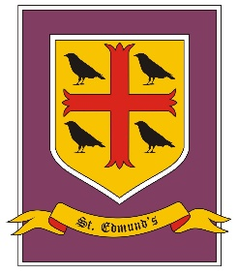
St. Edmund’s Catholic Primary School
Skelmersdale

POST: Site Supervisor
Location: ST EDMUND’S CATHOLIC PRIMARY SCHOOL, SKELMERSDALE, WN8 8NP
Tel: (01695) 724798
School website: https://www.stedmundswestlancs.co.uk/
Roll: 77
Grade: 2a Grade 4
Salary: 18,933 – 19,698
Term: 52 weeks
Hours: 20 hours per week
Post: Permanent
Required: ASAP
Closing Date: Tuesday 19th April 2022 12.00 NOON

We are a small school in Skelmersdale who serves the area of New Church Farm. Our children are wonderful and love to learn.
We are looking for a special person who will manage and maintain the school building and outside environment to a high standard ensuring the school is a safe, warm and welcoming for all children. All applicants should be well organised and have the ability to prioritise their workload. They must have good practical skills in order to carry out minor repairs and general maintenance, as well as some understanding of the wider roles required of a Site Supervisor. Our Site Supervisor will be expected to contribute to the smooth running of the school by managing our cleaning team. In partnership with the Headteacher and Business Manager, they will be responsible for the cleanliness of the school.
The post is a full-time position of 20 hours per week which involves two shifts of 7.15 – 9.15 and 16.00 – 18.00 Monday to Friday.
We would provide the successful candidate with the relevant training required in relation to the Site Supervisor role. We offer a small school family which helps and supports each other including a strong governing body.
Pre-employment checks will be undertaken before any appointment is confirmed. The school is committed to safeguarding and promoting the welfare of children and young people and expects all staff and volunteers to share this commitment. Successful applicants will be subject to satisfactory references and enhanced DBS clearance.
Candidates are invited to talk to the headteacher about the post and visits to the school are welcomed.
Closing date: Tuesday 19th April 2022 12.00 NOON
Shortlisting date: W/B: 19.4.2022
Interview date: TBC

