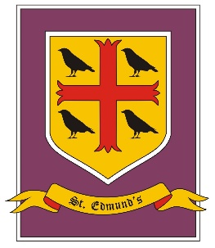
St. Edmund’s Catholic Primary School
Year 5-6 Curriculum Overview
Spring Term

Spring Term - Cycle A
Explore
Driver Subject: Geography

Skills: Explore issues and carry out research.
Recognise pupils’ role as global citizens.
Recognise that pupils can impact their environment and community.

 | Spring 1 | Spring 2
RE | Year 5  Mission – continuing in Jesus’ mission  Memorial sacrifice – The Eucharist | Year 5  Sacrifice- Lent a time for sacrifice
PSHE/RSHE | Health and wellbeing  Basic first aid, accidents, dealing with emergencies | Relationships  Friendships; relationships; becoming independent; online safety
RSE | Year 5: To show knowledge and understanding of the physical changes in puberty.  Year 6: To explain how human life is conceived.
English | NF - Debate - 5 deforestation  F – Stories from another culture– 5/6 (Journey to the River Sea, Eva Ibbotson)  Poems on a theme – ecology – 6 | NF - Explanation – 6 - rivers  F – Novel as a theme Running Wild (Michael Morpurgo
Maths | Y5: Number: Fractions Y6: Number: Ratio  Number: Decimals and Percentages  Y5: Number: Decimals  Y6: Number: Algebra  Measurement: Converting Units  Measurement: Perimeter, Area and Volume  Statistics
Science | Year 5 Living things and their habitats  Pattern seeking (scientific enquiry) | Year 5 Animals, including humans  Fair testing (scientific enquiry)
Geography | South America – rainforest – ecology - climate
History
Art and Design | Henri Roussea – artist study (rainforest/ animals)
Design Technology
Computing | Year 5 - Digital literacy - Use technology respectfully, responsibly and safely, knowing how to keep their information and passwords secure.
Music | Oceans seas and rivers topic – Charanga
PE
MFL - French | Year 5 -That's tasty | Year 5 - Friends and family

