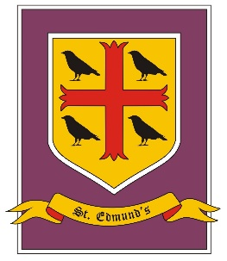
St. Edmund’s Catholic Primary School
Year 5/6 Curriculum Overview
Autumn Term

Spring Term - Cycle B
Explore
Driver Subject: Geography

Skills: Explore issues and carry out research.
Recognise pupils’ role as global citizens.
Recognise that pupils can impact their environment and community.

 | Spring 1 | Spring 2
RE | 1 Y6 Sources 2 Y6 unity | 3 Death and new life
PSHE/RSHE | Living in the Wider World - Media literacy and digital resilience; influences and decision-making; online safety
RSE | Physical and human life
English | Discussion/debate - native Americans/ colonists  Short stories with flashbacks - Harry potter extracts | Poems with a structure - Space themed eg When I’m astronaut by Bobbi Katz  Science Fiction stories Time Spinner by Roy Apps
Maths | Y5: Number: Fractions  Y6: Number: Ratio  Number: Decimals and Percentages  Y5: Number: Decimals  Y6: Number: Algebra  Measurement: Converting Units
Science | Y5 Forces  Sci En: observation | Y5 Earth & Space  Sci En: Communicating and research
Geography | North America  Earth and space – longitude /latitude
History | North America – Pocahontas/ colonists/ empire/trade 1
Art and Design |  | Twinkl UKs2 North American art unit - This ‘North American Art’ unit will teach your class about how to draw the other half of a famous image, make collage landscapes, create body abstracts, make ‘building block’ houses, draw patterned skulls 2
Design Technology | North America – food – cooking
Computing | Digital Literacy y5/6
Music | Space - charanga
PE
MFL - French | Twinkl – This is France unit 3 | Twinkl – all in a day unit 4

