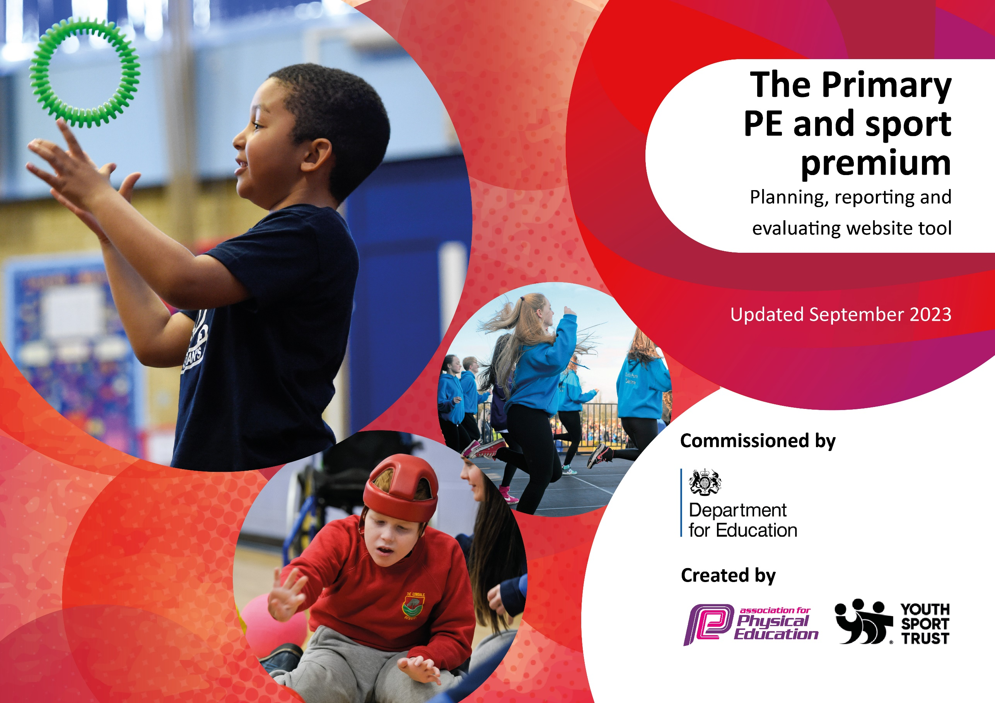

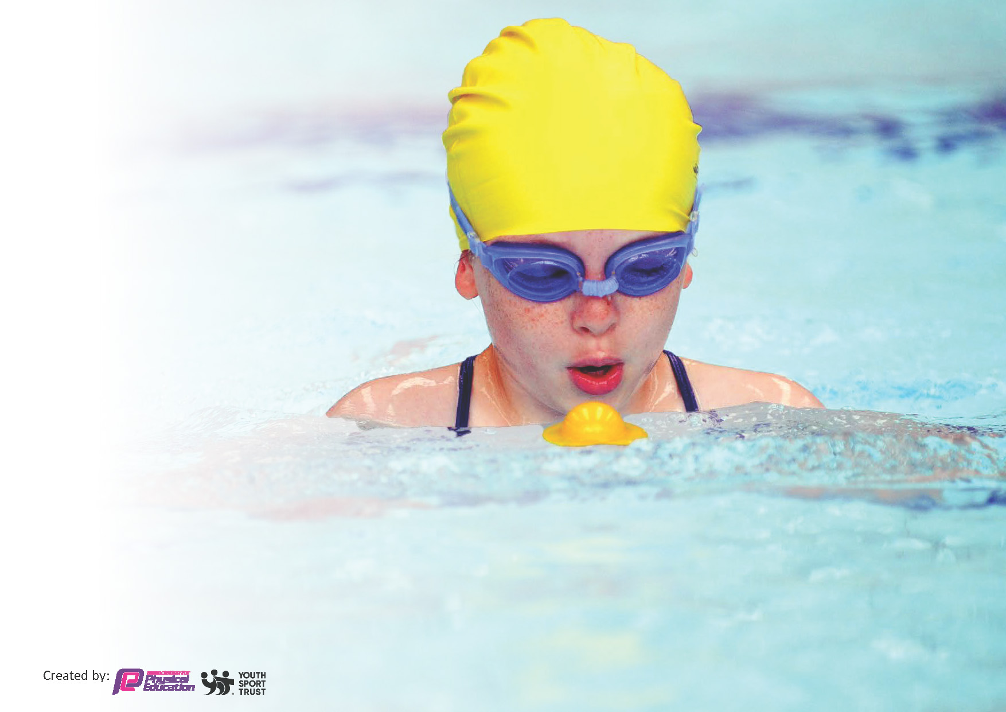
This template can be used for multiple purposes:
by:
- It enables schools to effectively plan their use of the Primary PE and sport premium
- It helps schools to meet the requirements (as set out in guidance) to publish information on their Primary PE and sport premium
- It will be an effective document to support Ofsted inspections enabling schools to evidence progress in Physical Education (PE) and evidence swimming attainment, which forms part of the PE National Curriculum. We would recommend schools consider
the Intent, Implementation and Impact of any spend, as examined within the Education Inspection Framework.

It is important that your grant is used effectively and based on school need.

Schools must use the funding to make additional and sustainable
improvements to the quality of the PE, School Sport and Physical Activity (PESSPA)
they offer. This means that you should use the Primary PE and sport premium to:

- Build capacity and capability within the school to ensure that improvements made now will benefit pupils joining the school in future years
- Develop or add to the PESSPA activities that your school already offers.

The Primary PE and sport premium should not be used to fund capital spend projects; the school’s core budget should fund these. Further detail on capital expenditure can be found in the updated Primary PE and sport premium guidance.

The Primary PE and sport premium guidance, outlines 5 key priorities that funding should be used towards. It is not necessary that spending has to meet all the key priorities, you should select the priorities that you aim to use any funding towards.

Although completing this template is not a requirement for schools, schools are required to publish details of how they spend this funding. Schools must also outline what the impact this funding has had on pupils’ PE and sport participation and attainment and how any spending will be sustainable in the future. All funding must be spent by 31st July 2024.

Review of last year’s spend and key achievements (2022/2023)
Actions taken |  | Impact | Review and Next Steps
1 | To employ a sports coach to work with all children on a weekly basis. | To engage all pupils in regular physical activity.  To give children access to a variety of differing sport genres.  To develop staff CPD in relation to teaching sports within the primary setting.  Children progress in PE ability and fitness. | All children have been engaged in regular physical activity and have had access to a variety of differing sports. Teaching staff have been present during the coaching sessions therefore developing their own CPD.  58% children have reached ARE and 75% children have made good or better progress in PE. Improvements need to made in PE next year, to ensure higher levels of attainment. PE Subject Lead to complete monitoring activities and complete a subject leader action plan.
4 | To continue to develop lunchtime supervision and pupil participation in active activities during lunchtime. | To engage all pupils in regular physical activity – The Chief Medical Office guidelines recommend that all children and young people aged 5 to 18 engage in at least 60 minutes of physical activity a day of which 30 minutes should be in school. | Children are encouraged during the school day to be active during lunch and playtimes. Children are provided with a range of play equipment which adults demonstrate how to use with the intention of children being able to use them independently.
6 | To provide all children with a Forest School experience. | To offer pupils a broader range of sports and activities. | All children have received 8 forest school sessions throughout the year. The sessions have provided the children with the opportunity to develop their skills of resilience, compromise and problem solving.  The children will continue to receive forest school sessions during 2023-2024. There will be investigation into the training of a school member of staff being forest school trained.
7 | To provide catch-up swimming for Year Five and Six | To engage all pupils in regular physical activity. | Refer to information above.

Key priorities and Planning – 2023/24 – 2024/5
Total amount carried over from 2022/23 | £0
Total amount allocated for 2023/24 | £16800 (80 pupils)
How much (if any) do you intend to carry over from this total fund into 2023/24? | £0
Total amount allocated for 2023/24 | £16800
Total amount of funding for 2023/24 to be reported on by 31st July 2024 | £16800

Action – what are you planning to do | Who does this action impact? | Key indicator to meet | Impacts and how sustainability will be achieved? | Cost linked to the action
Staff to assist West Lancashire Sports Partnership Sports Coach and observe how to deliver activities which develop the sports ability of children. E.g. Throwing and catching stance. | Staff to build their knowledge and understanding of PE and sport development. | Key indicator 1: Increase confidence, knowledge and skills of all staff in teaching PE and sport | Staff will have increased confidence in teaching PE and sport development. | £7908
Teachers to use ‘Suceedin’ to plan lessons so that they are consistent with WLSP sport coach lessons. | Staff to have access to ‘Suceedin’ platform (developed by West Lancashire Sports Partnership) which provides teachers with online planning and assessment activities and access to online CPD. | Key indicator 1: Increase confidence, knowledge and skills of all staff in teaching PE and sport | Staff will have increased confidence in teaching PE and sport development. | £0
Lunchtime staff to play physical games with the children. | Children to be encouraged to undertake 30 minutes of physical activity during lunchtime. | Key indicator 2: The engagement of all pupils in regular physical activity – Chief Medical Officers’ guidelines recommend that  primary school pupils undertake at least 30 minutes of physical activity a day in school | Children will undertake 30 minutes of physical activity during lunchtime. | £4763
To provide all children with an 8-week block of forest school. | To provide all children with an 8-week block of Forest School, so that they build resilience, problem solving skills and communication skills. | Key indicator 4: Broader experience of a range of sports and physical activities offered to all pupils | Children will experience a broader range of sports and we build their resilience, problem solving skills and communication skills. | £5,550
All children in Key Stage Two to have a weekly swimming lesson. | All children to be able to swim 25 m and more by the time they leave year six. | Key indicator 4: Broader experience of a range of sports and physical activities offered to all pupils | All children will be able to swim competently. | £3522
School is part of SHARES – A large group of school. The school takes part in competitions organised by SHARES such as e.g. swimming gala, athletics competition and football competition. | Children to attend competitions with other schools in the area. | Key indicator 5: Increased participation in competitive sport | All children will be given the opportunity to attend local competitions. | £0

Total of spend: £21,743 (-4,943)

Key achievements 2023-2024
This template will be completed at the end of the academic year and will showcase the key achievements schools have made with their Primary PE and sport premium spending.

Activity/Action | Impact | Comments

Swimming Data 2022/23
Meeting National Curriculum requirements for swimming and water safety.
Priority should always be given to ensuring that pupils can perform safe self-rescue even if they do not fully meet the first two requirements of the National Curriculum programme of study

Question | Stats: | Further context  Relative to local challenges
What percentage of your current Year 6 cohort can swim competently, confidently and proficiently over a distance of at least 25 metres? | 93% | The majority of children attending the school do not have outside of school swimming lessons therefore when they enter Year Three they have no experience of swimming or being in water. It is important to us as a school to provide lessons so that our children are able to swim and keep themselves safe when near water.
What percentage of your current Year 6 cohort can use a range of strokes effectively [for example, front crawl, backstroke, and breaststroke]? | 93%

What percentage of your current Year 6 cohort are able to perform safe self-rescue in different water-based situations? | 100%
If your schools swimming data is below national expectation, you can choose to use the Primary PE and sport premium to provide additional top-up sessions for those pupils that did not meet National Curriculum  requirements after the completion of core lessons. Have you done this? | Yes
Have you provided CPD to improve the knowledge and confidence of staff to be able to teach swimming and water safety? | No

National Curriculum Levels
 | End of Summer 2022-23 | End of Autumn 2023 -24 | End of Spring 2023-24 | End of Summer 2023-24
Year Three | - | 1/12 – 8%
Year Four | 3/12 – 25% | 3/14 – 21%
Year Five | 5/8 – 63% | 5/10 – 50%
Year Six | 4/9 – 44% | 5/9 – 56%
Head Teacher: | Annette Birmingham
Subject Leader or the individual responsible for the Primary PE and sport premium: | Michelle Nickson
Governor: | Angela Wright
Date: | 17.1.24
Signed off by:

